SCOUTS’ HONOUR
Celebrating the past and preparing for the future
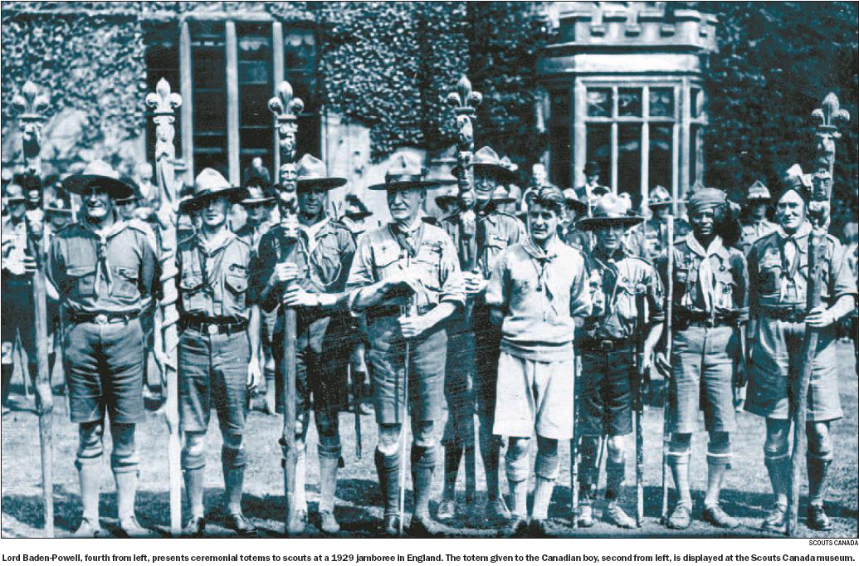

In September 1929, a brown- haired, eight-year-old boy marched into an old church in Leicestershire, England, and joined the 92nd Cubs. He wore the iconic uniform with pride. At 18, he swapped his Scout khakis for the grey- blue uniform of the Royal Air Force. When asked to describe the years he spent dodging German bullets in a Hurricane fighter plane, Alan Griffin, now 85, needs few words to answer: “It was hell.” And if he hadn’t been a Scout, he believes he might not have survived. “It may have saved my life during the war,” said Mr. Griffin. “We learned the buddy system, how to look after each other.” When the Second World War ended, Mr. Griffin again donned his blue and yellow Scout neckerchief. He’s been wearing it ever since. Today, he runs the Canadian Scouting Museum on Baseline Road. He also leads a troop, the 112th Nepean Rovers. By his reckoning, he’s one of the oldest active Scouts in Canada.
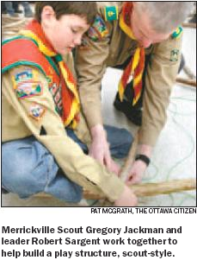
A recent heart attack has slowed him a little, though, and his medication sometimes steals the pep from his step. But Mr. Griffin, who moved to Canada in 1954, has no intentions of taking off his neckerchief anytime soon. More and more young Canadians, however, have no intention of ever putting one on.
Scouting, now in its 100th year, is flourishing. Global membership has nearly doubled since the early 1990s and now stands at 28 million.
But most of the growth is occurring in developing nations, where two- thirds of today’s Scouts live. In the U.S., membership is holding steady, but in Canada, Scouting is suffering.
According to Scouts Canada, which is marking the centennial tonight with a gala dinner at the Canadian Museum of Civilization, there are now fewer than 80,000 young scouts in this country. In the 1960s, when the movement peaked, there were more than three times that number.
There are some, however, who believe that today, perhaps more than ever, Canada needs Scouting. They say youth are too isolated, too self-centred and — to put it bluntly — too fat. Scouting, with its emphasis on community involvement, teamwork and physical activity, would do our kids nothing but good, they say.
But the competition for children’s attention is fierce. Cable television offers hundreds of channels. Last year, the video game industry had record profits. And the Internet is the digital world’s 7-Eleven: It’s always open.
‘I promise to do my duty . . .’
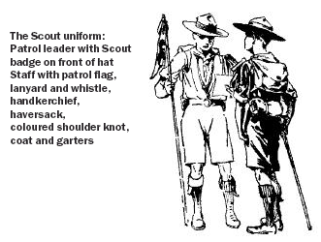
Kids who actually enjoy physical activity have more options today, too — snowboarding, tae kwon do, yoga. Add piano and Spanish lessons to the mix and it’s little surprise that the average suburban teenager has a schedule that would make a CEO look lazy.
Can Scouting really compete in Canada today? Could it actually be possible that in a few decades, the famous three-finger salute will be flashed for the last time?
When Robert Baden-Powell, a lieutenant- general in the British army, took 22 young lads camping on Brownsea Island in 1907, he didn’t have to compete with Gameboys or iPods for their attention. That trip, considered the beginning of Scouting, proved very successful. In fact, it wouldn’t be a stretch to claim that the outing, which spawned a world-wide movement that now has a presence in all but six countries, was the most successful camping trip of all time.
Baden-Powell’s Scouting for Boys, published in six parts in 1908, was also a success. It’s the fourth best-selling book in history, behind only the Bible, the Koran and Mao Tse-tung’s Little Red Book.
Canadian Scouting began a year after Baden Powell’s Brownsea Island outing, according to the 1982 book 75 Years of Scouting in Canada. A pastor named Ernest Thomas held the first official meeting in a Methodist church in Merrickville, Ont., the book claims. (Scouts Canada, however, says that may not be true: Two other troops — one in the Maritimes, one in St. Catharines — also claim to be the first.)
Since its beginnings, wherever they may have been, Scouting in Canada has seen many changes. In 1998, girls were permitted to join. A year later, Scouts Canada approved the creation of a troop exclusively for gays and lesbians. Many troops today no longer wear uniforms.
Despite these attempts to be more inclusive, Scouts Canada has been unable to slow the steady decline in its membership.
“I wonder if as we’ve become increasingly urbanized and electrified, that kids have become more worldly,” said Glenn DiPasquale, a psychologist who worked for many years in Toronto schools. “Are Boy Scouts a little too quaint?”
Mr. DiPasquale, a former Scout himself, says Scouts Canada may need a makeover, but the values the organization attempts to instill in its members are as relevant today as they’ve ever been — perhaps even more so.
One of Scouting’s principles is to respect others. Compared to previous generations, Mr. DiPasquale says, many of today’s children show little respect for anyone or anything. Because more families are living in large cities and children no longer know their neighbours, and because young people are spending more of their lives on the Internet, Mr. DiPasquale believes they have developed a sense of anonymity. As a result, they feel as if they’re not accountable to anyone.
“Nowadays, if kids mouth off at you in the parking lot, they don’t know you, and you don’t know them,” said Mr. DiPasquale. “Anonymity eats away at respect.”
Children today are also raised to be self-centred, Mr. DiPasquale says, because their parents only encourage them to participate in activities that will give them a competitive edge in society. The Scouts’ mission is to help young people be better citizens. Today’s parents seem to have a different mission: Pushing their children to be better than their neighbours’ children. Perhaps the not-so-young could also learn a thing or two from a Boy Scout.
Scouting also teaches children how to set and achieve goals, something few children do today, Mr. DiPasquale says.
“The whole badge system about that,” he said.
The physical benefits of Scouting are perhaps the most obvious of all. At the 2007 Canadian Scout Jamboree — to be held this summer in Tamaracouta, Que. — Scouts will participate in, among many other activities, mountain biking, swimming, volleyball, hiking, kayaking, dragon boat racing, canoeing and snorkelling. Notably absent from the list: an all-day Grand Theft Auto session.
Canadian children are less healthy now than at any point in recent history. Scan a few childhood obesity studies, and you’ll notice some reoccurring terms: Type 2 diabetes, hypertension, depression…. These illnesses, once suffered only by adults, have become commonplace in children.
“It’s the first generation in a 100 years that is thought to have a lower life expectancy than their parents,” said Kristi Adamo, a scientist with CHEO’s Childhood Obesity Research Unit.
Nobody is claiming a surge in Scout membership will mean the end of childhood obesity. But studies have shown that people who adopt active lifestyles when young often maintain those lifestyles. Obese children, however, usually become obese adults.
“It’s very hard to go the other way,” said Ms. Adamo.
Scouting’s benefits will be irrelevant, however, if the movement becomes a mere entry in our history books. Some within the Scouting body believe they know the cure for its membership woes. And it has nothing to do with making uniforms optional or offering a badge for instant messaging proficiency.
For Scouts Canada to survive, the theory goes, it must find a way to appeal to more of this country’s many cultural communities.
“It’s our future,” said John Plumadore, Scouts Canada’s director of development for diversity. “We better become aware of that.”
To attract new members from Canada’s diverse population, Scouts Canada has expanded its outreach programs. A recent push to reach the Chinese community in Toronto, Mr. Plumadore says, had fantastic results. (He says half of Toronto Scouts are now visible minorities.) A few months ago, the Toronto office hired its first Muslim staff member, and hopes to reproduce that success in the city’s Islamic community.
Scouts Canada offers to partner with institutions within various communities, and adapts its programs according to the cultural or religious traditions they value. Duty to God, for example, remains a Scouting principle, but Scouts Canada accepts that it can mean different things to different people.
“Duty to God can be expressed as duty to Allah,” said Mr. Plumadore. “Or to Buddha.”
John Neysmith, Scouts Canada’s international commissioner, shares Mr. Plumadore’s conviction that attracting youth from various cultures is important. But he also believes there is another way to invigorate Canadian Scouting.
“Unless we challenge our youth, they’re not going to join,” said Mr. Neysmith. “They can get fun in many other places.”
One way in which Scouting directors are attempting to challenge their troops is by encouraging them to take on community development projects in Third World countries. If a troop is interested in such a project, Scouts Canada will partner them with Scouts in a developing nation and provide funding for the project’s material costs. The troop’s members are responsible for raising money to cover their travel expenses.
When young Canadians are given the opportunity to serve others, Mr. Neysmith says, they embrace it. He’s seen it happen. The New Brunswick Scouting Council, he says, has become the world’s largest financial supporter of Street Scouting (a movement started in Nairobi, Kenya, in 1992 to help homeless orphans).
Of course, there are some Canadian troops that still do scouting the old-fashioned way — and manage to not only survive, but thrive. One such troop resides in Merrickville, where Canadian Scouting may have begun.
On a recent Monday night, seven boys and one girl gathered in the Merrickville Community Centre for their weekly Scout meeting. The troop’s total membership is 15, but if you include Beavers and Cubs, there are about 70 people involved in Scouting in Merrickville. Not bad, Scout leader Alex Beelich says, for a town with fewer than a thousand residents.
Mr. Beelich runs his troop the way his boyhood troop was run. Everyone wears a uniform: khaki shirt, red sash, red and yellow neckerchief. (One boy forgot his; A leader quickly fetched one for him.) His Scouts are as comfortable camping in winter as they are in summer. They can steer a canoe and handle a saw. If he dropped them off in the bush with a compass, Mr. Beelich says, they could all find their way home.
He knows that all kids are going to spend hours in front of some sort of glowing screen. That’s just the way it is today. But kids still love the outdoors, he says, and can be just as happy holding a canoe paddle as they can be holding a video game.
“Not everything has to have a battery.”
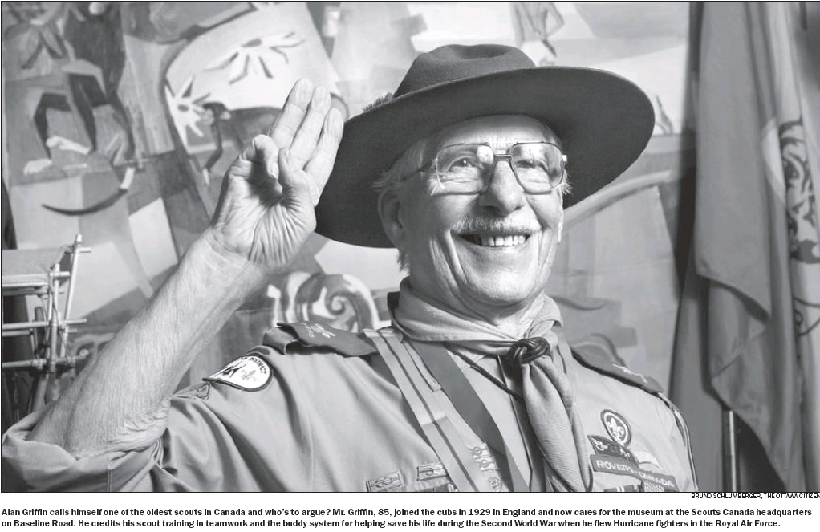

1908
SCOUTING FOR BOYS BY ROBERT BADEN- POWELL
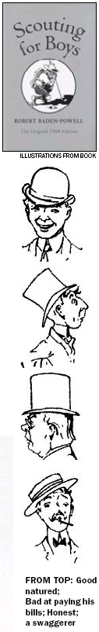
SUICIDE
Most people at one time or the other of their lives get a feeling that they will kill themselves; as a rule they get over it in a day or two, and find that it comes from nothing worse than an attack of indigestion, liver, or influenza, or from disappointment, or over- anxiety; but there are others with weaker minds, who read these newspaper accounts and brood over them till they can think of nothing else.
It only needs a sympathising friend to come along and take command of the would-be-suicide, and to give them something else to think about and to do. You can point out that suicide does no good to anybody; that it generally comes from something wrong with the bodily health, which makes the patient hysterical; that he has only got to command his own mind firmly, and the attack will pass off again....
Where a man has gone so far as to attempt suicide, a scout should know what to do with him. In the case of a man cutting his throat, the great point is to stop the bleeding from the artery.... In the case of hanging, cut down the body at once, taking care to support it with one arm while cutting the cord....
SMOKING
A scout does not smoke. Any boy can smoke, it is not such a very wonderful thing to do. But a scout will not do it because he is not such a fool. He knows that when a lad smokes before he is fully grown up, it is sure to make his heart feeble...
FITNESS
The secret of keeping well and healthy is to keep you blood clean and active...
The blood thrives on simple good food, plenty of exercise, plenty of fresh air, cleanliness of the body both inside and out, and proper rest of body and mind at intervals.
[Baden Powell cites the Japanese — he calls them ‘Japs’ — for their healthy lifestyles.]
“They eat very plain food, chiefly rice and fruit, and not much of it. They drink plenty of water, but no spirits. They take lots of exercise....
PATRIOTISM
Remember it is going to be the business of everyone of you to keep the old flag flying, even if you have to bleed for it — just as your forefathers did before you.
We have all got to die some day; a few years more or less of our own lives don’t make much matter in the history of the world, but it is a very great matter if by dying a year or two sooner than we should otherwise do from disease, we can help to save the flag of our country from going under.
Therefore think it over — BE PREPARED to die for your country if need be; so that when the moment arrives, you may charge home with confidence, not caring whether you are going to be killed or not.
‘SELF- ABUSE’
I have told you of the dangers of drink and smoking … but there is another practice which is perhaps more dangerous than either of them and it is one which is sure to tempt every one of you at one time or another…
The practice is called ‘self- abuse.’ And the result of self- abuse is always — mind you, always — that the boy after a time becomes weak and nervous and shy, he gets headaches and probably palpitation of the heart, and if he still carries it on too far he very often goes out of his mind and becomes an idiot.
ON ‘READING’ PEOPLE
It is said you can tell a man’s character from the way he wears his hat. If it slightly on one side, the wearer is good- natured; if it is worn very much on one side, he is a swaggerer; if on the back of his head, he is bad at paying his debts; if worn straight on the top, he is probably honest, but very dull.
2006 CANADIAN SCOUT HANDBOOK ON BEING PREPARED
“If someone is hurt in an accident, your first aid skills will prepare you to respond. Knowing the effects of tobacco, alcohol and other drugs on the mind and body will prepare you to say “no” when people offer these substances to you.
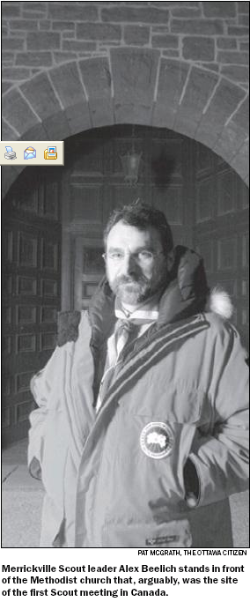
[Much of what scouts learn today is done by earning four “activity badges” — citizenship; leadership; personal development and outdoor skills — and 49 “challenge badges” in specific fields of interest, such as Lifesaving, Agriculture, Winter Sports, Cooking and Recycling.]
SAMPLE REQUIREMENTS
PERSONAL DEVELOPMENT PATHFINDER BADGE
SPIRITUAL:
Understand the role of your religion, spiritual belief, and/or church. Discuss your beliefs with the spiritual adviser of your choice.
SOCIAL:
3. Explore the area of social interaction with others. Subjects may include: dating; behaviour in public, sexually transmitted diseases, and abusive behaviours.
4. Know and demonstrate good personal grooming habits.
5. Explore at least two issues of public health. Subjects may include: AIDS, contagious diseases, blood supply or Medicare.
6. Explore at least two issues of public safety and security. Subjects may include: Neighbourhood Watch, Block Parents, swarming, the homeless, public facility safety, or safety inspectors.
7. Research and report on the effects of alcohol, tobacco and drugs
INTELLECTUAL:
8a. Review your progress toward goals in the Voyageur level, and 8b. Set new goals based on your progress in the Voyageur level
PHYSICAL:
9. Demonstrate knowledge of emergency treatment and first aid by qualifying at the St. John’s “ Emergency First Aid” level or the Red Cross “ Emergency level” OR
10. By demonstration, discussion or participation, show good knowledge of the following:
a) How to treat shock and choking;
b) Demonstrate not less than five bandaging techniques using triangular bandages
c) The meaning of first aid, and the management of a case
d) The types of wounds and dangers of infections
e) The general rules for treating fractures and poisons, as well as bleeding wounds
f) How to control bleeding
g) How to make stretchers and splints from items found at the site of an accident
h) How to treat an arm for a cut, burn and scald; and
i) CPR


