Valley Highlands - Hobby & Wheels - 2005

April 23rd to 24th
Merrickville Community Centre
105 Read Street, Merrickville, Ontario

A hobby show for Beavers, Cubs, Scouts, and Venturers will be held simultaneously with the racing. There is no charge for entries in the hobby show. Prizes will be awarded for 1st, 2nd, and 3rd places in each section. It is requested that all hobby show entries be left for the entire weekend so that they may be appreciated by all.

For the racing, there is $5 entry fee per vehicle. This covers the cost of a custom crest, building rental, awards, trophies, etc.

A custom crest will be given to each race participant. Additional crests may be purchased at the canteen for $3 each.

A canteen, run by the 1st Merrickville Scout Troop, will be in operation both days.

All racing entries (except Arden/Almonte) must be dropped off on Friday evening at the Merrickville Community Centre. This is to ensure that Saturday and Sunday are fun filled days for the youth and not consumed by administrative duties. Only one adult from each group (or groups) is required for the racing drop off. When dropped off, each vehicle must have a numbered sticker attached. This number must correspond written on the registration sheet and submitted with the vehicles. These stickers will be mailed or given to each group.

Hobby show entries may be dropped off on either Friday evening with the racing entries, or on Saturday morning.

New this year

- Cubs will be broken into two groups that will alternate between an outdoor activity and racing inside.
- Outdoor pioneering challenge, Chariot racing, for Cubs.
- Outdoor pioneering challenge, Monkey Gym, for Scouts.
- Game and outdoor activity for Beavers.
- No graphite.
- White tail Beavers have the option of racing Kub Kars with the Cubs.

Outdoor activities will proceed rain or shine. Ensure your youth are dressed appropriately.

Assistance from leaders in attendance is expected.

Please contact me if you have any questions.

Allan Yates
Chair, 1st Merrickville
Home: (613) 269-3074
Work: (613) 599-2148
Fax: (613) 269-3076
Email: allan@yates.ca
Valley Highlands Hobby Show 2005

Details:

- There is no charge for entry.
- Prizes will be awarded for 1st, 2nd, and 3rd places in the Beaver, Cub, Scout categories. Honourable mention ribbons will also be presented.
- Entries by leaders are also welcome (no prizes though).
- The attached entry form must be completed for each entry.
- Entries should be dropped off on Friday evening or on Saturday morning. Entry retrieval is Sunday at closing.
- Cub and Scout prizes will be announced at the closing on Saturday. Beaver prizes will be announced at the closing on Sunday.

Entry Suggestions:
- Collections (judging based on display)
  - Stamps
  - Coins
  - Scrapbooks (Cards, Photos, etc)
  - Stickers
  - Crests/Pins
  - Nature (Rocks, Shells, Leaves, etc)
  - Crests (Campfire blankets, ponchos)
  - Postcards

- Artwork
  - Crayons (Wax or pencil)
  - Pastels
  - Watercolours
  - Oil Paints
  - Pencil/Charcoal
  - Collage
  - Printing
  - Paint by numbers

- Scoutcraft
  - Model Pioneering (gadgets, etc)
  - Bird Houses & Feeders
  - Display Boards (Knots, Survival Kits, etc)

- Science
  - Electric Motors
  - Crystal Radios
  - Experiments

- Miscellaneous
  - Photography
  - Writing
- Crafts
  - Leatherwork
  - Woodwork
  - Glasswork
  - Metalwork
  - Basket weaving
  - Weaving
  - Macramé
  - Beadwork
  - Holiday Decorations
  - Puppets
  - Dolls & Stuffed Toys
  - Pottery & Clay Work
  - Ceramics
  - Dough Art
  - Paper Mache
  - Candle craft
  - Recycling (Popsicle sticks, macaroni, etc)
  - Decoupage

- Needlework
  - Sewing
  - Embroidery
  - Needlepoint
  - Knitting
  - Crochet
  - Corking
  - Rug Hooking

- Models
  - Plastic
  - Wooden
  - Working Mechanical
  - Working Electric
  - Meccano

Valley Highlands Hobby Show

Entry Form

Instructions:

Please complete separate page for each entry.
- For Section, please circle as appropriate.

Name: ________________________________________________

Group: ________________________________________________

Age: ________________________________________________

Section: Colony Pack Troop

Valley Highlands Wheels 2005

Details
- Open to Beaver Buggies, Kub Kars, and Scout Trucks.
- White tail Beavers have the option of racing Kub Kars with the Cubs.
- Kub Kars and Trucks to be dropped off at the Merrickville Community Centre on Friday evening.
- Prizes will be awarded for 1st, 2nd, and 3rd fastest vehicles in the Cub and Scout divisions.
- Prizes will be awarded for 1st, 2nd, and 3rd best looking vehicles in the Cub and Scout divisions.
- All youth must be in full uniform for their vehicle to be raced.
- A pit stop will be available for youth to make any necessary repairs to their vehicle.
- Racing results for each pack/troop will be given to the leader in charge.

Friday April 22nd 6:30pm – 8:00pm
- Kub Kar and Truck drop off and registration.
- Vehicles will be weighed and checked for size.
- Only one adult per group (no youth) required for drop off.
- Submit one completed registration form per section.
- Submit payment in full: $5 per vehicle entry.
- Event crests given to adult registering section/group.
- Hobby show drop off.
Sunday April 24th (Beavers)
12:30pm
- Beavers arrive.
- Payment in full: $5 per Beaver.
- Event crests given to adult registering colony.
1:00pm
- Opening ceremony.
- Game.
1:30pm
- Beaver racing and fun events.
- Beavers rotated through events every 15 minutes.
3:00pm
- Outdoor activity
4:00pm
- Beaver hobby awards.
- Closing.
Saturday April 23rd Cubs & Scouts)
8:00am
- Hobby show drop off continues.
8:30am
- Cubs and Scouts arrive.
9:00am
- Opening ceremony.
- Scout pioneering.
- ½ Cubs inside for racing.
- ½ Cubs outside for pioneering.
10:30pm
- Inside and outside Cubs switch.
12:00pm
- Lunch.
12:30pm
- Outside game for all Cubs.
- Scout truck racing inside.
2:00pm
- Cubs try Scout pioneering structure.
- Cub fun events.
- Cubs rotated through events every
15 minutes.
- Scout teardown of pioneering structure.
4:00pm
- Leader and parent racing.
- Cub and Scout hobby & racing awards.
- Closing.
Valley Highlands Wheels 2005

Fun Events for Beavers and Cubs
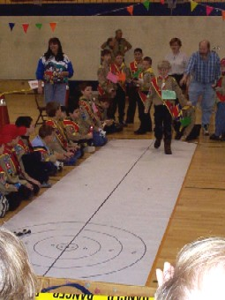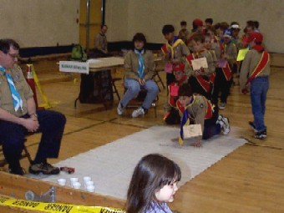
Curling Bowling

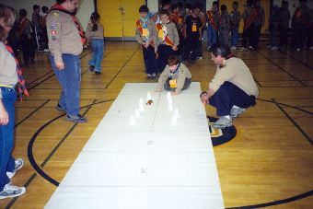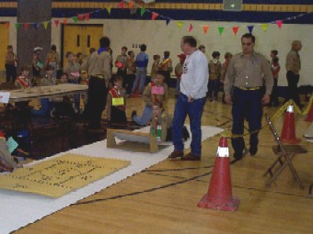
Obstacle Course Ramp Jump
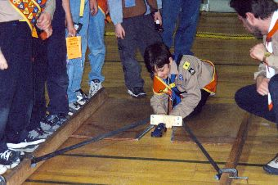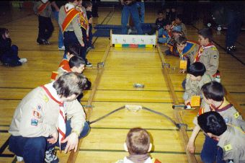
Sling Shot Sling Shot
Valley Highlands Wheels 2005

Rules

General Rules
- No graphite as a lubricant (it makes too much mess).
- No lubricants may be dripping from the vehicle.
- All weight must be solid, no liquid weight (i.e. no full pop cans).
- No sources of movement other than gravity.
- All vehicles must have been built during the current Scouting year.
- Wheel bearings, washers, and bushings are prohibited.
- Wheels and axles may not be modified in any way other than removing burrs, molding seams, and rough spots. Axles may be polished.
- No loose materials, all pieces must be permanently connected.
- The vehicles must not ride on any type of springs.
- Only wheels and axles provided in the Scouts Canada kits may be used.

Kub Kar Specific Rules
- Maximum weight is 142g (5 ounces).
- Maximum size is 7” long and 2 ¾” wide.

Scout Truck Specific Rules
- Maximum weight is 800g.
- Maximum size is 48 cm long, 9 cm wide, and 11 ½ cm high.
- All 18 wheels must contact the track.
- 10 wheels must be used on the cab, and the other 8 on the trailer.
- A pivot point must exist between the cab and the trailer.
Valley Highlands Wheels 2005
Scout Pioneering Project
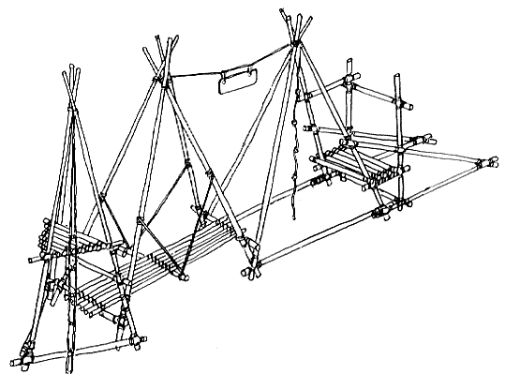

Cub Pioneering Project

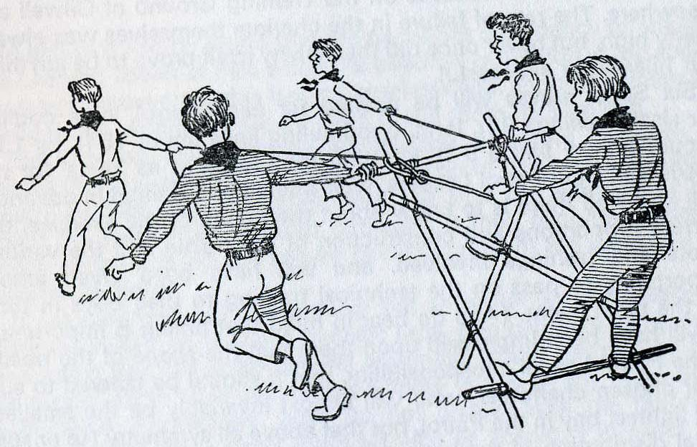
Valley Highlands Wheels 2005
Registration Form

Please complete one form per section. This form must be submitted with the vehicles.

Group: _______________________________

Leader in Charge: _____________________________________

Section: Pack Troop (circle one)

Car # Youth Name__________________________
_____ ____________________________________
_____ ____________________________________
_____ ____________________________________
_____ ____________________________________
_____ ____________________________________
_____ ____________________________________
_____ ____________________________________
_____ ____________________________________
_____ ____________________________________
_____ ____________________________________
_____ ____________________________________
_____ ____________________________________
_____ ____________________________________
_____ ____________________________________
_____ ____________________________________
_____ ____________________________________
_____ ____________________________________
_____ ____________________________________
_____ ____________________________________
_____ ____________________________________
_____ ____________________________________
_____ ____________________________________
_____ ____________________________________
_____ ____________________________________
_____ ____________________________________
_____ ____________________________________
_____ ____________________________________
_____ ____________________________________
Valley Highlands Hobbies & Wheels 2004



