Instructions
Divide Cubs into teams of six. Each six to build a catapult as per the attached photographs. Utilise twine for lashings.

Usage
Cubs can fire tennis balls at each other. Alternatively, there can be a competition as to who can fire a tennis ball the furthest.

Materials
Broomsticks
Twine
Scissors
Tennis balls
Catapult elastic with pocket with tennis ball

Credit
John Russell, Pinhoe Cub Scouts (UK), www.pinhoecubs.org.uk

Design Photographs

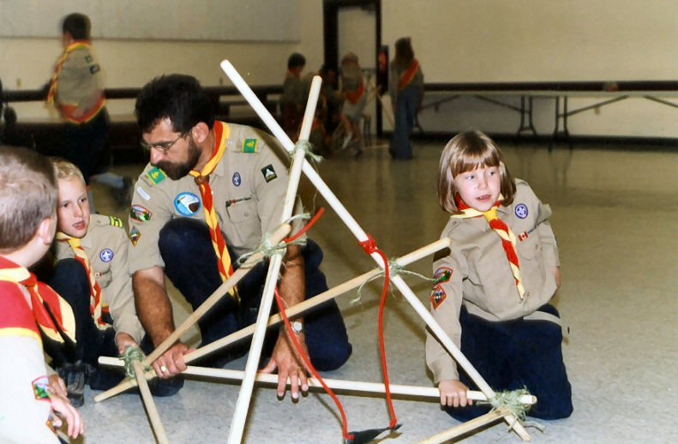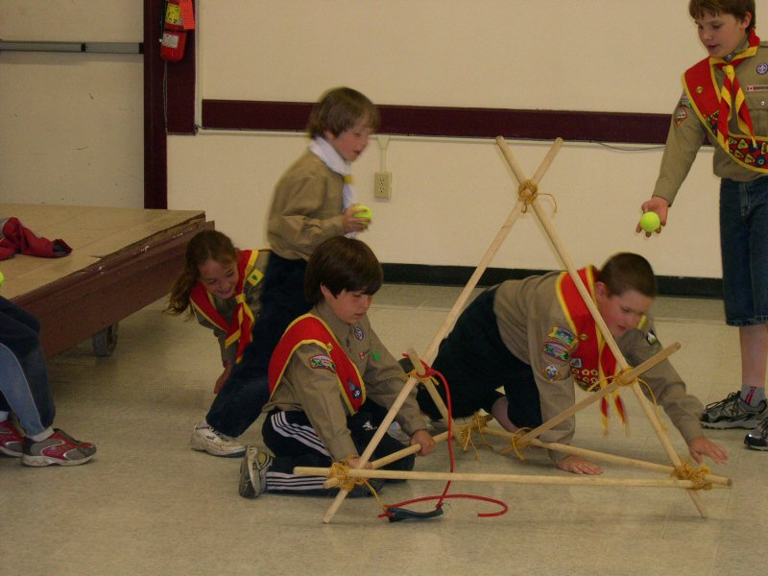

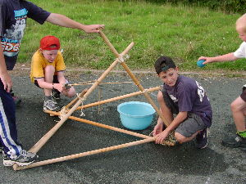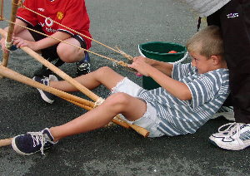

Cub Instructions

Build a catapult as show in the following photographs.

