Valley Highlands - Hobby & Wheels - 2006

April 29th to 30th
Merrickville Community Centre
105 Read Street, Merrickville, Ontario

Annual combination racing and hobby show.

The hobby show is open to Beavers, Cubs, Scouts. There is no charge for entries in the hobby show. Prizes will be awarded for 1st, 2nd, and 3rd places in each section. It is requested that all hobby show entries be left for the entire weekend so that they may be appreciated by all. For the past few years there have been very few entries. Please market this to the kids in your group.

For the racing, there is $5 entry fee per vehicle.

A canteen, run by the 1st Merrickville Scout Troop, will be in operation both days. Prices will be very reasonable, e.g. $1/hotdog

New this year

- Later start time, earlier finish time.
- Hobby show prizes for Cubs and Scouts only. Beavers will receive a participation ribbon.
- The last page of this package is a flyer for the parents.
- All registration on Saturday morning.
- New fun activities: Loop-the-loop track.
- Venturer demonstration of self-propelled cars going uphill.

Outdoor activities will proceed rain or shine. Ensure your youth are dressed appropriately.

Assistance from leaders in attendance is expected.

Please contact me if you have any questions.

Allan Yates
Chair, 1st Merrickville
Home: (613) 269-3074
Work: (613) 599-2148
Fax: (613) 269-3076
Email: allan@yates.ca
Valley Highlands Hobby Show 2006

Details:

- There is no charge for entry.
- Prizes will be awarded for 1st, 2nd, and 3rd places in the Cub, Scout categories. Honourable mention ribbons will also be presented. Participation ribbons for Beavers.
- Entries by leaders are encouraged (no prizes though).
- The attached entry form (or the equivalent information) must be completed for each entry.
- Entries should be dropped off on Saturday morning. Entry retrieval is Sunday at closing.
- Cub and Scout prizes will be announced at the closing on Saturday.

Entry Suggestions:
- Collections (judging based on display)
  - Stamps
  - Coins
  - Scrapbooks (Cards, Photos, etc)
  - Stickers
  - Crests/Pins
  - Nature (Rocks, Shells, Leaves, etc)
  - Crests (Campfire blankets, ponchos)
  - Postcards

- Artwork
  - Crayons (Wax or pencil)
  - Pastels
  - Watercolours
  - Oil Paints
  - Pencil/Charcoal
  - Collage
  - Printing
  - Paint by numbers

- Scoutcraft
  - Model Pioneering (gadgets, etc)
  - Bird Houses & Feeders
  - Display Boards (Knots, Survival Kits, etc)

- Science
  - Electric Motors
  - Crystal Radios
  - Experiments

- Miscellaneous
  - Photography
  - Writing
- Crafts
  - Leatherwork
  - Woodwork
  - Glasswork
  - Metalwork
  - Basket weaving
  - Weaving
  - Macramé
  - Beadwork
  - Holiday Decorations
  - Puppets
  - Dolls & Stuffed Toys
  - Pottery & Clay Work
  - Ceramics
  - Dough Art
  - Paper Mache
  - Candle craft
  - Recycling (Popsicle sticks, macaroni, etc)
  - Decoupage

- Needlework
  - Sewing
  - Embroidery
  - Needlepoint
  - Knitting
  - Crochet
  - Corking
  - Rug Hooking

- Models
  - Plastic
  - Wooden
  - Working Mechanical
  - Working Electric
  - Meccano

Valley Highlands Hobby Show

Entry Form

Instructions:

Please complete separate page for each entry.
- For Section, please circle as appropriate.

Name: ________________________________________________

Group: ________________________________________________

Age: ________________________________________________

Section: Colony Pack Troop

Valley Highlands Wheels 2006

Details
- Open to Beaver Buggies, Kub Kars, and Scout Trucks.
- White tail Beavers have the option of racing Kub Kars with the Cubs.
- Prizes will be awarded for 1st, 2nd, and 3rd fastest vehicles in the Cub and Scout divisions.
- Prizes will be awarded for 1st, 2nd, and 3rd best looking vehicles in the Cub and Scout divisions.
- All youth must be in full uniform for their vehicle to be raced.
- A pit stop will be available for youth to make any necessary repairs to their vehicle.
- Racing results for each pack/troop will be given to the leader in charge.
Sunday April 30th (Beavers)

12:00pm
- Registration.
- Hobby show drop off.
1:00pm
- Opening ceremony.
- Trading Post Game.
1:30pm
- Racing and fun events.
2:30pm
- Game.
3:00pm
- Closing.
Saturday April 29th (Cubs & Scouts)

9:00am
- Registration.
- Hobby show drop off.
10:00am
- Opening ceremony.
- Scout pioneering outside.
- ½ Cubs inside for racing.
- ½ Cubs outside for catapults.
11:30pm
- Lunch
12:00pm
- Sponsor and Adult Racing
- Venturer uphill car demonstration
12:30pm
- ½ Cubs inside for racing.
- ½ Cubs outside for catapults.
2:00pm
- Cubs try Scout pioneering structure.
- Cub catapult war
- Scout truck racing.
2:30pm
- Cub fun events
- Scout teardown of pioneering structure.
3:30pm
- Cub and Scout hobby & racing awards.
- Closing.

Valley Highlands Wheels 2006

Rules

General Rules
- No graphite as a lubricant (it makes too much mess).
- No lubricants may be dripping from the vehicle.
- All weight must be solid, no liquid weight (i.e. no full pop cans).
- No sources of movement other than gravity.
- All vehicles must have been built during the current Scouting year.
- Wheel bearings, washers, and bushings are prohibited.
- Wheels and axles may not be modified in any way other than removing burrs, molding seams, and rough spots. Axles may be polished.
- The vehicles must not ride on any type of springs.
- Only wheels and axles provided in the Scouts Canada kits may be used.

Kub Kar Specific Rules
- Maximum weight is 142g (5 ounces).
- Maximum size is 7” long and 2 ¾” wide.

Scout Truck Specific Rules
- Maximum weight is 800g.
- Maximum size is 48 cm long, 9 cm wide, and 11 ½ cm high.
- All 18 wheels must contact the track.
- 10 wheels must be used on the cab, and the other 8 on the trailer.
- A pivot point must exist between the cab and the trailer.
Valley Highlands Wheels 2006

Scout Pioneering Project

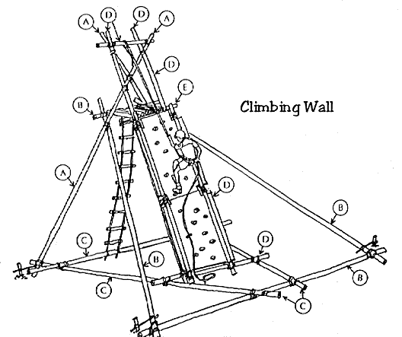

Cub Pioneering Project

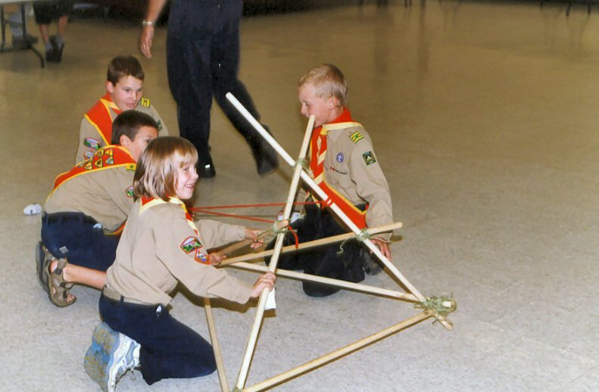
Valley Highlands Hobbies & Wheels 2006

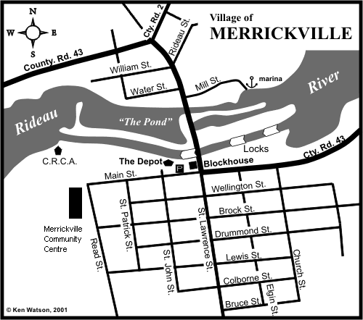

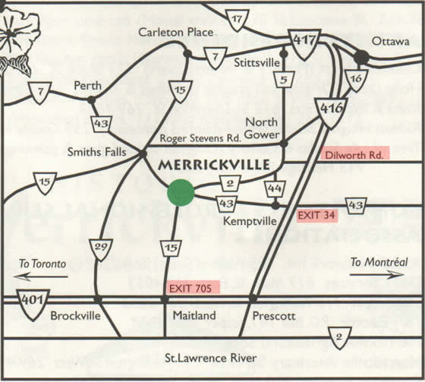

Valley Highlands 2006
Hobbies & Wheels

Beavers
Sunday April 30th
12:00pm – 3:00pm
Bring your Beaver Buggy and Hobby Show entries
Buggy Racing and Fun Events, Trading Post Game, Catamaran Racing

Cubs
Saturday April 29th
Registration 9:00-10:00am, Depart 3:30pm
Bring your Kub Kar and Hobby Show entries
Kub Kar Racing and Fun Events, Pioneering Catapults

Scouts
Saturday April 29th
Registration 9:00-10:00am, Depart 3:30pm
Bring your Scout Truck and Hobby Show entries
Truck racing, Pioneering Climbing Wall

Location
Merrickville Community Centre
105 Read Street
Parents, stay and watch your child, or visit the charming stores of Merrickville
www.realmerrickville.ca

Details
Full Uniform Mandatory
Racing Entry Fee $5/child

Canteen
A very reasonably priced canteen will be in operation (e.g. $1/hotdog)
Send your child with your loose change for snacks



