The 1st Merrickville Scout group is interested in restarting their Hobbies & Wheels event, which ran from 2004-2006. This event combines Kub Kar and Scout Truck racing with a hobby show. The event would be run as a single day for both Cubs and Scouts (and optionally white tail Beavers) to facilitate linking between the sections and for economies of scale. The purpose of the hobby show is to give kids the incentive and opportunity to involve themselves in hobbies other than video games. The activities are designed to support the hobby aspect, gives kids an incentive to participate, and to ensure the kids go home saying ‘Wow!’.

Date
A Saturday in April from 9:00am to 3:00pm. We are suggesting that we run this event every other year, with another group running something a bit different on alternate years to provide variety for the kids.

Racing
Each vehicle would race six times on Merrickville’s computer timed track. This ensures every kid gets the same opportunity for racing, regardless of the speed of their vehicle. The computerised scheduling automatically races slow against slow and fast against fast so everybody has a chance for close finishes.

Racing Prizes
Prize ribbons would be given for the following:
- Fastest three Kub Kars
- Fastest three Scout trucks
- Three best designed Kub Kars
- Three best designed Scout trucks
Certificates would be awarded for a variety of design criteria. Any existing area trophies could be awarded to their fastest Pack and their fastest Troop.

Kub Kar Fun Events
The Cubs will have the opportunity to run their Kars through the Kub Kar slingshot, Kub Kar bowling, Kub Kar Kurling, the Kub Kar ramp jump, and the first in Canada loop-the-loop track/jump after racing is completed. A Kub Kar seat belt demonstration (egg smashing) might be added.

Model Building
As part of the initiative to encourage constructive hobbies, each Cub and Scout would be given a model to build during the event.
- Plastic model aeroplane/helicopter building for Cubs
- Model rocket (or rocket propelled glider) building and launching for Scouts

Other Activities
Games and activities would be organised to keep the kids occupied when they are not racing. We would also plan to include:
- Meccano model display and building area for the kids
- Model aeroplane display and demonstrations
- Lego model display and building area for the kids
- Model train display
- Model rocket display and demonstration
Vehicles from the OPP, the fire department, and the ambulance service would be on hand for exploration by the kids.

Venturers
An invitation would be extended to Venturers to demonstrate self propelled Kub Kars or Scout Trucks. In the past these have been rocket propelled, but other means of propulsion would be encouraged as well. There would be no entry fee for the Venturers.

Crest
A custom embroidered crest would be created for this event. Each person entering a vehicle in the racing competition would receive a crest. Additional crests would be available for $3 each.

Location
The event would be held at the Merrickville Community Centre. Activities would take place both inside and outside. The event would run rain or shine.

Hobby Show
The hobby show would be open to Cubs and Scouts, with no charge for entries. Prize ribbons would be awarded for 1st, 2nd, and 3rd places in each section.

Attendance
Open to all Cubs, Scouts, and Venturers. White tail Beavers could participate with their Cub pack as a linking activity, racing either Beaver Buggies or Kub Kars.

Canteen
A canteen for lunch, snacks, and drinks would be in operation throughout the day. This would be staffed by the Merrickville Scouts and/or Venturers, with prices being kept very reasonable. Complimentary coffee would be available.

Financials
The cost would be $10/Cub and $15/Scout. This would include all activities, prizes, building rental, a plastic model aeroplane or model rocket to build and take home, and a custom crest. One rocket engine per Scout would be included; additional engines would be available for $3/each. Profit and loss for the event would be assumed by the Merrickville Scout group.

Photographs
For photos of the previous Hobbies & Wheels events, see www.1stmerrickville.ca/wheels/.

Registration
Estimates of attendance would be needed well in advance to ensure appropriate supplies are on hand. Entry fee, paid at the door, would only be for actual attendees.

Next Step
A long lead time is required to coordinate many aspects of this event, so confirmation of interest would ideally be received by the end of June. Comments, suggestions, and ideas are more than welcome; we want everyone to enjoy the event.

Allan Yates
Chair, 1st Merrickville
(613) 269-3074
allan@yates.ca

Race Track Start Race Track Finish Loop-the-loop Track
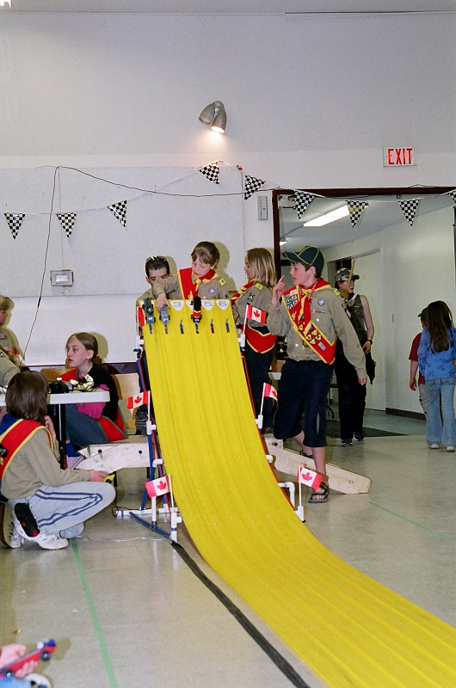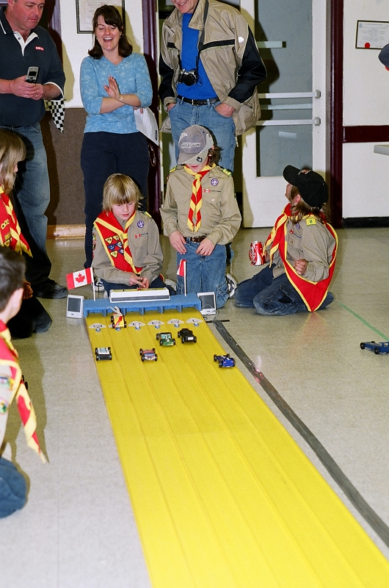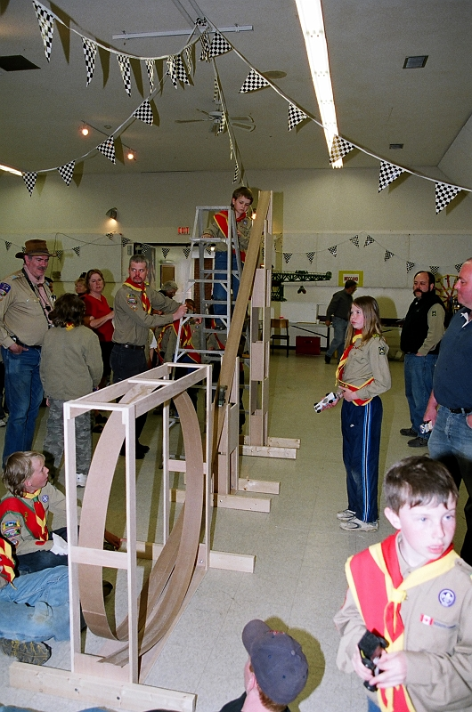

Kub Kar Slingshot Kub Kar Ramp Jump Venturer Rocket Kars
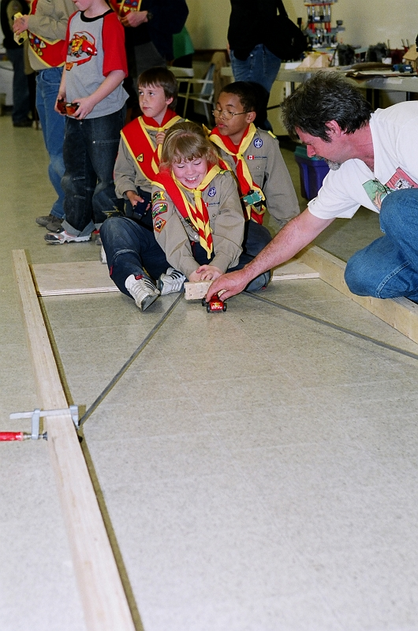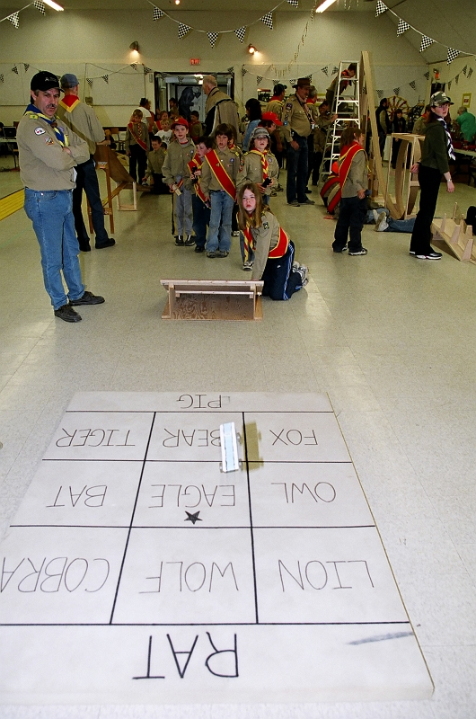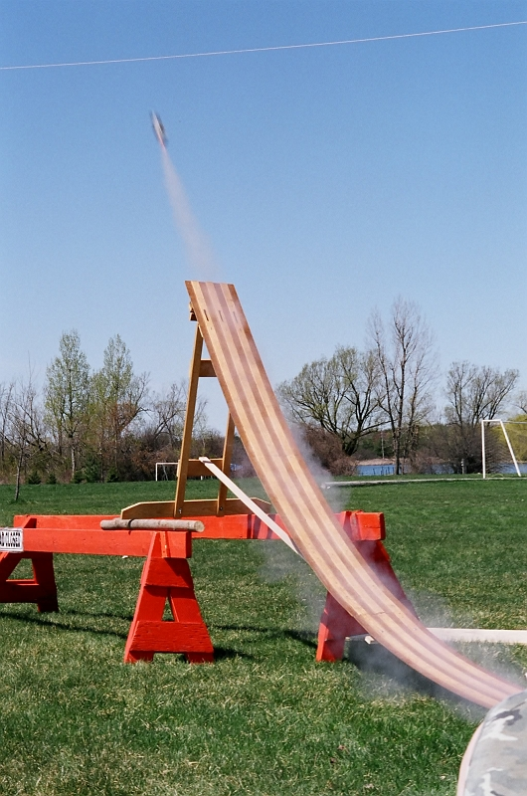
Kub Kar Bowling Kub Kar Kurling
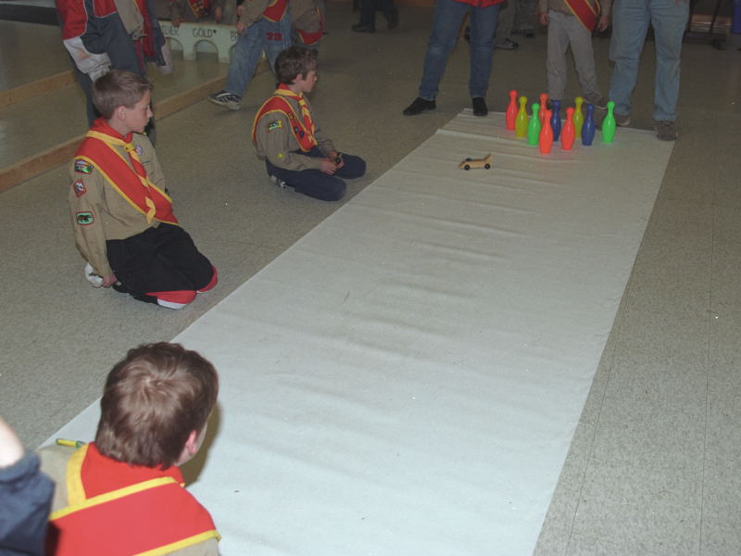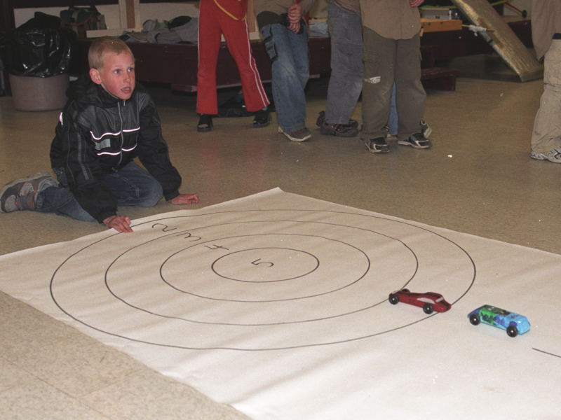

Cub Hobbies Scout Hobbies
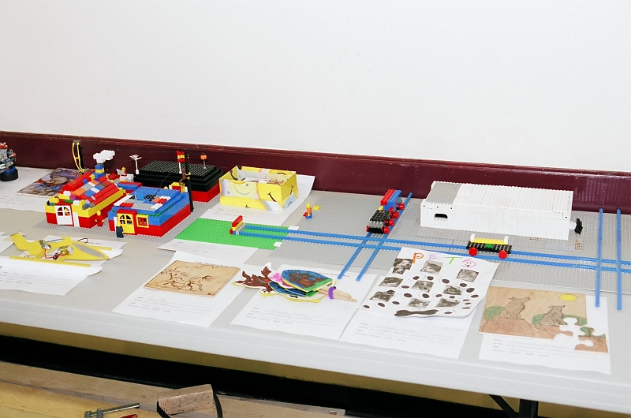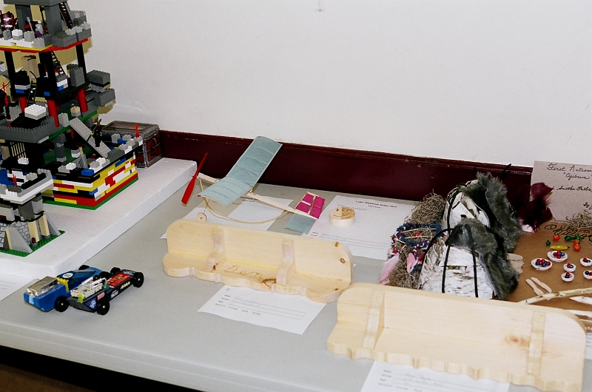

Meccano Model Display & Building Model Aeroplanes
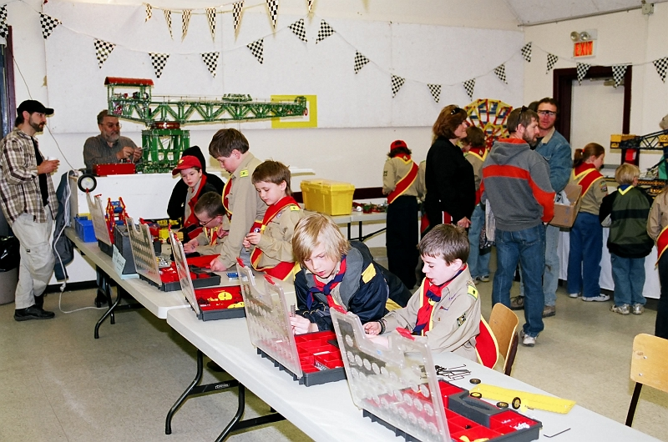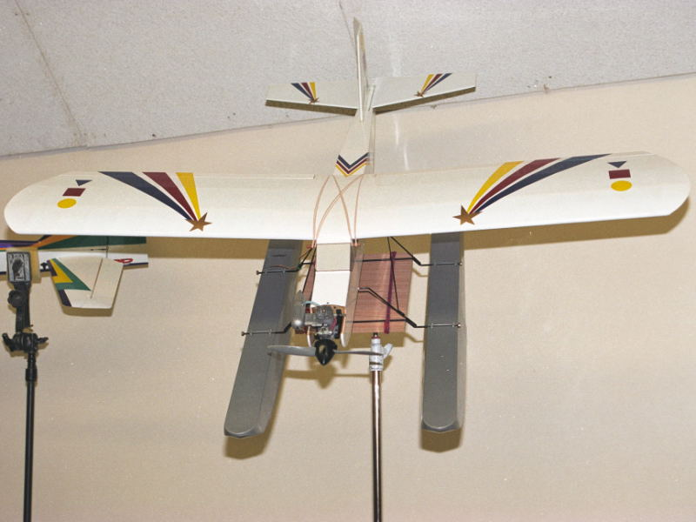

Kub Kar Seatbelt Demonstration Scout Model Rockets - Completed Kits
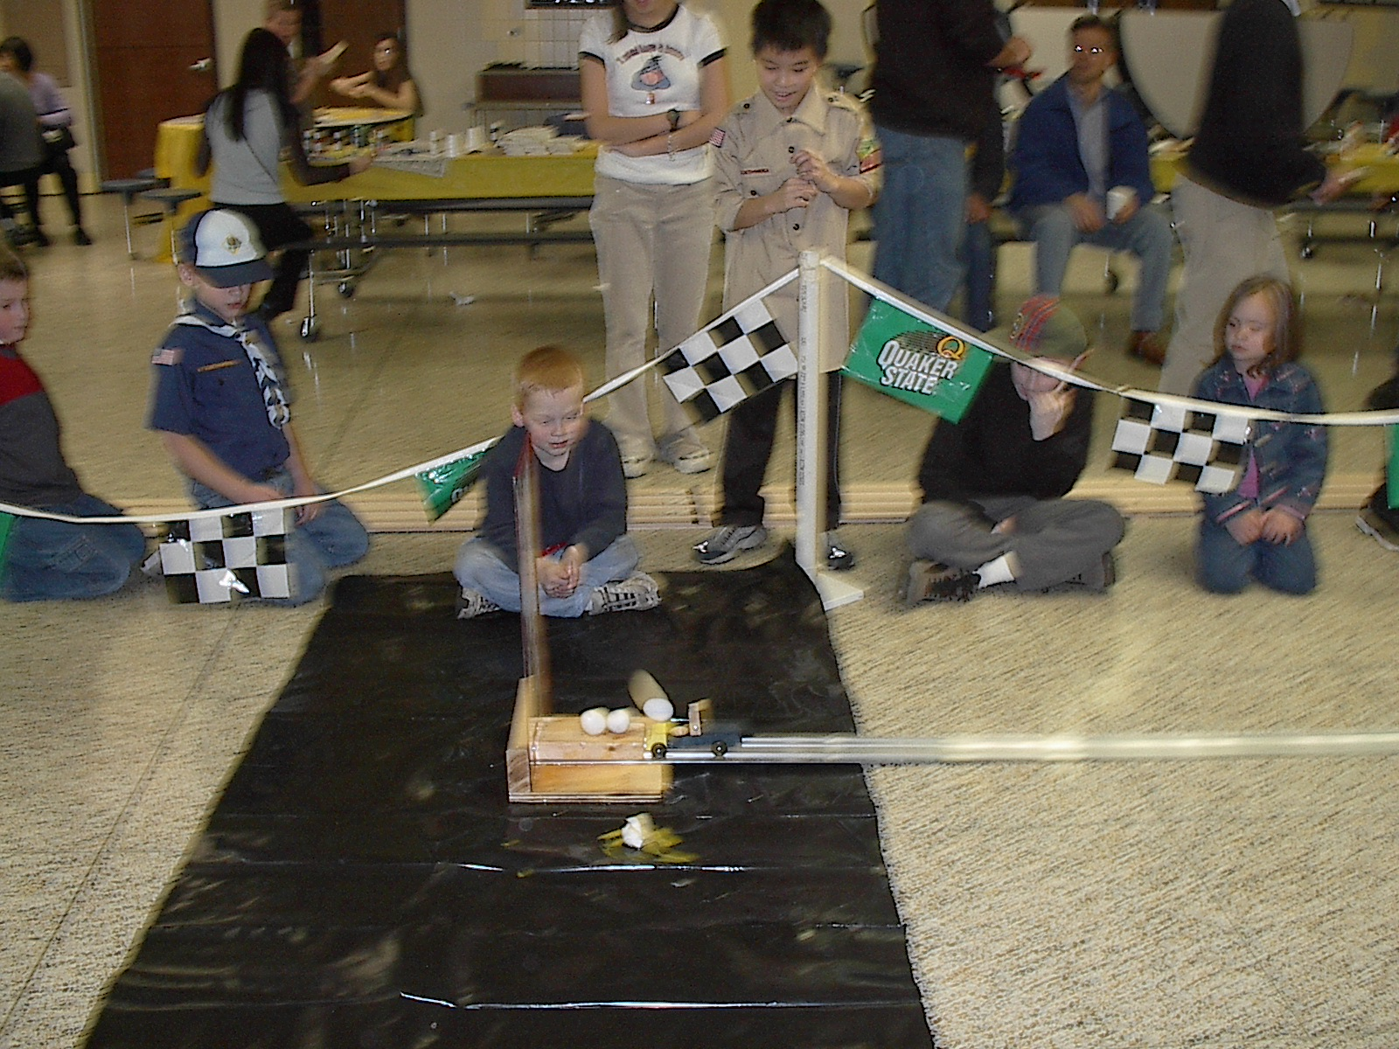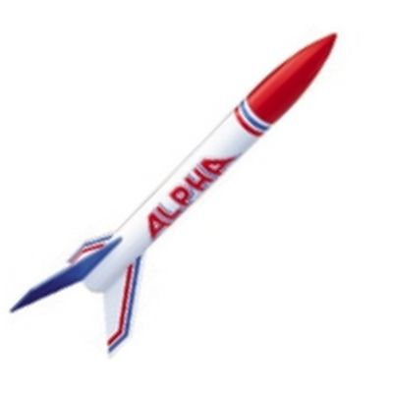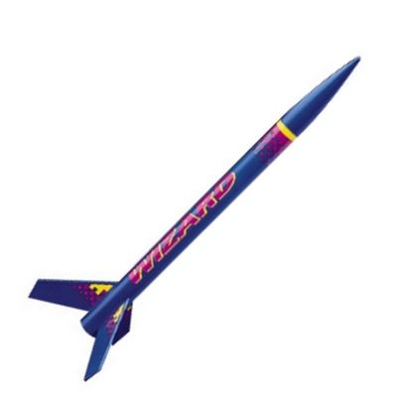

Scout Model Rocket Launched Glider - Completed Kit
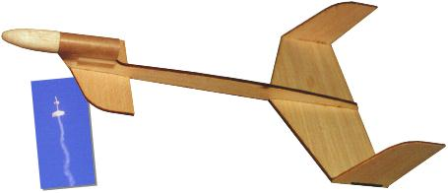

Cub Model Aeroplane - Completed Kit Cub Model Helicopter - Completed Kit


