Desired Features
- two top sections so that one may squeeze futher down into a narrower passage
- Holes drilled on top to allow for formations
- Wide enough for two people to cross through
- Increments of 1/4”
- Bungee pop-up top
- Steel reinforced sides
- Cut-out side windows to see inside
- Wheels for portability

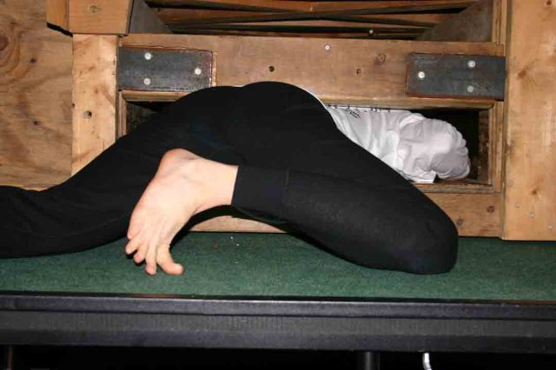

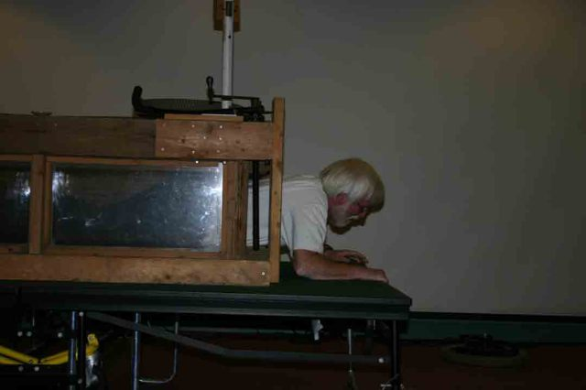

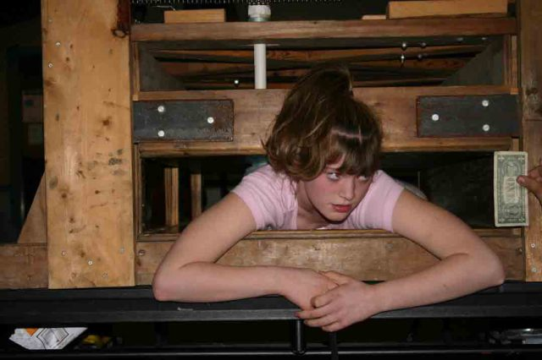

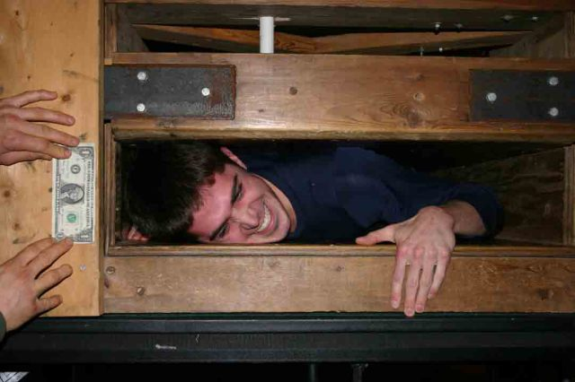

Thought I'd add to the discussion...I built a box that we called the Big"C". We used it at the CIG picnic and at Cave Capers one or two years in a row. It was basically (3)2.5ft sq plywood boxes screwed together. It had air gaps at the top and bottom on the sides for ventilation and the main funtion of the box was to create (2)90°turns. It had adjustable panels in the corners at 45°that forced the person crawling thru the box to do (2)complete rollovers to get thru it. Most of the time we would just put bungi cords on the corner boards instead of fixing them to a set distance. If you have ever been in a crawlway with 90°turns I think you will understand the manuver. One might conside this type of box more
fun than a squeeze box. Will try to find some pics, but it was a number of years ago.

www.youtube.com/watch?v=9bQPwl6mdJA

http://www.youtube.com/watch?v=i6gfMiwTHWA

http://www.youtube.com/watch?v=haul9ihO590

