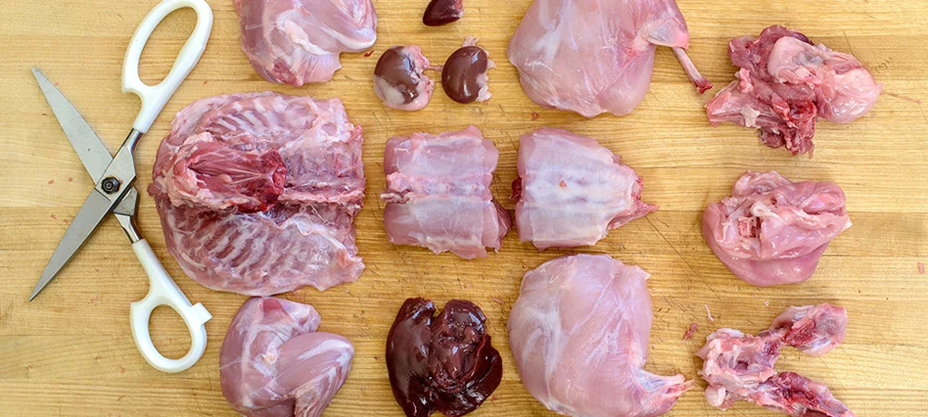
Rabbits might be small, but butchering them can be a big job if you’re not sure what you’re doing. Here’s a step-by-step guide for how to break down a whole wild rabbit from nose to toes. The organs are worth saving, especially if you have multiple rabbits, or you can freeze them until you have a big enough pile of hearts, kidneys, and livers to work with. Before you begin, make sure you have a clean work area, a sharp boning knife, and a cleaver.

Step1
Field dressed rabbit with liver and heart set aside.
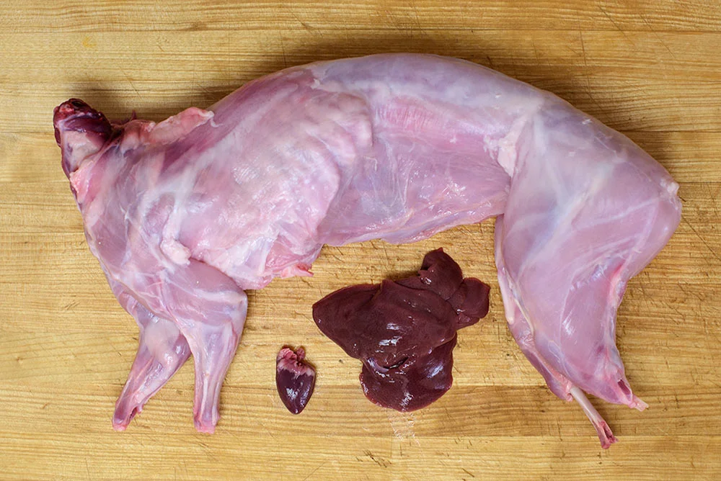

Step 2
Inside the rabbit: Loins, kidneys and organ fat visible.
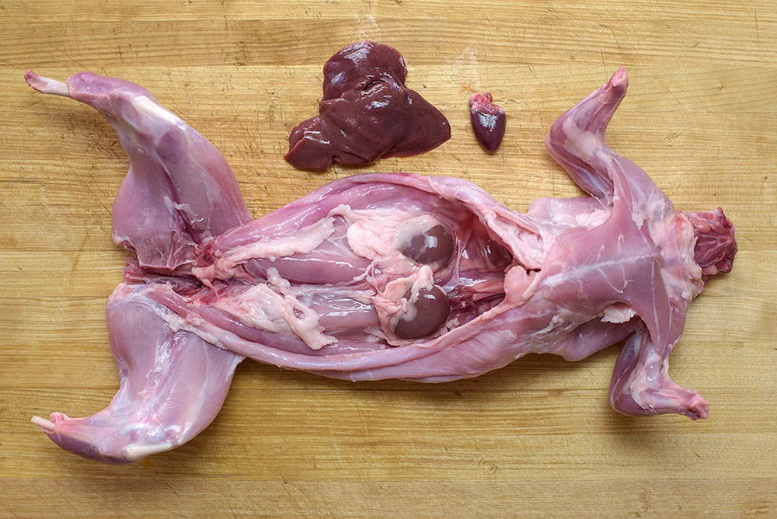

Step 3
Begin by removing the kidneys, and then trim away cavity fat. Set it aside to make stock. Lift the kidney to sever the fat and tissue.

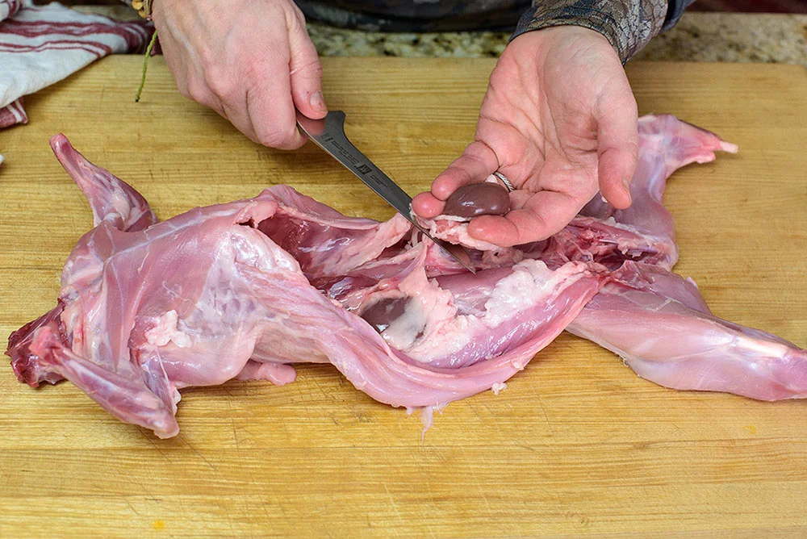

Step 4
Flip the rabbit on its side. Grab its front leg and lift outward to reveal the scapula. Position your boning knife behind the scapula, and cut downward across rib cage toward the sternum to remove the front shoulder and leg.
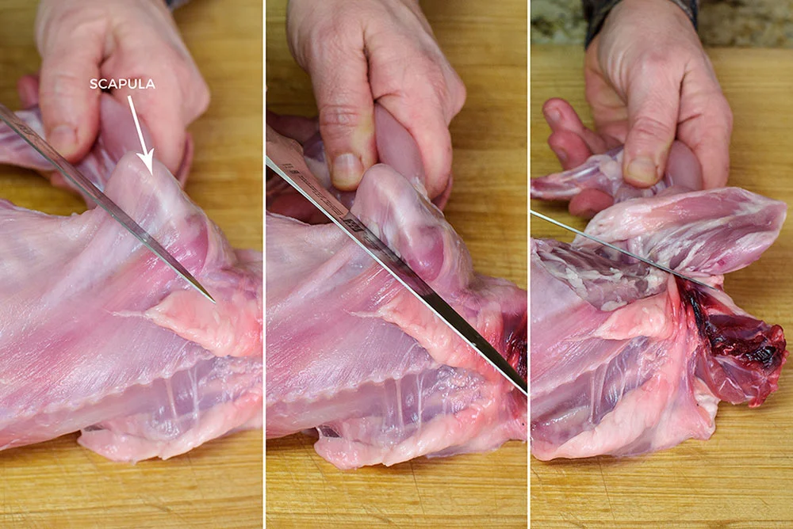

Step 5
Here’s the front left shoulder and leg, removed.
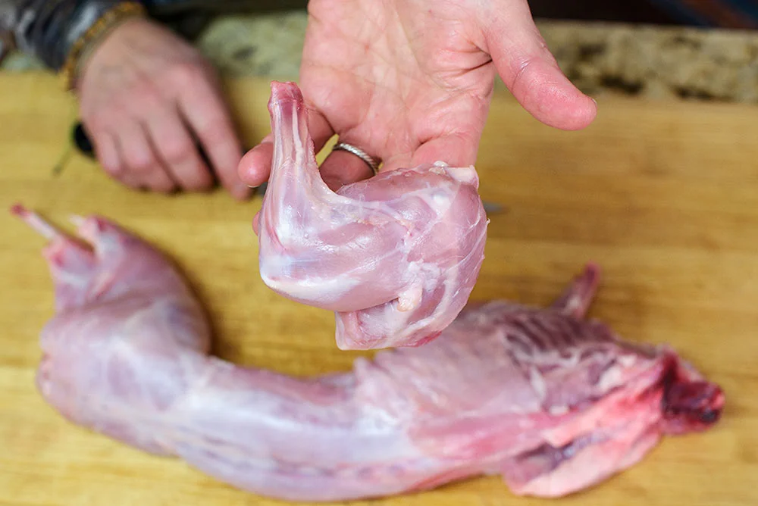

Step 6
Move to the left back leg. Some people will make a perpendicular cut across the back, but a perpendicular cut leaves the pelvis in place and adds more bones to chew around. Instead, follow the natural contour of the rump.
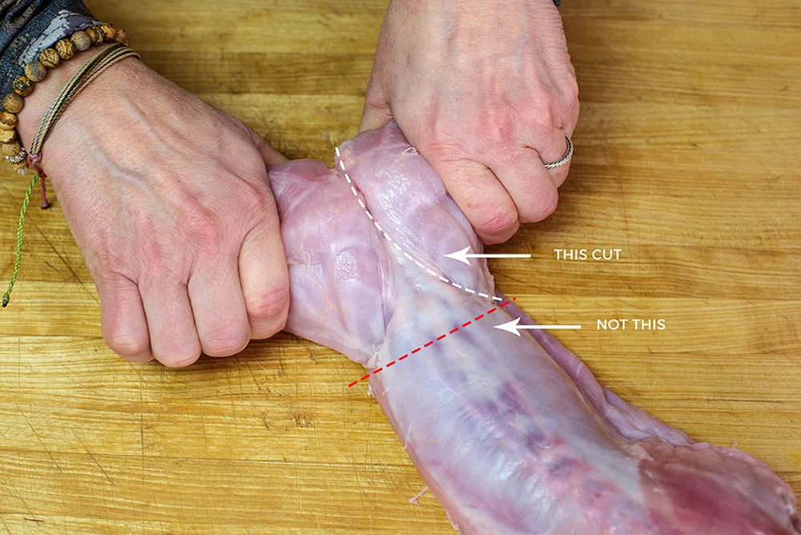

Step 7
Begin at the top of the hind leg following the contour.
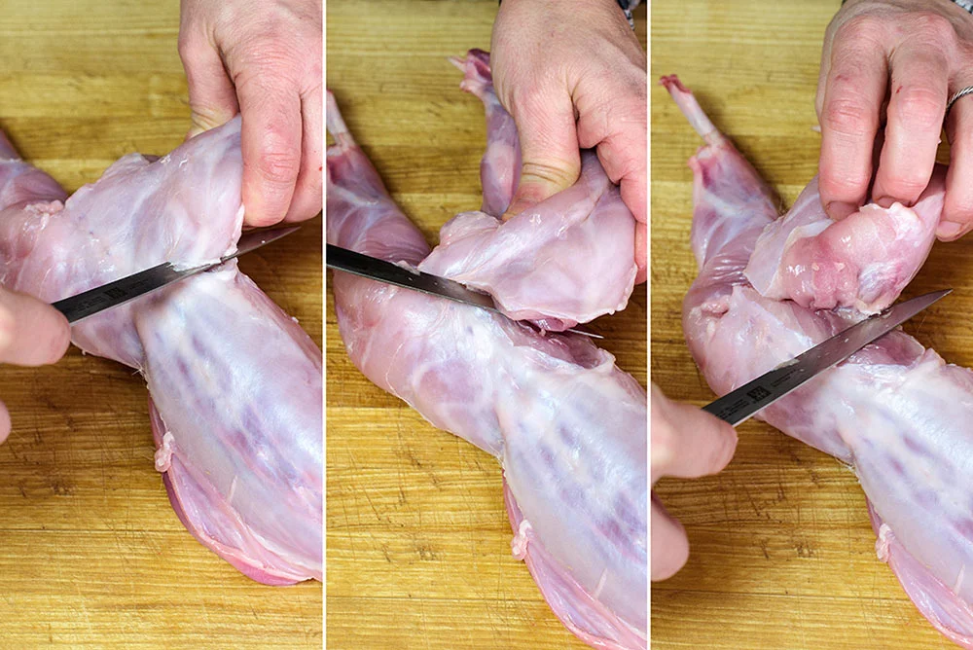

Step 8
As you get deeper into the cut, your knife will hit bone. This is where the femoral head connects to the pelvic socket. Pry the two apart and left the hind leg free.
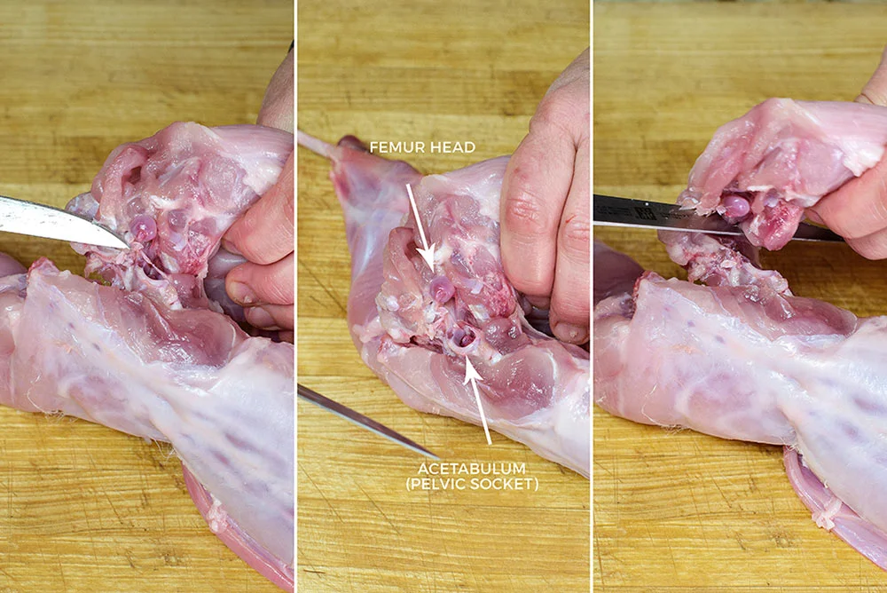

Step 9
Here’s the top and bottom of the removed left hind leg.
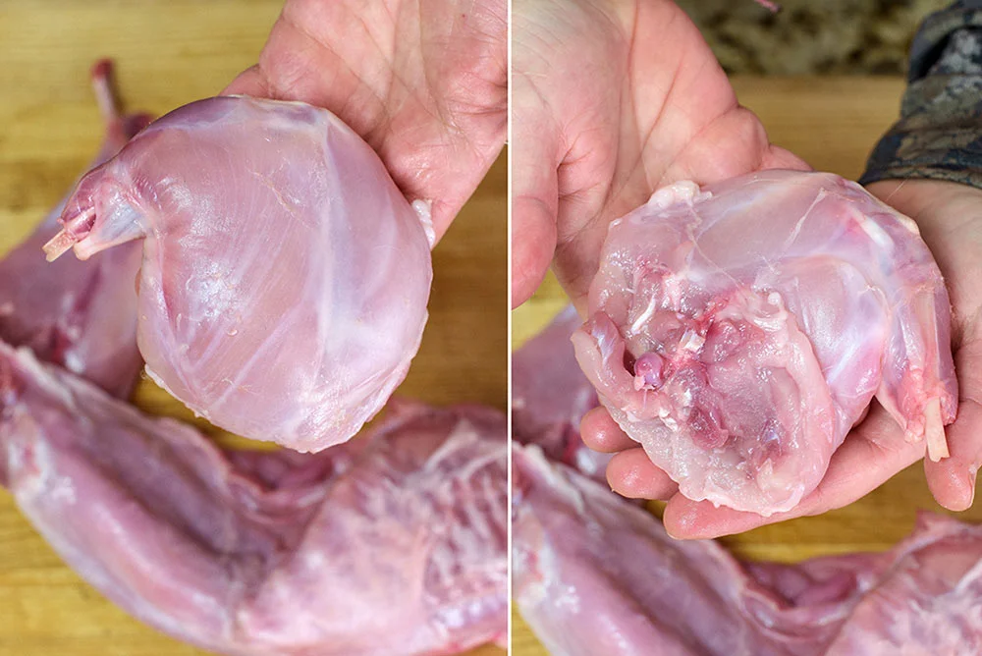

Step 10
Flip the carcass and repeat cuts with the opposite front leg.
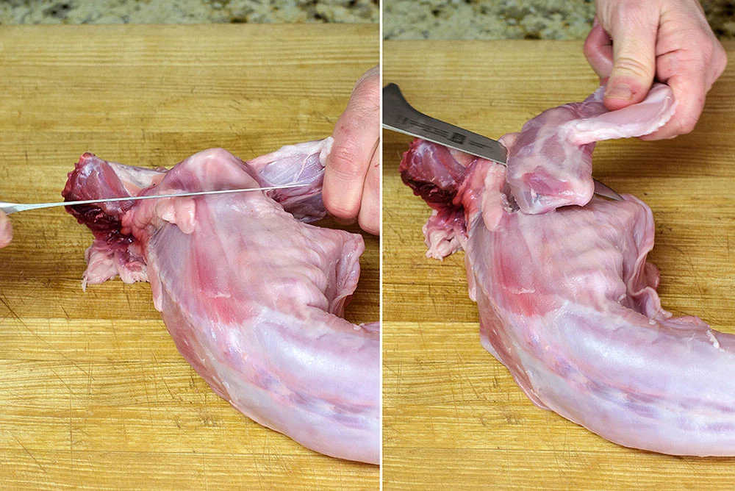

Step 11
Do the same with the remaining hind leg.
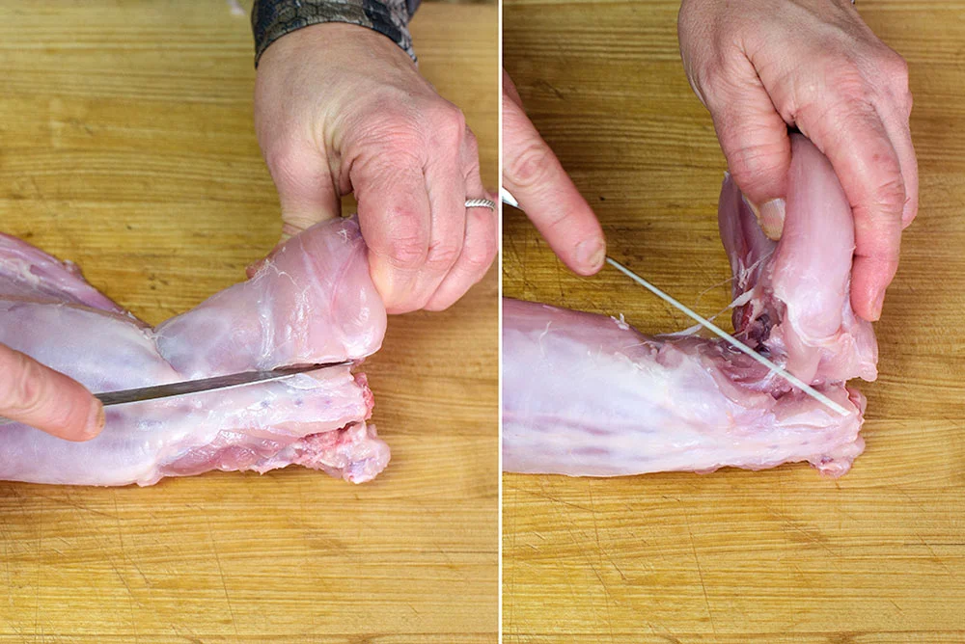

Step 12
At this point, the animal should resemble the picture below
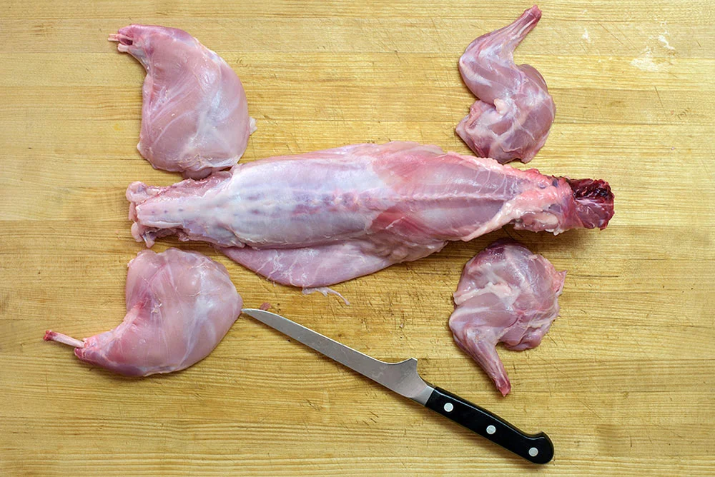

Step 13
Now move on to remove the pelvis bones on each side.
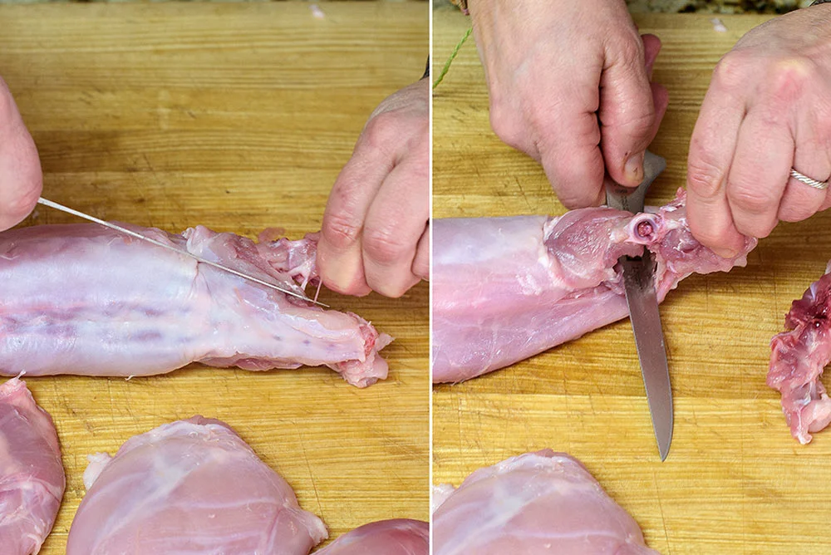

Step 14
Here are the pelvic bones when removed, which can join the pile for stock.
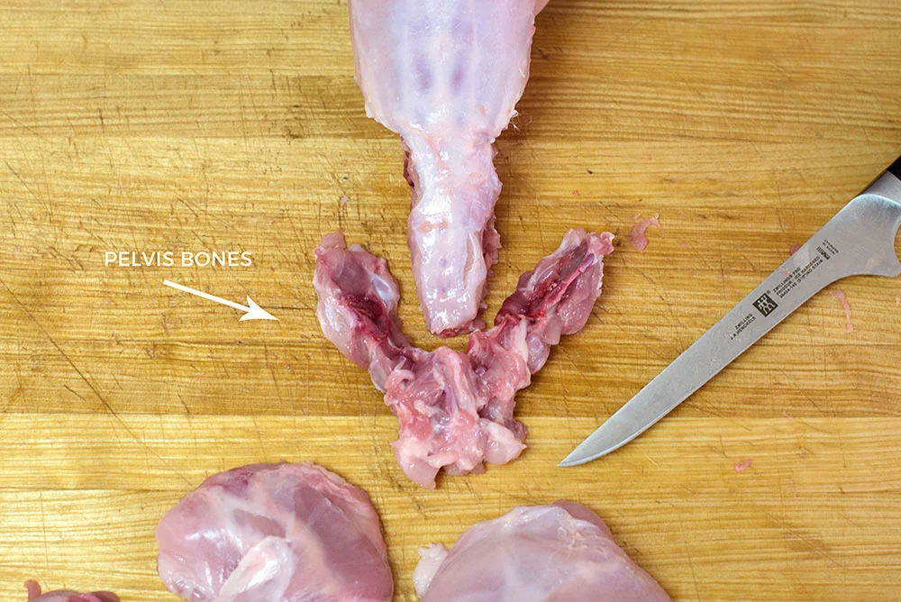

Step 15
Once the legs and pelvis are removed, the torso should resemble the image below.
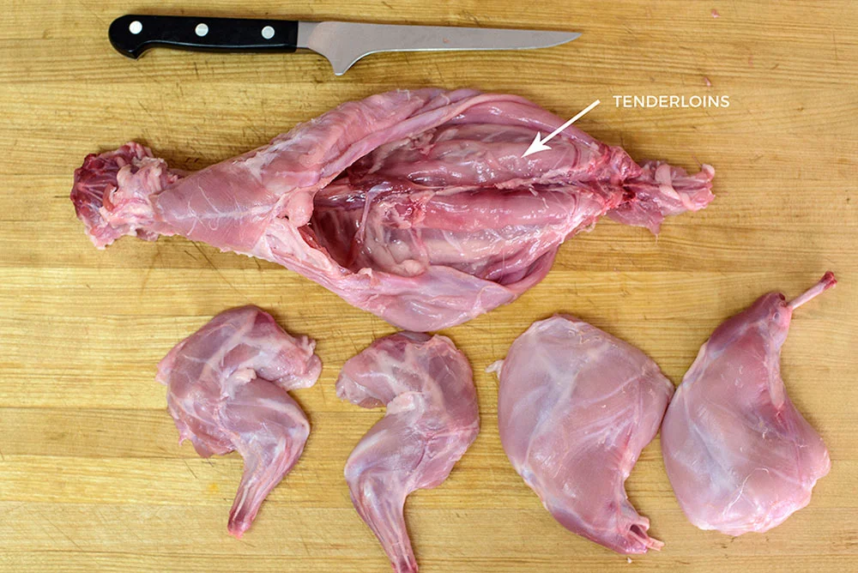

Step 16
Grab the rabbit’s neck and insert the knife under the sternum. Pull back and up to split.
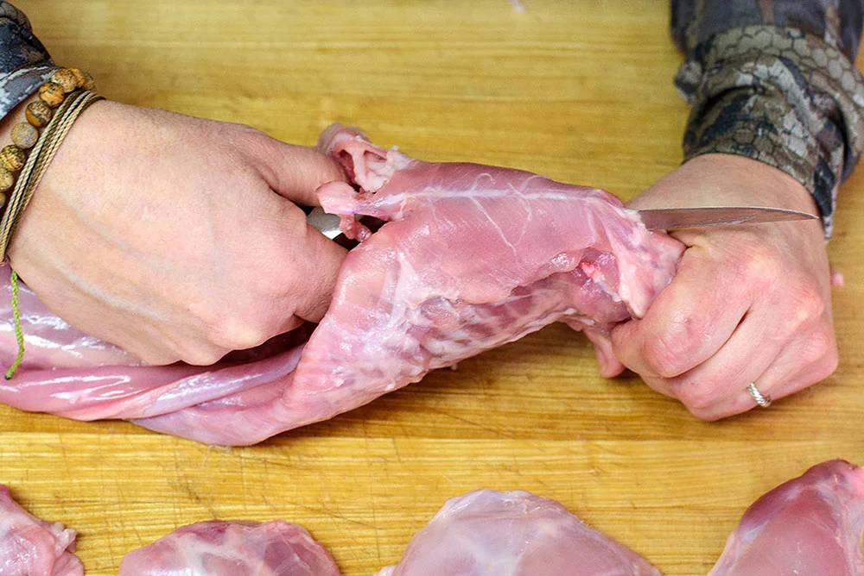

Step 17
Flip the torso over so the rabbit rests on its ribs. This makes it easier to trim out eye of the loin. Some folks will whack off the entire rack and either discard it or put it in the stock pile, but doing so sends the eye of the loin to the stock pile. Instead, trim it out before severing the rack. Begin trimming down from the neck along each side of the spine.
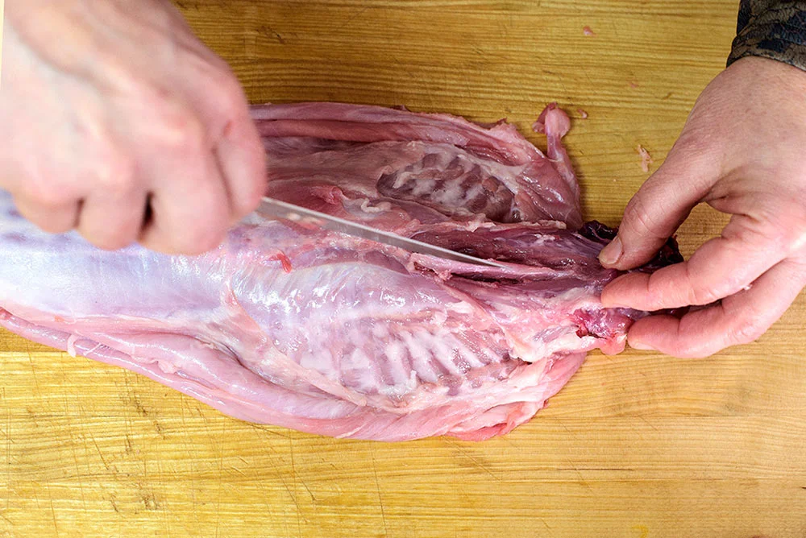

Step 18
Trim until you reach the last rib. Here you can see the trimmed eye of the loin ending at the rib. Coincidentally, look where the tenderloin begins: right where the eye of the loin ends.
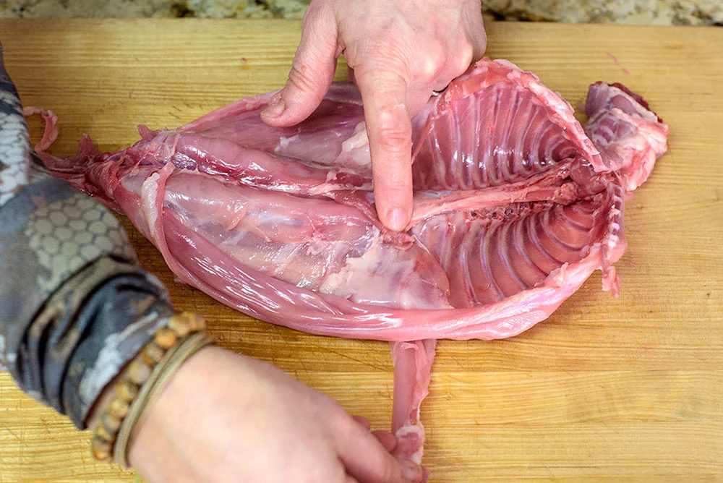

Step 19
Repeat this on the other side of the backbone.
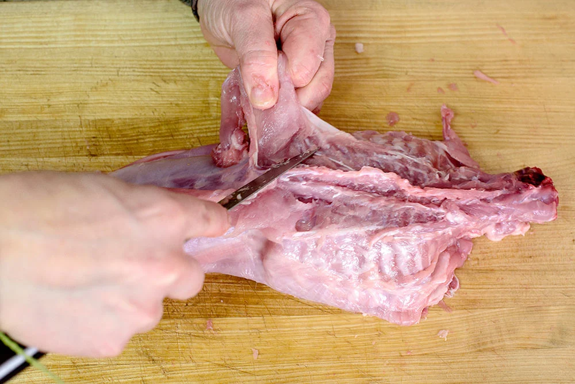

Step 20
Once the eye loins have been loosen and pulled back, sever the rack from the saddle.
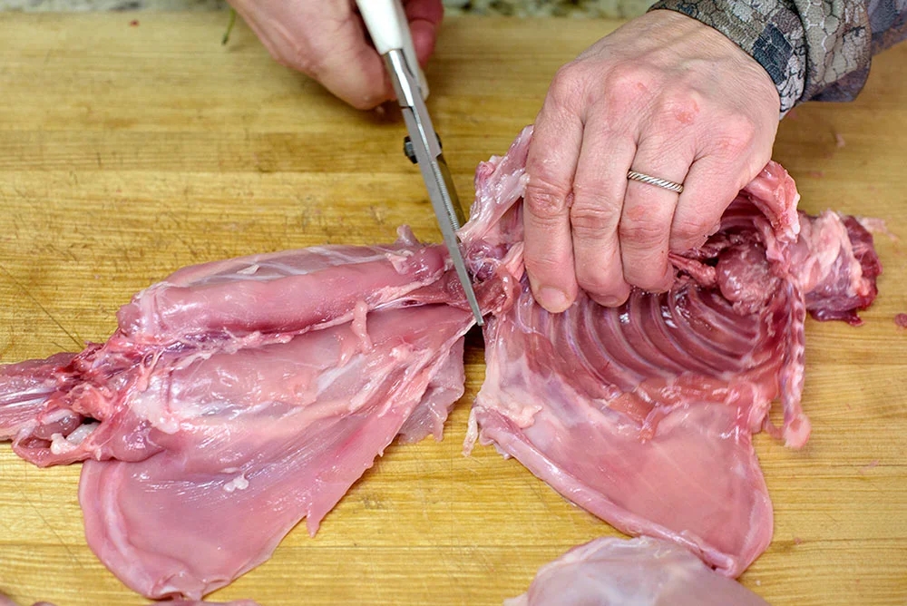

Step 21
It should look like this.
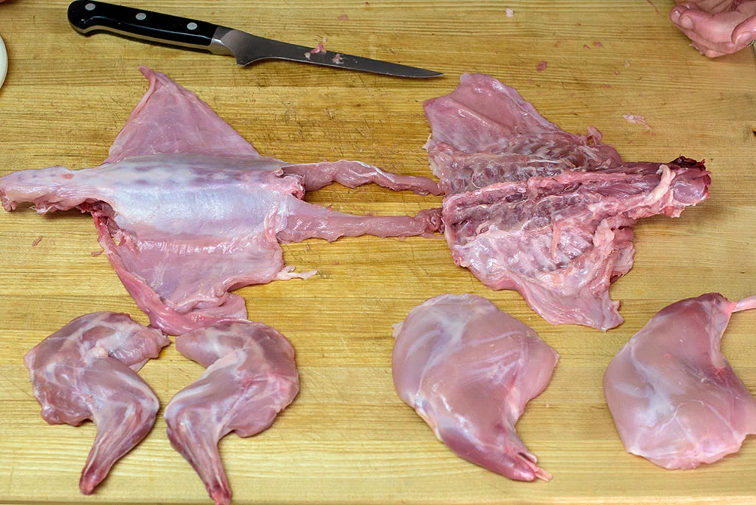

Step 22
Trim off tailbone and belly fat. The tailbone goes to the stock pile, and the belly fat can either be reserved for a roulade dish, or it can be added to stock. In the pas I’ve stuffed them with blanched asparagus, or spinach, pancetta, and some ricotta. Serve with a poached egg on toast for a wonderful breakfast treat!
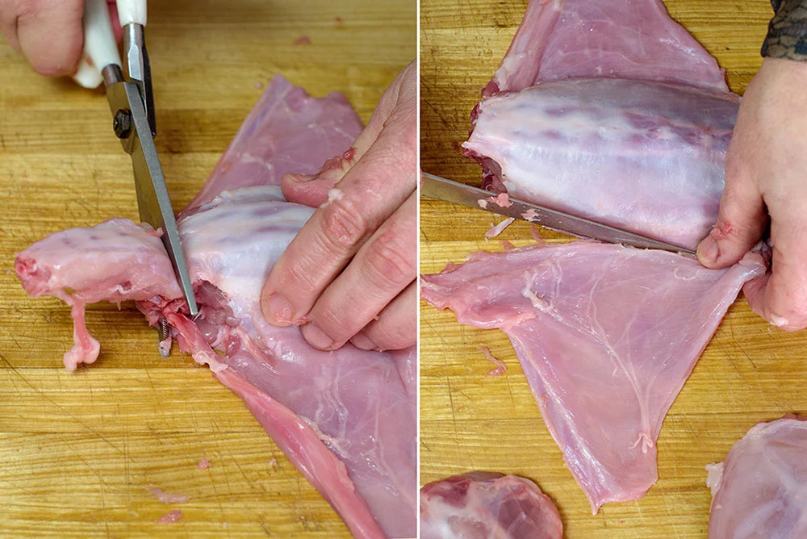

Step 23
Finally, split the saddle in two, tuck the eye loins under, and pull straws for who gets this piece!
