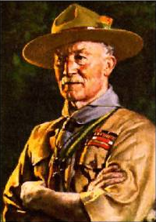
Lord Baden-Powell, 1857-1941
Rememberance

The following Merrickville Scouts gave their life for our country in World War II.

Wilmer Armstrong Died 1945 Aged 25
James Davis Died 1942 Aged 21
Alistair Watt Died 1945 Aged 21
Norman Watt Died 1943 Aged 21
Stanley Wilson Died 1942 Aged 19
Our Scout group is the oldest in North America. We were founded in 1908.
Agenda

6:00pm Arrival
Colouring, word search, mind games (answers at head table)
Memorabilia viewing
Climbing wall

6:30pm Flag break
O Canada
Grace
Dinner & Dessert (banana split)

7:15pm Entertainment
Awards
Slide show

8:15pm Closing remarks
Flag lowering
The Royal Canadian Legion
Branch #245

The sponsor of our Scout group
1st Merrickville Scout Group
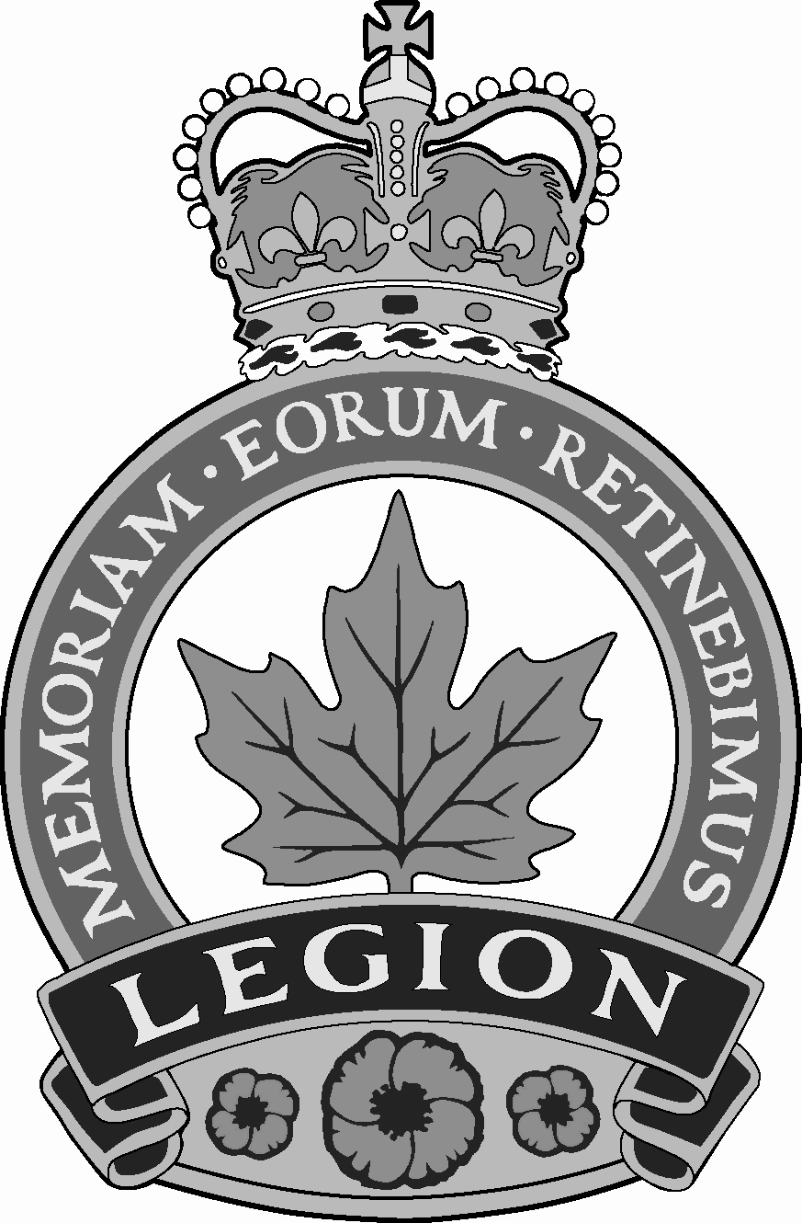
Eager Beaver Award
Merrickville Lion’s Club
½ week at Camp Opemikon

Wolf Cub Spirit Award
Solstar Enterprises (Custom Home Building)
1 week at Camp Opemikon
Lord Baden-Powell, 1857-1941
For photographs, schedules, and other information, see our website
www.1stmerrickville.ca
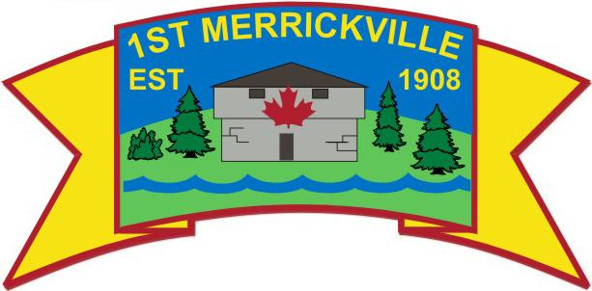
Thanks to support from the Government of Ontario, we offer an expanded canoeing program as well as rock climbing, rappelling, caving, and snowshoeing.
Upcoming Events
Scout Winter Camp March 1st/2nd
Cub Winter Camp March 1st/2nd
Beaver sleepover End of April
Cub/Scout spring camps May
Scout NiteVent May 9th/10th
Venturer rock climbing camp April
Venturer white water canoeing May/June
Scout/Venturer canoe trips July
Fundraising
We collect toner and ink jet cartridges, old cellular telephones, and pop cans. Please bring to any meeting.
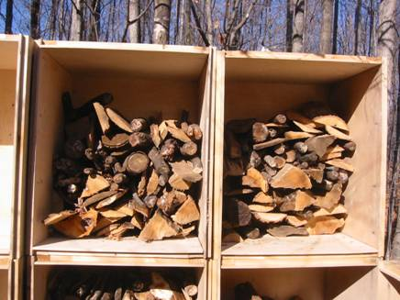
Plywood boxes for sale.

24” x 35” x 30”

Baltic birch plywood
with pine frames

Can be viewed at the Canal Gallery & Frame Shop

$15 each

