Cub Area Camp Impeesa
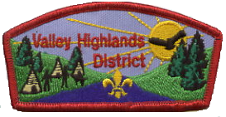
Spring 2006
Information Package

Date: Friday May 26th to Sunday May 28th

Location: Whispering Pines Scout Camp

The 1st Merrickville Cub Pack is pleased to introduce the 2006 Valley Highlands Cub Camp Impeesa – Operation Boot camp! While we are doing the up front organisation and setup, help from the other Pack leaders will be needed during the camp to run the activities and ensure the success of the camp. Most of all, active participation by the Cubs in the camp is the key to a good time. We guarantee fun activities, but you need to provide the Cubs.

Theme
The theme for the camp is Army Boot camp. The activities and deportment of the leaders will be based on the assumption that the Cubs have just joined the army and are in the initial training cycle. This is the one time Cubs can wear camouflage without getting into trouble! Decoration of campsites along the theme is encouraged. Costumes are also welcome. The more the leaders and Cubs put into the theme, the more they will get out of it. This goes for any themed camp. For instance, military ranks should be used when addressing leaders and kids throughout the weekend, and saluting should occur when ever possible.

Leaders To Bring
- $7 for each Cub in attendance.
- $2 for each additional crest desired (i.e. leaders who want them).
- Fee in the form of cash or cheque payable to ‘1st Merrickville Scout Group’.
- Their Cub Packs!
- One ration pack for each Cub and leader.
- Registration and Physical Fitness forms for all their Cubs and Leaders.
- Skits and songs for their Pack at the campfire.
- Watch(es) and pencil(s) for platoon leader(s).
- Medium sized tarp, rope, string, and rucksack (to carry the items) for platoon leader(s). Used by the platoon for shelter and lunch in the event of inclement weather.

Cubs To Bring
- Water pistols (optional)
- Toy pistols, toy rifles, etc (optional)
- Camouflage clothing (optional)
- High spirits!
- Knapsack to carry ration pack lunch.

Cost
The cost is $7 per Cub. There is no charge for leaders. The cost includes a custom embroidered crest for each Cub, all activities, take home items, prizes, and Saturday night mug-up. Additional crests may be purchased for $2 each.

Rules
- The assault course may be used during free time without supervision.
- Impress upon your Cubs that Cubs don’t steal shell casings from other Cubs (no repeat of the gold rush fiasco three years ago).
- The aerial runway is not to be used without the supervision of a 1st Merrickville leader.
- Have fun!
- Pick up all rubber bands from the guns.
- Leaders from all Packs help tear down the activities on Sunday before departing. Grumpy Merrickville leaders are not desirable!
Activities

All activities will proceed rain or shine, ensure your Cubs are dressed appropriately.

Aerial Runway (Zip line)
Need to escape from the enemy in a hurry? Jump on the seat and hurtle down 100’ faster than a speeding bullet!

Stretcher Carry
Your buddy is injured? Need to get him out of the line of fire? Construct a stretcher from natural materials and race it out of danger. Beware of the incoming projectiles….

Weaponry
Privates can’t train for the army without weapons practice. Learn the safe usage of sling shots. Put your knowledge to the test on the target range.

Semaphore
Need to talk to your buddies without anyone hearing you? Learn the techniques of semaphore and send your platoon in search of the enemy. Decoding secret messages.

Stealth Hunt
Can you sneak up on the enemy without being seen or heard? Can you hide and not be found? Learn how to make yourself disappear. Sneak attacks and all!

Dog Tags
If worse comes to worse, we need to know who you are. Make you own metal dog tag to take home.

Field Gun Race
Direct from the Royal Tournament in the United Kingdom. Working in your platoon, dismantle a field gun, carry the parts around the obstacles, send it across a miniature aerial runway, put it all back together again, and race it to the finish line. May the best platoon win!

Assault Course
Are you in good enough shape to run circles around the enemy? Fit enough to survive? Strong and agile? Test your mettle on our assault course. Elements will include a commando bridge, a 6’ scaling wall, barbed wire to crawl under, and a scramble net to climb over. Just wait for the leader competition…

Ration Pack Lunch
Learn what it’s like to eat in the field. Every bite is a surprise! The platoon leader will have a tarp for shelter (their responsibility to provide) in the event of inclement weather. Shelter setup will be the responsibility of the platoon.

Capture the Flag
Each platoon battling for supremacy in this war of attrition.

Platoons
All activities during the weekend will be platoon based. The Packs will be split apart, mixed up, and divided into eight platoons of approximately 9-11 Cubs each. The exact number will depend on how many Cubs participate in the camp. On the Friday evening at the leader meeting, each Pack will be given a brass identity disc on a bead chain for each Cub in their Pack. The disc will have two numbers on it: The first being the platoon number, the second being the person number. E.g. Disc number 1-4 means person #4 in platoon #1. These should be given to the Cubs on Saturday morning before the opening. The Cubs will need this disc to find their platoon. It will also be their access to dog tag making.

A platoon leader will be assigned to each platoon to take the Cubs to each activity and to supervise them during lunch.

Ration Packs
Each Pack is required to bring a ration pack lunch for each of their Cubs and leaders. The ration packs will be pooled in a central location and re-distributed to the Cubs and leaders. Each person will receive a ration pack made by a different Cub Pack. The ration pack should be in a brown paper bag that has been folded and sealed shut (using tape and/or glue) in the shape of a brick. The Cub Pack’s name should be written on the outside of the ration pack. For Saturday lunch, the Cubs will eat in their platoons. They will be encouraged to trade items between themselves to suit their tastes. That is what happens in the real military. The ration pack building could be done as part of a weekly meeting prior to camp. The content of the ration pack is at the discretion of the individual Cub Packs, but it does need to include enough nutritious food and drink for a Cub’s lunch. Some ideas are: A tetra pack, Melba toast, jam, chocolate bar, canned tuna, cheese, nuts, canned ham, sardines, cookies, crackers, fruit, etc. There will be no provision made for heating items. The ration pack should be self-contained (i.e. include plastic spoon/etc if required) and as non-crushable as possible. If a Cub has food allergies, it is the responsibility of a leader of that Cub Pack to ensure an appropriate ration pack is constructed and delivered to that Cub.

Schedule
Friday
7:00pm : Cub Packs arrive at camp.
8:00pm – 9:00pm : Informal campfire for adults and kids at main area campfire. Opportunity for the adults and kids to mix and mingle. Treats supplied. Spontaneous mock battles between the Cub packs on the road.
9:00pm – 9:30pm : Leader meeting at GHQ (area campsite in the main field). Don’t be late!

Saturday
7:00am : Reveille.
9:00am – 9:15am : Opening, flag break, main field, no uniform, costumes welcome. Cubs to bring knapsacks. Side arms distributed to Cubs (rubber band pistols).
9:15am – 9:30am : Cubs split into platoons based on identity discs. Ration packs distributed to platoons.
9:30am – 4:00pm : Activities by platoon. 50 minutes per activity including rotation time. Eight activities in total including lunch.
4:00pm – 5:00pm : Wide Game – Capture the Flag.
5:00pm – 7:00pm : Free time, supper, secret leader test during supper at each site.
7:00pm – 8:00pm : Dog tag making in main field. Cubs can drop by anytime during this interval. Their identity disc is their entry pass. Not everybody come at 7:00pm; not enough punches.
8:00pm – 8:30pm : Leader assault course competition.
9:00pm – 10:00pm : Formal campfire in area campfire pit followed by communal mug-up. Each Pack to provide one song and one skit per six Cubs in their Pack.

Sunday
9:00am – 9:30am : Fly your flag, march past inspection, drill demonstrations, full uniform, parade ground.
9:30am – 9:45am : Camp review, What are we thankful for, parade ground.
9:45am –10:00am : Closing. Flag lowering. Seven challenge award plaques awarded, Impeesa trophy.

Trophy and Prizes
A number of the activities will be competitive and points (in the form of empty shell casings) given to the corresponding Packs. Shell casings will also be given throughout the weekend for proper military conduct such as saluting an officer, teamwork, remembering their serial number, helping their buddy, most push-ups, etc. Use your imagination! Surprise us! The Pack with the most shell casings on Sunday (prorated by number of Cubs in their Pack), wins the Valley Highlands Impeesa trophy. Cubs get to keep the shell casings.

Prizes will also be given to the best platoon.

An army doesn’t run on its stomach any more. A secret test will be administered to the leaders from each Pack to see which officers can see the way of the future.

First Aid
First aid will be handled on a case by case basis by the first leaders informed. Pack leaders will be notified as required. There will be no staffed central first aid station.
Leader Meeting
A leader meeting will be held on the Friday evening. At least one leader from each Pack must attend. Bring your $7/Cub plus $2 for each extra crest desired. Submit all ration packs. Camp crests and identity discs will be given to the leader upon payment in full and submission of ration packs. Bring leader names for the volunteer roles if not already submitted. Detailed instructions and identification will be handed out for each volunteer role.

Weekly Meeting Preparation Ideas
Preparation work by the Cubs for the camp is not required, but here are some ideas that would be relevant:
- Practice marching whole Pack in step and making turns.
- Manufacture of ration packs.
- Stand at attention, stand at ease, saluting.

Attendance
The camp has been budgeted assuming the attendance of 70 Cubs and 15 leaders (with 80% of the leaders purchasing crests). Supplies will be purchased for 85 Cubs. 100 Crests will be ordered. Notification of camp participation and estimated attendance would be very much appreciated. In the event of any shortage of supplies, preference will be give to those packs who submitted attendance estimates.

Volunteers
The following positions will be required to be filled. Have names ready for the leader meeting on Friday evening. Each pack needs to provide at least two volunteers to fill the positions below. Packs with more leaders may need to provide more volunteers. First come first served. Platoon leaders are Sergeants. To make things simpler, it would be appreciated if names could be forwarded ahead of the camp so work can be done to fill any holes.

Platoon Leader #1 : Elizabeth Jackman – 1st Merrickville
Platoon Leader #2 :
Platoon Leader #3 :
Platoon Leader #4 :
Platoon Leader #5 :
Platoon Leader #6 :
Platoon Leader #7 :
Platoon Leader #8
Aerial Runway Captain : Mike Jackman – 1st Merrickville
Aerial Runway Lieutenant :
Stretcher Carry Captain :
Weaponry Captain : Robert Sargent – 1st Merrickville
Weaponry Lieutenant :
Semaphore Captain :
Semaphore Lieutenant :
Stealth Hunt Captain : Peter Cornelisse – 1st Merrickville
Stealth Hunt Lieutenant :
Dog Tag Captain :
Field Gun Race Captain :
Field Gun Race Lieutenant :
Assault Course Captain :

Rubber Band Pistols
Rubber band pistols will be distributed to each Cub. High visibility rubber bands will be used to eliminate the possibility of garbage being left at the camp.

Contacts
Contact any of the following with questions or suggestions:

General Baloo Mike Jackman 283-9936 sjackman@trytel.com
Colonel Akela Peter Cornelisse 269-4036 p.cornelisse@euro-appliance.ca
Major Smokey Robert Sargent 269-2521 robertsargent@295.ca
Major Mang Allan Yates 269-3074 allan@yates.ca
Aerial Runway

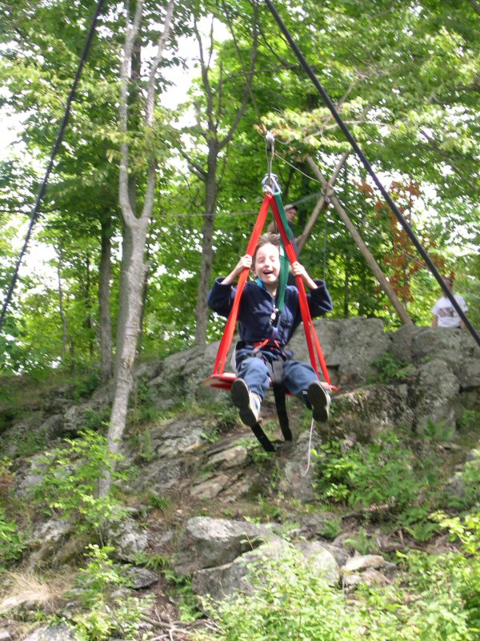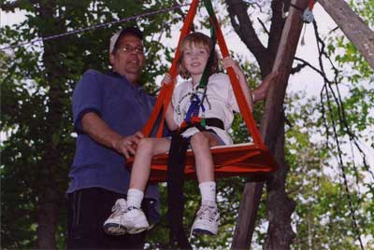

Field Gun Race

Note that the Impeesa setup will not be quite so elaborate, but the idea will be the same.

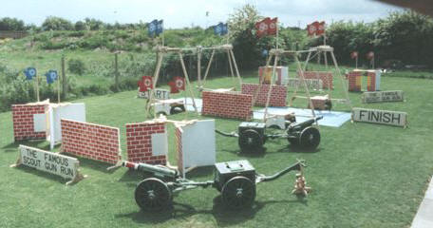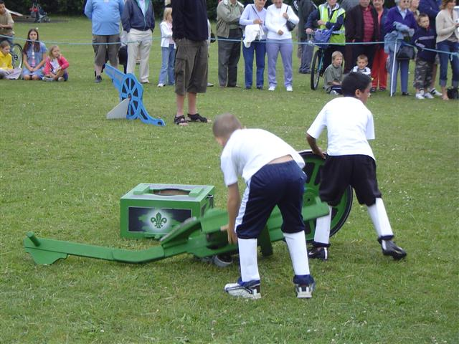

Example Ration Pack Rubber Band Gun


