Activities
Crate stacking
http://yates.ca/sc/merrickville/events/crate_stacking/
Obstacle course
Water gun battle
Fishing
Travois build & race
Canoe to island and cook lunch
Fire lighting (exploding paint cans)
Water slide
http://yates.ca/sc/merrickville/events/water_slide/
Bungee running
http://yates.ca/sc/merrickville/events/bungee_running/
Campfire battle (three fires, buckets of water in the centre w/cups, teams try to extinguish each other's fire)
Archery
Air rifles
Sling shots
Aerial Runway
http://yates.ca/sc/merrickville/events/aerial_runway/
Debris shelter building
Bow & arrow construction
Pioneering Pyramid
http://yates.ca/sc/merrickville/events/pioneering/
Cave Simulator
http://yates.ca/sc/merrickville/events/caving_simulator/
Cooking
First aid scenarios
Tracking (following rice crispie trail)
Tracking (following signs made from sticks and rocks)
Jumping net
Slippery pole (fixed)
Slippery pole (suspended)
Pioneering watch tower (leader built)
Ball throwing over barrier
Field Gun Race
http://yates.ca/sc/merrickville/events/fieldgun/
Chucking exploding film canisters at each other (Alka-Seltzer & water)

Games
Smugglers & Spies
http://yates.ca/sc/merrickville/cubs/docs/Cub%20Area%20Camp%20Impeesa%20WideGame%202006-05-26.pdf
Capture the Flag
Three legged race
Potato sack race
Tug of war

Cooking
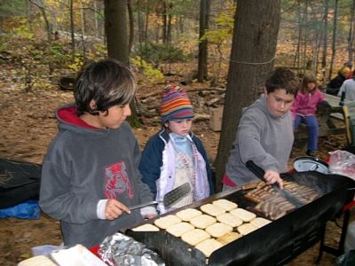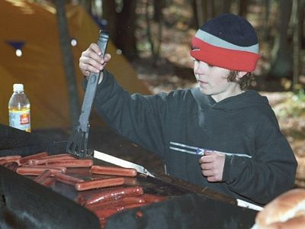

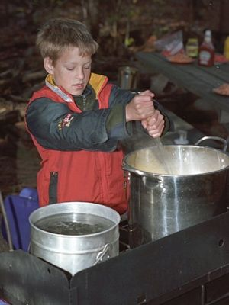

Cooking Hot Dogs in Juice Cartons
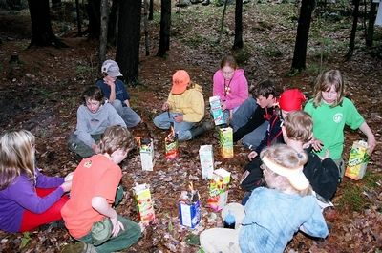

Aerial Runway
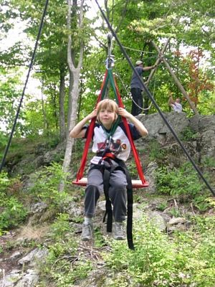

Archery & Slingshots
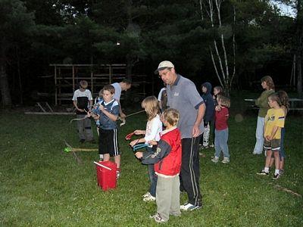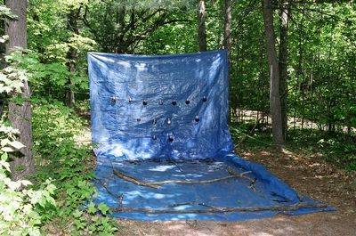

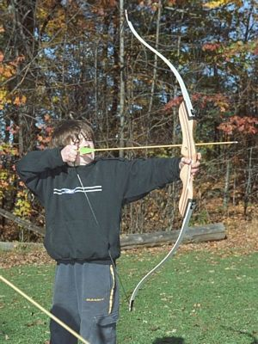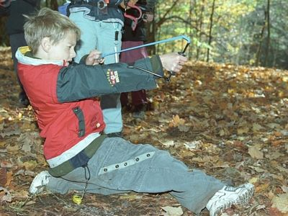

Fire Lighting
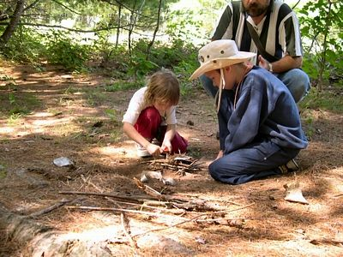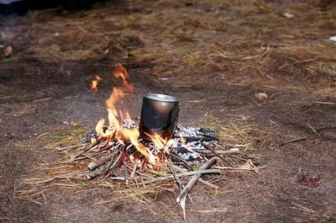

Catapult building
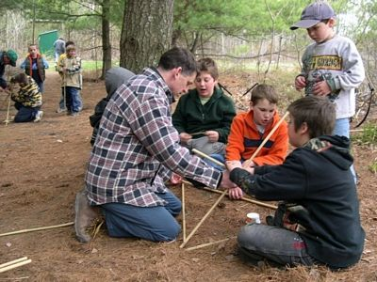

Campfire Battle
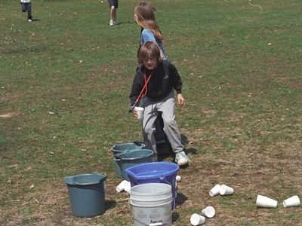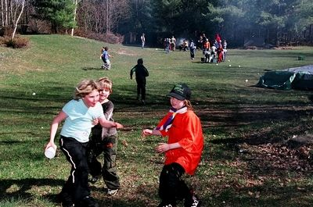

Crate Stacking
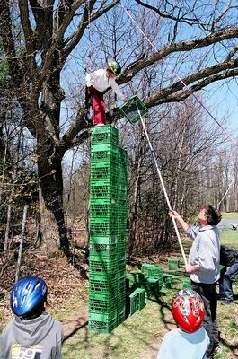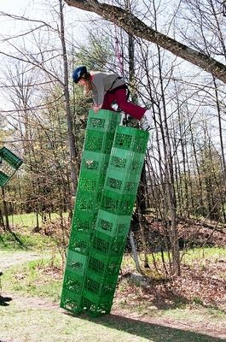

Building Travois and Racing
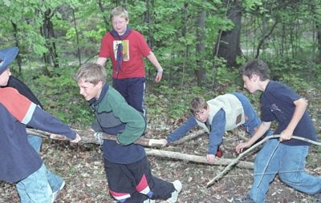

Obstacle course
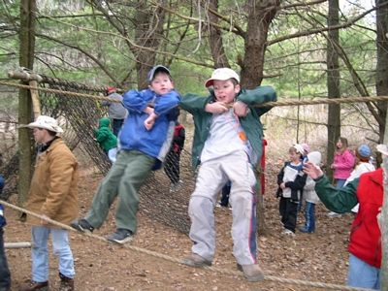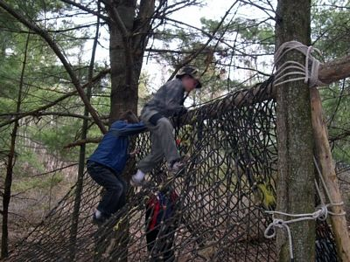

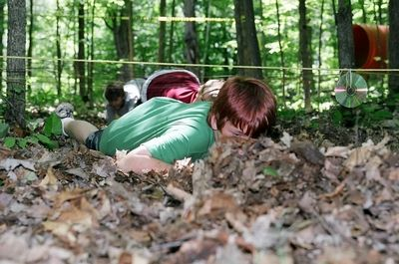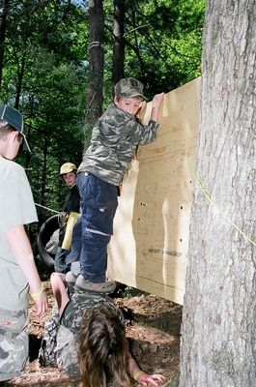

Bungee running
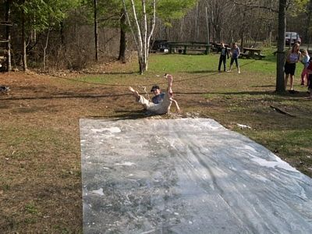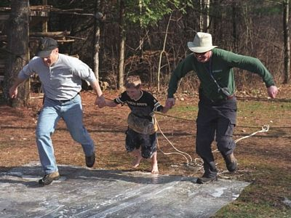

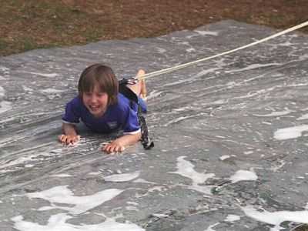

Canoe to Island for Lunch
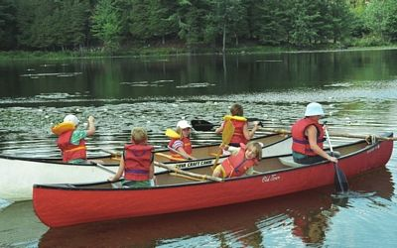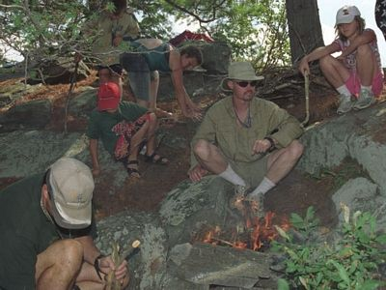
Slippery Pole (suspended)
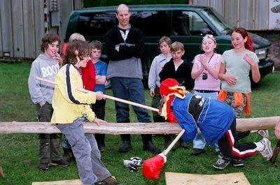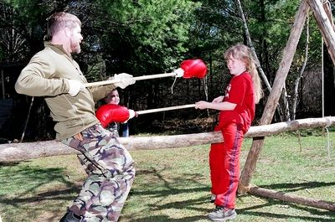

Slippery Pole (fixed)
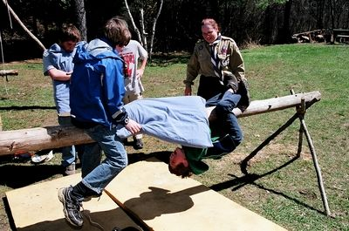

Jumping Net
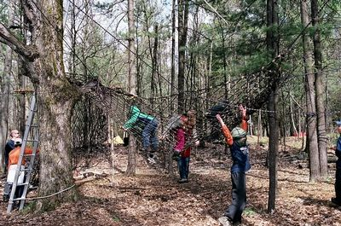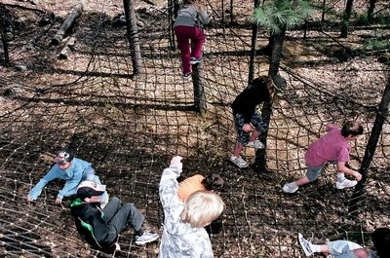

Throwing Balls Back and Forth
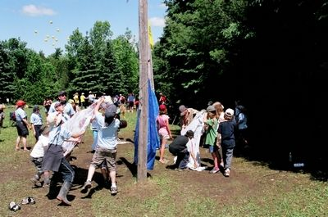

Air Rifles
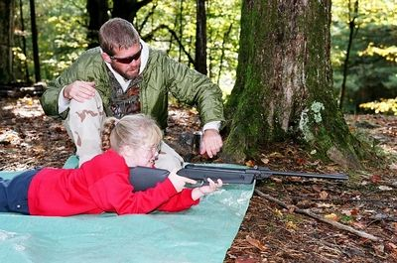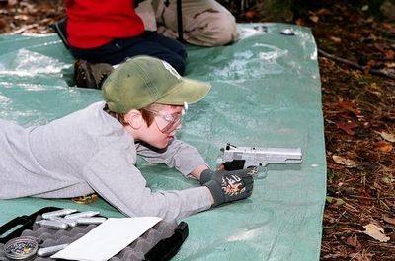

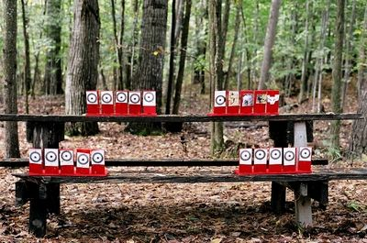
Pioneering Watch Tower
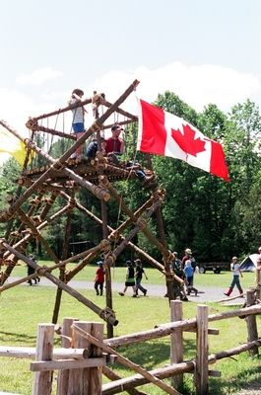

Water Slide
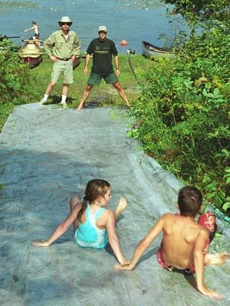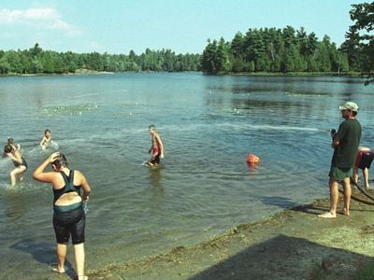
Semaphore
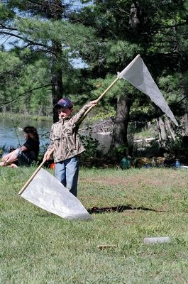

Making Bows & Arrows
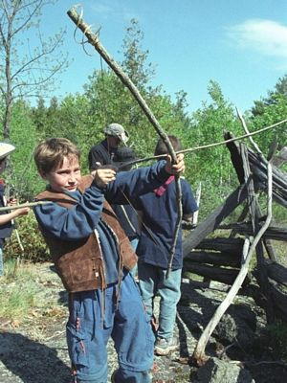

Dog Tag Engraving
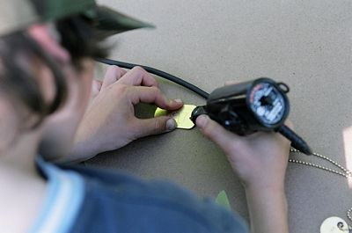

Hay Bale Maze
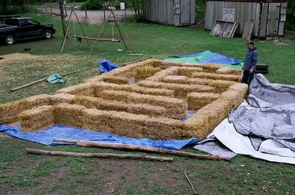

Hay Bale Fort & Night Attack
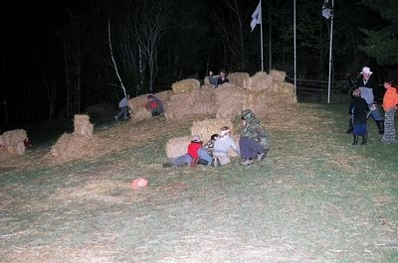

Debris Shelter
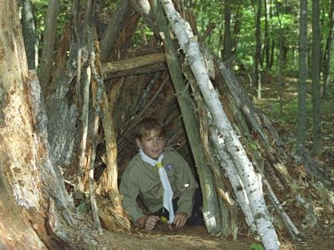

Orienteering
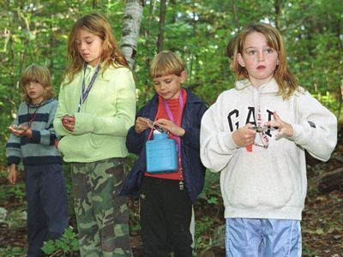

Pirate Stick Men
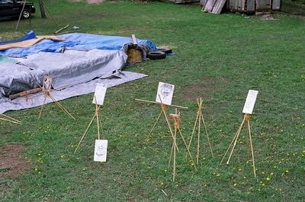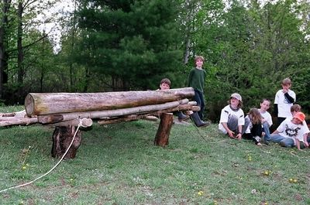

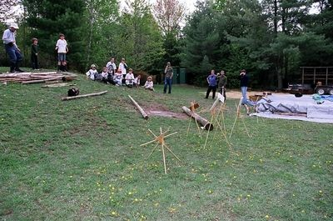

Field Gun Race


