
Sixer and Seconder Camp

The Sixer and Seconder roles in the Cub pack are important leadership positions. The Valley Highlands Area is orchestrating a special camp where the program will centre on this leadership role. There will be a lot of fun, a cookout, a campfire, and a program with a difference. The Cubs will be joined by Sixers and Seconders from Cub Packs across the Valley Highlands Area. It is highly recommended that your Cub attend this camp.

Date: Saturday October 4th to Sunday October 5th, 2003
Location: Whispering Pines Scout Camp
Departure: 1pm sharp on Saturday at the Merrickville Community Centre
Pickup: 3pm on Sunday at the Merrickville Community Centre
Cost: $15

We will be car pooling for the trip to and from camp. Car assignments will be made at departure time.

Please use the equipment list on the reverse side of this sheet. Full uniform is required for travel to and from camp.

As this camp conflicts with the Cub portion of Apple Day, your Cub is strongly encouraged to participate in Apple Day on Saturday morning instead.

Consent form and payment are due no later than October 1st, 2003.

If you have any questions, please contact your leaders:
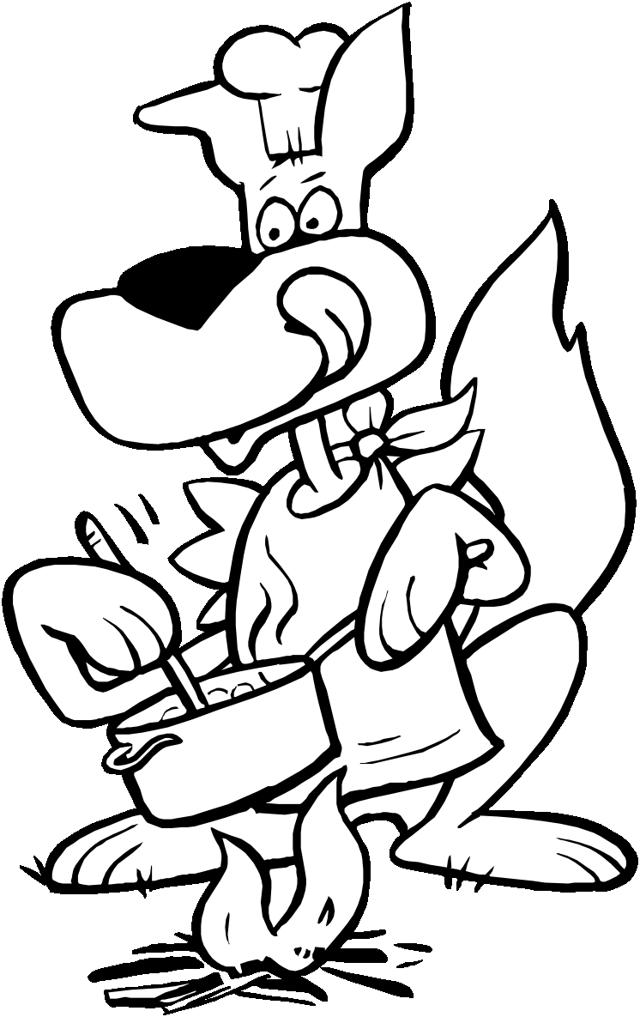
Keith Skelhorne (Akela) 258-9016

Alex Beelich (Chil) 283-3307

Peter Cornelisse (Ringtail) 269-4036

Doug Miron (Mang) 275-1271

Equipment List

- Flashlight with batteries (ensure batteries are fresh)
- Pajamas
- Sleeping bag
- Blanket
- Pillow (optional)
- Stuffed Toy (optional)
- Wash Kit: Hand towel, face cloth, soap, toothbrush, toothpaste, hair brush/comb
- Running shoes
- Sweater
- Jacket
- Water bottle
- Insect repellant
- Kleenex
- Eating Kit: Plate, bowl, mug, knife, fork, and spoon in mesh bag
- 3 complete changes of clothes
- Sleeping pad
- Rubber boots
- Rain coat
- Plastic bag for wet clothes

Full uniform is required for travel to and from camp.

Important:
- Do not pack food or drinks other than water. These can cause allergy problems as well as improper storage of food in tents.
- No pocket knives, jack knives, Swiss army knives, etc.
- No matches.
- No electronic devices (e.g. Radios, Tape/cassette players, Walkmans, GameBoys, etc.)
- Ensure all items brought to camp are identified with the Cub’s name.

