Valley Highlands Area: Scouts Canada. February 05


“Notes’N’News”


Volume one #4 Editor: Chris Tyler. Email: FirstscoutKim@aol.com



Full Last New First Full Last
Jan 25th Feb 2nd Feb 8th Feb 16th Feb 23rd Mar 2nd Sunrise 7.14 am Moonrise 1.00am

Editorial… Dull and overcast here today and quite cool, only about 74 with lows around 57/58 Brrrrrrr. Supposed to get brighter for the weekend though. We are told that Ottawa is a balmy 30 with lows of 10 and possibly some snow. If you think that’s cold, have a heart for the folks in Butte, Montana. Last night it was a bone chilling 91 Below Zero. Hope they had lots of fur bootlaces to keep their toes warm.

We are thinking about you as you prepare for Winterlude, Winter Camps, Torchlight Parade, and of course the B.P. Banquets. Get out there and enjoy the company of good friends and have some fun to wash away the winter blues. Chris and Etta.

Commissioner Jim…

Game of the month… You asked for some ideas for different games well try this one…
You will need two chairs; two blindfolds and eight clean empty tin cans.
Place a chair at each end of the hall with a blindfold on each. Spread the cans around the play area between the chairs.
Contestants are blindfolded and upon the Go command they must find a can (only one can at a time) either from the pile or the opposing chair and place it beneath a leg of their chair. They may even take their chair around with them (if this will not damage the floor) It’s a hilarious game and everyone will want to have a go. Let me know how it goes… ok!

Useless Trivia… Allowing yourself to be bored is a criminal waste of life.
Education is the key to Freedom.
An open mind is the best travelling companion.
Interviews… always seem to put the fear of…. Well, anyway, why not get respected business owners to give your group/unit a talk on Interviews, Techniques of: But make sure you get both sides – interviewing, and being interviewed.
The Public Library can put you onto some excellent resources. You will be surprised how helpful this can be down the road… Give it a try… and as always, let me know how you get on.

Useless Trivia…
“Probably one of the most important things I learned is listening to other peoples experiences.” Marcos Lopez.

What is Childhood… 111
Just as parents and teachers can help (or hinder) a child mastering the early conquests physical challenges, they can also help school-aged children become more emotionally sophisticated and confident
This month we look at the five greatest challenges faced by kids in school; patience, self-reliance, responsibility, bonding, and self-control.
Toddlers and preschoolers live in the moment. When they want something, anything – they want it NOW! All of that changes when they reach kindergarten. Sure they may still want things immediately, just as we do as adults, but they find that they have to spend more and more time waiting for the “good stuff.” This “delay of gratification” as psychologists call it, is a critical skill that all must learn, from which will come the first challenge Patience. Here are some things you can do to help; First though a word about realistic expectations. Remember that for a ten-year-old, an hours wait might not seem too bad, for a five-year-old it can be an eternity. Start off with small delays in which your child is almost certain of success and then work up. Also remember that children under stress are much less patient than those who are relaxed.
Teach Distraction. Let’s say that you are in stuck in traffic with your daughter. Instead of getting frustrated play a game or sing a song. Those kids who are best at delaying gratification tend to be creative in finding ways to take their minds off their frustrations.
Cook together. This is a great way for kids to learn patience. They can be involved in every stage of the process. Waiting for muffins to cool before you take a bite can take a good deal of self-control.
Give an allowance… And then let your child control it. At first she’ll probably spend it all at once. Help her to understand the many desirable things that she could buy if she saved a portion until the following week. Work your way up together to saving for several months. This is not only one of the most powerful tools for teaching patience, it will help your child become financially more sophisticated as a teenager.
Few things are as rewarding – and sometimes as difficult – to a school-age child as becoming more self-reliant. Whether it is crossing the street alone or completing a school project, kids crave appropriate challenges that enhance their sense of independence. The key in that sentence is “appropriate.” A child left alone for a few hours after school before he is emotionally ready will simply become frightened rather than confident. Age is not the only marker here; his temperament and previous experience also play a large role in how he approaches this type of emotional challenge.
Admit some of your mistakes. Toddlers and preschoolers find it hard to take responsibility for their actions. At that age they confuse doing something bad with being someone bad. ‘The plate broke’ – rather than – ‘I broke the plate.’ Since they believe they aren’t bad people, they could not have been the one to break the plate and, therefore, to take the blame. School age children must come to terms with this distinction between doing and being. One way they do this is by watching their parents. Until they become pre-teens, kids usually put their parents on a pedestal. Later they see them as they are.
Taking responsibility goes hand in hand with the feeling that you can and should ‘own-up when you have messed-up.’ If your children hear you admit when you have made a mistake, and then see how you recover from that error, including how you recover emotionally, they will better be able to take responsibility for their own actions and inevitable mistakes.
Help your child to get organized for homework. It is important that you give the child support she needs as her school assignments become more complex. Often the more important lessons learned from elementary homework have to do with the child’s feelings or accomplishment and responsibility. If you do her homework for her, you will undermine those important feelings. Review such principles as how to set out an essay. Let her show you her work and get your approval. But if she can’t do the work, talk to her teacher.
Friendships. Parents shouldn’t worry about the number of friends a child has. The difference between having no close friends and having one close friend is tremendous. The difference between one and many is very small. As friendships change, they require children to develop more sophisticated social and emotional skills. In particular they need to become more empathetic so they can view situations from the friends’ point of view. Parents can however help with this development by talking to their children about the ways friends can help each other in bad times, as well as have fun together in good times.
Above all be careful what you reward. A child who is expelled from school and goes skiing with dad because dad does not want to cancel his well earned trip, would be rewarding the behavior that got the child suspended in the first place, and might encourage him to repeat the bad behavior. A trip to McDonalds after losing a match rewards the child for ‘trying’ and that’s o.k. Good effort should always be rewarded. If your child knows that you are proud of them for trying they might stick with it long enough to master the situation. That is after-all the most important skill they can learn.

Riddle … The answer to last months riddle… The second doctor was the patient’s Mother.

Now try this one…
What book contains more stirring pages than any other book ever written? Answer next month.

And another… Which letter comes next in this series. W L C N I T? Answer next month.

Weather (Conclusion)…
We conclude the article on “The weather and how to cope with it” with the full Beaufort Wind Scale (below)
If you would like more information or program ideas on the weather, Clouds, Forecasting etc, please contact Stephen Mayne, Group commissioner for 1st Beckwith Group.
Email your requests to webmaster@lanarkweather.org also check out his website at www.lanarkweather.org

Here is the Beaufort Wind Scale…

Beaufort  Number | Limits of  Wind speed  In Knots | Descriptive  Terms | Sea Criterion  (conditions) | Land Conditions
0 | Less than One | Calm | Like a mirror | Smoke rises vertically
1 | 1 –3 | Light Air | Ripples but without foam crests | Flags Flap slightly
2 | 4 – 6 | Light Breeze | Small wavelets with unbroken crests | Leaves Rustle, Wind felt on face
3 | 7 – 10 | Gentle Breeze | Large wavelets with perhaps scattered white horses | Leaves in motion, Flags flap
4 | 11 – 16 | Moderate Breeze | Small waves, Frequent white horses | Dust rises, branches sway
5 | 17 – 21 | Fresh Breeze | Moderate waves, more pronounced: Many white horses, perhaps some spray | Small trees sway
6 | 22 – 27 | Strong Breeze | Large Waves forming, extensive white foam crests, likelihood of spray | Telephone lines whistle, Umbrellas hard to hold
7 | 28 – 33 | Near Gale | Sea heaps up with white foam blown in streaks along direction of wind | Trees sway, Hard to walk
8 | 34 – 40 | Gale | Moderately high waves, Foam blown in definite streaks along direction of wind, | Twigs fall, Cars buffeted.
9 | 41 – 47 | Strong Gale | High Waves, crests tumble and roll | Branches snap, Cars buffeted
10 | 48 – 55 | Storm | Very High waves; heavy tumbling waves; Poor visibility. Small craft in danger | Trees Fall, Risk of lightening, possible Personal injury
11 | 56 – 63 | Violent Storm | Exceptionally high waves, sea completely covered with white foam lying along direction of wind, Wave crests blown into froth, poor visibility. Small craft in severe danger | Check Insurance  Power outage possible  Some property damage  Risk of personal injury
12 | 64+ | Hurricane | Air filled with foam and spray, poor visibility, risk of cargo shifting and small craft in very severe danger | Pray  Severe property damage likely  Severe risk of personal injury

Natural Weather reports… Did you know that Dandelions forecast the weather with absolute accuracy? In sunny weather the flower is open but before it rains the flower closes up very tightly to protect the precious pollen from getting wet. When Fair weather is coming… geese, crows and swallows fly high, fishing is poor, ants scurry about their work pinecones, marigolds and dandelions open. When foul weather is coming… Birds fly low and line up in wires, Fish bite and so do flies, ants travel in lines, pinecones and flowers close. Just before a summer thunderstorm strikes, everything smells more strongly, even lakewater smells just before a storm. If the birds are restless and noisy you may still have a few minutes in which to take cover but when all goes silent run for cover or you’ll get soaked.
Did you know that crickets tell you what the temperature is…? Count the number of cricket chirps you hear in fifteen seconds… Divide this number by two and add 6. Your answer is the degrees of temperature in Celsius.
Smile-a-while… Two men were digging a ditch on a very hot day. One said to the other, “why are we down here in this hole digging when our boss is up there sitting in the shade under a tree?” “I don’t know” responded the other, “I’ll go and ask him.” So he climbed out of the hole and went to his boss saying “Why are we down that hole digging, while you’re up here sitting in the shade?” “Intelligence” said the boss. “What do you mean,’Inteligence’?” The boss said, “Well, I’ll show you. I’ll put my hand on this tree and I want you to hit it as hard as you can.” The ditch-digger taking an almighty swing, tried to hit the bosses’ hand. The boss, at the last moment removed his hand, and the ditch-digger hit the tree, breaking three fingers in the process. The boss said “There – that’s intelligence.” The ditch-digger went back to hole. His friend asked, “What did he say” “He said were down here because of intelligence.” “What’s intelligence” asked his friend. The ditch-digger put his hand in front of his face and said “Take your shovel and hit my hand as hard as you can.”

It Could Happen to You…
Boy Scouts Rescued after Utah Avalanche

SALT LAKE CITY - A huge wall of snow collapsed and buried the entrances to a series of manmade caves where more than three dozen Boy Scouts and their leaders were sleeping during a winter survival camping trip, but everyone was rescued unharmed. The scouts had carved the caves deep into the snow on a ridge in northern Utah's Logan Canyon, at an elevation of 7,400 feet.
''You're pretty cozy inside of them,'' said Randy Maurer, the father of one of the scouts. ''You're completely oblivious to what's going on outside.''
After the 39 scouts and scout leaders went to sleep Friday night, wind gusting to 64 mph piled snow into a huge cornice hanging over the slope where the scouts dug their caves. The 500-foot cornice collapsed just before 4 a.m. Saturday, burying the entrances to the caves under 6 to 8 feet of snow. Insulated by the thick snow around them, the scouts were unaware of the problem. ''It was a little bit more than what we expected to wake up to,'' Maurer said.
The avalanche was heard by a group of scout leaders who were sleeping in a nearby trailer, and they used an emergency roadside telephone to call 911. ''That probably made quite a bit of noise, I'm imagining,'' Cache County sheriff's Lt. Von Williamson said of the avalanche. ''But if they would have all been in the caves, I shudder to think how long it would be before we would have heard about this.'' Williamson said the Scout leaders who called for help knew approximately where the caves were, and emergency crews used shovels and snow probes to locate the scouts. Some of the boys, ages 12 to 16, were awakened when they were jabbed by the avalanche probes the rescuers were pushing into the snow. Maurer told The Salt Lake Tribune he was awakened by the sounds of the rescue effort. ''That was a big shock,'' said his son, Brock. ''It was a wake-up call for sure.''
By 7:05 a.m., everyone had been pulled from the caves uninjured. ''Some were pretty scared, some were only somewhat upset,'' Williamson said. ''It seemed to depend upon the age of the kids. The older kids took it a little more in stride.''
The scouts were on an annual excursion from the nearby Smithfield and Nibley areas of northern Utah.

Maybe there are lessons to be learned from this event. First, when building Snow Caves, to check that there is no possibility of such a thing as an avalanche happening to our youth. And secondly, a wise precaution to have alternative heated accommodation at hand, even if the youth do consider the adults to be chicken. I’m sure you can think of several others, but space here is limited so I don’t have room to go on about ensuring that someone unrelated to the participants, knows exactly where you are camping, and to stand them down when you leave the camp.

Campfire Skits
Now is the time to think about new campfire skits for the upcoming camping season. This month I am Introducing; King ID A Tyrants tyrant. Wizard. - An Assiduous student of evil. Blanch – Wizards wife – a domineering meddlesome nag. Rodney – A knight – a cunning coward. And Gwen – A fair maiden who has eyes for Rodney,
As the character base for a series of skits suitable for a Campfire Theme. With apologies to Johnny Hart & Brant Parker, Owners of these characters and their copyright.
In Medieval times the king and court were poorly educated people but the king ruled. The king’s word was law and woe-betide anyone whom failed to do his bidding or who spoke out against him. Punishment was normally a long spell in the castle dungeons, stretched on the rack, or as King ID might say “Orf wiv ‘is ‘ed”.
The following is an example taken from the authors’ book “The King is a Fink” published by Fawcett Press that will help the reader visualize the humor. Let the youth use their imagination both in portraying the story line and in the interpretation… Maybe a copy of the book in the troop library might spur some imaginative ideas… Enjoy!

Have a Patrol Photo
Competition…

Useless Trivia… The two most difficult moments of any project are the beginning and the end.
One is always free to Imagine…

IMAGINATION IS A WHOLE OTHER UNIVERSE WHERE ANYTHING IS POSSIBLE !

Imagination is the key that winds up the spring of the possible

As always… the scene must be explained so the assembly understands what the skit is about
The scene shown here can be used as is or it can be changed to encompass the whole Patrol as follows…
One member of the Patrol is the travelling salesman, the rest are wizards attending a conference.
The wizards are seated around the table….
Enter the salesman…. Carrying a large bag…
Several wizards place orders for the ingredients of their spells…. As in picture 2. (Youth can use their imagination here)
The salesman makes much ado packing the goodies into bags for each wizard, thanking them for their orders as he prepares to leave…
ONE wizard asks the question in pic 3. (Followed by a long pause…)
Salesman gives the punchline loud and clear.

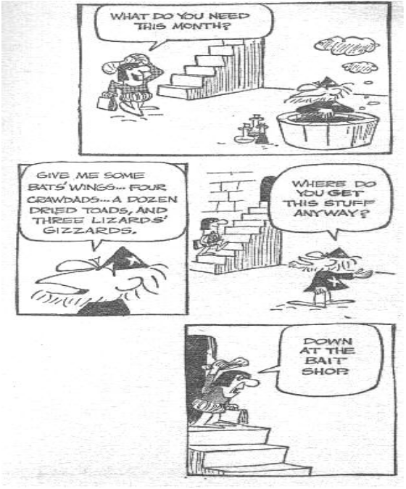

1

Everyday the Newspapers, magazines, comics and TV ads carry material that with a few moments thought can be turned into a couple of minutes of humorous entertainment.
Give it a try….
You might even surprise yourself.
… And we might even get some new skits at our campfires.
2
3

4


Most youth can get the use of a camera these days, so why not have a photo competition. Winter lends itself to some surprisingly good pictures both in the country and in town. Wind sculptures in snow, shadows caused by snow on the architecture, and sunlight reflecting off icicles, are but a few ideas to try out.
Let me know how you get on… even send me some pictures and we’ll publish them here

The lighter side… Two snakes were sunbathing in a clearing in the local jungle, One says to the other “Are we supposed to be poisonous?” The other snake replies “why?” … “ Because I’ve just bit my lip.”

Camp Bank… I have just been glancing through my copy of “The Scoutmasters First Year” 10th Edition 1948. It states… “One of the most dependable and satisfactory methods of raising summer camp funds is the Camp Fund Bank.”
Each week the youth deposit either a fixed amount or varied as decided by the Patrol Leaders Council, and recorded on a deposit card kept by the youth concerned and in a register kept by the Troop Scouter.
Now I can see several problems with this idea. It means a) that you have to actually plan at least one camp for the year. b) You have to estimate pretty accurately the cost of the camp and divide that sum by the number of week’s left until Departure day, giving you the weekly-recommended amount to deposit. C) Someone has to take the cash to the group treasurer for deposit in the Group bank a/c. and get it back again just before departure.
On the plus side, your youth learn to be thrifty, and it helps parents to find the camp fee gradually, rather than in one lump sum.
It seems that every good idea has its problems… But, It just might work!

Whittle a whistle… Here’s a program idea, gather together a pocket knife, green willow, poplar, basswood, or other smooth bark branch about 10cm long and 1 cm Diameter and a small basin of water.
Now, cut a line round one end of the branch 2cm from one end then place the branch in the water for about half an hour.
Gently pound the bark all round the branch to loosen the long ring without breaking the bark. Grip with both hands and Slide the long ring off the branch. Once it is off, slide it back on again. Cut a diagonal chunk off the long end of both bark and branch (about a cm should do) to make a mouthpiece and set aside. Now turn the branch so that the diagonal is toward the table and cut a notch in both bark and branch about 2cm back from the end, slide the bark off the branch again. Now cut off the branch at the notch and then Cut a sliver off the top of the diagonal chunk and insert it back into the mouthpiece end with the slivered part at top. Cut another piece 1 cm long off the remaining branch to make a bung for the other end of the bark tube. Blow your whistle… The following diagram may help…
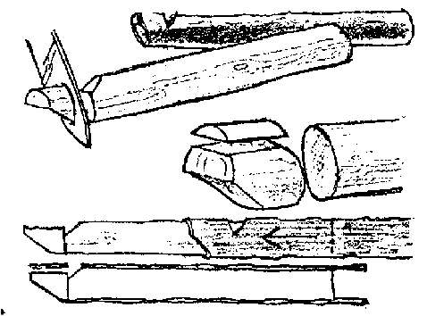
Try making Rock Sculptures… Find small rocks that you can glue together to make animal or people scenes. Stick them onto driftwood and use bits of twig etc for detail. Paint your creation with bright colours and when dry give a thin coat of white glue.
Don’t forget the Hobby Show and wheels rally is not far off.

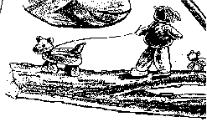

Fig:1 Fig:2

Telephone Marathon… Let us, as an area hold a brainstorming evening. We’ll sit Chief Grouch down beside the telephone from 6.pm – 10pm one evening in Late March to take your calls. All you have to do is to dial his number and give us your idea(s) for upcoming section programs. Things that you would like to see happen in Valley Highlands Area in the next year. Here is a list of non-Scouting Dates in 2005/6 that may spur some thoughts.
March 22nd – World Water Day. April 10th – 16th – National Wildlife Week. April 22nd. – Earth Day. April 29th – Arbor Day. May 1st – May 7th – National Forest Week. (May 7th – Scoutrees.) May 14th Intl; Migratory Bird day. May 29th – June 1st – Canadian Environmental Week. June 8th – World Oceans Day. June 12th – Canadian Rivers Day. July 16th – Parks Day. August 12th International Youth Day. October 24th – United Nations Day. November 21st World Fisheries Day. February 2nd – World Wetlands Day. February 15th – Flag Day. February 21st World heritage Day.
If you think this is a good idea… we’d like to hear from you… we would then set up the date subject to Scouter Ken’s busy schedule… Thank You.

Discovering Nature…
Most Children are interested in growing things. Cubs will probably already have grown fun things like carrot tops, peanut, mustard and cress, etc. at school or even play-school. At cub age they are ready for something more ambitious, so why not plan your own horticultural show.
Maybe there is a small area around your meeting place for a garden, if not, your sure to find a senior citizen who would trade some garden space for help with their own garden (a service project !)
You could have classes for flowers, potted plants, vegetables, miniature gardens and so on.
Here are a few ideas to do make the experience different.
What about a bottle garden? You will need a large-mouth bottle, some soil and a few stones or pretty gravel and a place to keep it where it will get sun for a short time each day. (The bottle will act as a miniature greenhouse and will cook the plants if it gets too much sun) You can even add bark and plastic toy people to liven up the scene, or if you grow ferns then put in toy lions and tigers to make a jungle scene.
Indoor gardens. With some imagination, a pretty indoor garden can be made from a shallow plastic container about 25mm deep filled with washed gravel. Slice the tops off some vegetables e.g. Carrots, Turnips, Beetroots, pineapples. Push the fleshy part into the gravel until it is covered. Fill container with enough water to keep the gravel moist. After a few days the plants will start to grow, but they will not put down roots.
Watch your name grow. Later when your marrow start to grow get the cubs to gently carve their name into the skin, taking care not to cut too deeply into the flesh, as the marrow continues to grow their name will also grow.
Square Tomatoes. If you can get hold of some clear square plastic containers, about 4 – 6cm should do. Fix them around a partially grown tomato and support it with wire to prevent it from breaking the stem. The tomato will continue to grow into the corners of the box… Hey presto… Square Tomatoes… Might catch on ! More Next month.

The Bones of an idea…
Have a Pirate theme meeting or camp…
Whilst approaching a desert island in search of buried treasure, your ship has been wrecked on a coral reef.
In preparation for this program the cubs in their sixes are renamed Purple Privateers, Crimson Cutthroats, Blue Buccaneers, Black Brigands etc and represent the different “Watches” If possible get cubs to dress for the part. I.E. striped tee shirt, vest, wellie boots, etc. Leaders are the Cap’n, first mate, Bosun, Cook and Q.M.

Get the cubs to make a flag for each six from stiff card bearing their Watch name.
They could also make bandanas from crepe paper in the colour of their Watch.
Also eye patches with black card and wool.
Play some games…
Pirates and Navy, Man the lifeboats, On the ship – In the sea, marooned on an island (Diminishing circles) Treasure chest Kims game, Make up a Widegame to “Rescue the Cap’n”, or “The bounty hunters”, etc.
Make plaster casts of local animal footprints, Make a collage of the local wildlife using twigs, leaves and flower petal’s, etc.
Light a fire and cook a meal. Make a pirate raft, go canoeing or fishing, have a pirate sports event.

Have a scavenger hunt, Blindfold trail, compass trail, tracking signs trail, nature hike, etc.
Rescue: signaling communications, make smoke signals, send a message in a bottle, try Indian sign language or deaf and dumb alphabet. Have a campfire, tell a yarn based on Robinson Crusoe, make up your own pirate campfire song or yell.

A Widegame. Close encounters of the absurd kind…
You (the Leaders) have been shipwrecked on a desert Island. You were fortunate to save some barrels of drinking water from the wrecked ship. The nearby islands are swarming with groups of pirates (The Sixes) whose drinking water has gone bad. They come to your island carrying animal bladders (Balloons) in search of water, which you are prepared to sell for Spanish gold in the form of yellow clue cards. You cannot speak each other’s languages but the natives are musical and can read music, therefore all communications must be in musical code (Below)
Each group of natives is given a name (Rednecks etc) also one- (1) life of red wool, a balloon and a clue card for each member. They must each write their group name in musical code on the clue card in the spaces at bottom left. In order to get their supply of water each native has to get through the gauntlet of other natives and present his clue card. The coded message below may have to be changed to suit local position of your shipwrecked crew. (This message reads – “The native camp is on the hill in the woods listen for the whistle.”)
Clue Card.
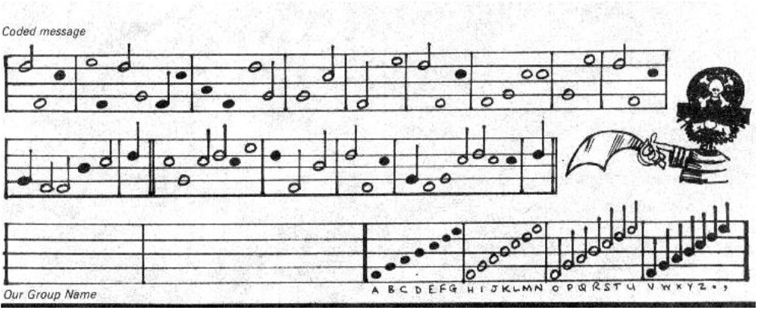

Finally…. Borrow a long rope from the Scoutleader; carefully tie each cub to this rope with about five feet of free rope between each cub. Now play a few games like man the lifeboats, North-South-East-West. Six-a-side soccer etc. or try an obstacle course.

A Challenge to Patrol Leaders… And Assistant Patrol Leaders aged 13 + yrs. First, select a minimum of three other PL’s or APL’s (from Any Troop in Valley Highlands Area) to make a team of FOUR. Write all of your Names, Telephone #s and Group Names, with a team name, in an email and send it to me, (Alyssa Comstock, DAC Youth, - smartkid_31@hotmail.com) not later than 30th March 2005. We will enroll you in the program and send you full details of the challenge. Here’s an outline.
The Challenge… 1) as a team take part in an expedition in unfamiliar adventurous country over three days (two nights) in July or August 2005. 2) As a team carry out a pre-arranged project during the three days of the expedition. 3) Each team to, (some weeks after the expedition,) produce a logbook and deliver a short presentation to the Deputy Area Commissioners…
Your team will need to become proficient in the following.  First aid;  Safety Precautions;  Treatment for exposure;  Route planning;  Navigation;  Camping and Cooking; The personal skills needed for your group project.

Useless Trivia… Anyone can hold the helm when the sea is calm. Pubilius Syrus
It doesn’t have to be dark to reach for the stars...
You can do anything, the only limits are set by your own imagination.
The man who does not read good books, has no advantage over the man who cannot read.

What is Childhood 1v… I think Kendra Grant, (16) a Patrol Leader from Brandon, Manitoba. Sums up this series when she writes…
“Every child has fantasies of being a grown-up, of owning a house, driving a car. But the funny thing is, when you finally do grow up, you get to pay this strange, horrible thing called a mortgage, and you get to drive 45 minutes in traffic.
That’s why I want to be a little kid again, and stay that way for the rest of my life. If I could, I’d stay 5 years old. Being 5 means colouring, eating cake off the filthy floor and getting immunized from cooties. You don’t know what war is or that you’ll eventually die. You don’t know the truth about Santa, the Easter bunny, or the tooth fairy, or dentists. You only know that you must look both ways before crossing the street and that 1+1 = 2. You don’t care about the quadratic formula or mitochondria or college, or taxes.
Why everyone I know wants to be grown-up so fast is beyond me. You’re only a child for 18 years, so enjoy it, once it’s over, no matter how much you wish for it, you can’t ever go back.
So, all you adults out there, whilst we need you to be there for us, support us, and help us get over our mistakes. Let us be kids while we still can.

The Months Ahead….
Need some ideas for themes for the coming months… Take a fresh look at some of these ideas.
Memories: Look back at the last 97 years of cubscouting and plan an evening or two with photos and or talks by now- elderly persons who have some good memories to share of cubscouting in the past.
The Saints: St.David. Hold an eisteddford. St Andrew. A highland games weekend. St. Patrick. An Irish music night.
St George. Games night revolving around the slaying of the dragon, and the knights of olde England. And of course many other Saints and other notable figures…
Our Community: Activities, which will help cubs, learn about their community, and, that will make our communities better places to live.
Out and About: An evening in the local woods, Tracking, Plaster casts, Bar-b-Que. etc. Find out about different breeds of cows and sheep, and some of the wildlife to be found locally… how they live… what they eat etc.
The Countryside: Life in the hedgerows, Animals and insects, Pond and river life.
Let’s explore: Expedition planning, Town/village scavenger hunt. The 24-hour clock (including bus timetables etc.) Visit a train station/museum and see how a railway operates. Maps: what can you see on a map? Can you find it on the ground?
Latitude and longitude. Grid references. Compass trails and compass games.
And last but far from least Sports and Leisure: Try a new sport, The Athletes badge, and Inter-Pack soccer challenge. Try a Frisbee contest. What about Shuffle and Horseshoes?

Welcome to Florida…
A group of Canadians were sitting round the pool here a couple of days ago, talking about their ailments…
“My arms have become so weak I can hardly lift my coffee cup,” said one elderly gent. “Yes I know,” said another “My cataracts are so bad I can’t even see my coffee.” “I couldn’t even mark an X at election time, my hands are so crippled” volunteered a third. “What… speak up, I can hardly hear you,” said a fourth.
“I can hardly turn my head, my arthritis is so bad,” said a fifth, to which several nodded weakly in agreement. “My blood pressure pills make me so dizzy I can hardly walk,” added another. “I forget where I am and where I am going,” said one gent. “I guess that’s the price we pay for getting old,” winced an old man as he slowly shook his head. The others nodded in agreement. “Well count your blessings,” said one woman cheerfully, “Thank God We Can All Drive.”

Marcus Aurelius said… Waste no more time arguing what a good man should be…
…. BE ONE.

And finally… A man walked into the income tax collector’s office, at the Department of Customs and Revenue, in Ottawa. Sat down, and smiled at everyone.
“May I help you?” asked the chief clerk “No,” said the man “ I just wanted to meet the people I’ve been working for all these years”.

An epitaph on a grave in Chalfont-st-giles, in England reads…
“When some people retire, nobody knows the difference.”

Then there was the undertaker who signed all his letters “Eventually Yours”

