Event
Car accessible weekend still camp with novice and advanced white water canoe courses. Course instruction will be qualified instructors from Bear Creek Outdoor Centre. Class I and II rapids will be used. Camping at Black Bear campground on a sandy beach.

Schedule
Friday May 23
Depart Merrickville from the community centre at 5:30pm.
Travel highway 43 towards Smiths Falls, Rosedale road to highway 15, on to Carleton Place, county road 29 to Arnprior, highway 17 to Petawawa.
Arrive Black Bear campground approximately 7:30pm.
Setup camp.
Travel distance approximately 200km.

Saturday May 24
White water canoeing on Petawawa river.
Make bag lunch at campsite.

Sunday May 25
White water canoeing on Petawawa river.
Make bag lunch at campsite.
Andreas picked up at ~12:00pm at the training area parking (marked on map).
Depart river approximately 3:00pm.
Arrive Merrickville approximately 6:00pm. Parents to be called enroute if return time significantly different.

Participants

Name | Type | Section | FW Skill | WW Skill | Course | PFD | Swimmer
Yates, Allan | Adult | Venturer | Stern - Adv | WW I & II | WW III | Own | Yes
Ricketts, Bill | Adult | Venture | Stern - Adv | None | WW I | Group | Yes
Sargent, Robert | Adult | Scout | Stern - Adv | None | WW I | Own | Yes
Catton, Ben | Youth | Venturer | Stern - Adv | WW I & II | WW III | Own | Bronze Medallion
Beelich, Andreas | Youth | Scout | Stern - Adv | None | WW I | Own | Star 5
Hitsman, Harry | Youth | Scout | Stern - Nov | None | WW I | Own | Bronze Medallion
McKay, Alex | Youth | Scout | Stern - Adv | None | WW I | Own | Yes
Sargent, Stacey | Youth | Scout | Stern - Nov | None | WW I | Own | Yes
Skelhorne, Bradley | Youth | Scout | Stern - Nov | None | WW I | Own | Yes

Safety Precautions
- All participants will wear a properly fitting life jacket and helmet when near the water.
- Life jackets and helmets will be securely fastened when worn.
- A paddle, for support, will always be carried when scouting rapids.
- No participants have mortal allergies.
- All usage of the river training area will be under the supervision of an instructor.
- A ratio of one instructor per four canoes will be maintained.

Kit List

Sleeping bag
Sleeping pad (optional)
Torch
Change of clothes (several)
Change of footwear
Trousers
Long sleeved shirt
Swim suit
Towel
Sweater or sweat shirt
Rain jacket
Rain pants (optional)
Pyjamas
Pillow (optional)
Wash kit: tooth brush, toothpaste, etc.
Water bottles w/carabiner, 2
Sunscreen
Insect repellant
Hat
Baseball cap
Kleenex
Toilet paper
Whistle on a lanyard
Knapsack
Kneepads (optional)
Bicycle gloves (optional)
Sunglasses w/strap (optional)
Water shoes (optional)
Pocket knife (optional)
Personal Flotation Device (optional)
Wetsuit (optional)
Folding chair (optional)

Quick dry materials such as polypropylene, polyester fleece, and a nylon wind jacket and pants are recommended. A rain suit can double as an extra layer in cold weather.

Wet feet are a given, and participants will get wet even if they don’t dump their canoe (which they are likely to do anyway).

No electronic games.

Menu

Friday
Supper
Brown bag from home or eat before departure

Saturday
Breakfast
Cereal, bacon, toast, jam, peanut butter
Lunch
Sandwiches (bacon, ham, buns, mayonnaise, lettuce, cheese), chicken noodle soup (if cold)
Supper
Spaghetti, Caesar salad, garlic bread

Sunday
Breakfast
Cereal, sausages, toast, jam, peanut butter
Lunch
Sandwiches (bacon, ham, buns, mayonnaise, lettuce, cheese), chicken noodle soup (if cold)

Snacks
Granola bars
Peanut M&Ms
Pringles
Apples
Gummy Bears

Drinks
Hot chocolate
Juice crystals, lemonade
Kool-Aid singles
Water
Orange juice
Coffee
Milk
YOPs
Grocery List
Bacon, 3 packages
Bread, white, 1 loaf
Jam, strawberry, 1 jar
Peanut butter, 1 jar
Beer nuts
Corn Pops, 1 box
Frosted Flakes, 1 box
Milk, 4 litres
Buns, Focaccia, 18
Cheese, large slab, 907g
Mayonnaise, squeeze, 1 bottle
Lettuce, iceberg, 1 head
Ham, 24 slices, 1 kg
Cup-a-soup, Chicken Noodle, 10 packages (have)
Granola bars, chocolate covered, 1 large box
Granola bars, sweet & spicy, 1 large box
Ground beef, 2 lbs
Spaghetti noodles, 1 package (900g)
Spaghetti sauce, 0.875 ml
Sausages, breakfast, 24
Hot chocolate, 10 packets
Apples, red, 1 bag
Apples, green, 1 bag
Coffee, regular (have)
Coffee, decaffeinated (have)
YOPs, 12
Kool-Aid singles, 3 boxes (have 1 box)
Juice crystals, lemonade, 1 container (have)
Caesar salad, 1 bag
Garlic bread, Texas style, 16 slices
Gummy Bears
Pringles, 2 containers
Vegetable oil

Hospital
The nearest hospital is the Pembroke Regional Hospital. To access the hospital from Highway 17, exit at the lighted intersection of Paul Martin Drive and Highway 41. Take Paul Martin Drive to Town Line. Turn right on Town Line. Turn left on Mackay Street and the hospital can be found three blocks away.

705 Mackay Street
(613) 732-2811

Common Camping Equipment
Personal
Pre-training notes
Sheath knife
Multi-tool
Thermometer
CDs
Trip plan
Watch
Camera
Camera spare battery
Camera battery charger
Mobile telephone
Mobile telephone car charger
Book
Physical fitness forms
Tent (poles, pegs, ground sheet)
Hammock
Headlamp
Lantern, battery
Pelican camera case, w/lanyard & carabiner
First aid kit
Truck garbage container w/bags
Briefcase
Weather forecast
Tents, 2 (1 Scout, 1 Cub)
Ground sheets, 2
Tent pegs
Tarps, medium, 2
Baler twine
First aid kit
Duct tape
Matches
Dish soap
Toilet paper
Tinfoil
Paper towel
Garbage bags, 10
Notebook & pencil
Pot sets, 2
Pot, large
Toaster, stove top
Frying pans, 2
Lanterns, propane, 2
Propane, 1 lb, 6
Stove, 2 burner, propane, 2
Basins, washing, 2
Kleenex
Water container, 2
Tea towel
Dish cloth
Spoon, large, 2
Spatula, 2
Paddling Equipment
Paddles, plastic/aluminum, 10
Lifejackets, large, extra, 1
Lifejackets, medium, extra, 2
Canoes, with fore/aft float bags & thigh straps, 5
Painters, 5
Bailers, 5
Canoe trailer (Kemptville Scouts)
Canoe tie down ropes, short, 8
Canoe tie down ropes, long, 2
Canoe supports, 2”x4”x6’, 2
Helmets, 9
Playing cards, 2 packs
Folding chairs, 3
Single cup coffee maker, 3
Coffee filters, #2, 20
Scrubbing pad, nylon
Carabiners, 9
Thermos, 3
Slings, small, 6
Cooler
Ice packs, 4
Cheese slicer
Spaghetti lifter
Paper bags, small, 20 (for lunches)
Dining shelter, self supporting (car port)
Cub picnic tables, 3
Ziploc bags, small (for sandwiches)
Ziploc bags, large
Sandwich bags
Milk jug
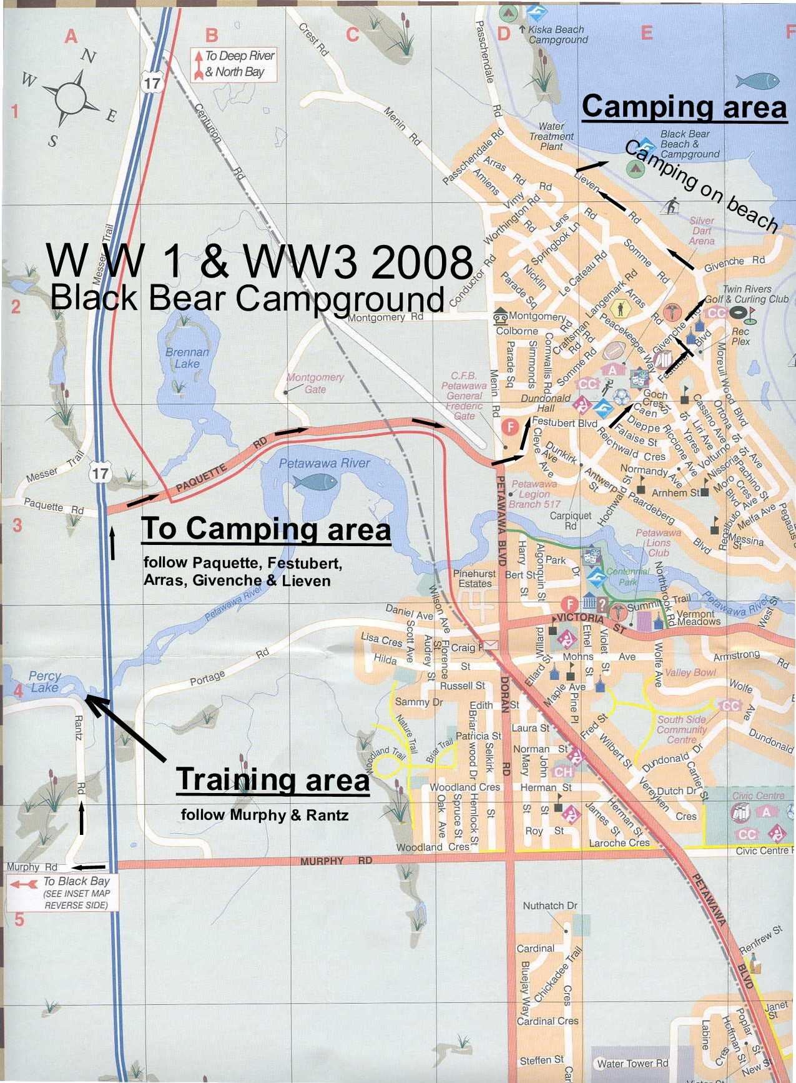
Black Bear Campground

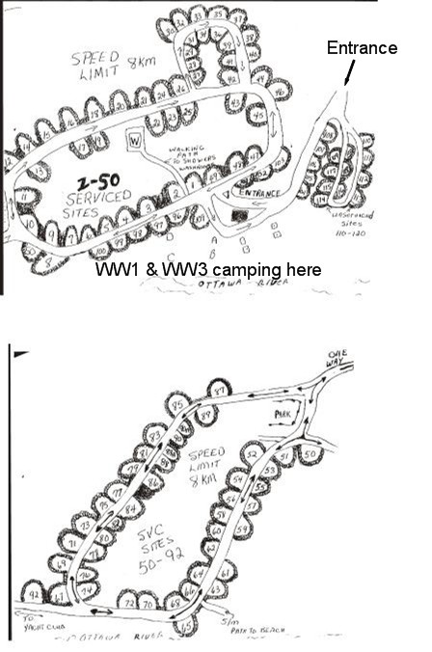

Black Bear Campground

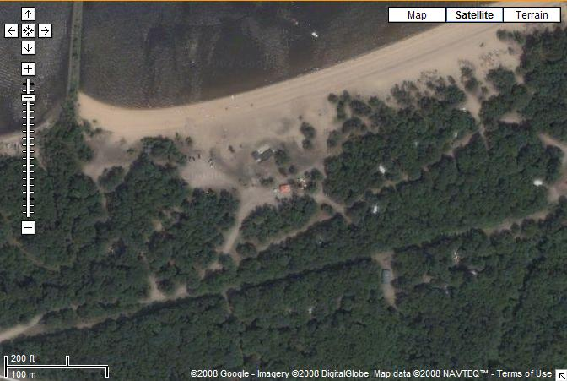
Campsite

Training Area

Left of the highway (upstream) is the beginners area. Big Eddy is more advanced for Sunday.

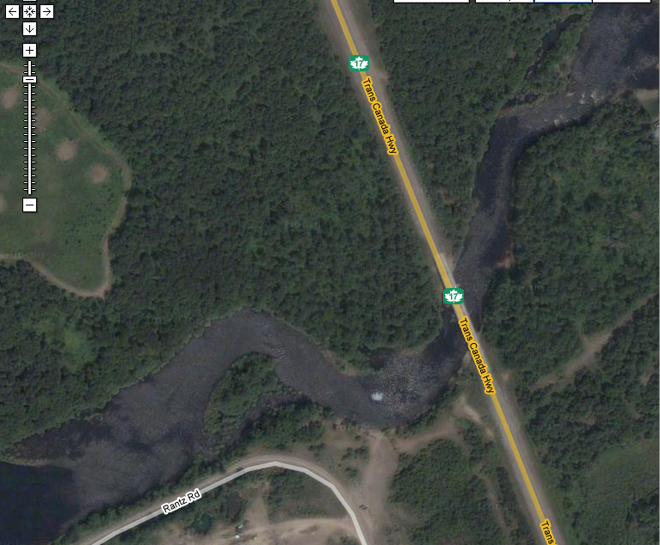
Big Eddy
Parking
& Lunch

Golf Club Rapids – White Water III Sunday Training Area

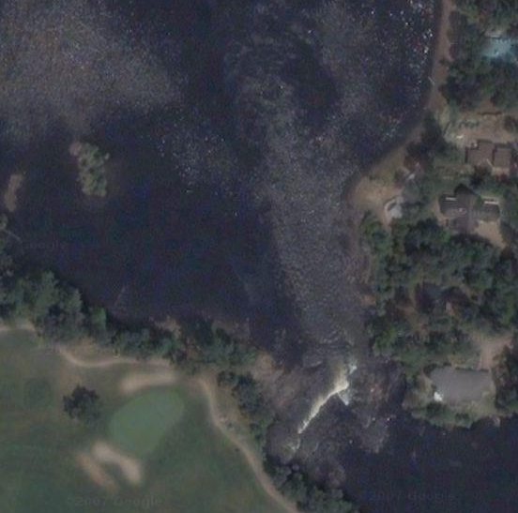

Map to Golf Club Rapids

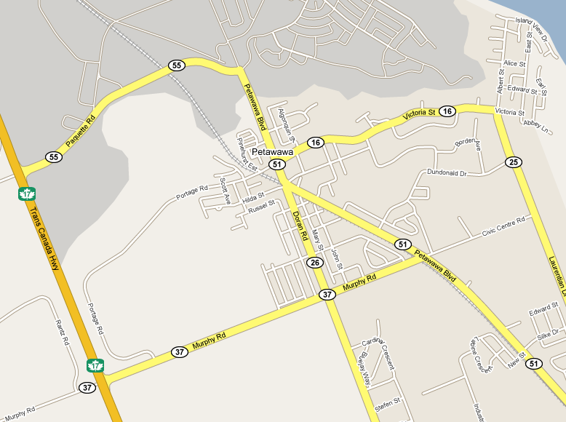
Big Eddy
Golf Club Rapids
Pembroke Regional Hospital



