Event
The Venturers will be winter camping, snow shoeing, skiing/snowboarding, and ice climbing in the Adirondack Mountains. This event is run over three weekends under the umbrella of the Venturer Advisors Forum. While snowshoeing up a 4,000’ mountain is the main objective of this event, we will be taking advantage of the location and time of year for other activities too. Since this is our only winter outing with the Venturers, we will be camping outside rather than using the adjoining heated Alpine Club of Canada cabin like most other Venturers. We will also have optional skiing/snowboarding and ice climbing available on the other days. The main event runs for the full Saturday and Sunday, with optional ski days on the Friday (Whiteface Mountain) and Monday (Gore Mountain).

Date
Friday February 13th – Monday February 16th

Location
Alpine Club of Canada Keene Farm
Keene, New York

Transportation
The Venturers will be driven by the leaders. It will be recommended to the drivers that they carry a minimum of $1,000,000 liability insurance per passenger. Allan will depart early Friday morning with those Venturers that wish to ski/snowboard. Bob will depart Friday evening with the remaining Venturers. Driving distance from Merrickville to Keene, NY is 286km; approximately four hours. Common equipment will be in a small utility trailer pulled by Allan. Bob will return Sunday evening, Allan will return Monday evening.

Vehicle | # of Seats (incl. driver) | Make | Model | Colour | License Plate
Allan | 7 | GMC | Yukon XL | Pewter | AKFA 929
Bob | 6 | Dodge | RAM 1500 | Black | 597 2NT

Qualifications
Allan has current standard first aid qualifications. Allan and Bob have previous snowshoeing experience in the Adirondacks.

Sleeping Accommodations
Venturers and leaders will be sleeping outside. A review of winter camping skills and examination of sleeping bags will be held. Each Venturer (or group of Venturers) will construct their own shelter. The shelters may be proper quinces, snow walls with a tarp roof, sticks and a tarp, etc. All first time participants must spend at least the first night in a homemade shelter. A heated cabin, owned by the Alpine Club of Canada, is nearby in the case of an emergency.

Food
- The menu will be planned by the Venturers.
- Those departing Friday morning must bring a bag lunch with them or be prepared to purchase their own lunch at Whiteface.
- For supper during the drive home (Sunday or Monday as appropriate), a stop at Subway Lake Placid is recommended.
- Citrus fruit cannot be taken into the US, though meat can be imported for personal consumption.
- A pump for water is available at the camping area.
In Case of Emergency
- 911 address of the hut is 193 Styles Brook Road, Keene, New York.
- Cellular service is unknown.
- Two first aid kits will be on site.
- Closest hospital is the Adirondack Medical Centre at 2233 State Route 86, (518) 891-4141.

Schedule
Allan departs from Merrickville Friday at 6:30am.
Allan arrives at Whiteface Mountain at 9:30am.
Bob departs Merrickville at 12:00pm, arriving Keene Farm at 4:00pm
Ski at Whiteface Mountain until 4:00pm.
Allan travels to Keene Farm, arriving at 5:00pm.
Setup camp Friday evening.
Snowshoe day outing on the Saturday. Depart 8:00am. Full day; bring packed lunch.
Tobogganing on Mirror Lake in Lake Placid Saturday evening (12pm - 4pm & 7pm - 9:30pm)
Ice climbing (8:30am (20 minute drive) at Rock and River Lodge, finish by 4pm or so).
Packed lunch and drinks. Dress in layers.
Ski goggles
For those leaving on Sunday:
Depart Keene at 5:00pm. Stop at Lake Placid Subway for supper.
Arrive Merrickville at 10:00pm.
For those staying for Monday:
Sleep in ACC cabin.
Skiing Monday at Gore Mountain; bring packed lunch.
Depart Gore Mountain at 4:00pm. Stop at Lake Placid Subway for supper.
Arrive Merrickville at 10:00pm.

Attendance
Name | Type | Attending | Depart | Return | Ski Whiteface | Ice Climb | Ski Gore
Catton, Ben | Youth | Yes | Morning | Monday | Yes | Yes | Yes
McKay, Alex | Youth | Yes | Morning | Monday | Yes | Yes | Yes
Szalai, Adam | Youth | Yes | Morning | Sunday | Yes | Yes
Szalai, Grant | Youth | Yes | Morning | Sunday | Yes | Yes
Taylor, Max | Youth | Yes | Morning | Monday | Yes | Yes | Yes
Sargent, Bob | Adult | Yes | Evening | Sunday
Yates, Allan | Adult | Yes | Morning | Monday | Yes | Yes | Yes

Attendance Counts
Type | Depart |  | Return |  | Ski  Whiteface | Ice  Climb | Ski  Gore
Type | Morning | Evening | Sunday Evening | Monday | Ski  Whiteface | Ice  Climb | Ski  Gore
Youth | 5 | 0 | 2 | 3 | 5 | 5 | 3
Adult | 2 | 1 | 1 | 1 | 1 | 1 | 1
Total | 10 | 1 | 3 | 4 | 6 | 6 | 4
Car Spots | 13 | 7 | 6 | 7

Financial Budget
Item | Cost | Notes
Allan truck fuel | $114 | 286km each way @ 20 cents/km
Bob truck fuel | $114 | 286km each way @ 20 cents/km
Food | $140 | $20/person @ 7 people
Camping fee | $113 | $7/person/night @ 7 people + $15 for third night in cabin
Propane | $24 | 6 - 1lb tanks @ $12 for 3 tanks
Tobogganing | $66 | $5/toboggan/2 youth + $3/youth
Base cost | $571
Base cost/Venturer | $114 | 7 Venturers
Advertised base cost/Venturer | $90 | Was $100 last year with no tobogganing
Optional Activities
White Face Lift Ticket | $75 | US$60/youth, US$74/adult
Ice Climbing | $95 | US$75/person
Gore Mountain Lift Ticket | $70 | US$55/youth, US$71/adult (holiday rate)
Sunday night cabin fee | $5 | Per person
Sunday food fee | $5 | Per person

The event has been designed such that the youth do not have to pay for the more expensive activities if they are not interested in them. Appropriate no cost alternative activities are available.

Whiteface Mountain Skiing/Snowboarding
For those Venturers travelling Friday morning, they will have the option of skiing at Whiteface Mountain. Those who are not skiing may relax in the lodge with Bob. Each person skiing/boarding must supply their own equipment; a helmet is strongly recommended. Rental equipment is not permitted as a credit card is required for security. To get to the mountain, turn left in Lake Placid towards Wilmington.

Mountain | Summit Elevation | Vertical Drop | # Trails
Gore Mountain | 3,600’ | 2,300’ | 90
Whiteface Mountain | 4,386’ | 3,166’ | 80

Further Information
For additional information, the following documents are published by the Venturer Advisors Forum:
- Winter Adventure Information
- Winter Adventure Clothing
- Winter Adventure Checklist

Mountain
Last year we climbed (and one lad snowboarded down!) Hurricane Mountain. It was an ascent of 2,000’ for a final elevation of 3,694’ and the trail was 8.5km in length. This year the plan is ….
Ice Climbing
On the Sunday, the Venturers will have the option of shopping in Lake Placid or ice climbing. The ice climbing will be through the company Adirondack Rock and River Guide Service. This will be top rope climbing. The company will provide American Mountain Guide Association certified guides along with all necessary equipment, training, and instruction. We will be supplying our own helmets and harnesses to obtain a reduced fee. Venturers also have the option of coming with the ice climbing group, but not actually climbing.

The Rock and River lodge is at the end of Alstead Hill Lane, off route 73, between Keene and the town of Lake Placid. Continue past the Bark Eater Inn on Alstead Hill Lane for 5km to the end of the road. Contact information: www.rockandriver.com, (518) 576-2041. 8:30am start, ~4:00pm finish. Old ski pants recommended as crampons are very sharp.

Name | Harness Size | Helmet Size | Needed
Catton, Ben | Medium | 2 | Yes
McKay, Alex | Small | 1 | Yes
Szalai, Adam | Medium | 2 | Yes
Szalai, Grant | Medium | 2 | Yes
Taylor, Max | Medium | 2 | Yes
Sargent, Bob | Medium | 2 | Yes
Yates, Allan | Medium | 2 | Yes

Gore Mountain Skiing/Snowboarding
This activity will occur after the official end of the Scouts Canada trip. Those youth who wish, and have their parent’s permission, may stay for the Sunday night and Monday (Ontario family day) for a ski outing to Gore Mountain. This resort is a one hour drive south of Keene. Unfortunately we are now in President’s Week in the US, so holiday lift ticket rates apply ($3 surcharge for youth, $9 for adults). Sunday night accommodation will be in the ACC hut. If there are four youth or less, then the cabin cost is $15 total (because Allan is an ACC member); otherwise it is $15/person. A $5 charge will be added to cover the cost of the extra day’s meals. Take county road 9N to Keene, then county road 73 to the I-87. Take the I-87 (the Northway) to exit 26 (Pottersville). Follow the Gore Mountain "Trailblazer" signs through Olmstedville then left on Route 28N to North Creek. Make a left turn onto Route 28 and then a right to 793 Peaceful Valley Road.

Risks
- Minor injuries: Treated with first aid kit.
- Major injuries: Evacuation and transport to hospital; alternatively a leader will be sent to fetch medical personal by returning to the parking area and driving to a telephone to summon paramedics.
- Hypothermia: The wearing of hats and gloves will be recommended. If the weather is very cold, hot drinks will be taken in a thermos for the hike. Layering is required to reduce perspiration and subsequent chilling.
- Head injury: Helmets will be strongly recommended for skiing, and will be mandatory for ice climbing.
Personal Equipment
No electronic games.
Change of clothes (as many as desired)
Sweater or sweatshirt
Thermal or technical long underwear (optional)
Technical under shirt (optional)
Gloves and/or mitts, 2 pairs
Winter hat (with spare for sleeping)
Winter coat
Winter boots
Socks, thick, for sleeping
Snow pants (old pair recommended for ice climbing)
Track pants (optional)
Sleeping bag (-20C rating or use 2)
Sleeping pad (closed cell foam or Thermarest)
Pillow (optional, for sleeping during drive too)
Flashlight
Spare batteries
Headlamp (recommended)
Wash kit (tooth brush, tooth paste, soap, hair brush, etc)
Shampoo, no-rinse (astronaut shampoo) (optional)
Towel
Mess kit (Plate, bowl, mug, knife, fork, spoon) in mesh bag
Water bottle (must be Nalagene polycarbonate if using as a hot water bottle at night)
Kleenex
Plastic bag for wet clothes
Whistle
Water bottle (must be Nalagene brand polycarbonate if used as a hot water bottle)
First Aid or Survival kit (optional)
Campfire blanket (optional)
Pocket knife
Chapstick (optional)
Ski helmet (highly recommended if skiing or snowboarding)
Skis & ski poles & ski boots (optional)
Snowboard & snowboard boots (optional)
Folding chair (optional)
Shovel, snow (for building shelter)
Thermos (optional, for hot drinks on the hike and during ice climbing)
Watch (optional)
Camera (optional)
Pocket knife (recommended)
Multi-tool (optional)
Birth certificate or passport
Consent form, signed
Out-of-country health insurance details
Slippers (optional, for those in the hut on Sunday night)
Knapsack (for snowshoe hike and ice climbing to carry lunch, water, etc)
GPS (optional)
Rucksack or duffel bag
Ski poles (recommended, for snowshoeing)
Common Equipment (Tractor Trailer)
Stoves, propane, 2
Allan’s Personal Equipment
Altimeter
Thermometer
Utility trailer
Tarp to cover utility trailer
Bungee cords for securing tarp to trailer
Rope to secure trailer contents
Lock for trailer
Book
Topographic map, Adirondacks, 2
Road map, New York State
CDs
Cash, Canadian
Cash, US
Truck garbage bag holder
Garbage bags for truck, 6
Mobile telephone
Mobile telephone charger
Inverter
Camera
Camera spare battery (charged)
Wrist guards
Knee pads
Butt pad
Saw
Hatchet
ACC membership card
Pillow, extra
Sleeping pad, extra
Tent, 4 man + poles + snow tent pegs
Folding chair, extra, 2

Mantles, spare
Lanterns, propane, 4
Pot sets, 2
Pot, large
Frying pan, 2
Spatula, 2
Large spoon, 2
Water containers, 2
Coolers, 2
Tarps, 2 large
Tarps, 5 medium
Tarps, 8 small
Binder twine, 1 roll
Wash bowls, 2
Dish soap

Common Equipment (Other)
Firewood
Kindling
Newspaper
Matches
Tinfoil
Garbage bags, 5
Paper towel
Toilet paper
Climbing harness, small, 1
Climbing harness, medium, 6+1
Climbing helmet, size 1, 1
Climbing helmet, size 2, 6+1
Propane, 1 lb, 8
Snowshoes, 7 pairs
Dish towel
Dish cloth
Bob’s Personal Equipment
Toboggan, load carrying bucket style
GPS
Radios, FRS/GMRS, 2

Allan’s Emergency Equipment
Sand
Traction aids
Tow ropes, 3
Blankets, 2
Shovel, snow, small
Sleeping bags, winter
Menu

Friday
Snacks
Hot chocolate, box
Coffee, small can
Marshmallows, Jet-puffed
Granola bars, Nature Valley Sweet 'N' Salty, 32-pack
Granola bars, Nutri-Grain, large box
Milk, 3.25%, 4 litres
Juice crystals
Lunch
Brown bag from home

Dinner
Stew, beef

Saturday
Breakfast
Pop-tarts
Lucky Charms
Bacon & eggs for leaders

Lunch
Sandwiches, ham & turkey, cheese

Dinner
Chili

Sunday
Breakfast
Pop-tarts
Oatmeal
Bacon & eggs for leaders

Lunch
Granola bars
Sandwiches, ham & turkey, cheese

Dinner
Soup, chicken noodle

Monday
Breakfast
Lucky charms

Lunch
Sandwiches, peanut butter and jam

Dinner
Subway

Grocery List

Bread, white, 4 loaves
Lucky Charms, 2 regular boxes
Peanut Butter, crunchy, Kraft
Jam, Strawberry
Pop Tarts, not chocolate, 5 boxes of 8
Stew, NFL Chunky, 7 cans
Chili, 7 cans
Oatmeal, 7 packages
Hot chocolate, small box
Coffee, small can
Marshmallows, Jet-puffed
Granola bars, Nature Valley Sweet 'N' Salty, 32-pack
Granola bars, Nutri-Grain, large box
Milk, 3.25%, 4 litres
Ham, 30 slices
Turkey, 30 slices
Cheese, real, 14 slices
Soup, chicken noodle, 1 large can
Juice crystals, 1 large container
Eggs, 1 dozen
Bacon, 1 lb

Rock and River Ice Climbing

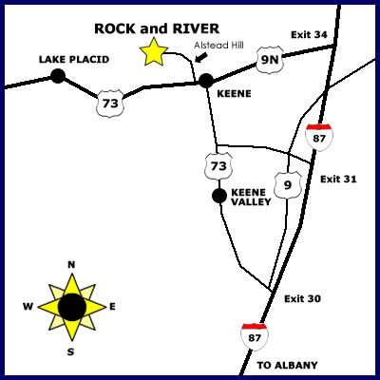


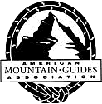
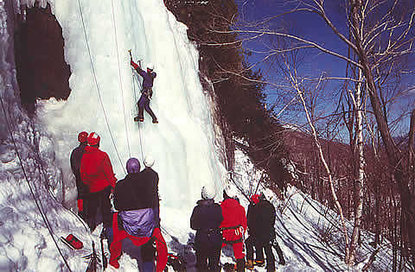
Whiteface Mountain
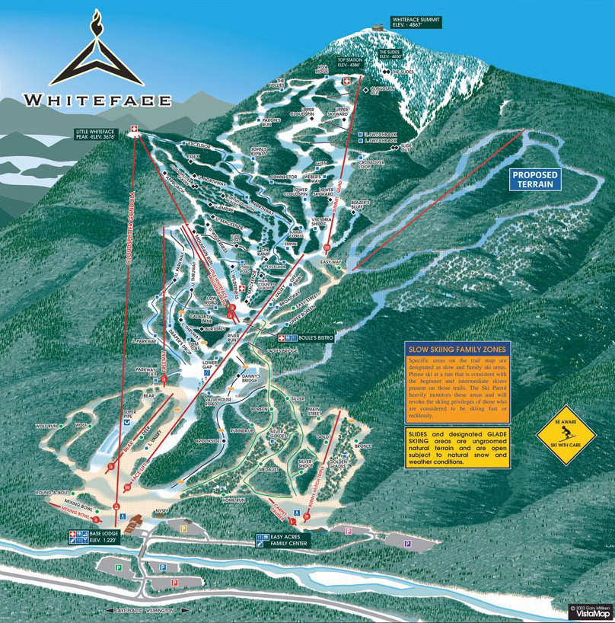
Gore Mountain
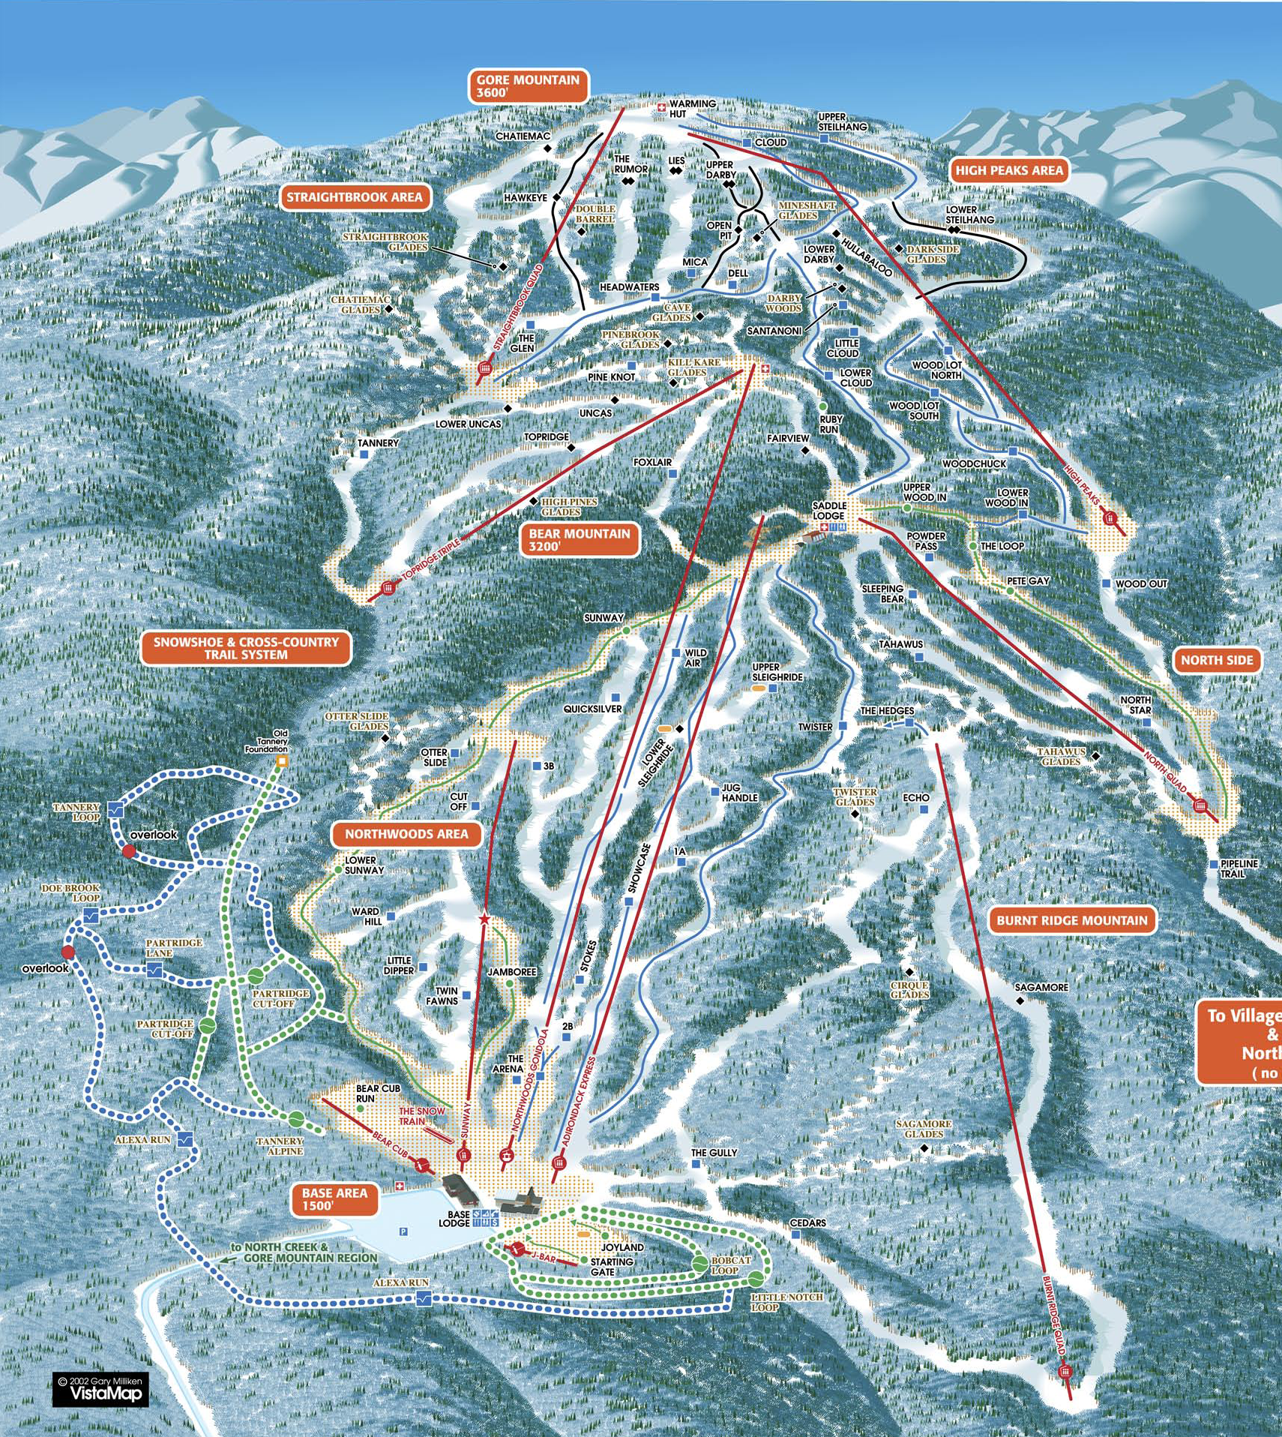

Report
We gathered at 6:00am at the tractor trailer to pack all our equipment. A little confusion as to whether Adam & Grant had actually brought their identification; Frank found it in the truck where Susan had placed it :) Alex arrived at 6:15am, we're not sure where he was lost. The lads gathered the equipment they wanted and loaded up the trailer. The trailer was covered with a tarp and securely lashed down with many ropes and bungee cords. An introduction to the Truckers Hitch for some of the lads. We departed at 7:00am.

When our snowshoes went to the Adirondacks the previous weekend, on the way back the driver's car was searched and he (Christiaan - our climbing instructor) was hassled by the customs folk as they thought he was trying to import the snowshoes. He managed to get through, but we wanted to make sure that didn't happen again. So we stopped at customs before leaving Canada. They wanted to see the snowshoes so we had to open up the trailer and dig them out. The customs guys found that their stickers wouldn't stick to the plastic, so they stamped our invoices and shipping documents. They also asked us to engrave serial numbers on the snowshoes (e.g. numbers 1 to 24) for the next trip. The trailer was lashed down again, and we were on our way.

We made a quick stop at The UPS Store in Ogdensburg to pick up my new ski jacket. Burton of course! Lots of oohs and aahs in the truck.

We arrived at Whiteface Mountain at 10:30am. Unfortunately, we packed some ski boots in the trailer and had to open it up for the second time that day! And lash it down for the third time! When we went to purchase our lift tickets, there was a big warning that the conditions were not that great and single trip lift tickets (for $20) were available if people wished to check out the hill before committing to the full lift ticket. We decided to go this route. We took one lift up, skiied part way down, and caught an intermediate lift back up (they don't check tickets on those lifts). So we skiied for about an hour before arriving at the bottom. We found the conditions to be fine, so we went to upgrade our tickets. At this point it was just after 12:00pm. The lady said if we waited until 12:30pm we could get 1/2 day lift tickets! Given that last year they refused to sell us 1/2 day lift tickets, we were quite surprised. So we had lunch and came back at exactly 12:30pm. We then skiied until 4:00pm when the lifts closed.

Another 45 minute drive got us to the ACC property. Bob had already been there for a couple of hours, and had his tent all setup. I setup a tent for myself. The older Venturers had decided not to make Alex spend his first night in a homemade shelter (like they did last year), but to let him sleep in their shack. So they all set to work cleaning the rubbish out of the shack and tarping it all over to make it somewhat habitable. There are four bunks in the shack and a table. Alex was offered the table :) They decided to do all their cooking in the shack, so Alex's bed roll moved around a fair bit during the day. The lads got a couple of propane lanterns going, and got the temperature fairly comfortable, at least compared to outside in the wind. The kids hit the sack pretty early. When I did a bed check, I found that Alex's sleeping bag was a little thin for winter camping, and thus I expropriated Ben's second sleeping bag for Alex to double up with. That's two years in a row Ben has had to give up his second sleeping bag. Max evidentially learnt his lesson from last year, and was perfectly packed this year.

At 7:00am on Saturday the Venturers were kicked out of bed to make breakfast as we wanted to be on the road by 8:00am for snowshoeing. The lads couldn't be convinced to try one of the more challenging mountains, but settled for Cascade mountain; which though a little taller than last year's Hurricane mountain, is still classified as an introductory hike. The trail was hard packed and there was quite the stream of people; compared to last year's one couple we met. Adam, Grant, and Ben decided not to put on their snowshoes. Pretty silly, as I found the traction provided by the snowshoes was great. The Adirondack park service actually requires people to have snowshoes or crampons with them during the winter; or they issue fines. The lads made it to the summit in two hours; Bob came in at three hours (we need to get him out a little more often). The weather was very warm, but the wind at the summit was ferocious. But a beautiful view. We had lunch at a sheltered spot and then came down, sliding when ever possible. Descent time was about an hour. Next time the kids should bring Crazy Carpets. Nobody carried a snowboard up this year.

With most of the afternoon still available, we drove in to Lake Placid. We checked out the toboggan slide, which was supposed to be open, but wasn't. The kids weren't that impressed, and said they weren't interested in returning in the evening for it. We checked out a few other stores, including Eastern Mountain Sports. I thought that might be large, but the selection wasn't that great. We then headed back to Keene Valley. First we had a look at Chapel Pond slab, a rock climb that Ben, Max, and I did last November. Then we headed into The Mountaineer - an excellent outdoor clothing/equipment shop. We browsed around for a bit, and Bob tried to negotiate a discount on badges for the mountain. The clerk wouldn't budge, as he had last year, so Bob left quite peeved with them.

Back at the shack, the lads added a couple of more tarps for wind proofing and two more propane lanterns for heating. Bob's propane tent heater was also brought in. They got the temperature up to 23C at the ridge; it was -12C outside. It was darn comfortable. The lads actually got a lot more interaction and team building in this shack than they would have around a campfire. It was one of those things you couldn't plan, but worked out perfectly. They never bothered having a fire at all. Next time we should look at running off a 20 lbs tank; that would work out a lot less expensive than the 1 lb disposable tanks. Since Ben didn't whine about giving up his second sleeping bag on the first night, I leant him my fleece sleeping bag liner for the second night. The lads went to sleep around 9:30pm.

Up again at 7:00am on Sunday, and off to ice climbing. The Rock and River guide lodge was just a 15 minute drive around the corner. We were all outfitted with ice climbing boots and crampons. One ice axe in each hand is also used when climbing. We brought our own helmets and harnesses to save us a few dollars on the fee. It was about a half hour drive to the ice face. This was located on private property, and thus we had exclusive use of it. The ice is man made; they pump water to the top of the cliff and drizzle it out. The guide was great, there was nothing he wouldn't do to keep us happy. As we finished with one route, he would move the ropes over to another section of the cliff. We could climb non-stop all day. We found ice climbing to be easier than rock climbing. Every hand hold and foot hold is perfect, versus the piddly bits of rock you have to deal with during rock climbing. Going up spindly waterfalls was the funnest. The base of the cliff was littered with ice chips be the end of the day. The lads said they are interested in doing that again, but want a more exciting place next time with lots of spindly waterfalls. Though this location was perfect for an introduction. We tried a mixed rock/ice route, but none of us had the strength/technique to do it. It required climbing along a crack in the rock using mostly just your arms and the ice axes wedged in the crack. You can practice with just a single ice axe, it forces better body position, but I think only Alex tried that (and he did it on a couple of routes). Rock climbing equipment is inexpensive compared to ice climbing; we were using $1,200 of gear per person on our climbs.

As we drove into the ice climbing location, we found it was right beside a small hill that was exclusively a terrain park! A fellow operates this hill so the local kids have somewhere to play. There are no lift tickets to purchase. He has a rope tow and is thinking about getting a T-bar going. The hill is covered with features on which to do ski/snowboard tricks. The lads were drooling. They asked if they could spend a day there next year. We said sure if they wanted to organise it. So we stopped to talk to the owner before we left and exchanged email addresses. Their website is http://www.otismountain.com/otisisfun/. Max was going to drop him an email just to touch base.

Bob, Adam, and Grant left to go home at the end of the day, while Max, Ben, Alex, and I headed back to the shack. With the three remaining lads doing all the tear down of the camp, cleaning up, etc; Adam & Grant were sent home with the pots and stove to wash. That was a fair a division of labour as we could do. I think Adam & Grant got the best deal as they could do their task indoors!

The shack was returned to it's condition prior to our arrival (i.e. filled with junk), and the trailer loaded up with all the equipment. The Venturers worked really well together; they were a team in motion. Everybody just kept going until all the tasks were done; no chivvying needed at all. That was a pleasure to watch. We then moved into the heated cabin for our last night. We relaxed by the wood stove for a while, then I motivated the lads to get supper cooking. After supper, we rested for a bit. There was another Venture company in the hut, and their leaders were working on convincing their lads to attend a group camp and have activities and a campfire with their Beavers/Cubs/Scouts. Our lads looked at me: if you even think of asking us... Later we headed to bed on mattresses in the sleeping loft. The lads decided that they wanted to sleep in a bit, and settled on an 8:00am rise time. Bang on 8:00am I woke them up; I had been awake reading since 6:30am, I can't sleep as long as they do. After breakfast, we did a bit of cleaning in the cabin and finished our packing of the trailer and truck. One of the other group's Venturers was asked to do some vacuuming; it was a little while before he came back saying he couldn't find an outlet! There's no electricity in the cabin :) We got away at 9:30am.

It was about an hour drive to Gore Mountain. There was quite a few cars in the parking lot; where we had to take a shuttle to the hill. But the mountain covers a large area, so it wasn't crowded and didn't have long lift lines. The lads loved the terrain park, they said it was the best they had seen. Most of their day was spent there. Everybody kept together during our runs which was quite nice. The conditions were actually a little icier than Whiteface. In the terrain park, while the kids were doing the huge jumps, I was practicing on the little ones. I was having a great time, but I fell on landing at one point. It wasn't a big fall, but I hit my shoulder at just the wrong angle. A sharp pain, and that was the end of my snowboarding for the day. This was at 2:30pm, so I relaxed in the first aid hut with an ice pack and Ibuprofen for the remainder of the day.

It turned out that I have a separated shoulder and am looking at six weeks of physiotherapy for recovery. I can't lift anything heavier than a pencil with my right arm at the moment. It's lucky one of our cars has an automatic transmission.

We departed the hill around 4:30pm, and were back in Merrickville by 9:00pm. Only Alex was hungry on he way home, even though he had double the lunch of everybody else, so we pointed him towards the granola bars and kept on driving.

The Venturers picked Pop Tarts and Lucky Charms for their breakfasts. Neither Bob nor I can stomach that stuff, so we feasted on eggs and bacon. The kids found they could eat their Pop Tarts without even having to get out of their sleeping bags in the morning. The canned stew, canned chili, and canned soup worked well for the suppers. Lunches were a little thin as they consisted of frozen turkey/ham and fake cheese. No mayonnaise, mustard, lettuce, real cheese, etc. A little more effort needed on the menu. Also discovered that non-Kraft peanut butter is terrible. Chocolate for dessert would have been appreciated too; lucky Allan brought a little.

Carolin's ski box worked great. It was very much appreciated.

You must have pretty thick skin to survive in our group, the teasing is pretty well endless. I am no exception, with my purple fleece, the lads took to calling me Barney. "There's goes Barney climbing the ice". I threatened to learn some Barney songs and sing one every time they called me Barney; that would be a pretty good punishment given my singing voice :)

Financial Statement

Item | Category | Revenue | Expense
Registration - Andreas | WinterAdventure | $150.00
Registration - Adam & Grant | WinterAdventure | $165.00
Registration - Max | WinterAdventure | $265.00
Registration - Alex | WinterAdventure | $260.00
ACC fee | WinterAdventure |  | $71.00
Registration Refund - Andreas | WinterAdventure |  | $150.00
Registration - Adam & Grant | WinterAdventure | $165.00
Registration - Adam | WinterAdventure | $95.00
Mileage - Allan | WinterAdventure |  | $132.75
Mileage - Bob | WinterAdventure |  | $89.10
Food - Bob | WinterAdventure |  | $178.46
Whiteface lift tickets - Allan | WinterAdventure |  | $340.27
Gore lift tickets - Allan | WinterAdventure |  | $283.78
Ice climbing - Allan | WinterAdventure |  | $583.10
Toll - Allan | WinterAdventure |  | $4.71
Toll - Allan | WinterAdventure |  | $4.71
Whiteface parking - Allan. | WinterAdventure |  | $15.09
Food - Allan | WinterAdventure |  | $12.20
Registration - Ben | WinterAdventure | $330.00
Registration - Grant | WinterAdventure | $95.00
Registration - Max | WinterAdventure | $95.00
Food - Allan | WinterAdventure |  | $18.53
Allan ice climbing & skiing | WinterAdventure | $240.00
Registration - Alex | WinterAdventure | $95.00
Propane - Allan | WinterAdventure |  | $44.21

Balance: $27.09

