On Target
Your culinary skills were put to the test in this woodland kitchen. You need to model yourself on Jamie Oliver to cook the perfect pancake to help you get round the targets in the trees.
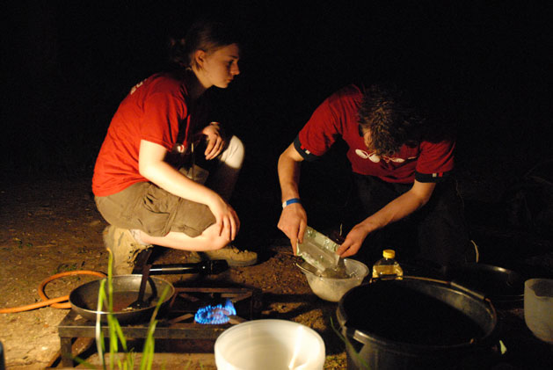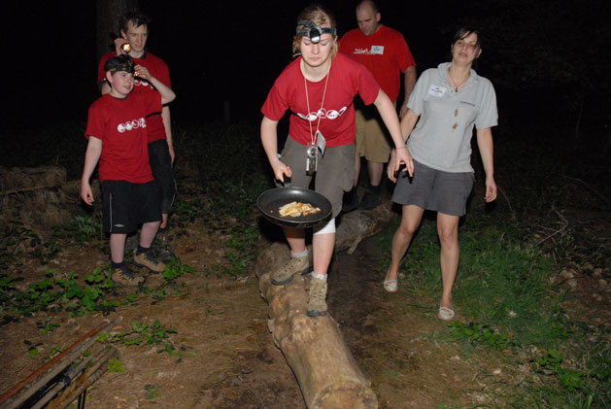

Child’s Play
This adventure playground may have been built for kids, but with the Apex adaptations, it becomes a whole lot harder. Only the most physically able teams could complete the course to find their way to the crucial punch box.
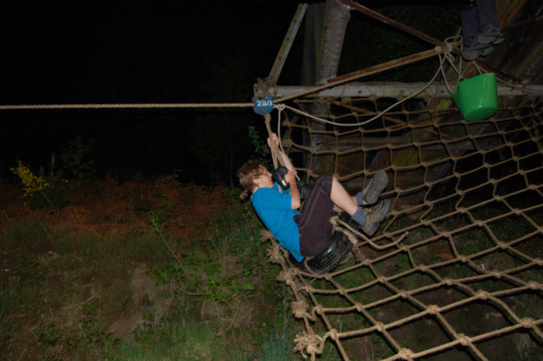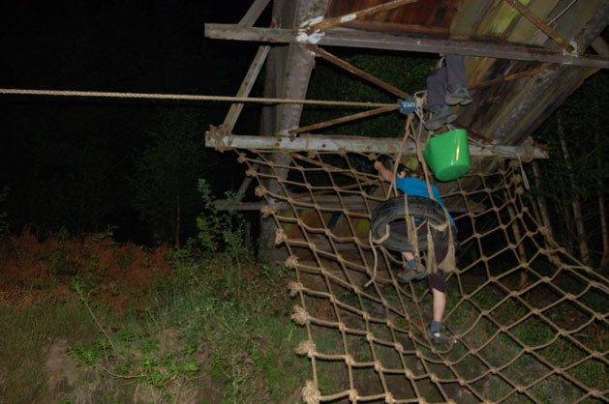

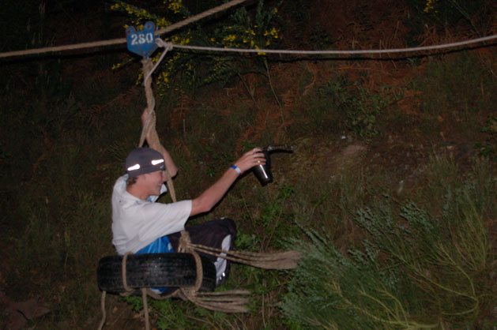

Delve of Doom
Is that custard? Or is it jelly? Are those maggots? Or maybe they're crickets? It took a brave and clear head to take this on. But teamwork was critical, if only to decide who would face the unknown contents at the Delve of Doom.

It’s Electric
You've got the battery and you've got the light, now you need to complete the circuit. But when it's several hundred metres long, and weaving through the forest, did your team manage to find the right items to put in the right gaps to illuminate your way to the fifty points?

Go Chimp!
You've heard of the Go Ape ropes courses - well this is the Apex's very own miniature version. It's a rope course up in the trees - and the wobbling lines are the only way to reach the crucial electronic punch.
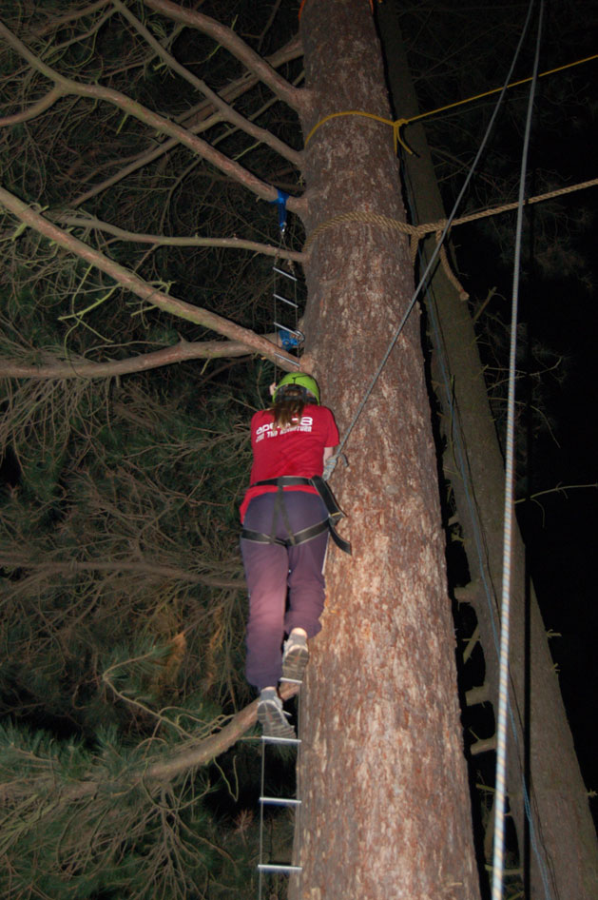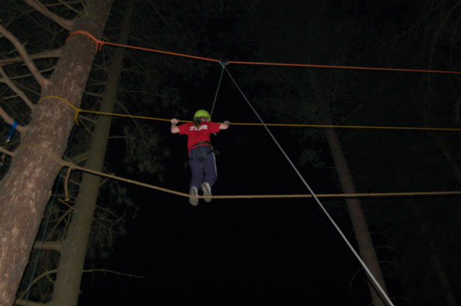

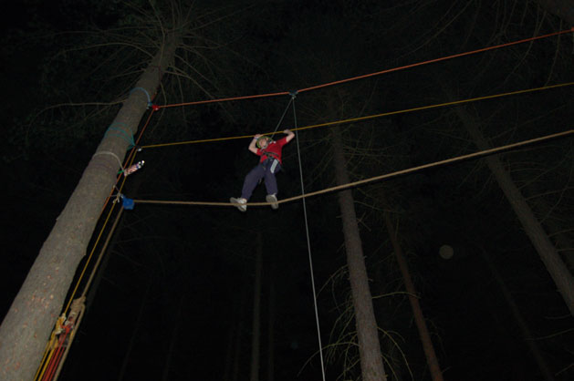

Thick as a Plank
It's a classic logic puzzle used in military training the world over. Could your team work together to discover the best way to use the barrels and planks to complete this taxing challenge?
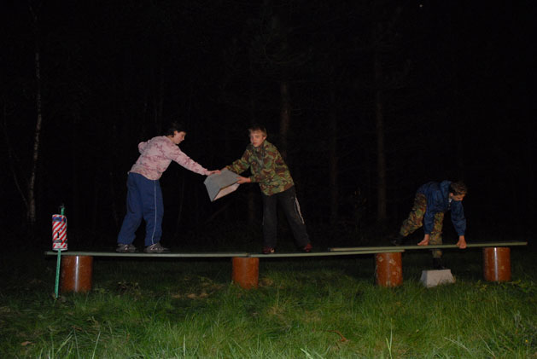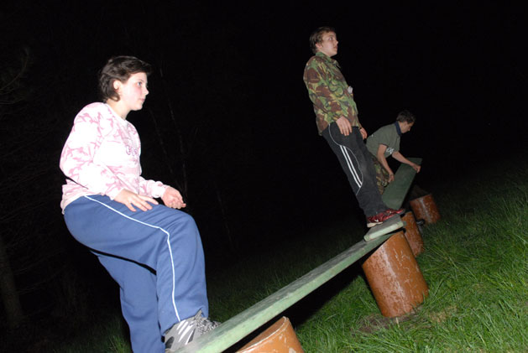

Ascension
This one was quite simply about you going up in the world! The caving ladders were suspended from the railway bridge and the only way to reach your fifty point prize was to tackle the wobbling stands of metal - and keep heading upwards!
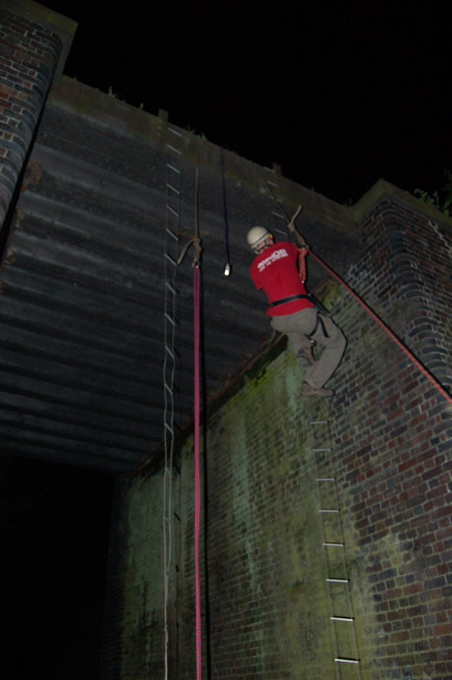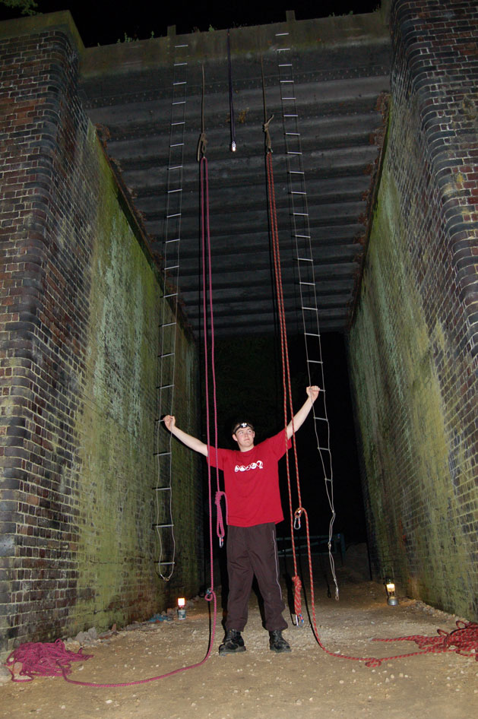

Crazy Catapults
It's the way people in the middle ages would defend their castles, but tonight this was your only way to defend your chances of winning. The soggy sponges needed to be fired with accuracy and power to win this woodland challenge.

Top of the Pops
This base was about being protective and gentle while still battling through the tough undergrowth of Sherwood. Did your team manage to get round the course without popping your crucial cargo of balloons?
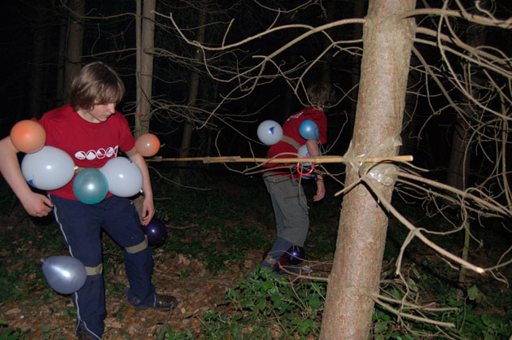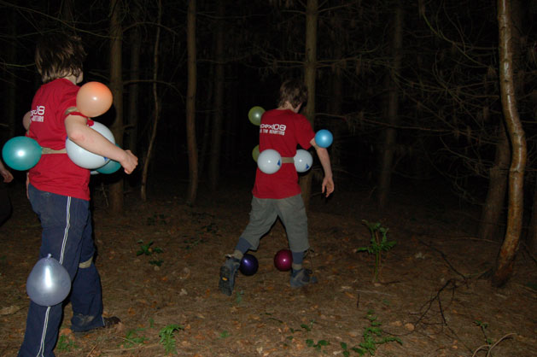

Off the Rails
You're on a derelict railway line and have to escape. But a tough and intriguing challenge stands in your way. Your team had to tackle the obstacles at this trackside base to claim the fifty point reward.

Flaming Arrows
Either a catapult like shown below, or with regular bows.
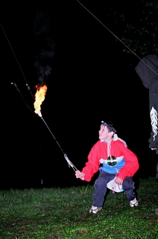

Jousting Swing
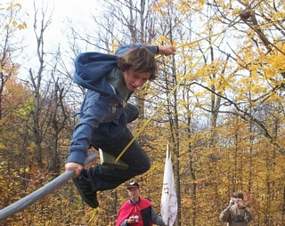

Spider Web
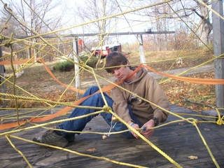

Tomahawk Throwing (fake)


Obstacle Course
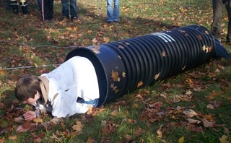

Apple Bobbing


Dueling
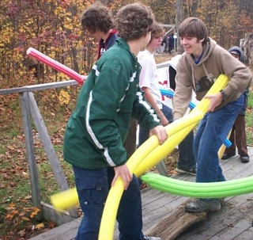

Blind Water Balloons
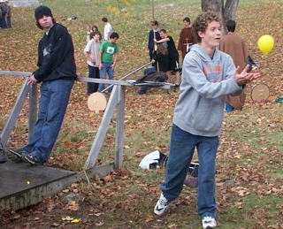

Tomahawk Throwing (real)


