Overview

This is a bicycle touring trip around Lake Champlain in New York and Vermont. The Venturers will camp with their leaders in the ACC hut in Keene, NY on Friday night. On Saturday morning the Venturers will depart on the bicycle trip as a group without the leaders. On Sunday, the leaders will then meet the Venturers at the destination on Sunday afternoon. Road bikes will be used, rented where necessary, to increase the distance able to be travelled. Venturers will travel self-sufficient with food and camping equipment.

Participants
 |  |  |  |  |  | In Command
Name | Type | Bicycle | Height | Inseam | Qualifications | Road | Overall
Catton, Sam | Youth | Rental | 67” | 30” |  | 1st
Dionne, Nick | Youth | Rental | 68” | 32” | Wilderness First Aid
Gale, Calvin | Youth | Rental | 66” | 30” | Standard First Aid |  | 1st
Kerr, Aidan | Youth | Rental | 71” | 34”
Savage, Lochlan | Youth | Rental | 71” | 34”
Yates, Laura | Youth | Own |  |  | Advanced Wilderness First Aid | 2nd | 2nd
Hamill, Stew | Adult | N/A
Yates, Allan | Adult | N/A |  |  | Standard First Aid

Financial Budget
Item | Budget | Actual | Notes
Mileage, 600km | $150
Mileage, Allan, 692km w/ trailer |  | $173 | $0.25/km
Mileage, Stew, Van, 972km |  | $243 | $0.25/km
Mileage, Stew, truck, 878km |  | $220 | $0.25/km
ACC Hut fee | $15 | $30 | Two nights
Camping fee | $34 | $32
Ferry fee, bicyclist, $5/person | $30 | $25
Food ($25/person) | $200
Food bought before |  | $26
Food during ride |  | $130
Supper on way home |  | $158
Maps, 2 | $13 | $13
Bridge tolls |  | $9
Road bike + pannier rental, 5 | $400 | $524 | Budgeted at 4
Return tow Malone to Keene |  | $500
Total | $842 | $2,083
Total per Venturer (6) | $140 | $347
Advertised total fee per Venturer | $140

Safety Precautions
- Helmets will be worn at all times while Venturers are bicycling.
- Group will stay together at all times while on the road.
- Prior to camp, bicycles will be checked for roadworthiness including tire inflation.
- Basic repair tools will be carried including spare inner tubes and pumps.
- All bicycling will be during daylight hours.

Schedule
Friday April 27th
Pickup rental bicycles and panniers from the Bloomfield Bicycle Company at lunch time.
Meet with bicycles and personal gear at Allan’s house at 5:00pm.
Depart 5:30pm.
Arrive at ACC hut, in Keene, a drive of 300 km, 3 hours, at 9:00pm.

Saturday April 28th
Wake up at 7:30am with departure by 9:00am.
Venturers bicycle to the Shelburne Camping Area, following the routes shown on the Lake Champlain Bikeways Map.
Ferry from Essex (NY) to Charlotte (VT). Departures every hour on the half hour.
Campsite reserved at the Shelburne Camping Area.
Total bicycling distance 85km. Optional shortcut reduces distance by 6.5km.
Venturers will purchase necessary food enroute; Shelburne Supermarket recommended.
Optional side trip to Burton Flagship Store; not all Venturers have to go.
Venturers to calculate overall speed for the day, so they can ensure they have a good schedule for Sunday.
Leaders will remain in Keene for Saturday night.

Sunday April 29th
Wake up at 7:30am with departure by 9:00am.
Ensure campsite is left cleaner than upon arrival.
Venturers bicycle from campground to Chimney Point (VT).
Total bicycling distance 50km.
Venturers take the ferry (departs every 15-30 minutes).
Venturer arrive at Crown Point (NY) no later than 2:30pm.
Leaders meet Venturers at Crown Point (NY), load bicycles, and drive to Keene Valley.
At The Mountaineer in Keene Valley, purchase hiking boots for Europe.
Depart at 6:00pm
Stop for supper on the way home.
Arrive in Merrickville at approximately 10:00pm.
Wet and dirty equipment distributed for cleaning and drying. Pickup at Allan’s house. Venturers will call with exact time.

Monday April 30th
Return rented bicycles and panniers to the Bloomfield Bicycle Company after lunch.

Equipment
During the bicycle rides the Venturers will carry with them all necessary camping equipment.

Venturers will use road bikes rather than mountain bikes. There will each be equipped with a rear carrying rack and a pair of rear panniers. Road bikes and panniers will be rented from the Bloomfield Bicycle Company for those without. Rentals will be picked up Friday at lunch, and returned on Monday after lunch.

Meals
Saturday lunch will be carried from the start. Groceries for all remaining meals will be purchased enroute. Just before the campground there is a full grocery store, Shelburne Supermarket. Nearby there is also the Shelburne Country Store. The campground has a small store on site with some staples, but milk is not stocked at this point in the season. The same stores are passed on Sunday leaving the campground.

In Case of Emergency
While the Venturers will be expected to handle any unexpected challenges themselves, as a very last step they will be able to contact the leaders in Keene.

The Venturers will carry a sealed package containing a copy of their physical fitness forms.

The Venturer's maps will include the location of the hospitals and bicycle repair shops.

Pre-Trip Training
A bicycle repair training session was held last year, specifically including the repair of flat tires. The bike tour last year around Prince Edward County was a training run for this trip; the same Venturers are involved.

Two overall plan review sessions will be held with the Venturers to ensure they are all aware of the trip details and their options for various issues that may arise. The first is a high level overview, and the second will include a multitude of scenarios that might be encountered.
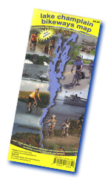

Route
The route is based on those published in the Lake Champlain Bikeways Map, and has been developed in conjunction with the publishers. The route avoids main roads where ever possible, or roads without paved shoulders.

A bicycling speed of 15 km/hour has been assumed, plus breaks.

The Venturers are to record their start and end times each day for future planning.

Photographs
Venturers will be strongly encouraged to take photographs throughout their tour.

Sleeping Arrangements
The five male Venturers will be split between a 3-man tent and a 2-man tent. The female Venturer will be using a bivy sack. Hammocks were considered but the idea discarded due to the low temperature at night at this time of year.

Resources
www.champlainbikeways.org
www.localmotion.org

Shelburne Camping Area
4385 Shelburne Road
Route 7
Shelburne, Vermont
05482
(802) 985-2540
www.shelburnecamping.com

ACC Keene Farm Hut
193 Styles Brook Road
Keene, New York
12942

Hospitals
Adirondack Medical Centre
29 Church Street
Lake Placid, New York
12946
(518) 523-3311

Fletcher Allen Health Care
Medical Center Campus
111 Colchester Avenue
Burlington, Vermont
05401
(802) 847-0000

Stew’s Accomodation
Trail's End Inn
62 Trail's End Road
Keene Valley
(800) 281-9860

Mobile Telephones
Stew (613) 298-8464
Mary Lou (613) 298-1425
Sam (613) 601-2699

Vehicle
Manufacturer: GMC
Model: Yukon XL Denali
Colour: Pewter
License plate: AKFA 929

White cargo trailer (6' x 12'), license plate: C3529H

The Mountaineer

1866 New York State Route 73
Keene Valley, New York
(518) 576-2281
Open daily 8:00am to 5:30pm

Bloomfield Bicycle Company
225 Main Street
Bloomfield, Ontario
(613) 393-1060
www.bloomfieldbicycle.ca

Eastern Mountain Sports
100 Dorset Street
South Burlington, Vermont
(802) 864-0473

Tire Size
Laura: 700x23C

Bicycle Shops
Plattsburgh
Maui North 518-563-7245 31 Durkee Street
Mountain Riders 518-324-9900 30 City Hall Place
Viking Ski & Cycle 518-561-5539 453 State Route 3

Lake Placid
High Peaks Cyclery & Mountain Guide 518-523-3764 2733 Main Street
Placid Planet Bicycles 518-523-4128 2242 Saranac Avenue

Grand Isle
Grand Isle Canoe, Bike & Kayak 802-372-3777 300 US Route 2
Ken's Island Peddler 802-372-4809 194 US Route 2

Swanton
Porter's Bike Shop 802-868-7417 116 Grand Avenue

Georgia
White's Green Mountain Bikes 802-524-4496 Route 7

Burlington
North Star Sports 802-863-3832 100 Main Street
Old Spokes 802-863-4475 322 North Wonooski Avenue
Royal Cycles 802-864-7059 41 King Street
Ski Rack 802-658-3313 85 Main Street

South Burlington
Alpine Shop 802-862-2714 1184 Williston Road
Earl's Cyclery & Fitness 802-864-9197 2500 Williston Road
Eastern Mountain Sports 802-864-0473 100 Dorset Street

Middlebury
Alpine Shop 802-388-7547 Merchants Row
Bike Center 802-388-6666 74 Main Street

Rutland
Green Mountain Cyclery 802-775-0869 133 Strongs Avenue
Sports Peddler 802-775-0101 158 North Main Street
Questions for Plan Review Session
- Where are you camping?
- What do you do if a bicycle breaks?
- What do you do if a bicycle breaks and you can't fix it?
- When do you need to be at the finish?
- What do you do if somebody breaks their wrist?
- What do you do if somebody scrapes their leg?
- What do you do at the campsite?
- Can you have a campfire at the campsite?
- Where are you departing from?
- What do you do if you notice one person from the group is missing?
- What do you do with your dishes at the campsite?
- What do you need to do at the campsite?
- What do you do with the equipment at the campsite on Sunday morning?
- Can you stop for snacks?
- What do you do if it rains?
- What is in the first aid kit?
- How can you fix a dangling part on a bicycle?
- Where is the first aid kit?
- Who has the bicycle repair kit?
- Who has the water bottle?
- What are the routes?
- Do you have to stay on the route?
- Where are the maps and schedules?
- Who has the bicycle pump?
- Who has the spare inner tube?
- When do you call for leaders for help?
- When do you not call leaders for help?
- Who can you ask for help?
- How can you get help?
- Where do you go for help?
- What do you do if involved in an automobile collision and nobody is hurt?
- What do you do if involved in an automobile collision and somebody is hurt?
- What do you do if you are attacked by somebody?
- What do you do if somebody gets lost?
- What do you do if the group is lost?
- What do you do if you are behind schedule for the destination on Saturday?
- What do you do if it gets dark and you haven't made it to the campsite yet?
- What do you do if you are behind schedule for the destination on Sunday?
- When do you spend the emergency money?
- Which is preferred, spending the emergency money or calling leaders for help?
- Who has first aid qualifications?
- Who takes charge of a medical situation?
- Who is in charge?
- Who is second in command?
- What do you do if chased by a dog while on your bicycle?
- What do you do if bitten by a dog?
- What does the group do if a person is lost?
- What does a person do if they are lost?
- When can you take shortcuts on the road route?
- What type of truck did we bring and the license plate number?
- How many groups do you split into while bicycling?
Personal Kit List
Passport
Consent form
Sleeping bag
Headlamp or torch
Change of clothes
Trousers
Long sleeved shirt
Shorts
Towel
Sweater or sweat shirt
Track pants (optional)
Rain jacket
Rain pants (optional)
Wash kit: tooth brush, tooth paste, soap, shampoo, chapstick, etc.
Mess kit: plate, bowl, cup, knife, fork, spoon in mesh bag
Water bottles
Sunscreen (optional)
Kleenex (optional)
Toilet paper (optional)
Bicycle, road (if not using rental)
Bicycle helmet
Bicycle lock (if not using rental)
Bicycle gloves (optional)
Sunglasses (optional)
Pocket knife (optional)
Sheath knife (optional)
Camera (optional)
Multi-tool (optional)
Compass (optional)
Pocket money (optional)
Camelback (optional)
Bike rack (optional)
Panniers (optional)

No electronic devices.

Packing must be very light. Everything must fit into two panniers and what can be strapped onto the rear rack. This includes 1/3 of a tent and each person’s portion of the common equipment (e.g. first aid kit, repair kit, cooking kit, etc.).

Menu

Friday
Supper
Eat before departure of brown bag from home

Saturday
Breakfast
Cereal, milk, bagels, English muffins
Lunch
Tortillas, turkey, lettuce
Supper
Venturers: TBD
Leaders: Restaurant

Sunday
Breakfast
Venturers: TBD
Leaders: English muffins, peanut butter
Lunch
Venturers: TBD
Leaders: Tortillas, turkey, ham, lettuce
Supper
Restaurant

Beverages
Leaders: Coffee (w/cream)
Juice boxes

Condiments & Seasonings
None

Snacks
Venturers
Granola bars
Sesame snacks
Cookies, Oreos
Leaders
YOPs
Granola
Yogurt

Grocery List
Item | Quantity | Status | Store | Notes
Frosted Flakes | 1 regular box
Cheerios | 1 regular box
Milk, 3.5% | 2 litre carton
Tortillas | 14 |  | Costco | 2/person/meal
Lettuce, iceberg | 1 head
Turkey | 1 double pkg (800g) |  | Costco
Mayonnaise | 1 bottle | Have
Apples, red | 1 bag (8)
Granola bars, sweet & salty | 1 large box (32) | Have | Costco
Oreos | 1 bag
Sesame snacks | 1 box | Have | Costco
English muffins | 4 | Have
Peanut butter, crunchy, Kraft | 1 container | Have
Coffee, decaffeinated | 1 small can | Have
Hot chocolate | 12 packets
YOPs | 4
Granola | 1 box | Have
Yogurt | 4 | Have
Chili | 1 can

Camping Equipment (Venturers)
Camping Equipment (Base Camp)
Matches, 1 box
Single cup coffee maker
Coffee filters, #2, 10
Toaster, stove top
Bungee cords (to hold bikes in trailer)
Rope (to hold bikes in trailer)
Air compressor, 12V
Garbage bag
First aid kit, expedition
Ziploc bags, large (for lunch wraps)
Saran wrap
Tent, MEC Apollo (3 man), w/poles & pegs
Tent Footprint, MEC Apollo
Tent, MEC Gemini (2 man), w/poles & pegs
Tent Footprint, MEC Gemini
Bivi Sack
Tarp
Paracord
Frying pan
Stove, MSR SimmerLite
Fuel bottle, MSR, 590ml
Fuel pump, MSR SimmerLite
Matches, 1 box
Toilet paper
Dish soap
Scrubbing pad, nylon
Garbage bag
Spatula, nylon
Tea towel
White gas
Bungee cords
Bicycle multi-tool
Pot, medium
Pot holder
Tire pump, Schrader valve
Presto to Schrader valve adapter
Spare inner tube, 26"
First aid kit
Wrench, adjustable, small, 2
Allen keys, metric
Compass
Wire
Cable ties
Duct tape
Multi-tool
Notebook
Pencil
Physical fitness forms
Quarters (American) for emergency telephone calls
Money to pay for food, camping, and ferries (2 x US$100)
Emergency funds, US$100

Allan’s Extra Kit
Sheath knife
Thermometer
CDs (travel pack)
Trip plan
Watch
Camera
Camera spare batteries (charged)
Inverter
Books
DVDs
Laptop
Laptop power supply
Inverter
Earphones
Physical fitness forms
Truck garbage container w/bags
Briefcase
Weather forecast
Shaver
Contact lens solution
Spare contact lenses
Notebook & pencil
Kleenex
First aid kit
GPS, automotive
ACC membership card

Route Overview
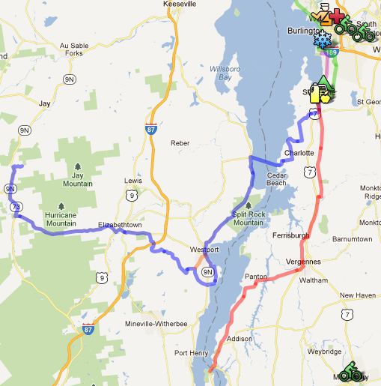
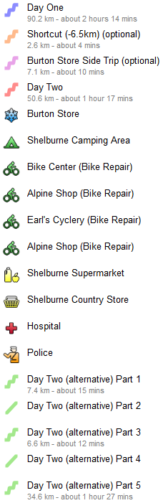

Route can be found on Google Maps at http://g.co/maps/eaakw.
Elevation Saturday Elevation Sunday
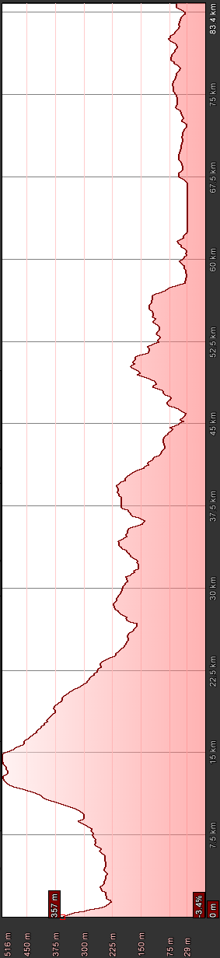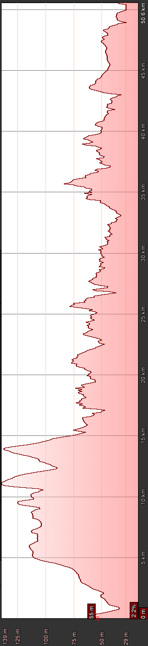
Directions to ACC Hut
From Ottawa, take Highway 417 east until exit 58 and turn right onto Highway 138 south to Cornwall and follow signs for Bridge to USA. Cross over the bridge (toll payment required), go through Customs, and take Highway 37 east to Malone. In Malone, Highway 37 changes to Highway 30 south to Paul Smiths. Take a left turn onto Highway 86 to Lake Placid. A short cut, bypassing Lake Placid, may be taken by turning right on County Road 35 (Old Military Road); then turning right on Highway 73 east. Otherwise, proceed into and through Lake Placid, turning right onto Highway 73 east. Keep on Highway 73 until Keene. In Keene, turn left onto 9N. Travel 5km and turn right on to Styles Brook Road. Go 1.5km up a hill to the small sign for the ACC Montreal Section. Turn left into the parking lot and hike up the hill to the hut. The path to the hut is at the far end of the parking lot, up through the trees. The path to the camping field is directly ahead of the driveway where it turns left into the parking lot; up a small hill.

Map to Lake Placid & ACC Hut
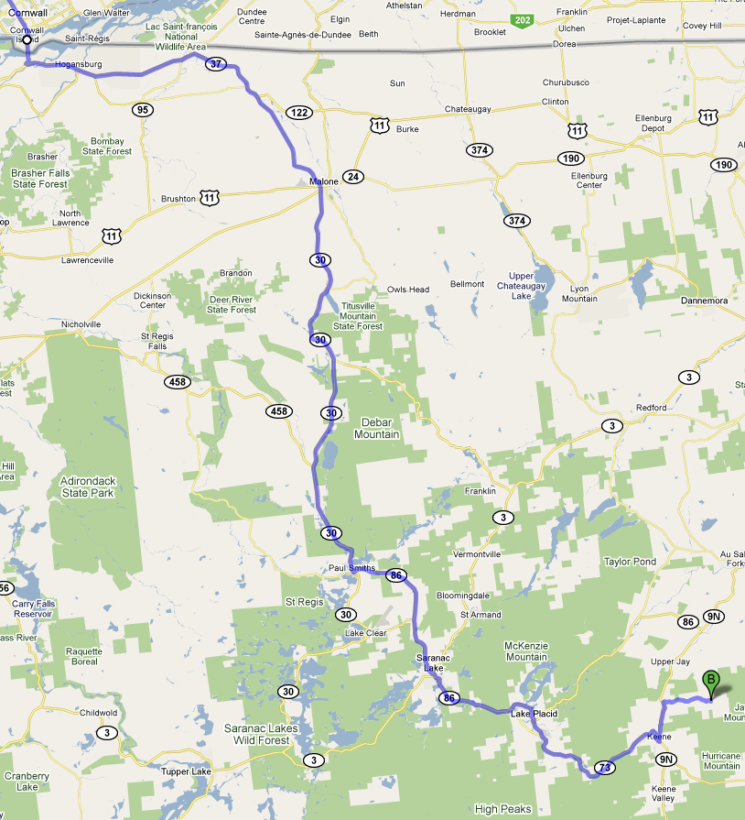
ACC Hut
Shortcut around Lake Placid
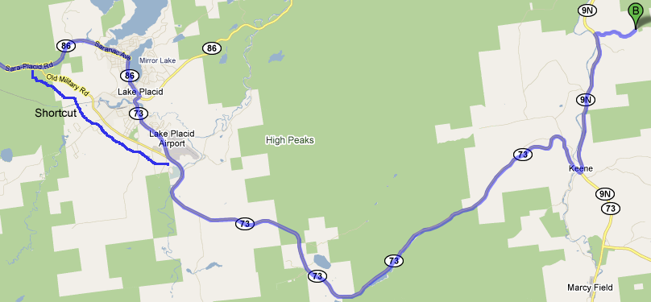

Map to Hut
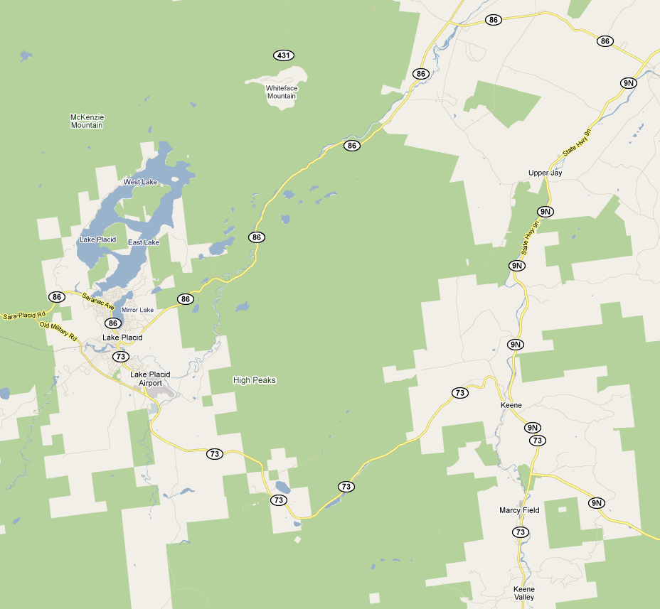
ACC Hut
Styles Brook Road
The Mountaineer
Adirondack Medical Centre
Shelburne Camping Area
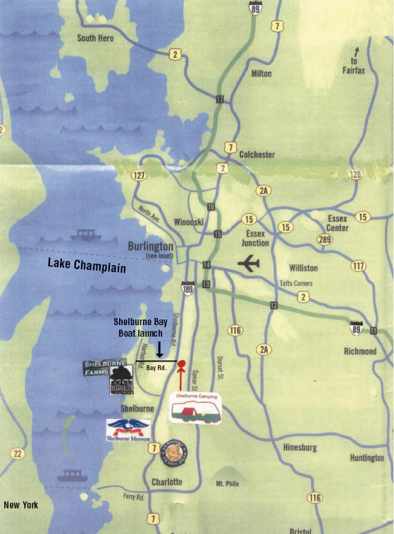

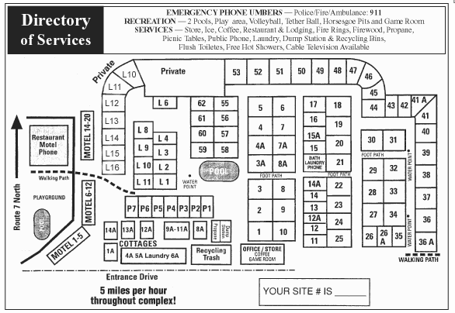

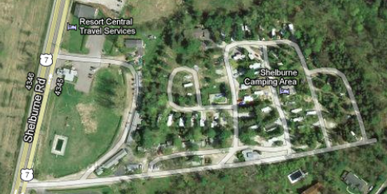
Shelburne Supermarket
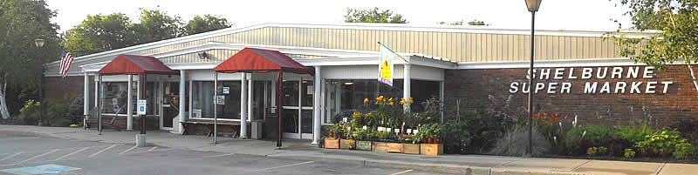

20 Shelburne Shopping Park
Shelburne, Vermont

Monday - Saturday: 8:00am - 8:00pm
Sunday: 8:00am - 7:00pm
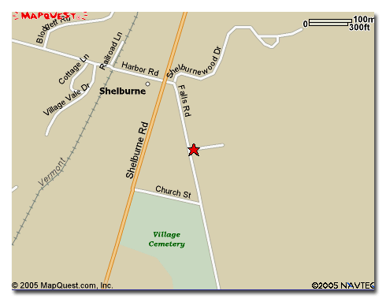
Ferry: Essex (NY) to Charlotte (VT)
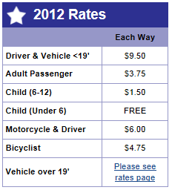
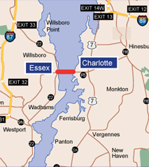

Crossing time is 25 minutes.

Fuel surcharge of 3.5%.

Charlotte, Vermont to Essex, New York
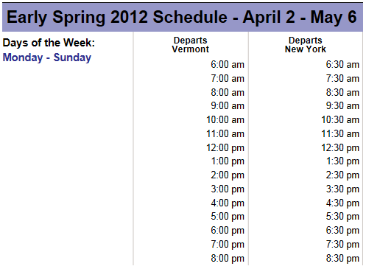

Ferry: Chimney Point (VT) to Crown Point (NY)
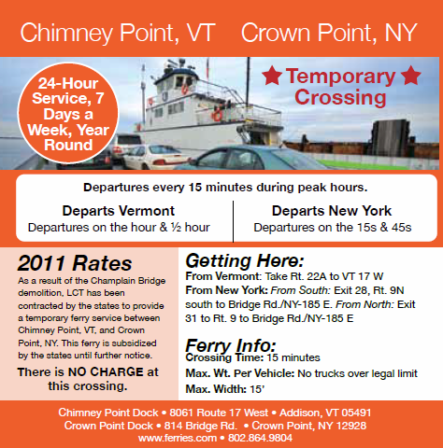

The Shelburne Country Store
29 Falls Road
Shelburne, Vermont

Open 9:00am - 6:00pm daily.



Cycling Speed
Saturday (85km) |  |  | Sunday (50km)
Actual Time (hours) | Calculated Speed (km/h) | Actual | Estimated Time Required (h) | Actual
1 | 85.0 |  | 0.6
1 ½ | 56.7 |  | 0.9
2 | 42.5 |  | 1.2
2 ½ | 34.0 |  | 1.5
3 | 28.3 |  | 1.8
3 ½ | 24.3 |  | 2.1
4 | 21.3 |  | 2.4
4 ½ | 18.9 |  | 2.6
5 | 17.0 |  | 2.9
5 ½ | 15.5 |  | 3.2
6 | 14.2 |  | 3.5
6 ½ | 13.1 |  | 3.8
7 | 12.1 |  | 4.1
7 ½ | 11.3 |  | 4.4
8 | 10.6 |  | 4.7
8 ½ | 10.0 |  | 5.0
9 | 9.4 |  | 5.3
9 1/2 | 8.9 |  | 5.6
10 | 8.5 |  | 5.9

Saturday
Depart Keene: ________
Short cut used? ________
Arrive Ferry: ________

Depart Ferry: ________

Arrive Grocery Store: ________

Depart Grocery Store: ________
Actual Cycling Time: ________
Arrive Campground: ________

Sunday
Depart Campground: ________ (necessary)

Depart Campground: ________ (actual)
Actual Cycling Time: ________
Arrive Ferry: ________

Use only actual cycling time in the Saturday time calculation.

Use Sunday estimated cycling time required to ensure departure is early enough, cycling speed is fast enough, and any stops are not too long. To ensure arrival at finish on time.
Shelburne Village
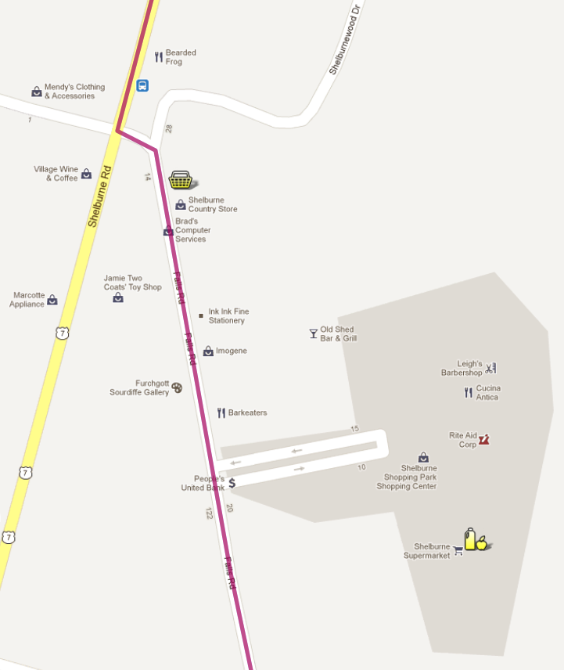
Burton Flagship Store
80 Industrial Parkway
Burlington, Vermont
05401
(802) 660-3200

7km from campground.

Monday - Saturday: 10:00am - 7:00pm
Sunday: 11:00am - 6:00pm
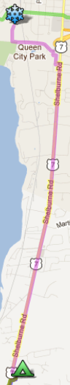

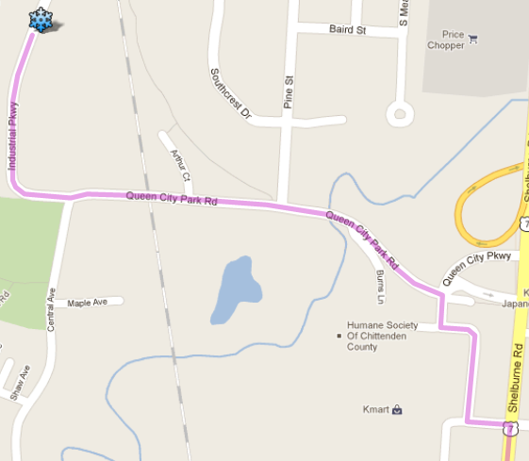

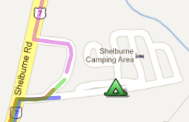

Hospital, Police Station, and Bicycle Repair Shops
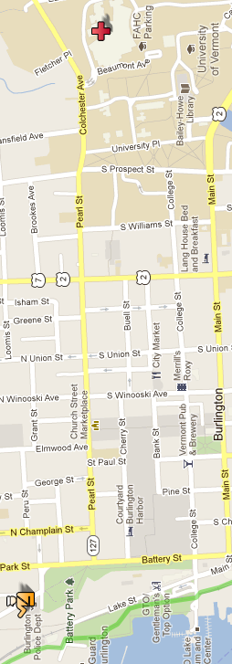
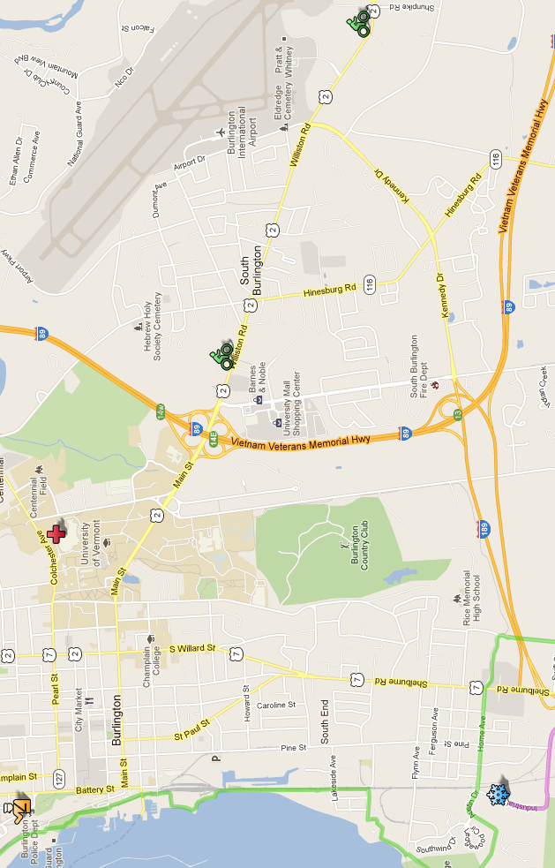
To Campground
To Campground
Large Scale Map, Sheet #1
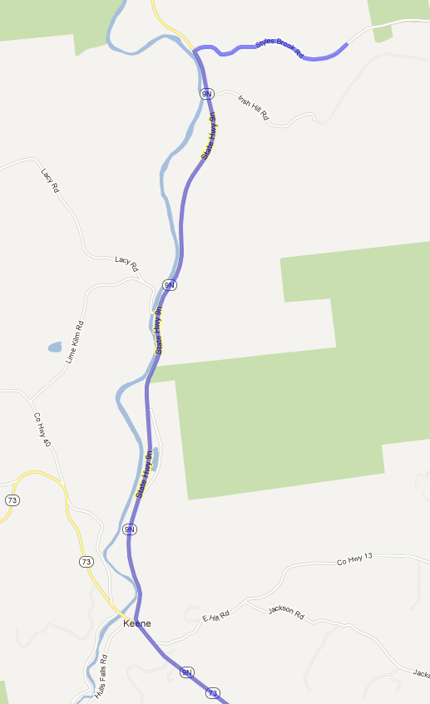
Start
Large Scale Map, Sheet #2
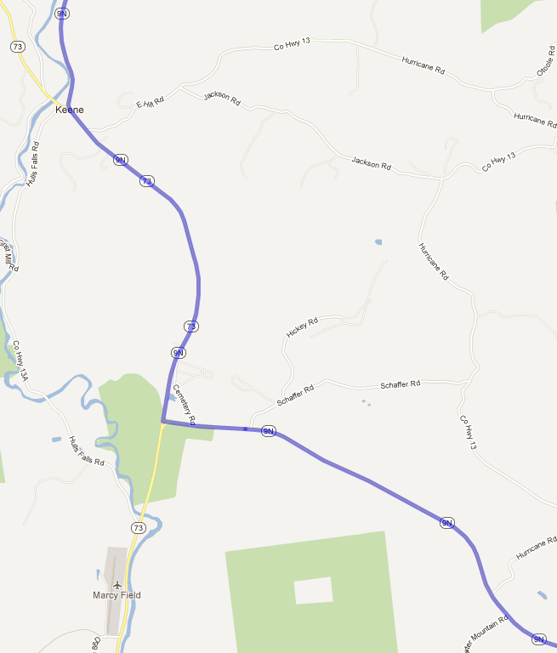

Large Scale Map, Sheet #3
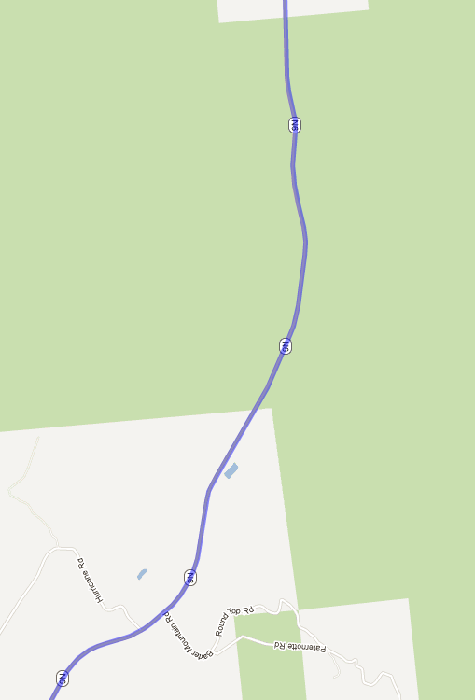

Large Scale Map, Sheet #4
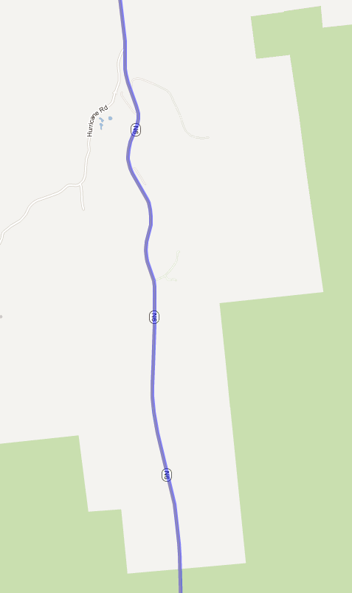
Large Scale Map, Sheet #5
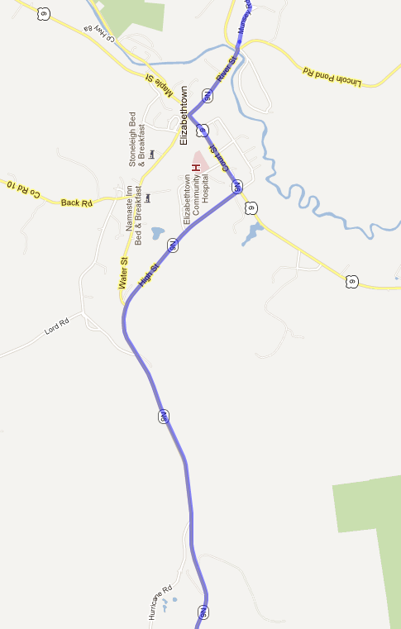

Large Scale Map, Sheet #6
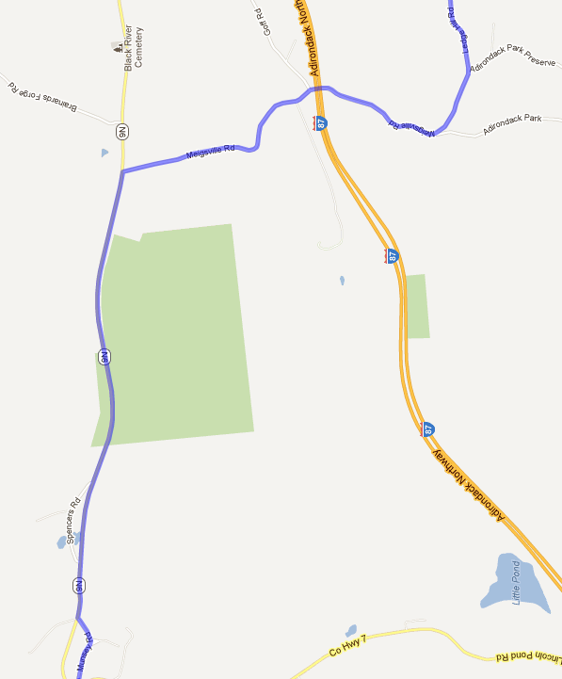
Large Scale Map, Sheet #7
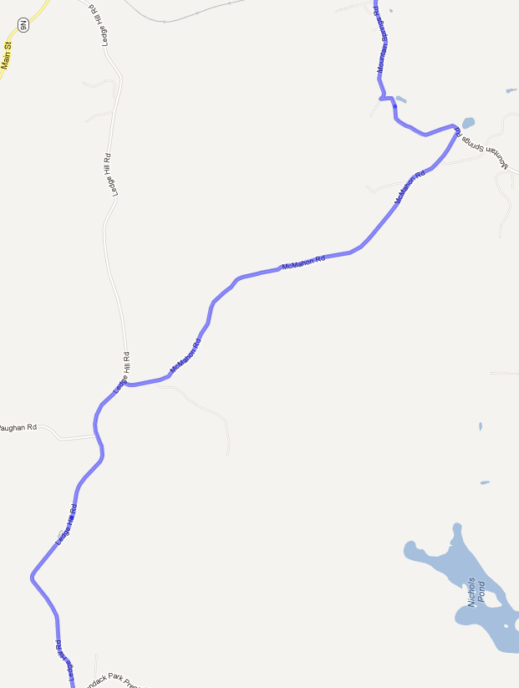
Large Scale Map, Sheet #8
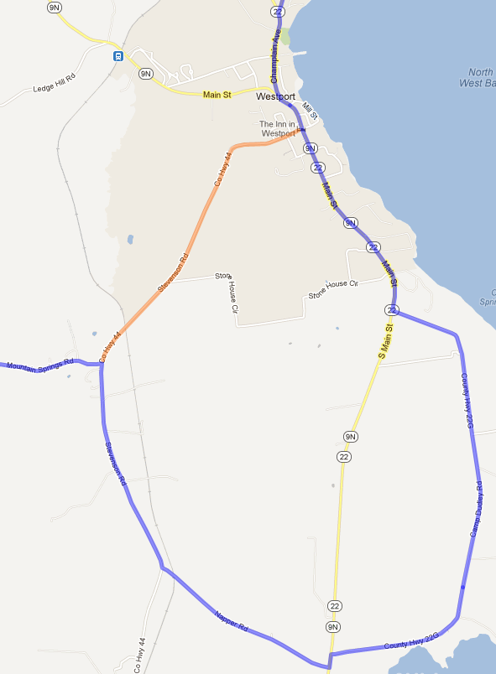
Optional Shortcut
6.5km route reduction
Large Scale Map, Sheet #9
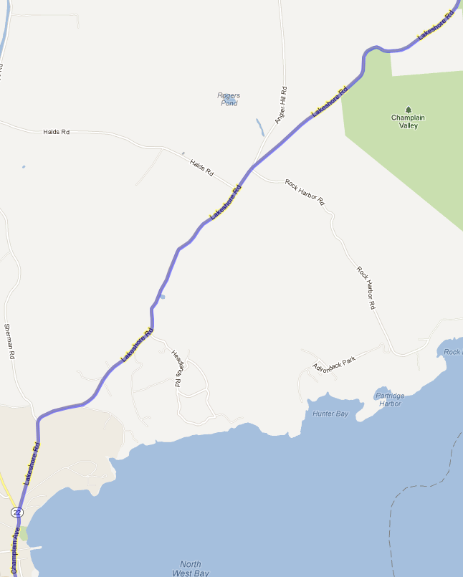
Large Scale Map, Sheet #10
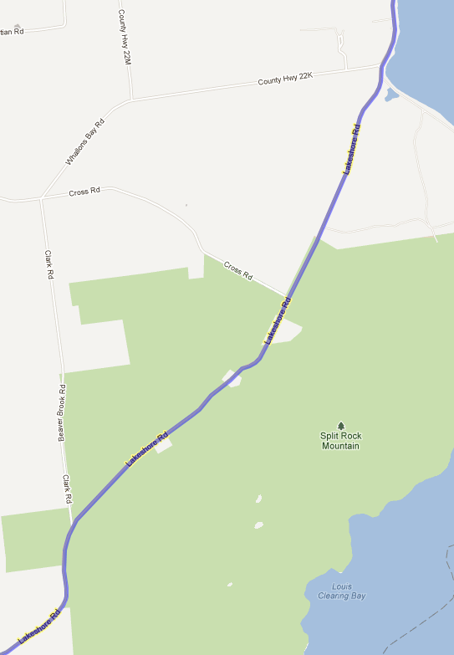
Large Scale Map, Sheet #11
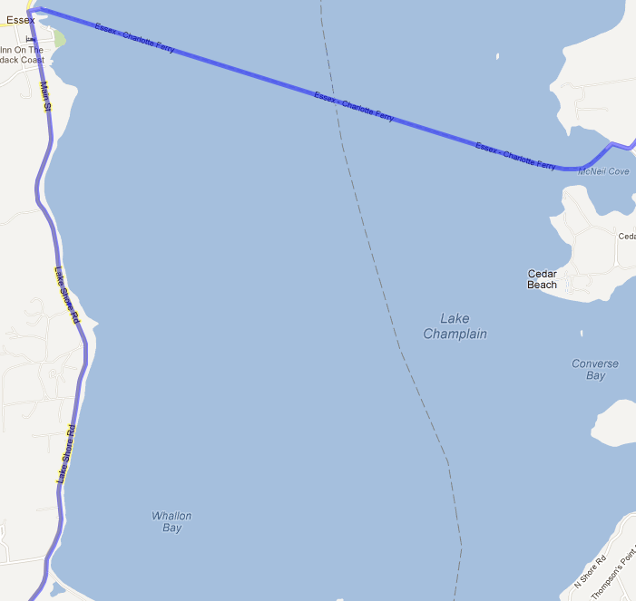

Large Scale Map, Sheet #12
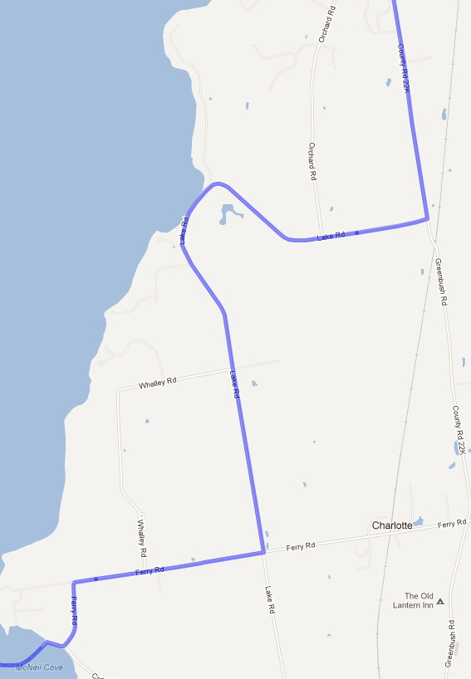

Large Scale Map, Sheet #13
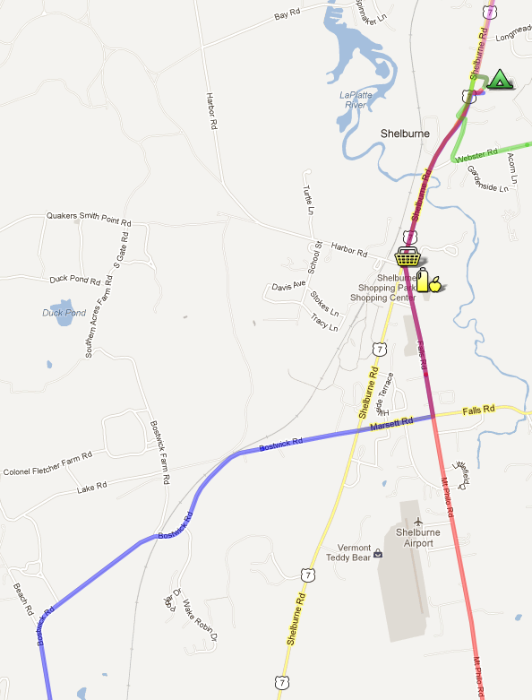
Large Scale Map, Sheet #14
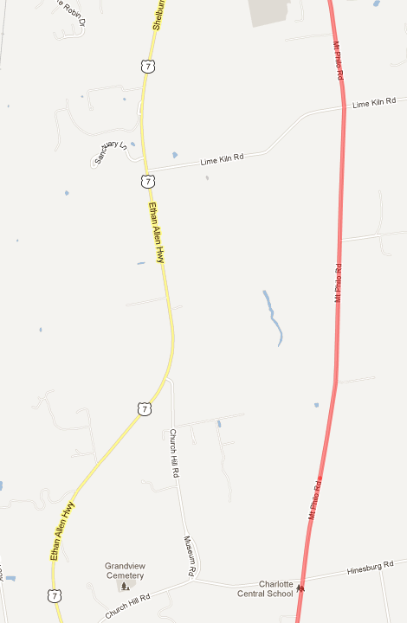
Large Scale Map, Sheet #15
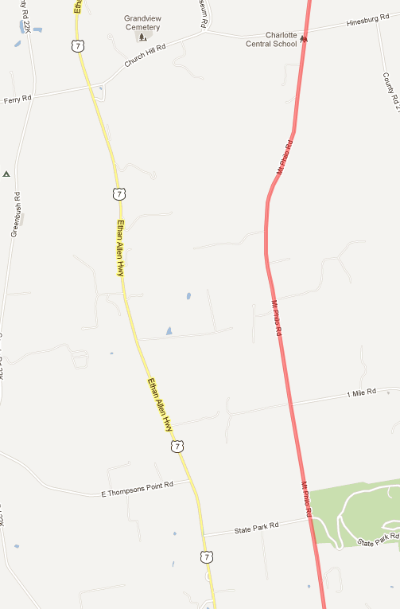
Large Scale Map, Sheet #16
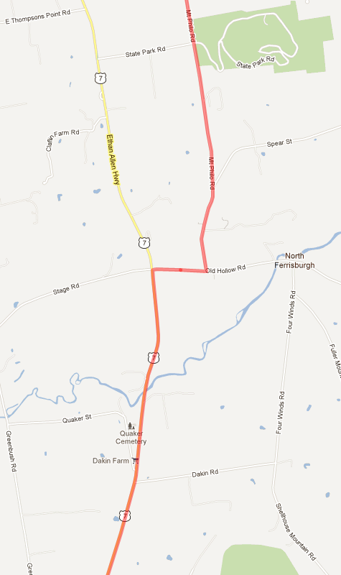
Large Scale Map, Sheet #17
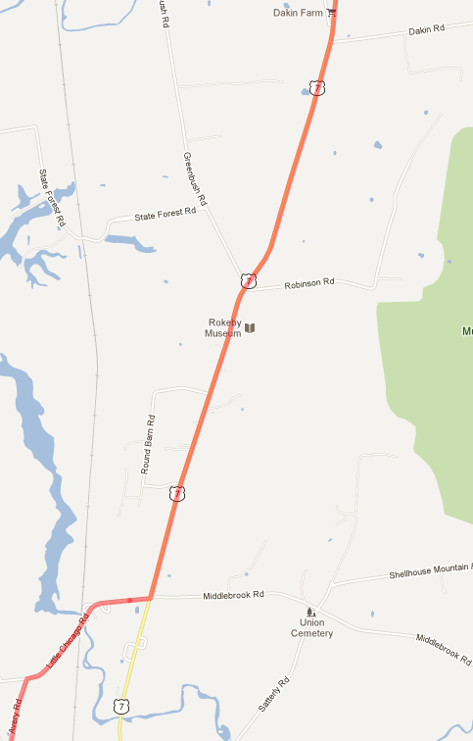
Large Scale Map, Sheet #18
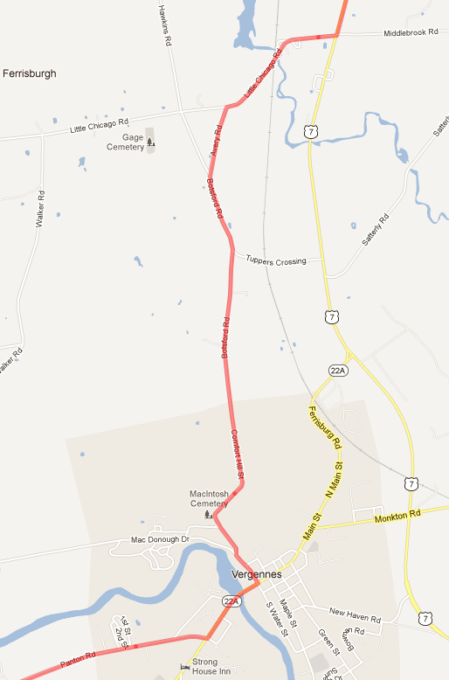
Large Scale Map, Sheet #19
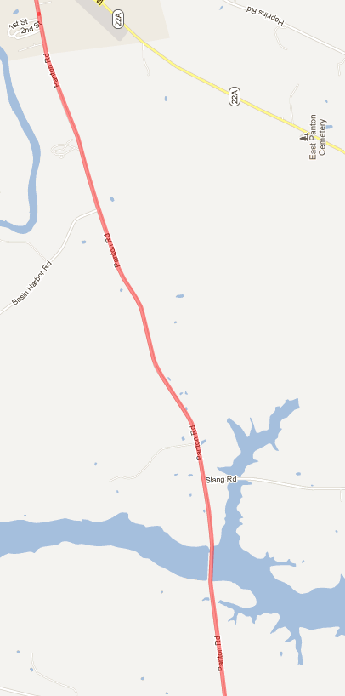
Large Scale Map, Sheet #20
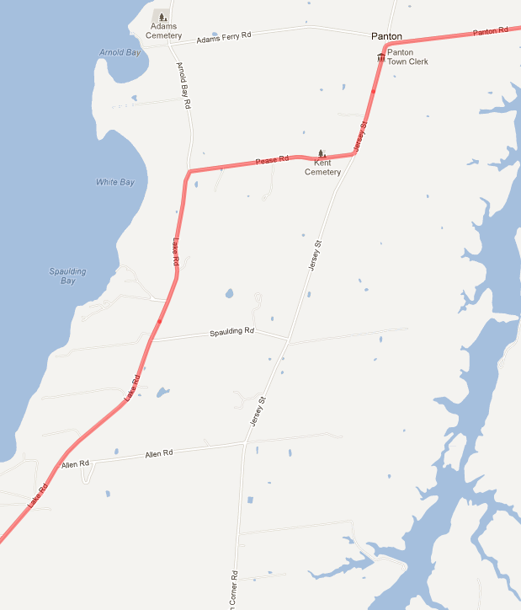
Large Scale Map, Sheet #21
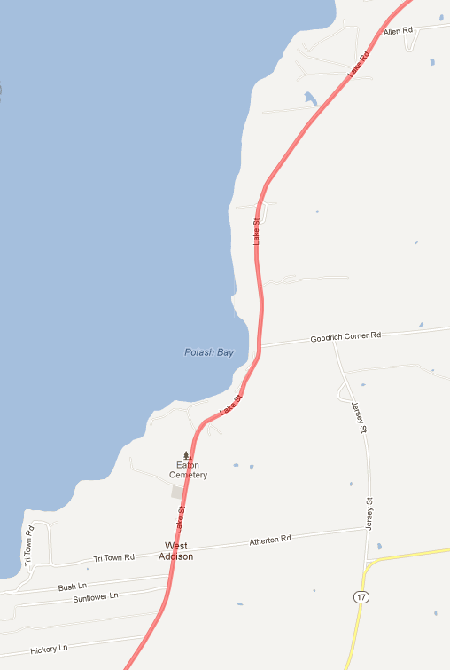
Large Scale Map, Sheet #22
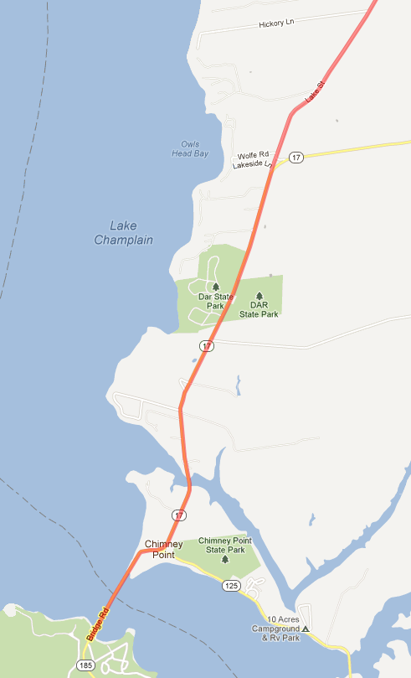
Finish
Report
I would consider this trip to be a successful failure. For those of you who are not Apollo fans, that was the term NASA used to describe the Apollo 13 mission. While we didn’t get everybody around the tour, we did get everybody safely home. All the Venturers were challenged both physically and mentally; a wee bit more than anybody had planned. They said the Saturday ride was the absolute hardest thing they had ever done. Within a week or so, they will have forgotten the pain, and will be very proud of their achievement, Stew and I certainly are.

I just found that Google Earth will give elevation profiles based on the route plotted in Google Maps (http://g.co/maps/t4pye), so we get the following details on the route taken. This would have been quite handy before the trip :)

Route Statistics
 |  | Elevation |  | Max Slope |  | Avg Slope |  | Planned | Actual
Day | Distance | Gain | Loss | Up | Down | Up | Down | Time | Time | Avg Speed
Saturday | 79 km | 1,046m | 1,347m | 10.8% | 14.1% | 2.4% | 2.7% | 6 hours | 9 ½ hours | 8 km/hour
Sunday | 51 km | 630m | 650m | 12.8% | 8.3% | 1.9% | 2.1% | 4 hours | 4 ½ hours | 11 km/hour

Saturday was actually 8 ½ hours of bicycling, as 1 hour was taken up dealing with Laura’s roll. Thus gives an average speed of 9 km/hour.

Bicycle Timing
Day | Location / Activity | Arrive | Depart
Saturday | ACC Hut |  | 10:00am
 | ACC Hut hill after Laura’s roll |  | 11:00am
 | Charlotte for Ferry | 2:30pm | 2:30pm
 | Shelburne Supermarket | 7:30pm
 | Shelburne Camping Area | 8:00pm
Sunday | Shelburne Camping Area |  | 8:45am
 | Crown Point | 1:15pm
 | Leader’s arrive | 2:15pm
 | Everybody depart |  | 3:00pm

Friday started off fine with Stew picking up the rental bicycles and panniers in Picton (Prince Edward County) at the Bloomfield bicycle shop. The bikes looked nice, though Sam figured he got stuck with worst colour, poor baby. The bikes has been preset by the shop to match the Venturers height & inseam, and labeled. The Ventures started showing up at 5:00pm. Calvin remembered to show up this time, but Lochlan forgot his bike again :) Luckily he didn’t need it this time :) We then went to pick up Nick; but he didn’t have a bike helmet! Why didn’t he say something earlier, as the bike shop hand them out free with the rentals if needed! So back into Merrickville to grab one of the extra helmets at Sam’s house (regular bike paradise that place).

Crossed the border fine at Cornwall ($5 bridge toll due to third axle!), with all the permission slips examined in details, into the Indian reservation and then things started going downhill. The transmission in the truck started acting up, and then it went completely :( We pulled over to the side of the road, and luckily Stew noticed we had stopped and he pulled over about a kilometer in front of us. Laura and Aidan set off jogging to fetch him back. This was 8:00pm. Before he arrived back, a tribal police car stopped to see if we needed help. The police officer had a look at the engine and diagnosed a burst automatic transmission hose from the transmission cooler. All the ATF fluid had been dumped on the road. We were directed across the road to a gas station parking lot, and the police ordered a tow for us.

There were several options at this point: Call home to be picked up (we were about 1 ½ hours from Merrickville), get a tow from Merrickville, take a motel for the night (there was one just up the road), or try to get to Keene and save the trip. We decided to go for the last option, as we had all the bikes and thus couldn’t recover any expenses, and it would be a pity to spoil all the preparations (it took a lot of effort just to get to this point).

We were near a pizza place, but the police office said it was really sketchy, and to definitely not go into the bar area. So Stew to Mary Lou up the road to Subway for supper. The police eventually left us, but gave us the dispatch telephone number in case the tow truck didn’t arrive. Well, after calling every half hour for the next two hours, at 10:00pm the tow truck finally showed up; with the sign ‘One Call Does it All!!’ on the side! We explained our predicament, weekend plans, and desires. It turned out his sons are in Scouts and one of the one of the police dispatchers is a Scout Master! The tow truck operator is also a mechanic, so he said he would tow the truck and cargo trailer (he brought a flatbed) to Keene, bring the truck back to his shop in Malone, and then try and get it fixed for us on Saturday. What am amazingly nice guy!

The ride to Keene was an experience in itself. There was five of us in the tow truck (all with seat belts) and two in Stew’s van. The van had it nice, but in the truck the heat was stifling and country music to boot! It is normally a 1 ½ hour drive to Keene from there, but it took us three hours. We arrived at the ACC hut at 1:00am. The Venturers had been calculating during the drive how hours of sleep they would get (not many is the answer :)). Stew went off to his bed & breakfast and we crept into the hut. To keep the disturbance to the minimum, four of the lads slept on the padded benches around the wood stove in the living room. The other three of us found mattresses in the main sleeping loft.

It took me a while to get to sleep, a lot of adrenaline running around in my system I think. But I awoke by 7am. I let the Venturers sleep until 7:30am, as that was the planned rise time, and I figured they would need as much sleep as possible (little did I know...). Good breakfast and they made themselves wraps for lunch. Stew showed up bright eyed and bushy tailed at 8:30am and we started the bike packing. All the personal and group gear packed into the two panniers and on the back rack much easier than we thought it would. Though bungeeing on Lochlan’s suitcase was a little tricky! A little MacGyver work got Sam’s handle bar bag attached.

A little test ride around the parking lot had Aidan’s chain falling off a lot; once he had figured out toe clips that is :) One of the gears was bent, and a little bit of work with pliers seemed to address that. Nick complained his front/rear brakes were swapped, but there was no time to play with that. At 10:00am, one hour behind schedule, they were ready to go. Off they went, around the corner, out of sight, out of mind... or so we thought...

15 seconds down the steep hill leading from the hut, they encountered what is termed “speed wobble”. As they picked up speed, some of the bikes started rapidly swaying and the front wheel vibrating back and forth. It turns out this is quite common with loaded bikes, but was not something we had come across in all our due diligence research. Laura lost control at this point and went head over heels, bike and all. Stew was driving back to his inn at this point, and came across the Venturers on the side of the road. Laura was patched up and she tried again, but had lost confidence and was a little shocky. So all the group gear she was carrying was transferred to the other bikes, and Stew brought her back to me at the hut.

During the repair work on Laura, it was believed that there was no medical tape in the first aid kit they were carrying. So Stew drove back to the hut and retrieved the tape from our expedition first aid kit. Upon reviewing the first aid kit upon our return, I found there was tape present (I last used it to bandage a puncture in Lochlan’s leg when he slipped on an apple :)). This underscores the importance of reviewing the first aid kit before a trip. We do this as a matter of standard practice with our expedition kit before our canoe trips, but did not do it for this small kit of Allan’s before this trip. The small kit was used to minimise the weight carried.

The remaining Venturers carried on, taking the shortcut on the route (knocking 6.5km off). They reached the ferry bang on the half hour, and thus didn’t have to wait for the crossing. No problem purchasing the tickets. At the bottom of a number of the hills they found the chains coming off the bikes. Aidan tells of a “near death experience” with speed wobble while bombing one hill! He’s now a born again Christian and plans to attend church every week :) They reached the grocery store at 7:30pm.

Remember the saying about never go grocery shopping when you are hungry? Well the Venturers were starving when they entered the supermarket, and it shows. They first purchased a few bars to keep themselves alive while shopping. Sam and Calvin continued on to the campground, 1km up the road, to empty their panniers to make room for the groceries, and then returned. They couldn’t find hamburger patties, so just got ground beef and made patties with that (just that!). Sausages for breakfast. The only real waste was the discarded condiments. More thought should go into efficient and cost effective meals for future trips. Scan of the receipt included below as Cheryl got such a kick out of it, so other mothers might as well. We hadn’t had a discussion with respect to a food budget during the route, but we need to for next time... They did actually eat quite healthy, including $30 worth of fresh organic berries! The lights were being turned off for the night in the store as they finished their shopping.

They arrived at the campsite at 8:00pm, and not surprisingly the office was closed. So they just grabbed the first site that took their fancy. They managed to find some firewood and had a campfire. The stove, an MSR Dragonfly, was taking too long to fry the hamburgers, so they used fire (lucky they had an old beat up one; they couldn’t have done that with our good pots). They visited the office in the morning and paid. A table in the trip plan allowed them to calculate the necessary departure time in the morning, based on their speed today. They had been so slow, they were almost off the bottom of the table :)

The Sunday route went fine, with the Venturers stopping for pizza along the way, and arriving at the pickup at 1:15pm, well ahead of the 2:00pm schedule. The websites and ferry schedule we examined showed a temporary ferry at the finish, but the replacement bridge had actually been in place for at least a year! The Venturers did say that the scenery was very beautiful throughout the route, and they loved the camel they saw guarding sheep.

Stew and Allan arrived at the Crown Point finish at 2:15pm. It took us longer than we thought it would to drive from Keene (45 minutes). The Venturers were sprawled out on a grassy hill; we didn’t even see them initially. That is, all except Nick who was curled up in a sunny corner fast asleep. The panniers were all emptied and the bicycles and gear loaded into the cargo trailer for the trip home. Unfortunately Sam left his father’s toolkit in the saddle bag, and it wasn’t noticed until after the bikes had been dropped back off Picton. We’ll have to go pick it up or get it shipped back.
However, the lads couldn’t wait to tell us about Saturday. It turned out that a combination of not enough food, food not spread out over the day, too many hills, bikes heavy with panniers, not used to bicycling with a loaded bike, and a long route made the day extremely long and challenging. They said it was the most mentally and physically challenging thing they had ever done, and had been pushed way beyond where they thought their limits were. They had to walk up a number of the hills. They considered stopping multiple times, and just camping by the side of the road, but they had no food and took the route page by page and made it through. They said if we had showed up at the campsite, they wouldn’t have had very many nice things to say :) i.e. they would have killed us! Sunday was much more enjoyable, although a number of them were very saddle sore. Also by that time, they were getting used to bicycling with panniers. No hills had to be walked on Sunday.

The Venturers wrote down a few more comments on things they learnt:

- Electrolytes helped a lot on Sunday.
- Cliff bars were a good choice.
- Alternative campsites should have been found ahead of time and placed on the map.
- Later in the season next time, so it would be a little warmer overnight.
- Shopping worked well.
- Good location for bicycling. Paved shoulders everywhere, sometimes even wider than the car lane, and little traffic.
- Hills should be taken into account on the route.
- Smaller snacks rather than one large meal for lunch.

They didn’t get receipts for all their expenses, but that hadn’t been discussed ahead of time. Out of the US$400 they had with them, they spent $178 on food, camping, and the ferry.

Weather in April is always hit and miss. We had good luck last year, and again this year. While the forecast for Sunday kept alternating between sun and 20mm of rain, we ended up with sun and warmth. It was a little chilly overnight, just below freezing, but nothing to write home about. In fact, the Venturers said they were glad it wasn’t really hot, or Saturday would have been an even worse killer.

On Saturday at about 2:00pm, Stew received a call from our friendly mechanic, indicating that the truck had been fixed. Stew picked Allan up at the ACC hut, and we drove 1 ½ hours back to Malone. We picked up the truck and returned to Keene with both vehicles. The tow truck operator had arrived back in Malone between 3:00am and 4:00am, and was awake at 6:00am! The blown hose/pipe had been temporarily fixed, but the transmission was not in good shape. It was reluctant to get into 3rd gear, and wouldn’t go into 4th. But 3rd gear seemed solid once it was in, so we should be good for the trip home. Maximum speed in that gear is ~100km/hour. Stew got the home address of the mechanic / tow operator, and we will get the Venturers to at least send him a thank you card, and we may send him a little gift as well; he really went above and beyond for us.

We stopped at The Mountaineer in Keene Valley, arriving at 3:30pm, to allow the Venturers to purchase hiking boots for Europe. The reason for stopping here was that from talking with the staff, I had a real warm fuzzy feeling that they would fit the boots well. The owner had also hiked the Tour du Mont Blanc a couple of years ago, and thus knew which boots would be most appropriate. They gave us a 10% discount and then no HST! Total purchase was: 8 x boots, 1 x rucksack, 4 x socks, 1 x rain jacket, and 1 x rain pants. They also threw in a Mountaineer bandana for each of us, just requesting a photo of us in the alps for their website. Lochlan had left his jacket in the ACC hut on Saturday morning (silly boy!), so Stew went to fetch this while the rest of us did the boot fitting.

Then off to the ADK Café in Keen for supper at 4:30pm. We went here during our ice climbing trip, based on a recommendation from the Mountaineer, and the food is absolutely delicious! They didn’t disappoint us this time. Meat loaf, chicken pot pie, lasagna, and Lochlan’s half chicken with macaroni and cheese (that was some pile of food!). Departed 6:00pm, for the drive home. I would have thought everyone would go straight to sleep, but they chattered like magpies all the way back. Aidan dropped off at Highway 416 and Oxford Station Road at 9:15pm. Nick and Calvin dropped off at home, and finally Sam at 9:55pm. Each Venturer took a portion of a tent home for cleaning and drying.

Stew and Allan had interesting drives through the Adirondacks and on paved county roads through New York state via Potsdam on the way back to the border crossing at Johnstown, following the fastest routes chosen by the GPS. The one through the Adirondacks back to Keene Valley from Lake Champlain was a slalom course.

Stew, bless his heart, returned the bicycles on Monday to Picton.

Photos can be found at http://1stmerrickville.ca/venturers/pictures/2011/2012-04-27/index.htm. The Venturers took quite a few during the route, but didn’t get any of the campsite!

Certainly a trip to remember :) Definitely educational for the Venturers, and that’s what matters.


