Event
This is an adventure race for Venturers and Rovers, comprising hiking, mountain biking, canoeing, rappelling, and an aerial runway. Competition will be between teams of 3-6 individuals. Rock climbing and crate stacking will be offered as separate activities after the completion of the race. A communal supper will be served. This is a single day event on the Saturday, but camping will be available on the Friday and Saturday nights.

Date
Saturday October 4th, 2008

Race Start
Drop your team(s) for hiking at 369 Wolford Centre Road. You may drive down the laneway and utilise the turning loop. This property is owned by the Merrickville group treasurer. You must arrive at least 10 minutes prior to your team’s designated start time; if you miss your start time you will be bumped to the end of the list. Teams will be given maps and instructions for the route. Your exact start time will be sent to you the week before the race.

Race Finish
The race finishes at the boat launch ramp at the westerly end of the Lion’s Club campground in Merrickville.

Race Equipment Switchovers
Upon arrival at the race start, support vehicles will be given full details of the locations where bicycles and canoes need to be pre-positioned.

First Aid
Each team is required to have a first aid kit with them at all times. Qualified first aid personal will be located at the rappelling site and the finish. The course is within civilisation so houses are generally within a half hour walk of the route. St. John Ambulance volunteers, and their equipment, will be located at the main camp. The closest hospital is the Kemptville District Hospital at 2675 Concession Road, Kemptville, (613) 258-6133.

Inclement Weather
The event will proceed rain or shine. The rock climbing and rappelling may be cancelled if safety is compromised. Since the river is narrow, canoes may be pulled to the side in the event of lightning. A shelter will be available for the dining area in the Lion’s Club campground.

Crate Stacking
Crate stacking is an activity imported from the UK by the Merrickville Scout group. It is an enjoyable pastime for Cubs through Venturers (and even adults!). This, and the rock climbing, is intended as filler between finishing the race and the serving of supper.
The objective is to make a stack of milk crates as high as possible. The crates are stacked in a single or double column. One person is designated the climber and has to keep climbing up the stack to place the next crate as the tower gets higher. The climber wears a climbing harness with a rope up and over an anchor on a tree branch and held by a belayer. Another person is designated the helper and passes crates up to the climber, using a pole when necessary. Eventually the tower falls over and the climber is left suspended in mid air and is lowered to the ground.
Helmets must be worn by the climber, the helper, and the belayer. All safety equipment will be provided. Those Venturers trained in belaying, typically from VenClimb, will provide the belaying function. The maximum height reached is usually about 10-15’. The harness is worn backwards so the rope is not in the way.

For further information and photos, see: http://www.1stmerrickville.ca/events/crate_stacking/

Rappelling
The rappelling (abseiling) activity will take place in a local quarry. The rock face is 30’ high and solid with a large flat area at the top for operations. A safety belay, from the top, will be used. Participants will control their descent speed using a figure eight descender. A helmet must be worn; either their bicycle helmet or a provided climbing helmet is acceptable. All equipment will be provided. Qualified personal will be supervising this activity.

Aerial Runway
An aerial runway will be available at the rappelling site. The design is one successfully used by the Merrickville group at the Whispering Pines Scout camp twice before. It is based on a 3/8” stainless steel aircraft cable and an industrial pulley. Two braking systems are used, an initial bungee cord and secondary rope brake. The construction practices of the UK Scout Association’s Aerial Runway Fact Sheet (FS120006) are followed. The participant sits on a bosun’s chair with a climbing harness secured as a backup. Climbing grade equipment and practices are used throughout.

For further information and photos, see: http://www.1stmerrickville.ca/events/aerial_runway/

Rock Climbing
The Scouts Canada Quebec Council climbing wall is being brought in for the camp. The race participants will have exclusive use of this from 4:00pm to 6:00pm. It will be located at the main camp (a five minute walk from the Venturer camp). Belaying services and climbing harnesses will be provided.

Supper
Supper will include drinks, main course, and dessert. The intention of the meal is to be nut free, but no guarantees will be made. The packages will be kept where possible so the kids can examine them.

Camping
Camping will be available at the Lion’s Club campground for no extra charge. Water will be available from the Legion adjacent to the campground on the Saturday. A porta-potti will be present. Both water and washrooms will also be available at the main camp in the fairgrounds (a 5 minute walk). Fires are allowed, however there is limited firewood available onsite. There are numerous trees for the attachment of tarps in the case of inclement weather. Picnic tables are available.

Contact
Allan Yates
205 Wolford Drive
Merrickville, Ontario
K0G 1N0
(613) 269-3074 (Home)
(613) 599-2148 (Work)
(613) 222-7469 (Mobile)
allan@yates.ca

Centenary Camp Activities
Youth and leaders are welcome to wander around the rest of the camp and investigate the various activities. If an activity is not currently being used by the Beavers/Cubs/Scouts, then the Venturers and their leaders are welcome to try things out. Groups camping over Saturday night are welcome to participate in the main campfire. On Sunday morning there will be a parade through the village, a Scouts Own, and the camp closing ceremonies. Full uniform is required for the Sunday activities. After the closing, Venturers are more than welcome to help in the tear down of the main camp.
Schedule
8:30am - 11:30am
Teams will be started every 10 minutes.

2:00pm
First team should finish about now.

4:00pm
Last time should finish about now.

4:00pm - 6:00pm
Climbing tower available for exclusive use by race participants.

6:30pm
Supper served

7:00pm
Winner announced

Team Kit List

General
Clothing for each team member suitable for forecast weather conditions
First aid kit
Water bottle (filling available at rappelling and canoeing start)
Lunch
Snacks
Sunscreen
Insect repellant
Plate, mug, knife, fork, spoon for supper

Hiking
Hiking boots or sturdy footwear (recommended)
Compass (required)
Whistle (required)

Mountain Biking
Mountain bike (front shocks and wide knobbly tyres recommended)
Puncture repair kit (optional)
Tyre pump (optional)
Bicycle helmet (required for those under the age of 18)

Canoeing
Personal Floatation Device (PFD) or Life Jacket, one per person
Paddle, one per person
Bailer, one per canoe
Painter or grab loop, one per canoe
Floating throw rope, one per canoe
Canoe, one per 2-4 people

Rappelling
All required equipment and instruction will be provided. You may bring your own equipment if desired.

Climbing
All required equipment and instruction will be provided.

Crate Stacking
All required equipment will be provided

Upon arrival at the finish, teams may wish to have dry clothing and footwear available.

All teams need to know how to follow a compass bearing!

Teams will not be allowed to start without a compass and a whistle!
Support Vehicle Instructions

Drop your team(s) for hiking at 369 Wolford Centre Road. They require a compass and a whistle. You may drive down the laneway and utilise the turning loop. This property is owned by the Merrickville group treasurer. You must arrive at least 20 minutes prior to your team’s designated start time. If you miss your start time, you may be bumped to the end of the list.

Drop your team’s mountain bikes at the bottom corner of Kerford Road, a dirt road goes off at this corner. Your team will be at this location approximately 1 1/2 hours after they start hiking.

You may enter the quarry (at 328 Carleys Corners Road) to observe the rappelling and aerial runway, but please keep to the marked trails. Support vehicles are not permitted in the quarry.

Drop canoes and pickup mountain bikes next to 669 County Road 23, this is the Lower Nicholson’s locks. There is a large parking area at the top. A road leads down to the river, but vehicles are not permitted. Your team will be at this location approximately 1 1/2 hours after they depart the rappelling.

Meet team at finish at the Lion’s Club campground. You may drive into the campground to pickup the canoes at the far end; there is a turning loop.

Map of Race Start
Race Start
369 Wolford Centre Road
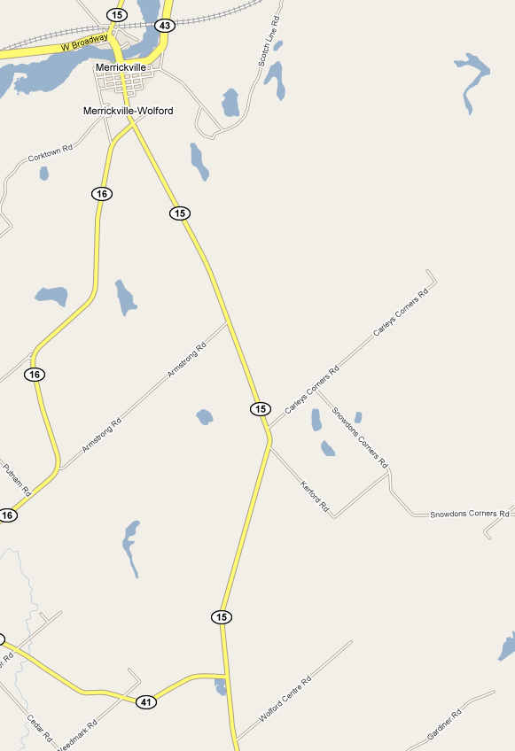
Bicycle Drop Off
Rappelling
Aerial runway
328 Carleys Corners Road

Map of Race Finish (Village of Merrickville)
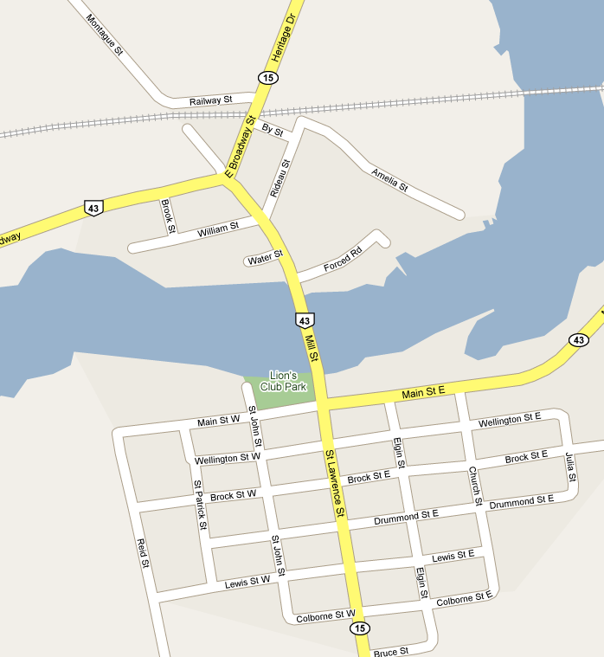
Race Finish
Fair Grounds
Rock Climbing
Centenary Camp
Lion’s Club Campground Entrance

Map of Bicycle/Canoe Switch
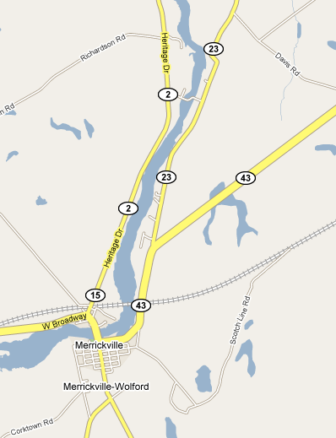
Canoe Drop Off
Bicycle Pickup
669 County Road 23 (Burritts Rapids Road)
Race Finish
Lion’s Club Campground
Maps to Merrickville
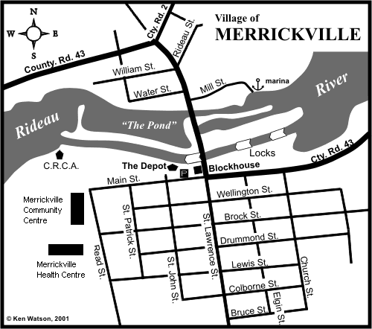

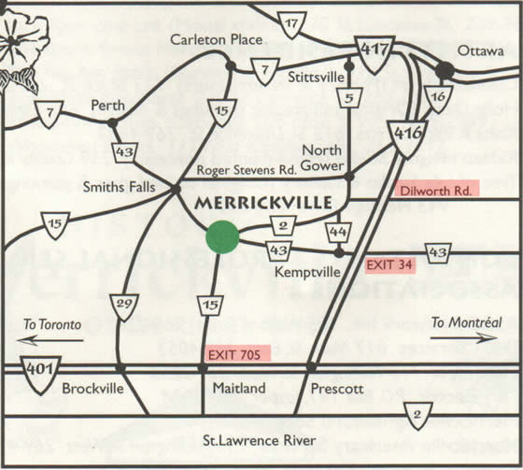
Crate Stacking
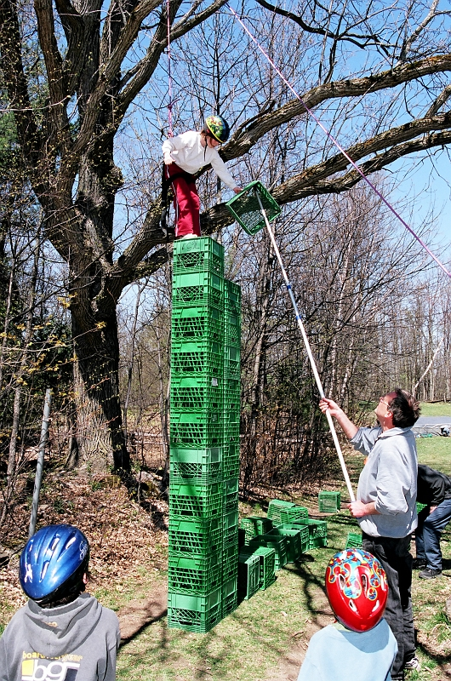

Crate Stacking
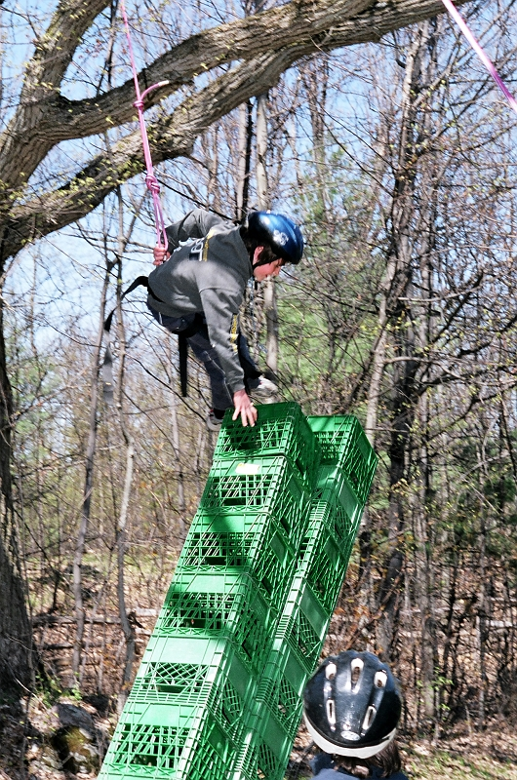

Aerial Runway
Showing secondary brake rope in the foreground, bosun’s chair, safety harness, “A” frame, and primary brake rope going back up the hill.


