Overview
Weekend backpacking trip in Frontenac Provincial Park. The Venturers will be doing the trip without leaders present.

Schedule
Friday November 16th
- Arrive at Frontenac Provincial Park at approximately 8:00pm. It is a 2 ½ hour drive from Merrickville.
- Camp in picnic area outside park office. Campfire not allowed. Running water not available.

Saturday November 17th
- Dismantle tents no later than 8:30am.
- Check in at the park office and place the campsites in the name of one of the Venturers (aged at least 16).
- Weigh rucksacks.
- Depart from park office no later than 10:00am.
- Hike approximately 5-6 hours to campsite; ~13km.
- Camp for the night.

Sunday November 18th
- Depart from campsite no later than 10:00am.
- Hike approximately 4-5 hours to park office; ~11km.
- Arrive at park office approximately 3:00pm

Route
The hiking route starts at the park office. Big Salmon Lake Road is closed at this point in the season. The route continues along the shore of Big Salmon Lake, turning south shortly after campsite #4, and stopping at campsite #1. The return route continues, passing by campsite #2, and ending at the park office.

Transportation
Parents will be responsible for driving their kids to and from the park.

Sleeping Arrangements
The four lads will be sharing a single tent and Laura will be in a bivi sack.

Equipment Packing
- Common equipment will be divided amongst the Venturers.
- Jam will be repackaged from glass jar into a plastic container (not a squeeze tube).
- Excess food on Saturday morning will be cached or left at the park office.
- Rucksacks expected to weigh 30-40 lbs.

Participants
Name | First Aid | Command
Catton, Sam |  | 2 IC
Gale, Calvin | Standard | 1 IC
Savage, Lochlan
Yates, Laura | Advanced Wilderness

Tasks
- Take many photos.
- Record departure and arrival times each day.

Risk Management
- Laura and Calvin have current first aid certification.
- Emergency supplies are cached throughout the park in 55 gallon steel barrels; shown as first aid signs on map.
- A SPOT satellite transceiver will be carried by the Venturers. They will check-in at: Saturday departure, Saturday lunch, campsite arrival, Sunday departure, Sunday lunch, and Sunday arrival at park office.
- All drinking water will be purified using chlorine bleach, at the ratio of eight drops per gallon (two drops per litre), shaken well, and let sit for 30 minutes.
- All participants have significant hiking and camping experience.

Budget
Item | Budget | Actual | Notes
Camping fee | $25 | $32 | $2.25/person/night + HST
Food | $125 | $106 | $25/person
Contingency | $50
Total | $200 | $138
Total per Venturer | $40 | $35

Hospital
Kingston General Hospital
76 Stuart Street
Kingston, Ontario
(613) 548-2333

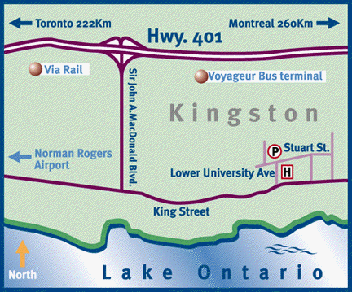

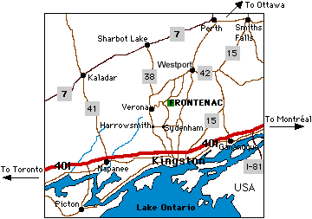
Frontenac Provincial Park
1090 Salmon Lake Road
Sydenham, Ontario
(613) 376-3489

Campsite #1 on North Buck Lake will be reserved for five people.

Camping fee is $2.25/kid/night for a youth group. Reservation required.

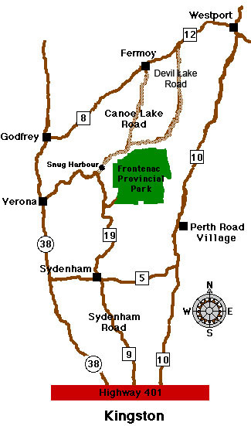
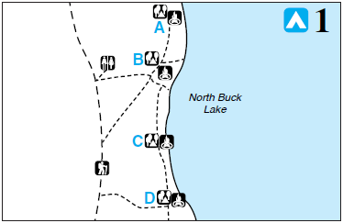

Fish available in North Buck Lake are Bass, Lake Trout, Pike, and Black Crappie.

Directions:
Merrickville, Smiths Falls, County Road 15, Lombardy, Portland, Crosby, County Road 42, Newboro, Hutchings Road, County Road 10.

Shortcut: Perth Road Village, Wilmer Road, Norway Road, Charlie Green Road, Little Long Lake Road.

From Westport drive south towards Kingston on County Road 10 (the Old Perth Road). Shortly after Perth Road Village, you will see a Provincial Park sign indicating a right turn on County Road 5. Go as far as the village of Sydenham,

As you enter the village of Sydenham, watch for another Park sign on your right (1.9 km). From then on follow the signs. You will go through Sydenham crossing a small bridge over the Millhaven creek and passing a grocery and a beer store on your right as you leave the village. After driving 13 Km on curvy County Road 19, you will see a larger Park sign indicating a right turn and a drive of 2.4 km. This is the Salmon Lake road (just after the Outfitter), it ends at Frontenac Park.
Campsite 1A Campsite 1B
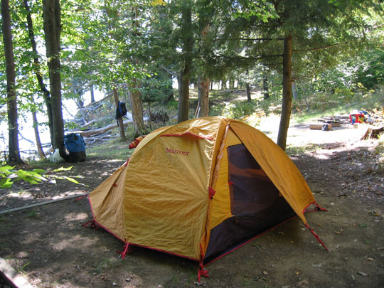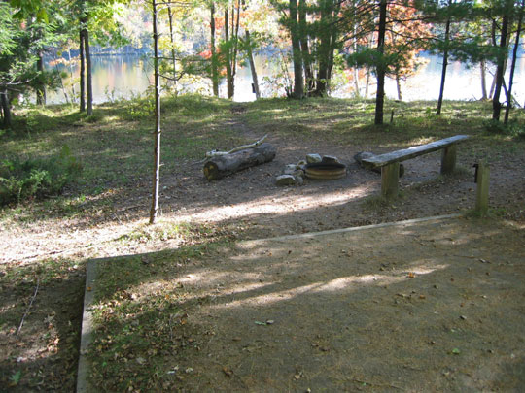

Campsite 1C Campsite 1D
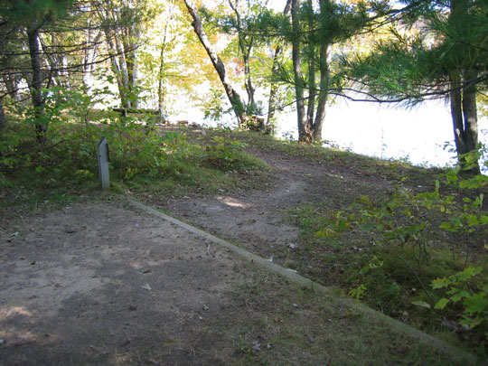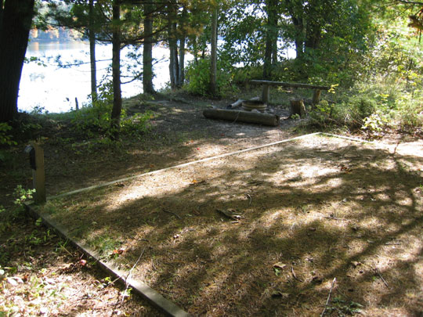

Short Cut Map
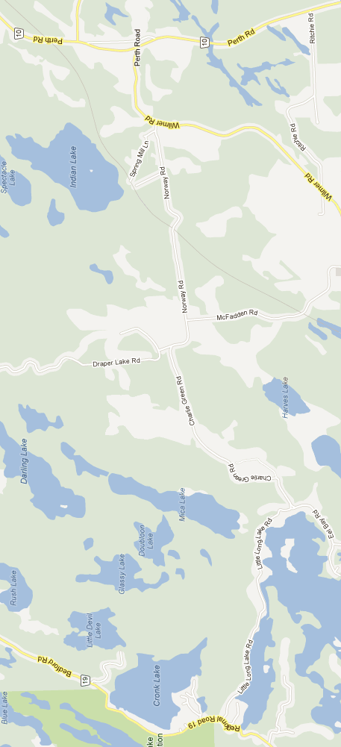
The shortcut is not for use in the winter, as Little Lake Road is not maintained from November through April.
Driving Options
Route | Length | Duration
Via Sydenham | 116km | 1h 30m
Via Long Lake Road | 104km | 1h 25m

Menu
Friday Supper
Brown bag or eat before departure

Saturday Breakfast
Toast, eggs, peanut butter, jam, bacon

Saturday Lunch
Tortilla wraps (2pp), turkey, roast beef, mayonnaise, mustard, horseradish, lettuce, cheese

Saturday Supper
Chili, grated cheddar cheese

Sunday Breakfast
Toast, eggs, peanut butter, jam, bacon

Sunday Lunch
Tortilla wraps (2pp), peanut butter, jam

Snacks
Cliff bars, apples, smores (marshmallows, graham crackers, chocolate bars)

Drinks
Hot chocolate
Personal Kit List
Rucksack
Rucksack rain cover or plastic bags
Hiking boots
Hiking socks, 2
Sleeping bag, fall/winter
Sleeping pad
Torch and/or headlamp
Change of clothes
Change of footwear (recommended)
Socks
Trousers
Long sleeved shirt
Towel
Sweater or sweat shirt
Sweat pants
Rain jacket
Rain pants
Gloves
Pyjamas
Pillow (optional)
Wash kit: tooth brush, tooth paste, soap, shampoo, chapstick, etc.
Shampoo/body wash, no-rinse (astronaut) (optional)
Mess kit: plate, bowl, cup, knife, fork, spoon in mesh bag
Water bottle
Toque
Toilet paper
Kleenex (optional)
Pocket knife (optional)
Sheath knife (optional)
Camera (optional)
Multi-tool (optional)
Compass (optional)
Fishing rod & tackle (optional)
Technical long underwear (optional)
Watch (optional)
Plastic bag for wet clothes

All personal kit must be packed in a rucksack.

Kit must be rain proof, either using either dry sack(s), garbage bag(s), a rucksack rain cover, or a water proof pack.

Electronic devices are not permitted.
Grocery List
Item | Quantity | Status | Store | Notes
Bread | 1 loaf
Eggs | 12
Peanut butter, crunchy | 1 large jar |  |  | Kraft
Jam, raspberry | 1 large jar |  |  | ED Smith
Bacon | 2 lbs
Tortillas | 16 |  |  | 2/person/meal
Turkey or roast beef | 1 pkg (400g)
Mayonnaise | 1 bottle
Mustard, Dijon | 1 bottle
Horseradish | 1 bottle
Lettuce | 1 head
Cheese | 970g |  |  | Shredded
Chili | 4 cans
Cliff bars, peanut butter | 8 |  |  | 2/person
Apples | 1 bag
Marshmallows | 1 bag
Chocolate bars | 4
Graham crackers | 20
Hot chocolate | 10 pkgs

Group Equipment
Tent, MEC, Apollo (3 man)
Footprint, MEC, 4 man
Bivi sack
Tarp, light weight
Paracord
First aid kit
Tensor bandage
Matches
Newspaper
Saw, folding
Dish soap
Dish cloth
Dish towel
Garbage bags, 2
Pot set, MSR, 3 pots (only the 2 largest pots)
Stove, MSR Dragonfly
Stove, MSR WhisperLite
Fuel bottle, MSR, Dragonfly
Fuel bottle, MSR, WhisperLite
Frying pan
Toaster, stove top
Bleach w/dropper
Collapsible water container
Thermometer
Camera, 2
Utensil Roll-Up
Wooden spoon
Serving spoon
Spreader, 2
Spatula
Can opener
Hanging scale
Notepad
Pencil
SPOT Satellite Messenger
Hiking trail maps, 2
Physical fitness forms
Canoe barrel, 30 litre
Zip lock bags, large (for storing food outside of boxes)
Plastic wrap (for wraps)

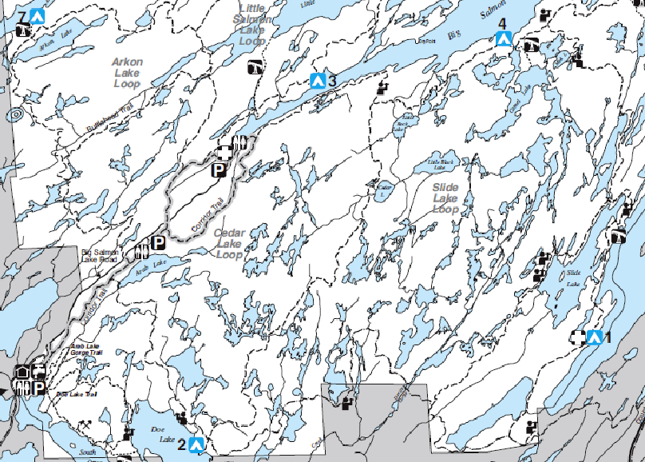
Trail Map
Campsite
Start/Finish
Report
The trip went well, and quite smoothly, considering this was the kids first exposure to light weight camping. They indicated they enjoyed themselves and would be interested in giving backpacking a go again, but in a more challenging location. Europe was the preference :), but perhaps something can be arranged in the Adirondacks. While the Venturers said the effort of the hike was good, but as they only hiked ~4 ½ hours on the Saturday and ~3 ½ hours on the Sunday, including breaks, I would say that the hiking was a little too easy.

Friday evening, before departure, the Venturers packed the camping equipment into their rucksacks and reviewed the food to ensure nothing had been forgotten. A few Ziploc bags were added for the purpose of taking food out of the original containers for easier packing. We tried to weigh the rucksacks using the hanging scale, but I had forgotten that it’s maximum weight was 25 lbs. A bathroom scale was brought into service and the rucksacks weighed in at 23 - 40 lbs. Lochlan’s load was easily double everybody else’s, he had brought two huge sleeping bags and half his wardrobe! We also found out that Calvin weighed more than Sam, much to Sam’s dismay. At their age they seem to want to weigh more; that objective will change eventually :)

An easy drive to Frontenac Provincial Park, just 1 ½ hours. We found the cross-country shortcut, bypassing Sydenham; much easier to find as Google has more road names than the provincial road map. Comparison later in the weekend showed the shortcut to only reduce the travel time by five minutes and 12km, but it’s a more interesting route.

Upon arrival at the park, the kids thought they had died and gone to heaven. While most people see a park office, these lads saw a climbing gym! They figured they would just camp beside it for the weekend :) Camp was setup and a picnic table dragged under a park office light for the never ending card games of President (mixed in with koala bear hugs to the posts!). The next morning the leftover food from making the lunch wraps was cached in a canoe barrel, along with half of Lochlan’s personal gear!

The trail was very well marked, though Sam did get the group on the wrong trail for a bit at one point. There was one other group camping at their campsite on Saturday night, and maybe 1-2 other groups camping throughout the park. There were quite a few day hikers on the trails. Calvin had some fun with his beaver imitation, gnawing at trees! At one point he said the tree tasted sugary, inciting a group taste-testing of said tree! Sam said the tree (sap) didn’t taste sugary at all, only for Calvin to say that it was awesome to be able to get three other people to lick a tree :) They hung their food in a tree on Saturday night, but instead of using the normal method of throwing a stone tied to the line, they sent Sam to climb the tree. Why do things the easy way, when there is a fun way :) They made hot water bottles on Saturday night, using their Nalgene water bottles, but didn’t put a sock over them like they were told, and Calvin burned himself; but he won’t say where :) While filling the bottles, they held them by the cap, but as the neck ring heated up, it slipped off Laura’s bottle and hot water cascaded everywhere. This is how they learn…

Because it became dark so early, their internal clocks were screwed up and they felt it was much later than it actually was. They were in their sleeping bags by 9:15pm. Supper was similarly rushed, with the Venturers starting to eat s ’mores as soon as supper was finished. Said internal clocks malfunctioned for getting them out of bed as well... The Venturers stayed in their sleeping bags for a while after they woke up.

While sitting around the campfire, one of the discussions that happened was what they would do if a bear came that night. They decided that they would fight valiantly to save their Cliff bars. There was also an idea of putting the bivy sac half sticking out of the tent so that if a bear would come, it would see a giant turtle and become very scared. Laura would then make turtle noises to make it more realistic. What does a turtle chewing lettuce sound like anyway?

At lunch on Sunday, while sitting around, Calvin wanted to see the map that Sam had, so, being too lazy to get up (both of them), Sam made a paper airplane out of it and flew it to Calvin. Then Calvin made a paper airplane to send it back, only for it to fall in no-man’s land between Calvin, Sam and Lochlan. Then Laura decided she wanted to see the map, but nobody wanted to get up. The boys came up with the solution of throwing sticks and rocks (Lochlan threw leaves) at the paper until it moved enough that Sam could get to it with a stick. He tried to make a paper airplane, but gave up and scrunched the map up instead to throw to Laura. A very complex operation...

The equipment all worked out fine. More Ziploc bags or some plastic wrap should have been brought to hold the wraps after they had been made. Toilet paper was used as paper towel which they nixed from the packing list. Two stoves were good as it allowed toasting and frying at the same time for breakfast. About 1 ½ bottles of white gas were consumed. One frying pan was fine. The large tarp was left behind as the weather forecast called for no rain. A smaller plastic sheet was taken just in case a windbreak was required; it wasn’t used for that, but it was used to reinforce the garbage bag used to hang the food in a tree. The Venturers claimed the thermometer was always reading -30C or so. It worked fine for me when I tested it upon their return, but I replaced the battery just in case, as it had never been changed. Since the MSR SimmerLite and DragonFly stoves each take a difference fuel pump, I will be attempting to colour code the stove bags and fuel pumps to make getting matching pairs easier. The folding saw worked great; they made lots of firewood and had a good fire. The can opener wasn’t needed as the cans of chili had pull top lids.

From an organizational perspective, the Venturers generally appeared to do a good job. They arrived at their destinations on time, didn’t get too lost :), tracked their departure/arrival times, and took lots of photos. The only key area for improvement I noticed was with respect to a comment about pots sitting around for a long time because nobody wanted to wash them. We have not yet been able to get the Venturers to a stage where they are volunteering for tasks for the good of the team, nor yet developed their leadership skills to the extent where tasks are being assigned.

Food worked well. Too much chili; 1 can per person would have been adequate. S ’mores with After Eight mints didn’t work, but done the regular way they were excellent (normal chocolate had been brought too). The thin spreader was voted useless (not stiff enough), but they liked the more expensive wide one. They got tired of jam and peanut butter as they had it for both breakfast and wraps on the Sunday. Frying eggs in the bacon fat worked fine. The entire block of cheese was used; extensive amounts on the chili. All the hot chocolate packets were used Saturday morning and night.

The SPOT Satellite Messenger worked perfectly sending position updates throughout the weekend. Gave a nice warm fuzzy feeling back home. Real time tracking would have been nice, but not a necessity, to help time the Sunday pickup.

Cheryl sent up a couple of thermoses of hot chocolate and some cookies to the pickup, so there was a little bit of relaxation and telling of stories from the weekend. Camping gear was extracted from the rucksacks and distributed for each person to take items home for cleaning and drying. We returned by a little different route, they are all about the same length, so we would pass by Lochlan’s house for ease of dropping him off. Everybody snoozed on the way home. Subsequently Sam and Calvin were dropped off at their respective houses.

Itinerary
Step | Awoke | Arose | Depart | Arrive | Bed | Breaks
Saturday | 7:00am | 7:30am | 10:45am | 3:40pm | 9:15pm | ~1h20
Sunday | 7:15am | 7:50am | 10:15am | 2:00pm |  | ~1 hour

SPOT Satellite Messenger
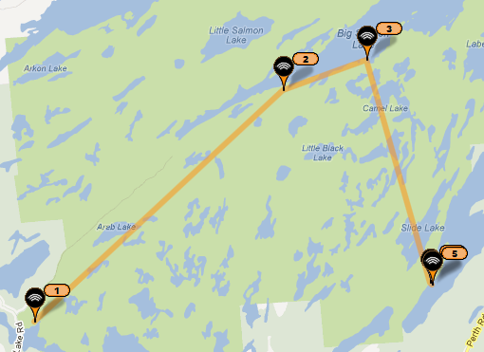

Check In | Date/Time | Location
1 | 11/16/2012 08:28:58 PM | Park Office
2 | 11/17/2012 12:12:59 PM | Trail
3 | 11/17/2012 01:10:34 PM | Campsite #4
4 | 11/17/2012 03:58:06 PM | Campsite #1
5 | 11/18/2012 09:09:57 AM | Campsite #1

