Event
This is a car accessible weekend still camp with novice and intermediate white water canoe and kayak courses. Course instruction will be qualified instructors from Paddler Co-op. Class I, II, & III rapids will be used. Camping will be at Paddler Co-op. Senior Scouts (those eligible to join Venturers in the fall) will be invited to participate as their introduction to Venturers.

Schedule
Friday May 29th
Depart Merrickville from the community centre at 5:30pm. Bob and Allan will drive 13 Scouts/Venturers. Two Venturers will go up with the Carleton Place Venturers; they will depart ~8:00pm from John Stalker’s house in Carleton Place (2511 Tenth line Beckwith). Gen Stalker, the driver, has had her G2 for six months. One other female Venturer will be in the car.
Travel highway 43 to Perth, highway 7 to Kaladar, highway 41 to Denbigh, highway 28 to Hardwood Lake, county road 514/515 to Palmer Rapids.
Arrive Paddler Co-op approximately 9:00pm.
Setup camp.
Travel distance approximately 200km; 3 hours.

Saturday May 30th
White water canoeing and kayaking on the Madawaska River.

Sunday May 31st
White water canoeing and kayaking on the Madawaska River. For Canoe II participants, there will be a river trip from Aumond’s Bay to Buck Bay. Canoe I and Kayak I participants will not do the river trip; the Kayak II participants may do the river trip (it will depend on the overall skill level). The river trip is approximately 10km in length.
Make bag lunch at campsite. Lunch and dry clothes to be in dry bags for the river trip. Take thermos of hot soup if weather is cold.
Depart river approximately 4:00pm.
Arrive Merrickville approximately 7:00pm. Parents will be called enroute with exact arrival time.
Equipment will be returned to tractor trailer. As required, common kit will be distributed for cleaning and drying. Two Venturers will have to be picked up from Carleton Place.

Participants

Name | Type | Section | Course | Boat | Chest | PFD | Fee
Sargent, Robert | Adult | Venturer | Canoe II | Canyon |  | Salus Medium | $65
Yates, Allan | Adult | Venturer | None | Cottager | 41" | Salus Medium
Beelich, Andreas | Youth | Venturer | Kayak I | Fun | 37" | Salus Medium | $135
Blaedow, Brody | Youth | Scout | Canoe I | Canyon |  | Evolution Small | $115
Catton, Ben | Youth | Venturer | Kayak II | Fun | 36" | Salus Medium | $135
Gale, Calvin | Youth | Scout | Canoe I | Canyon |  | Evolution X-Small | $115
Gale, Jennifer | Youth | Venturer | Canoe II | Canyon |  | Salus Small | $115
Hitsman, Harry | Youth | Venturer | Canoe II | Canyon |  | Salus Small | $115
Jackman, Gregory | Youth | Scout | Canoe I | Canyon |  | Evolution Small | $115
McKay, Alex | Youth | Venturer | Kayak I | 2Fun | 28" | Salus Small | $135
Moodie, Bruce | Youth | Venturer | Canoe II | Canyon | 36" | Salus Small | $115
Skelhorne, Bradley | Youth | Venturer | Canoe II | Canyon | 31" | Salus Small | $115
Szalai, Adam | Youth | Venturer | Kayak I | Fun |  | Salus Small | $135
Szalai, Grant | Youth | Venturer | Kayak I | Fun |  | Salus Small | $135
Taylor, Max | Youth | Venturer | Canoe II | Canyon | 34" | Salus Small | $115
Course Pre-Requisites

Course | Pre-Requisite
Canoe I | None
Canoe II | Canoe I
Canoe III | Canoe II
Kayak I | Canoe II
Kayak II | Kayak I

Participant Qualifications

Name | WW Experience | ORCA | Swimmer | First Aid | Boat  Rescue | River  Rescue
Sargent, Robert | Canoe I | No | Yes | No | No | No
Yates, Allan | Canoe I/II/III, Kayak I | MW 1 | Yes | Standard | Yes | Yes
Beelich, Andreas | Canoe I/II/III | MW 1 | Bronze Cross | Standard | No | No
Blaedow, Brody | None | No | Yes | No | No | No
Catton, Ben | Canoe I/II/III, Kayak I | MW 2 | Bronze Medallion | No | No | No
Gale, Calvin | None | No | Yes | No | No | No
Gale, Jennifer | Canoe I | No | Yes | No | No | No
Hitsman, Harry | Canoe I | No | Yes | Standard | No | No
Jackman, Gregory | None | No | Yes | No | No | No
McKay, Alex | Canoe I/II/III | MW 1 | Yes | No | No | No
Moodie, Bruce | Canoe I | No | Yes | No | No | No
Skelhorne, Bradley | Canoe I | No | Yes | Standard | No | No
Szalai, Adam | Canoe I/II | No | Yes | No | No | No
Szalai, Grant | Canoe I/II | No | Yes | No | No | No
Taylor, Max | Canoe I equivalent | No | Yes | Yes | No | No

Safety Precautions
- All participants will wear a properly fitting PFD and helmet when near moving water.
- PFDs will be equipped with whistles.
- PFDs and helmets will be securely fastened when worn.
- A paddle, for support, will always be carried when scouting rapids.
- No participants have mortal allergies.
- All usage of the river training area will be under the supervision of an instructor.
- A ratio of one instructor per four canoes, and one instructor per six kayaks, will be maintained.

Financial Budget

Item | Budget | Notes | Actual
Truck + trailer mileage | $126 | 210km each way @ $0.30 /km | $167
Truck mileage | $105 | 210km each way @ $0.25/km | $116
Carleton Place car cost | $40 | Two kids with Carleton Place | $8
Propane | $20 | 4 - 1 lb tanks @ $15 for 3 tanks
Food | $300 | $20/person @ 15 people
Base cost | $591
Base cost/Venturer | $46 | 13 Scouts & Venturers

 | Scout/Venturer |  | Adult
Item | Canoe | Kayak | Canoe | Kayak
Course Fee | $76.88 | $97.38 | $76.88 | $97.38
Base cost | $46.00 | $46.00
Council Subsidy | ($10.00) | ($10.00) | ($10.00) | ($10.00)
Budget Total | $112.88 | $133.38 | $66.88 | $87.38
Advertised Total | $115 | $135 | $65 | $85

Item | Budget | Actual | Notes
Mileage | $231.00 | $282.90 | Shuttling not budgeted & canceled river trip pickup
Carleton Place car cost | $40.00 | $16.00
Propane | $20.00 | $32.21 | 9 tanks purchased instead of 4
Food | $300.00 | $334.72
Course fee | $1,023.43 | $1,023.43
Mesh bags |  | $18.08 | 2 floatation storage bags lost
Total | $1,614.43 | $1,707.34
Revenue | $1,660.00 | $1,660.00
Balance | $45.57 | ($47.34)

Kayak Sizing

Model | Ideal Overall Weight | Quantity Available
2Fun | 120-150 lbs | 1
Fun | 140-180 lbs | 4
SuperFun | 210-265 lbs | 1

PFD Sizing

Salus Kayak Guide | Chest Size | Quantity Available
Small / Medium | 32" - 40" | 8
Medium / Large | 36" - 44" | 4
Large / Xtra Large | 40" - 48" | 0
Xtra / 2Xtra Large | 44" - 52" | 0

Evolution | Chest Size | Quantity Available
X-Small, Red |  | 2
Small. Yellow |  | 1

Personal Kit List

Sleeping bag
Sleeping pad (optional)
Torch
Change of clothes (several)
Change of footwear
Trousers
Long sleeved shirt
Swim suit
Towel
Sweater or sweat shirt
Rain jacket
Rain pants (optional)
Pyjamas
Pillow (optional)
Wash kit: tooth brush, toothpaste, soap, shampoo, chapstick, etc.
Shampoo, no-rinse (astronaut shampoo) (optional)
Mess kit: plate, bowl, cup, knife, fork, spoon in mesh bag
Water bottle w/carabineer
Sunscreen
Insect repellant
Hat
Baseball cap (optional)
Kleenex
Knapsack
Kneepads (optional)
Bicycle gloves (optional)
Sunglasses w/strap (optional)
Water shoes (optional)
Pocket knife (optional)
Wetsuit (optional, recommended for kayaking)
Folding chair (optional)
Dry bag (optional)
Soccer ball (optional)

Quick dry materials such as polypropylene, polyester fleece, and a nylon wind jacket and pants are recommended. A rain suit can double as an extra layer in cold weather.

Wet feet are a given, and participants will get wet even if they don’t dump their canoe (which they are likely to do anyway). Some form of water shoes, or sneakers that can get wet, are recommended. Glasses should be secured with a strap.

No electronic games.

Menu

Friday
Supper
Brown bag from home or eat before departure

Saturday
Breakfast
Cereal, bacon, toast, jam, peanut butter
Lunch
Sandwiches (bacon, ham, buns, mayonnaise, lettuce, cheese), chicken noodle soup (if cold)
Supper
Chili, buns

Sunday
Breakfast
Cereal, sausages, toast, jam, peanut butter
Lunch
Sandwiches (bacon, ham, buns, mayonnaise, lettuce, cheese), chicken noodle soup (if cold)

Snacks
Granola bars
Peanut M&Ms
Gummy Bears
Apples
Butter tarts
Two bite brownies

Drinks
Hot chocolate
Juice crystals, lemonade
Orange juice, tetra paks
Kool-Aid singles
Water
Coffee
Milk
YOPs
Grocery List

Bacon, 4 packages
Bread, white, 2 loaves
Jam, strawberry, 1 jar
Peanut butter, 1 jar
Peanut M&Ms, 1 large bag
Corn Pops, 1 box
Frosted Flakes, 1 jumbo box
Milk, 3.25%, 4 litres
Buns, Kaiser, 26
Cheese, large slab, 900g
Mayonnaise, Miracle Whip, squeeze (if possible), 1 bottle
Lettuce, iceberg, 1 head
Ham, 40 slices
Cup-a-soup, Chicken Noodle, 15 packages
Granola bars, chocolate covered, 1 large box
Granola bars, sweet & salty, 1 large box
Chili, beef or steak (or both), 11 large cans
Sausages, breakfast, 36
Hot chocolate, 20 packets
Apples, red, 1 bag
Apples, yellow, 1 bag
Coffee, regular
Coffee, decaffeinated
Coffee, individual packets, regular
Coffee, individual packets, decaffeinated
YOPs, 24
Kool-Aid singles, 3 boxes
Juice crystals, lemonade, 1 container (have)
Gummy Bears
Vegetable oil
Butter tarts, 12
Pringles, 4 cans
Brownies, two bite, 2 containers
Juice, tetra pak, various flavours, 36

Hospital

St. Francis Memorial Hospital
7 St. Francis Memorial Drive
Barry’s Bay, Ontario
(613) 756-3044

Camping Equipment (tractor trailer)
Tent, Scout, 4
Allan’s Extra Kit
Pre-training notes
Sheath knife
Multi-tool
Thermometer
CDs
Trip plan
Watch
Camera
Camera spare battery
Camera battery charger
Mobile telephone
Mobile telephone charger
Inverter
Book
Physical fitness forms
Tent , 4 man (poles, pegs, ground sheet)
Headlamp
Lantern, battery
Pelican camera case, w/lanyard & carabineer
First aid kit
Truck garbage container w/bags
Briefcase
Weather forecast
Clipboard
Shaver
Contact lens solution
Notebook & pencil

Paddling Equipment
Paddles, canoe, plastic/aluminum, 14
PFD, Salus, small/medium, 8
PFD, Salus, medium/large, 4
PFD, Evolution, red, x-small, 2
PFD, Evolution, yellow, small, 1
Canoes, Canyon, 6
Float bags, 6 pairs
Canoe trailer
Canoe tie down straps, short, 12
Canoe tree tie down straps, long, 4
Helmets, white water, 15
Helmet fitting pads, lots
Kayak, Fun, 4
Kayak, 2Fun, 1
Kayak skirt, Fun/2Fun, 5
Paddles, kayak. 5
Bailers, 6
Throw bag, North Water, 70', 1
Dry bag, 2
Ground sheets, 4
Tent pegs
Tarps, large, 2
Baler twine
First aid kit
Dish soap
Pot sets, large, 2
Pot, large
Toaster, stove top
Frying pans, 2
Griddle
Lanterns, propane, 2
Propane, 1 lb, 8
Stove, 2 burner, propane, 2
Basins, washing, 2
Water containers, 2, full
Tea towel
Dish cloth
Spoon, large, 2
Spatula, 2
Cooler
Ice packs, 3
Cheese slicer
Scrubbing pad, nylon
Garbage bag holder
Garbage bags, extra large
Dining shelter, self supporting

Equipment (Allan)
Kleenex
Matches, 1 box
Duct tape
Toilet paper
Tinfoil
Paper towel
Playing cards, 2 packs
Chairs, folding, 3
Single cup coffee maker
Coffee filters, #2, 10
Carabineers, 3
Thermos, 2
Ziploc bags, small (for sandwiches)
Ziploc bags, large
Ropes, tie down, several
Thermometer, w/ immersion probe
Inflator, 12V
Inflator, manual

Paddler Co-op

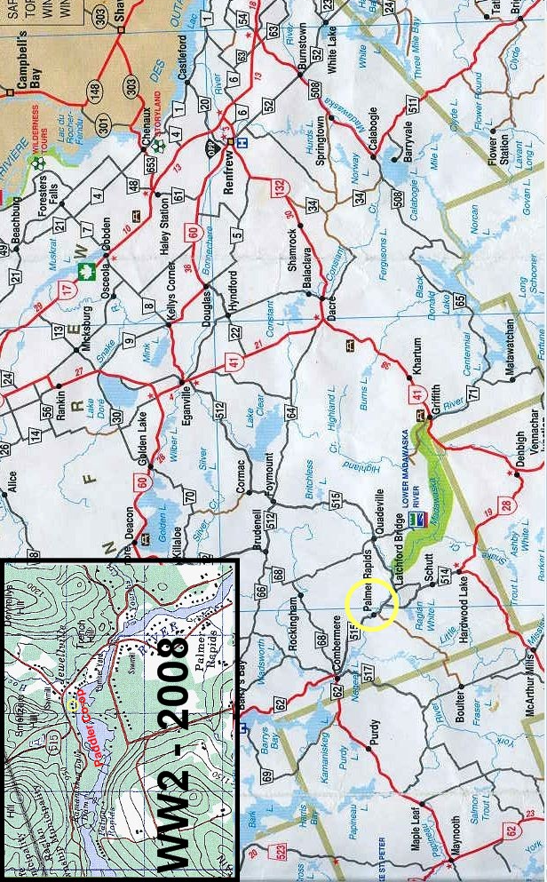
Paddler Co-op

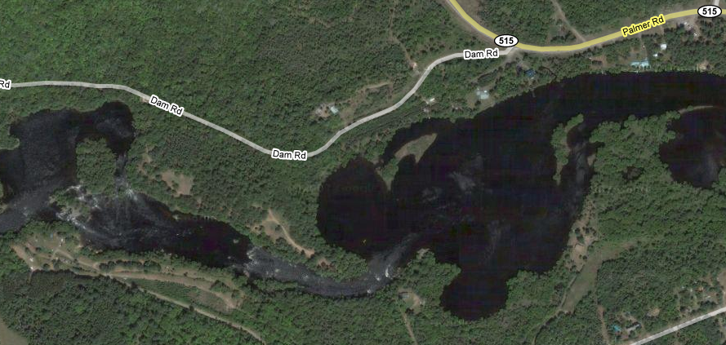
Lower Set
Base
Upper Set

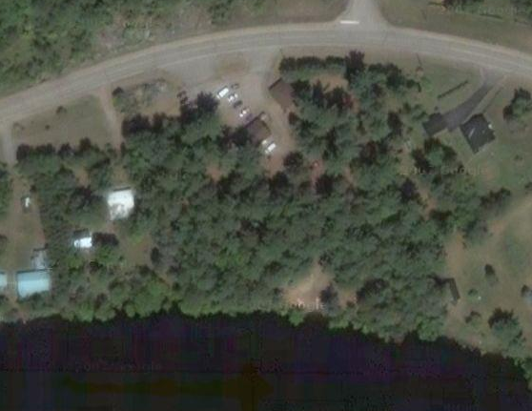
Beach
Boat house
Camping
Administration
Lower Set

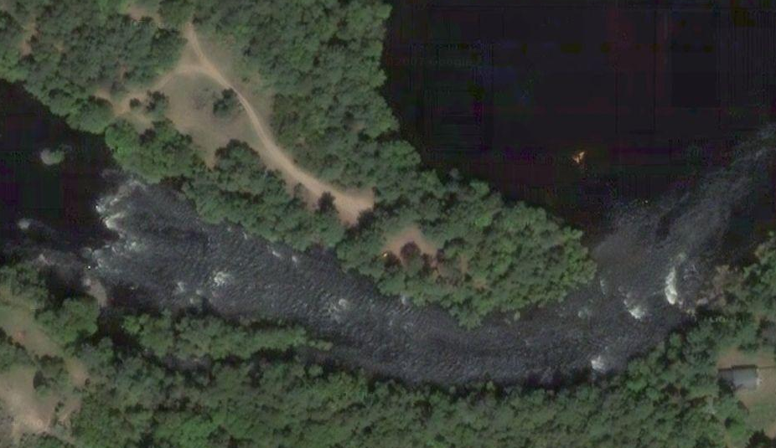
Upper Set

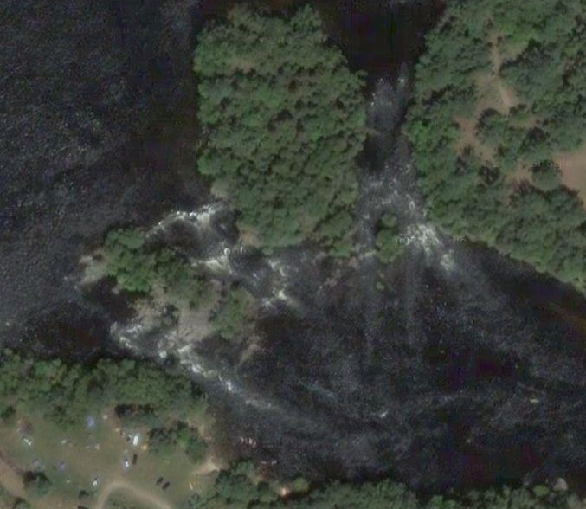

River Trip

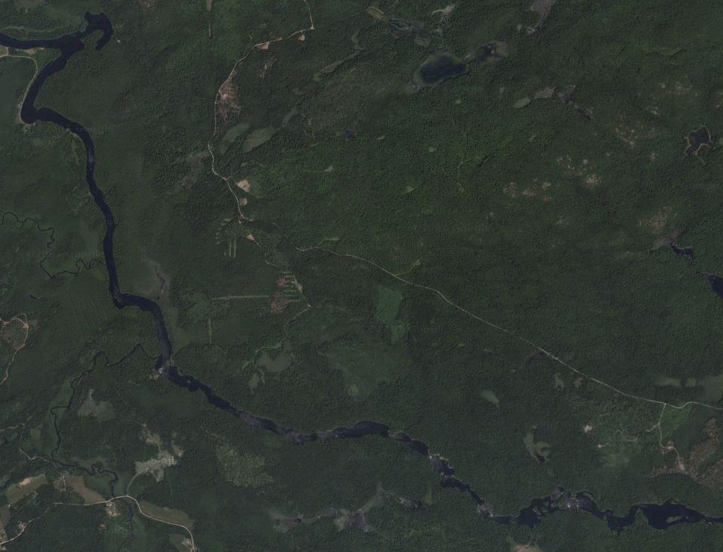
Start - Aumond’s Bay
Finish - Buck Bay
Canoe Eater
Rifle
Examination
Snake
(Haas Hole)
Island
Narrows
Split Rock

River Trip
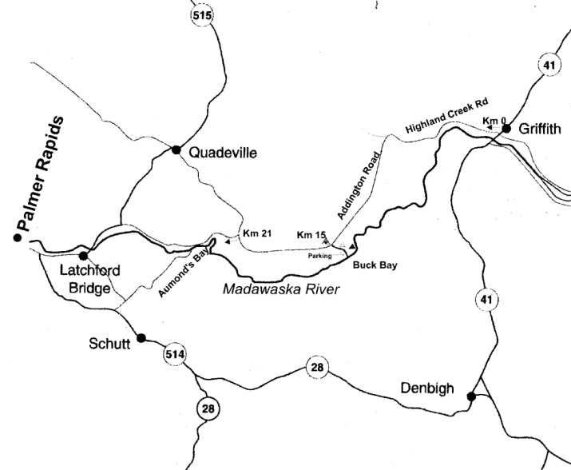
St. Francis Memorial Hospital

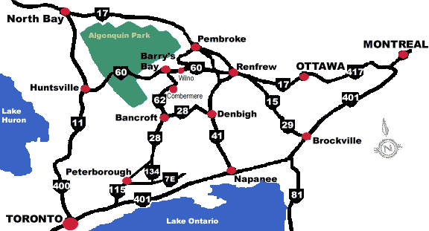

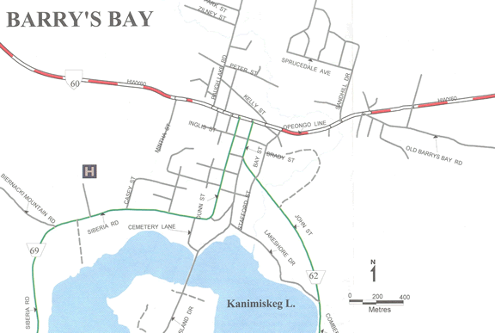

Report
I hope all the Scouts and Venturers had a good time. I certainly saw big smiles on on some of their faces. Whitewater always makes for good fun, in spite of the inclement weather.

We met at 5:30pm on the Friday to pack the equipment (since they had not figured out how to do that ahead of time). They discovered that the Scouts had not replaced the tents from their camp two weeks ago, and were at a loss of what to use. Eventually they found some Cub tents and those were taken. There was also only one small pot set present; the rest are AWOL. They also couldn't find any first aid kits, but they may not have looked hard enough. Lets just say, that at this point the Venturers were not too happy. It took them an hour and a half to get it all done, and we departed at 7:00pm.

Due to a shortage of transportation spots in our cars, Max and Alex were driven up by the Carleton Place Venturers. Their departure time was scheduled to be 8:30pm.

It was an easy three hour drive to Paddler Co-op. There were a lot of speed traps and OPP cruisers around. As we approached Palmer's Rapids, a couple of cops were handcuffing a guy against a car. We thought about stopping and taking a photograph, but we decided that discretion was the better part of valour :)

We walked around in the dark looking for a campsite, eventually picking a nice flat spot just off the parking lot at the top. The lanterns were unpacked and it was found that the bases were missing from the bags, so the lanterns couldn't be stood on a table. Three tents and a tarp were setup. The older kids went to bed pretty much right away, while the younger ones stayed up until about midnight.

It rained over night, and while the tarp kept the rain off, the central support fell down. They had been told it needed to be tethered in three directions, but they didn't listen... They kids also left the last tent and screened shelter in the back of Bob's pick-up truck, so they got soaking wet.

Max and Alex hadn't showed up by the time the last kids went to bed. Bob and I had long been in bed. They showed up in the morning. They arrived sometime after midnight, the driver had gotten lost several times. They couldn't find our campsite, so they slept in the car :( The two girls, who brought them up, couldn't be bothered to setup their tent, so they slept in the car as well.

None of the kids got up on time in the morning. They were reminded on Friday night that before they could paddle in the morning, they needed to get the canoes outfitted (off the trailer, floatation bags installed and inflated, and bailers made and tethered), breakfast eaten, dishes washed, campsite tidied. So naturally it was a mad rush for them. As we wouldn't let them go paddling until all the tasks were finished, the instructors were yelling at them as they were holding up the session starts.

We had kids on all four types of courses this weekend: Beginner and intermediate canoeing, as well as beginner and intermediate kayaking. The river was about two feet higher than normal for this time of year, so it made quite a change in the rapids. Some get washed out, but others had much larger standing waves at the bottom.

I took one of our canoes, and canoed from group to group getting a few photographs. I spent some time sitting on a rock at the bottom of the main set of rapids, and right before lunch a group came down and at least five of their six canoes flipped. Utter carnage :) The rest of the groups, including ours, sneaked down the the other side of the river, which didn't make for good photos.

After lunch, one of the other leaders asked to borrow my canoe to take someone down the rapids. He leant me his solo boat in return. Having been in one of these before, I knew they were hard to keep going straight. But it was good practice, and it was nice and light to portage to the upper set of rapids. As I was sitting at the bottom of the rapids, I see a red canoe (upside down) go by with a thunk through the big wave. When I next look to the shore, the guy who borrowed my canoe is standing there dripping wet! Where's my canoe! Get back in the river and rescue it! :) While he is an excellent paddler, his bowman managed to lean over the gunwale too far and they lost it.

The kids spent the entire day learning and practicing their moving water turns, eddying in and out, ferrying, and running rapids. I think everybody flipped at least once. The weather for a little cool first thing in the morning, but warmed up nicely for the afternoon. The water temperature was 15C.

Our new kayakers all seemed to like that sport. They played some more off the beach after the course ended for the day. Some of our other lads joined them to try the kayaks out. They are looking forward to doing a kayak course next year. We ended the day with a chili and stew supper (no cheese grater in the kitchen utensil box).

That evening we had them get the canoes and equipment loaded on the trailer in preparation for the river trip. They had to make sure they left the right amount of gear for the people staying, and for the people on the trip. More on that later. While I wasn't signed up for a course, I was told that I could tag along on the river trip if I liked. So I found a pro paddler (the one who borrowed my canoe earlier) that would come in my tandem canoe with me. This was going to be fun.

The older Venturers headed to bed about 8:00pm, and the younger ones followed sometime later.

Sunday was the river trip for the experienced canoes/kayakers and more work in the local rapids for the beginners. It was a cold morning with a temperature of 8C. They had decided the night before that they needed to get up at 6:15am to get ready on time. The first one arose about 7:30am.... We were scheduled to leave at 8am, and as I said I would be leaving for the river trip with or without them, they were quite motivated to get ready quickly. They were ready on time, but I'm sure their breakfast was a little thin, and their packed lunches a little sparse. Then we were asked to wait until all the other groups were ready to go, and that turned out to be another 45 minutes :)

We drove to the put-in for the river trip and dropped off the kids and canoes. Then we took the vehicles and trailers to the take-out, and were shuttled back to the put-in. It is quite the operation, and takes about 1 1/2 hours. At this point the kids discovered they were one helmet short. While they had ensured enough equipment was left for the beginners, they hadn't checked to see if enough was present for the river trip. They managed to borrow a helmet off another group who had a spare. The kayakers started first as they are the slowest on the flat water sections. The group with our kids was the second last to start (they are spaced out at intervals). I started off around the same time.

At this point the wind picked up and we started getting some rain. We were heading into the wind, and a few of the kids (not ours) were complaining about being cold and were having trouble keeping up. One of the other canoes had a not so good stern paddler (an adult) and a weak bow paddler. The guy in my canoe, their leader, asked if I would take over that canoe with one of the weak paddlers. So I hopped from the bow of my canoe to the stern of the other canoe. And we both drove our canoes into the wind across the next bay. Now I was looking forward to sterning down all the rapids.

However, it was soon noticed that one kid was heading for hypothermia, and one other had psychological hypothermia (he was wimpish). The weather was deteriorating with sleet and snow. With the river level being high, the rapids were going to be a little more tricky, meaning quite a few people would be going for a swim and would thus be soaking wet. Also, once we got past the first rapid, there are no road evacuation points, and it would be at least a three hour paddle to get anybody out. So the head instructor (Spike from our original courses two years ago) called the trip off for the kid's safety. This was the right decision. He then hopped out of his solo boat and into a tandem with another instructor and beetled off to get the other groups to either turn back or stop at the first rapid where they could be collected.

The fun now was to get our vehicles and trailers back from the take-out point, and recover all the boats and people from both the put-in and from the first rapid. Luckily one leader had both a car and a key to that car still at the put-in. So eight of us got in the car the size of a VW Golf: The driver, two in the front seat (a woman (Spike's sister) on top of a man), three in the back seat, and two in the hatch back! Note that though this was both legal and safe, the driving was off road on a dirt track through the bush, we would never do this with the kids. However, we wanted as many cars back as soon as possible, so we could get the kids back to a spot where they could get dry clothes. We then brought a suite of vehicles back to the put-in.

The kayakers, and one group of canoes, made it to the first rapid. It was a 1 1/2 hour paddle for the kayaks. Playboat kayaks don't travel fast on flat water, especially with a head wind. They at least got to play in the rapid for a bit. Ben said snow was accumulating on his kayak as he was surfing.

The beginner canoers/kayakers actually got the best deal, as they did whitewater runs until lunchtime. They were pulled off the river at that point as too many of the kids were getting cold.

We got the river trip kids and canoes back to Paddler Co-op. I then went with the convoy to the first rapid, it's a long roundabout drive, to pickup the remaining kids along with their canoes and kayaks. We made it back to Paddler Co-op at 2:00pm. I drove a total of 110km for all this shuttling! Time for me to eat lunch. I had been going non-stop for hours, and I wasn't moving until I had eaten a proper lunch. We made our final departure about 3:15pm.

We arrived back in Merrickville at about 6:15pm, and the kids had the equipment stored and divided up for cleaning/drying in about 20 minutes. They all called home and were picked up around 7:00pm.

Two mesh bags, that store canoe floatation bags, were lost. The kids left them in the canoes on Saturday morning when they installed the bags, so naturally when the canoes flipped, the bags were lost. The Venturers will have to purchase replacement bags.

The appropriate clothing for the conditions is very important for many of our activities. Our kids were actually dressed quite well, and while they were a little cool, they were in no danger of going hypothermic (at least at the beginning of the trip). We all realise that it can be unreasonable to purchase clothing specific to moving water as it would only be used a few times a year, but in the event of inclement weather, it can make life a lot more comfortable for the kids. I brought along a farmer john wetsuit and neoprene booties this time, and they made a world of difference. A paddling jacket or dry jacket would be the next step.

Due to the kids being spread across many rapids, and since their actual runs though the rapids are non-deterministic, photographs are hard to come by. The selection (including a couple of videos) I obtained are up on the website (http://www.1stmerrickville.ca/venturers/pictures/2008/2009-05-29/index.htm). If you would like a CD of the photos, just ask.

Not only didn't the Venturers like getting up in the morning, they weren't keen on making the cooked breakfasts they had planned. So we returned with a lot of the breakfast food. Other than that, most of the food was eaten. With a large number of kids, Kool-Aid singles should not be brought; a large container of juice crystals is much more cost effective. Key items left over:

3lbs of bacon
2 packs of sausage (15 per pack)
2 boxes of cup a soup
1/2 lb of each kind of coffee
1 box of hot chocolate (10 per box)
1/2 can of juice crystals
Bag of apples

We really tried to let the kids run the weekend themselves, but what we found is that none of them would take charge, and the rest of them would stand around waiting to be told what to do. So tasks never got done in parallel. Everything took way longer than it needed to.

While the finances haven't been finalised, it looks like the weekend came in about $50-$100 over budget (on a $1,600 weekend). Food was a little over budget, and mileage was quite a bit over budget due to the extra shuttling from the canceled river trip.

As a group we need to do a better job of managing the shared equipment as we can't afford to have separate sets for each section.

Bob has made a good suggestion that personal equipment be issued at the beginning of these events and marked with the individual's name. They would then be responsible for it until it is stowed upon our return to Merrickville. Things like, helmets, harnesses, PFDs, paddles.

