Event
The Venturers will be winter camping, snow shoeing, skiing/snowboarding, and ice climbing in the Adirondack Mountains. The Winter Adventure event is run over four weekends under the umbrella of the Venturer Advisors Forum. While snowshoeing up a 4,000’ mountain is the main objective of this event, we will be taking advantage of the location and time of year for other activities too. Since this is our only winter outing with the Venturers, we will be camping outside rather than using the adjoining heated Alpine Club of Canada cabin like most other Venturers. We will be multi-pitch ice climbing (with commercial guides) on Friday, snowshoeing on Saturday, and skiing/snowboarding on Sunday.

Date
Thursday February 25th – Sunday February 28th

Location
Alpine Club of Canada Keene Farm
Keene, New York

Transportation
The Venturers will be driven by Allan.

Vehicle | # of Seats (incl. driver) | Make | Model | Colour | License Plate
Allan | 7 | GMC | Yukon XL | Pewter | AKFA 929

Qualifications
Allan and Max have current standard first aid qualifications. All participants have previous ice climbing and snowshoeing experience in the Adirondacks.

Sleeping Accommodations
Venturers and the leader will be sleeping outside in separate tents or shelters. A review of winter camping skills and examination of sleeping bags will be held. Venturers may construct their own shelter (e.g. quinces, snow walls with a tarp roof, sticks and a tarp, etc.) or make use of a small outdoor shed with bunks. A heated cabin, owned by the Alpine Club of Canada, is nearby in the case of an emergency.

Food
- The menu will be planned by the Venturers.
- For supper during the drive home a stop at Subway Lake Placid is planned.
- Citrus fruit cannot be taken into the US, though meat can be imported for personal consumption.
- A pump for water is available at the camping area.
In Case of Emergency
- 911 address of the hut is 193 Styles Brook Road, Keene, New York.
- Cellular service is unknown.
- A first aid kit will be on site.
- The closest hospital is the Adirondack Medical Centre at 2233 State Route 86, (518) 891-4141.

Schedule
Thursday February 25th
Meet at tractor trailer at 4:30pm and load equipment.
Depart Merrickville at 5:00pm.
Stop at the UPS Store in Ogdensburg to pick up package for the Valley Highlands area. Store closes at 6:00pm.
Travel 250km, 3 hours.
Arrive at the ACC cabin at 9:00pm. Stay in the ACC cabin on Thursday night.

Friday February 26th
Elevation of Keene is 1,053' (321m).
Ice climbing on Friday with Rock and River; start time is 8:30am. Travel time is 15 minutes.
Lunch provided by Rock and River.
Pick up two pairs of snowshoes from The Mountaineer on Friday before 5:30pm.
Setup camp Friday evening and camp.

Saturday February 27th
Snowshoe up Algonquin or Giant Mountain. Depart 8:00am. Full day; bring packed lunch.
Camp Saturday evening

Sunday February 28th
Depart ACC at 8:00am. Travel 120km, 2 hours.
Skiing at Gore Mountain; bring packed lunch.
Depart Gore Mountain at 4:30pm.
Stop at Lake Placid Subway for supper.
Travel 300km, 4 ½ hours.
Arrive Merrickville at 10:00pm.
Distribute gear for cleaning and drying.

Attendance
Name | Type
Catton, Ben | Youth
McKay, Alex | Youth
Taylor, Max | Youth
Yates, Allan | Adult

While Allan will be the only Merrickville adult present, we will be with two adult guides during our ice climbing and with multiple adult leaders during our camping and snowshoeing.

Financial Budget
Item | Cost | Notes
Allan truck fuel | $175 | 254+30+118+280=682km @ 25 cents/km
Food | $100 | $25/person @ 4 people
Camping fee | $71 | $7/person/night @ 4 people + $15 for first night in cabin
Propane | $24 | 6 - 1lb tanks @ $12 for 3 tanks
Bridge tolls to/from USA | $6
Trip leader honourarium | ($50)
Base cost | $326
Base cost/Venturer | $109 | 3 Venturers
Base cost/Venturer | $109
Advertised base cost/Venturer | $110
Gore Mountain Lift Ticket (youth) | $59 | US$53/youth, US$64/adult
Ice Climbing | $143 | US$130/person
Total | $332

Gore Mountain Skiing/Snow boarding
On Sunday we will be skiing and snowboarding at Gore Mountain. Each must supply their own equipment; a helmet is strongly recommended.

Take county road 9N to Keene, then county road 73 to the I-87. Take the I-87 (the Northway) to exit 26 (Pottersville). Follow the Gore Mountain "Trailblazer" signs through Olmstedville then left on Route 28N to North Creek. Make a left turn onto Route 28 and then a right to 793 Peaceful Valley Road.

Mountain | Summit Elevation | Vertical Drop | # Trails
Gore Mountain | 3,600’ | 2,300’ | 90

Further Information
For additional information, the following documents are published by the Venturer Advisors Forum:
- Winter Adventure Information
- Winter Adventure Clothing
- Winter Adventure Checklist

Snowshoe Mountaineering
We plan to climb Algonquin or Giant Mountain.

Risks
- Minor injuries: Treated with first aid kit.
- Major injuries: Evacuation and transport to hospital; alternatively a leader will be sent to fetch medical personal by returning to the parking area and driving to a telephone to summon paramedics.
- Hypothermia: The wearing of hats and gloves will be recommended. If the weather is very cold, hot drinks will be taken in a thermos for the hike. Layering is required to reduce perspiration and subsequent chilling.
- Head injury: Helmets will be strongly recommended for skiing, and will be mandatory for ice climbing.
Ice Climbing
On Friday we will be multi-pitch ice climbing. The exact route will be determined at that time. The guide company, Rock and River, will provide American Mountain Guide Association certified guides along with all necessary equipment, training, and instruction. We will be supplying our own helmets and harnesses to obtain a reduced fee. Old ski pants recommended as crampons are very sharp.

The Rock and River lodge is at the end of Alstead Hill Lane, off route 73, between Keene and the town of Lake Placid. Continue past the Bark Eater Inn on Alstead Hill Lane for 5km to the end of the road. Contact information: www.rockandriver.com, (518) 576-2041. 8:30am start, ~4:00pm finish.

Name | Harness Size | Helmet Size
Catton, Ben | Medium | 2
McKay, Alex | Small | 2
Taylor, Max | Small | 2
Yates, Allan | Medium | 2

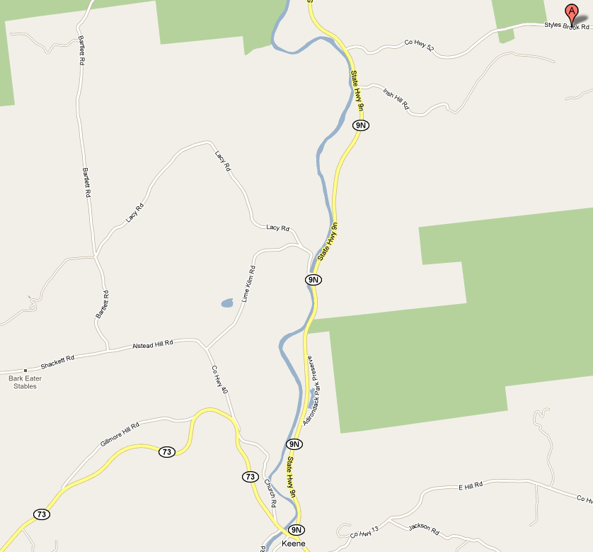
Personal Equipment
No electronic games.
Change of clothes (as many as desired)
Sweater or sweatshirt
Thermal or technical long underwear (optional)
Technical under shirt (optional)
Gloves and/or mitts, 2 pairs
Winter hat (with spare for sleeping)
Winter coat
Winter boots
Socks, thick, for sleeping
Snow pants (old pair recommended for ice climbing)
Track pants (optional)
Sleeping bag (-20C rating or use 2)
Sleeping pad (closed cell foam or Thermarest)
Pillow (optional, for napping during drive too)
Flashlight
Spare batteries
Headlamp (recommended)
Wash kit (tooth brush, tooth paste, soap, hair brush, etc)
Shampoo, no-rinse (astronaut shampoo) (optional)
Towel
Mess kit (Plate, bowl, mug, knife, fork, spoon) in mesh bag
Water bottle (must be Nalagene polycarbonate if using as a hot water bottle at night)
Kleenex
Plastic bag for wet clothes
Whistle
First Aid or Survival kit (optional)
Campfire blanket (optional)
Pocket knife
Chapstick (optional)
Ski helmet (highly recommended if skiing or snowboarding)
Skis & ski poles & ski boots (optional)
Snowboard & snowboard boots (optional)
Thermos (optional, for hot drinks on the hike and during ice climbing)
Watch (optional)
Camera (optional)
Pocket knife (recommended)
Multi-tool (optional)
Birth certificate or passport
Consent form, signed
Out-of-country health insurance details
Slippers (optional, for use in the hut on Sunday night)
Knapsack (for snowshoe hike and ice climbing to carry lunch, water, etc)
GPS (optional)
Ski poles (recommended, for snowshoeing)
Common Equipment (Tractor Trailer)
Stove, propane
Allan’s Personal Equipment
Altimeter
Thermometer
Book
Topographic map, Adirondacks, 2
Road map, New York State
CDs
Cash, Canadian
Cash, US
Truck garbage bag holder
Garbage bags for truck, 6
Mobile telephone
Mobile telephone charger
Inverter
Camera
Camera spare batteries (charged)
ACC membership card
Pillow, extra
Tent, 4 man + poles + snow tent pegs

Allan’s Emergency Equipment
Sand
Traction aids
Tow ropes, 3
Blankets, 2
Shovel, snow, small
Pillow
Lanterns, propane, 4
Frying pan, 2
Spatula, 2
Large spoon, 2
Water container
Cooler
Tarp, large, 1
Tarp, medium, 2
Binder twine, 1 roll
Wash bowl
Dish soap
Stove top toaster

Common Equipment (Other)
Matches
Tinfoil
Garbage bags, 5
Paper towel
Toilet paper
Climbing harness, small, 1
Climbing harness, medium, 3
Climbing helmet, size 2, 4
Propane, 1 lb, 8
Dish towel
Dish cloth

Menu

Thursday
Snacks
Hot chocolate, box
Marshmallows
Granola bars, Nature Valley Sweet 'N' Salty, 32-pack

Beverages
Milk, 3.25%, 1 litre
Juice crystals
Dinner
Eat before departure or brown bag.

Friday
Breakfast
Corn Pops

Lunch
Provided by Rock and River

Dinner
Hamburgers, buns

Saturday
Breakfast
English Muffins

Lunch
Granola bars
Wraps, ham & turkey, cheese

Dinner
Chicken burgers, buns

Sunday
Breakfast
English Muffins

Lunch
Wraps, ham & turkey, cheese

Dinner
Subway or equivalent

Grocery List

Pita wraps, 8
Corn Pops, 1 regular box (have)
Peanut Butter, crunchy, Kraft
Jam, Strawberry
English Muffins
Hamburgers, 4
Chicken burgers, 4
Hamburger buns, 8
Hot chocolate, small box
Granola bars, Nature Valley Sweet 'N' Salty, 32-pack
Milk, 3.25%, 4 litres
Ham, 20 slices
Turkey, 20 slices
Cheese, real, 14 slices
Soup, chicken noodle, 1 large can
Juice crystals, 1 large container (have)
Mayonnaise
Ketchup
Lettuce

Rock and River Ice Climbing

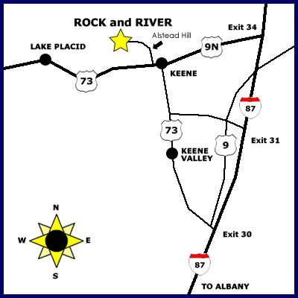

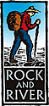
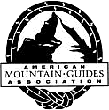
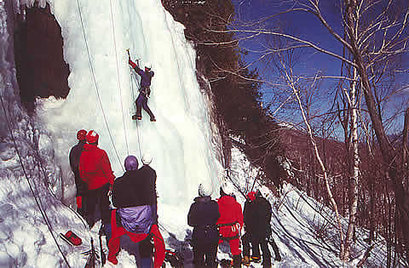
Gore Mountain
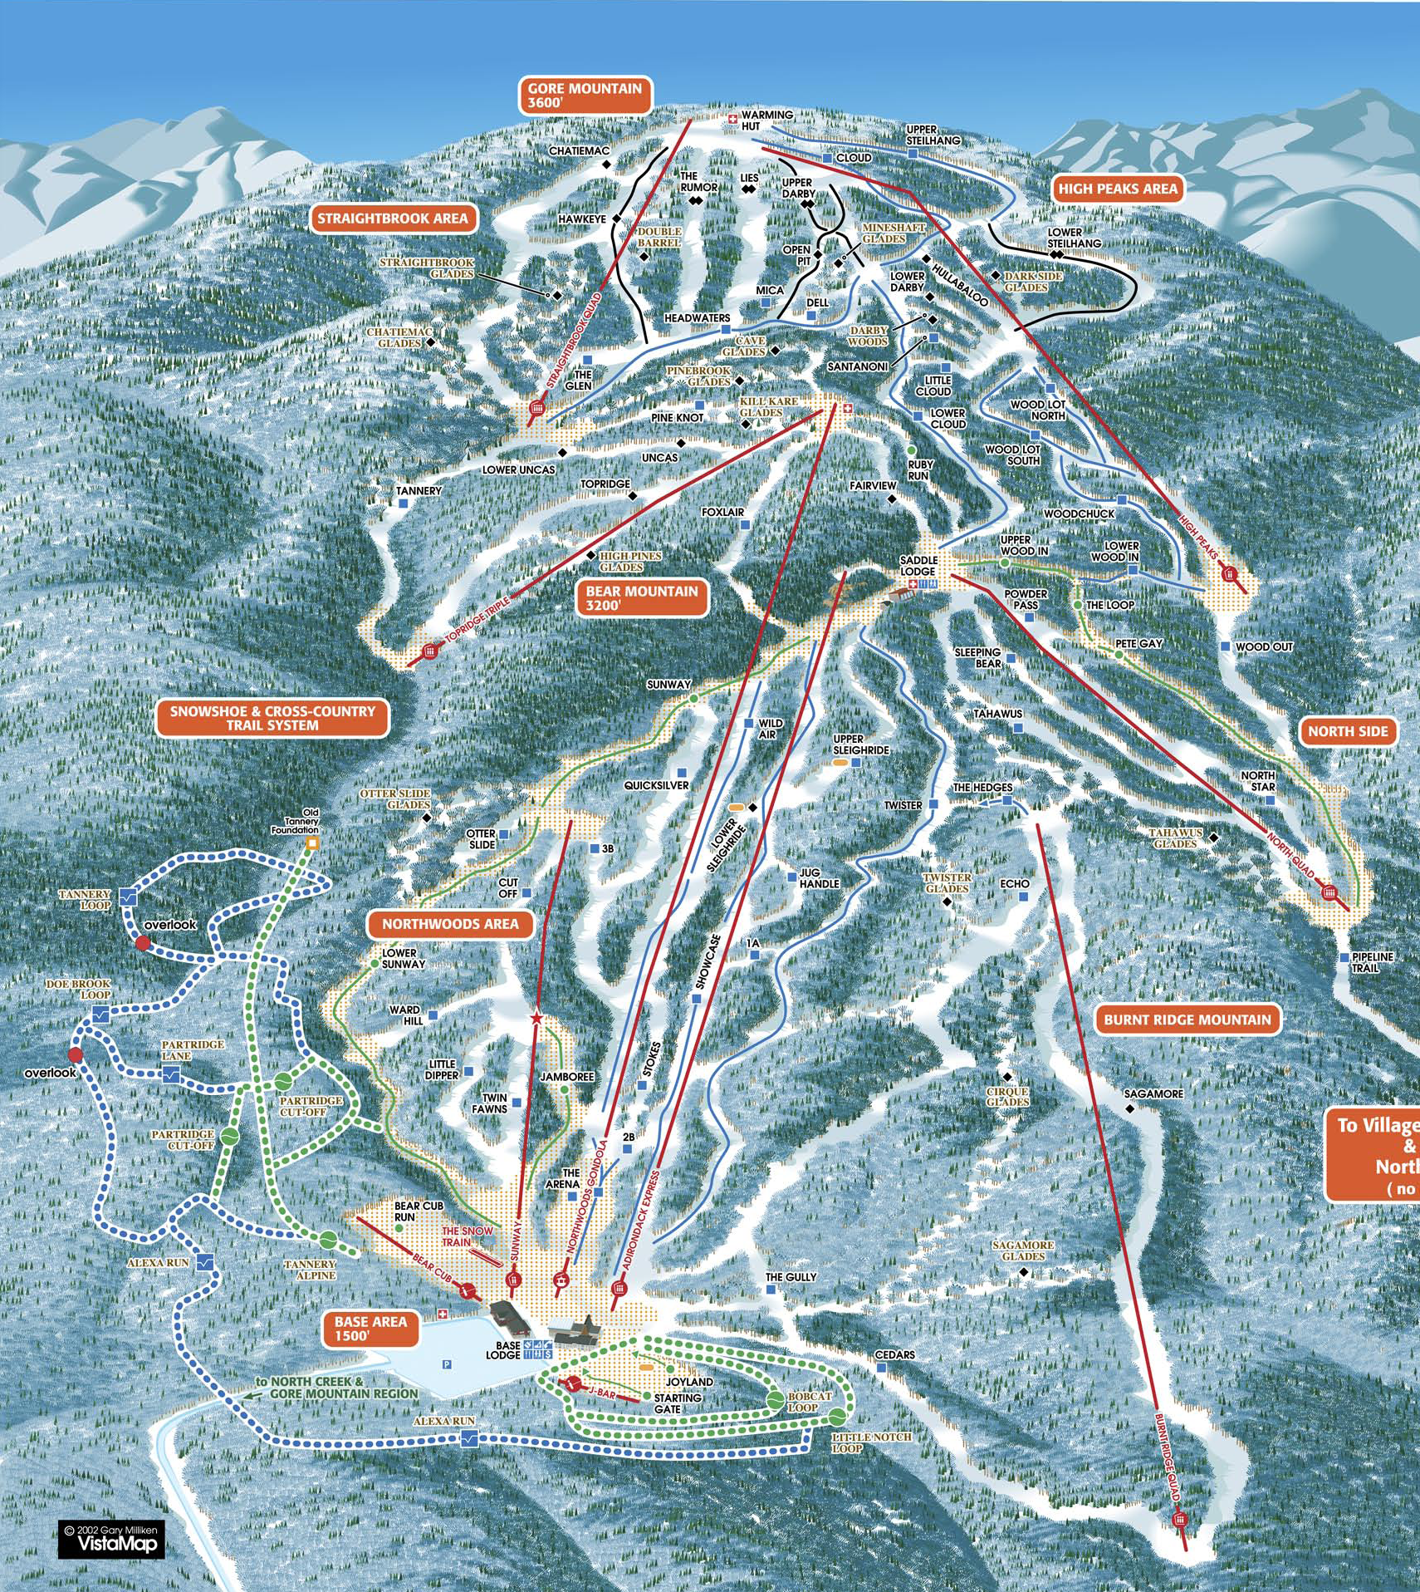

Report
While the plan for this trip probably changed the most I have ever seen, both before and even during the trip, it actually worked out really well in the end. I would actually say that of the four weekends that Venturers have been to the Adirondacks this winter, we had by far the best conditions. It is unfortunate that we could only get three Venturers (Ben, Max, and Alex) to participate.

Everybody was ready on time and we were able to get quickly packed and on the road. We didn't have much to pack, just a stove, lanterns, and some cookware. Even though the kids were planning on sleeping in a shack, I had them throw in a tent just in case. Crossing the border was easy, even though the US border guard (for the first time) asked to see our “take your kid out of the country” permission forms. Max didn’t have his proper form, just a note scribbled on the back of a Wal-Mart receipt!

Our first stop was The UPS Store in Ogdensburg. The kids are used to visiting this place and hunting for parcels. On this occasion we were picking up a replacement tarp for the Valley Highlands area marquee. It was damaged during our polo canteen by the wind and the area were purchasing a new one. While the area isn’t asking us to pay for the tarp, it was the least we could do to pick it up for them; and bring it back into Canada duty free.

We then settled down for our drive to Keene. With the recent huge snowfalls, we discussed the idea of going to Jay Peak instead of Gore Mountain for our ski day. Based on people’s previous experience with Jay, it was an easy decision even given the estimated three hour drive from Keene to Jay Peak. At this time the lads started talking about the upcoming gold medal hockey game, and somehow we figured out that we could watch it at Jay Peak after our skiing before we came back to the camp. Talk about a convoluted trip!

Upon arriving at the ACC (Alpine Club of Canada) property in Keene, the Venturers immediately noticed that somebody had already moved into “their” shack! They were extremely upset. To add insult to injury, the people were just using it for sleeping, and hadn’t tarped and heated it like our guys do. Lucky we had brought tents. We set up camp, and then I invited the lads into my tent (which was being heated with a propane lantern) for munchies. We sat around and chatted for about an hour before we hit the sack. It was only just below freezing during the night, so this wasn’t hard core winter camping.

On Saturday morning we woke to another 2” of fresh snow, it had completely covered our tents. That's the first time that has ever happened to me. We set off at 8:00am with a group of Ventures from 2nd Russell for our snowshoe climb up Giant Mountain. There we so many Venturers present this weekend, about 54, the we ran out of snow shoes (expected), so we stopped at The Mountaineer to rent four more pairs for the day. The start of the trail up Giant Mountain is just past Chapel Pond were we have rock climbed before. We started hiking at 9:00am. Initially we were behind a couple from Quebec, but eventually we passed them. They actually gave up about half an hour before the summit. This meant we were breaking trail, through one to two feet of snow, all the way to the summit at 4,627’ (a 3,050' elevation gain). It was really hard work. At times it was so steep and the snow so deep that we were going one step up and two steps back. We made it to the summit in four hours. We could have done it in a bit less, but we kept waiting for the other group that had a not so athletic person in their midst. On one rest break we were eating partially frozen granola bars and I broke a tooth! This was the best climb we have done; even more fun than Hurricane Mountain on our first year. The trip down was a lot easier, with a lot of sliding and jumping being done. We arrived back at the truck in an hour and a half.

Since all our clothes were soaking wet, the kids asked if we could go to a laundry mat to dry them. We asked at The Mountaineer, and they said the closest laundry mat was in Lake Placid. We drove on over and discovered that the directions we received were to an out-of-business laundry mat. We asked again and were directed to the other side of town where we found it. I don’t think I have been in a laundry mat since my days at university; and I have never taken photos inside one before. We ran all our jackets, pants, gloves, and even our boots through the dryers. Alex was fascinated with watching the drying rotate :) It probably only took a couple of dollars and about 45 minutes in total. Actually, we nearly made a profit as the kids found 75 cents in various coin returns. It was nice to be dry again!

As we planned to watch the hockey game, the lads were insistent that we have Canada flags or have our faces painted red and white. You can imagine how hard it is to find a Canadian flag in Lake Placid! We drove around looking for likely stores, and stopped when saw a store with what looked like flags in the window. Upon entering the store, it turned out to be all ladies swimwear or dance costumes :) We asked about flags anyway. The lady actually had a couple of handheld flags she purchased on a trip to Niagara Falls and used periodically in a display outside. She figured we wouldn’t be able to find anything, so she gave us her two flags. Lake Placid people are nice. We checked out a few other stores but couldn’t find anything Canadian, other than a hockey jersey for some outrageous price.

Max wanted to visit the Bobsled/Luge run, so we stopped in there on the way back to our camp. It was partially up a hill, and Ben and I were not too impressed with having to climb again :) But it was pretty neat see the racers tear down the track. It was the general public giving it a try, something like $50-$70 a run. Eventually we pried Max away, and we finished the trip back to the camp. Then we cooked the chicken burgers for supper and we turned my tent into a dental surgery.

My dentist and I already knew this tooth had a problem, and I was scheduled for a crown on Tuesday. But it couldn't quite last the until then. I wasn't in pain, but the remaining tooth was sensitive. When I upgraded our first aid kit for the Lievre River canoe trip last summer, I included an emergency dental module. So I figured this was the time to put it to use. I didn't want to risk the tooth getting worse during the remainder of the trip. So I appointed Ben the dental surgeon and Alex took on the photographer role (got to have slideshow material!). Incidentally, this years slide show is viewable at http://www.youtube.com/watch?v=TWSeMfuHmSY). We heated up my tent with a propane lantern, and started work. Ben applied Clove oil to the remaining tooth, this is an anesthetic. Then he covered the exposed surfaces with a temporary dental filling material. It hardens in a few minutes and it was still holding strong on Tuesday. It was a good learning experience to see how some of our first aid materials worked, and fun for Ben. My dentist was impressed with the dental work; he thought a real dentist had done the work. He said never in his 30 years of practice had he seen a non-dentist repair job. He said Ben should think about taking up dentistry. The only suggestions my dentist made were to wet the gloved finger so the filling material would release easier (Ben said it kept sticking to his glove), and that an emery board could be used to smooth the sharp edges of the broken tooth (need to add that to our first aid kits).

We were up and going by 5:30am for our trip to Jay Peak on Sunday. It was pretty easy driving and we made it in 2 ½ hours. We had decided that making breakfast before we left wouldn’t really work, so we stopped at a small café in Montgomery Center just behind Jay Peak for breakfast. The food was OK, but it was certainly luxurious to be served hot coffee. We then finished the run to the mountain, and purchased our lift tickets (Max bought his own). Unfortunately it turned out there was a coupon on Jay’s website for $20 off that we didn’t know about. Then up and away we went.

The snow and weather conditions were impeccable. Tons of powder and a park full of huge jumps for the kids (my board stays on the ground!). No wind, even at the top of the Gondola, so there was even powder up there. Ben and Max tried out the Chutes off the Gondola. They said it was a cliff they were trying to ride down, with an insane amount of powder. Alex learned that he really likes glades. At lunch time we headed back to the truck, made up wraps, and brought them back to the lodge to eat. I found out the kids prefer iced tea drink crystals over lemonade, and especially over cherry flavour. Alex and Max switched skis and boards for the last run of the day. I was pretty impressed how well Alex was able to stay upright on the board. The kids said my new goggles looked really cool :) Cheryl have them to me for Valentines day. All in all the most amazing skiing we have had this winter. Well worth the excursion.

Around 3:30pm we called it quits, changed out of our ski equipment, and headed to the new Tram Haus lounge for the hockey game. We arrived partway through the 2nd period, when the score was one - nil. The lounge was absolutely packed and extremely loud. We headed for a coffee bar at one end so we could get non-alcoholic drinks, and found a pretty good standing spot on the stairs in front of one of the televisions. I hadn’t seen a hockey game in probably 20 years. I thought I was going to be bored, but it was nail biting! The atmosphere in the lounge was great, with a lot of rivalry between the representatives of the two countries. It was good to have our flags. The kids agreed it was a lot more fun watching the game there than it would have been at home. We stayed until the medal ceremony and sang O Canada.

Another 2 ½ to 3 hour drive brought us back to camp around 10:00pm. A quick check showed the cabin to be unlocked, I had forgotten to bring the combination from home, so we broke camp and headed into the cabin. Alex started a fire in the stove and Ben started cooking the hamburgers. We really pack our days full. Ben found some Montreal Steak Spice which he added to the hamburgers. The kids all liked the taste and said we should bring that every time. There was a bunch of junk lying around the cabin, including a climbing harness, a sleeping bag, some food, and some very dirty dishes. We weren’t sure if they all belonged to somebody or had been left behind. We got to bed around 11:30pm.

In the morning we found a stranger sleeping in the living room of the cabin! Alex said he thought he came in around midnight or so. He didn’t get up while we cooked breakfast and tidied up, so we still don’t know which stuff belonged to him. He was a mystery from Delaware. Upon talking with Christiaan, this guy has been staying at the hut all winter; he has a term off from school. His stuff is a mess and he goes out to a movie in the evenings and doesn't get up until near lunch each day. A cabin bum :)

At 8:00am we had finished packing the truck, it was stuffed full now as we were transporting 36 pairs of snowshoes, and drove over to Rock and River, our ice climbing guide company. When we arrived we found only one of our guides had arrived. As well, so much snow had fallen that the multi-pitch route we wanted to do, would possibly be too dangerous and would have been more of a snow climb than an ice climb. The owner felt so bad, he only charged us $50/person instead of the $130/person for which we had planned. This is even less expensive than the group rate of $85/person we paid last year. So while we didn’t get to do our desired multi-pitch route, we did get a very sweet deal. And it means we will just have to go back again one day :) Because we were still officially on private guiding, lunch was also included. We gave a sandwich order to the cook, and the sandwiches and a table full of snacks showed up from which we could pick whatever we wanted. Mothers should take note :)

We ended up doing our climbs in a canyon off Chapel Pond. These are 100’ high. We brought along our Canada flags and planted them at the tops of our climbs in honour of our victory. This brought a quite a few comments from a few other climbers who were present :) We climbed from 9:00am until 2:30pm. The climbs were a lot more challenging, especially physically, compared to what we did last year. They were a lot of fun. By the end our arms were so tired we couldn’t swing the ice axes anymore.

We loaded ourselves back in the car, and departed at 3:00pm. After three days of continuous exercise we were exhausted; both our arms and legs were sore. By 6:30pm we were in Merrickville, where we unloaded the truck and divided up the gear for cleaning and drying. Everybody was picked up or dropped off by 6:50pm.

Final costs:

Max: $170
Ben: $170 + $50 lift ticket = $220
Alex: $170 + $50 lift ticket = $220; paid $266 thus $46 refund
Allan: $170 + $70 lift ticket = $240

Date | Item | Category | Revenue | Expense
23-Feb-10 | Winter Adventure, Alex | WinterAdventure | $266.00
23-Feb-10 | ACC fees | WinterAdventure |  | $75.00
26-Feb-10 | Food | WinterAdventure |  | $50.00
28-Feb-10 | Drinks during hockey game | WinterAdventure |  | $18.00
28-Feb-10 | Jay Peak lift tickets | WinterAdventure |  | $171.06
28-Feb-10 | Sunday breakfast at diner in Montgomery Ctr | WinterAdventure |  | $34.05
1-Mar-10 | Bridge tolls | WinterAdventure |  | $6.00
1-Mar-10 | Ice climbing, Rock and River | WinterAdventure |  | $227.02
1-Mar-10 | Mileage, 1,043km | WinterAdventure |  | $260.75
1-Mar-10 | Snacks | WinterAdventure |  | $14.28
1-Mar-10 | Snowshoe transfer cost from event budget | WinterAdventure | $50.00
3-Mar-10 | Winter Adventure, Allan | WinterAdventure | $240.00
 | Winter Adventure, Ben | WinterAdventure | $220.00
 | Winter Adventure, Max | WinterAdventure | $170.00
 | Winter Adventure refund, Alex | WinterAdventure |  | $46.00

