My daughter and I had a successful cruise out of Blind River earlier this summer. After recommendations from some of the folk we met at the time, our desire was to see the eastern end of the North Channel. Thus we planned a six day cruise starting from Little Current on Manitoulin Island.
The boat is Wayfarer W728, purchased by my late father, Frank Yates, in 1972 from the late Wallace Schwenger in Kingston. This Wayfarer has a wooden hull, deck, and spars, with all its original fittings. Cruising modifications are limited, and mainly consists of numerous stainless steel eye bolts tucked under the gunwales for easy attachments of fenders, storage bags, and water bottles. While we sleep on the floor boards, all cooking is performed on shore.
Cruising equipment includes:
- Grapnel anchor with 150’ of rode
- Hans Gottschling canvas boom tent
- Self-made mosquito netting tent
- Honda 2.3 HP 4 stroke outboard motor w/ eight litres of fuel
- Main sail with single set of reefing points
- 50 Amp-Hour LiFePO₄ battery for lighting and charging
- TrakMaps printed chart w/ case
- Navionics electronic chart plotter on an iPhone
- Portable VHF marine radio
- LED light string under the boom
- Anchor light
Camping equipment includes:
- 15’ x 15’ silicone nylon tarp from Cooke Custom Sewing
- Sleeping bags
- Sleeping pads
- Svea white gas stove
- Folding table
- Collapsible chairs
The always fun challenge is pulling the gear out of the bow compartment every afternoon, and loading it back in every morning.

Day 1
Spider Bay Marina, operated by the local municipality, at Little Current is an excellent departure point. There is private marina, Boyle Marine, next door, however they do not appear to have a launch ramp. The staff are very friendly with an inexpensive $5 ramp fee, along with $5/day parking the includes both the vehicle and trailer. Lots of available parking. The marina and ramp are well sheltered with a good dock.
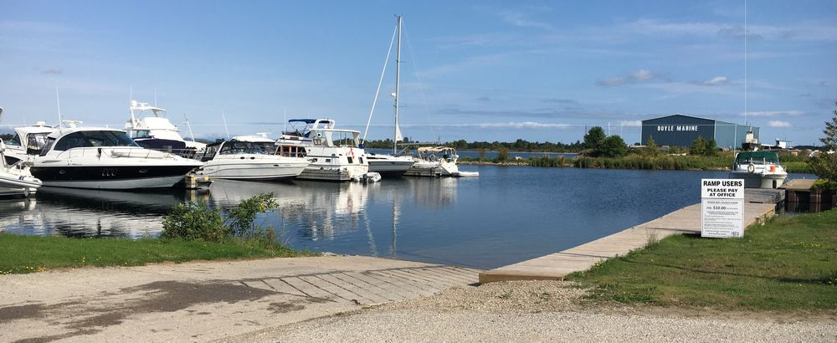
The first day was intended as short, due to a later start time from the travel to Little Current. Our plan was to anchor at Bedford Island. However, upon arrival we found it to be treed all around the shore, with no nice, exposed sections of granite. Thus, while fine for a keel boat, not great for a dinghy wanting to camp. As the day was still early, we decided to check out anchorage possibilities further west, in the hope of finding the granite we had come to love during our previous cruise. We found a couple of possibilities on Bears Back Island, but nothing that really grabbed our fancy. It had some promising promontories, though it was all sedimentary rock, and not that great protection.
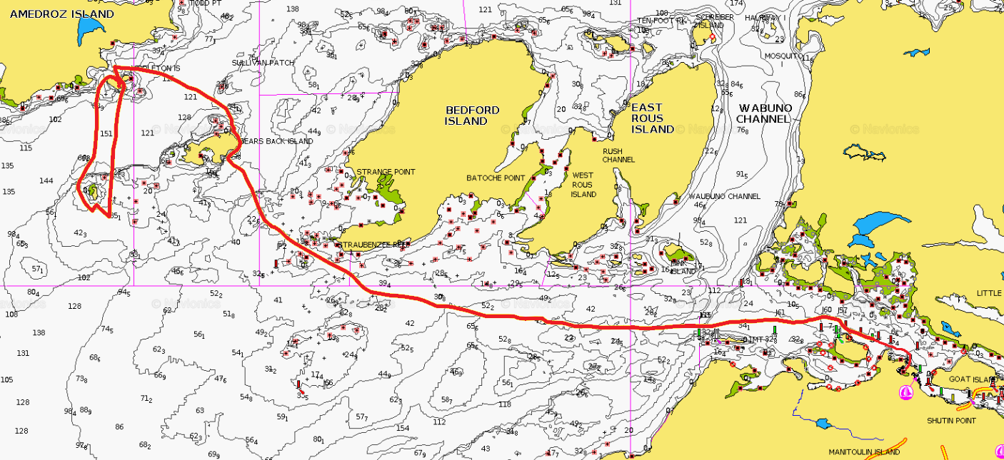
So, on we moved to Amedroz Island, specifically Middleton Island off its coast. Circling these, we found a nice little bay, away from the keel boat anchorage, that of course only a dinghy could enter. Great views and solid granite.
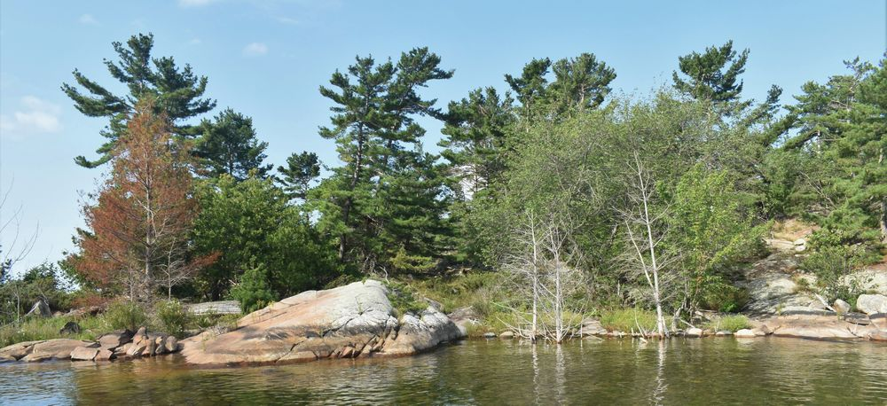
As it was still early, we did a circumnavigation of Elm Island before landing. Total distance sailed of 13 NM over 4 1/4 hours.
The bay was entirely sheets of granite on the bottom, and quite shallow, so I walked our grapnel anchor out and dropped it into a crack. Rock solid! This anchorage was the only one on the cruise where we had a vertical rock race against which to moor. All other anchorages had shallow sloping rock, which is much more challenging for the deployment of fenders.
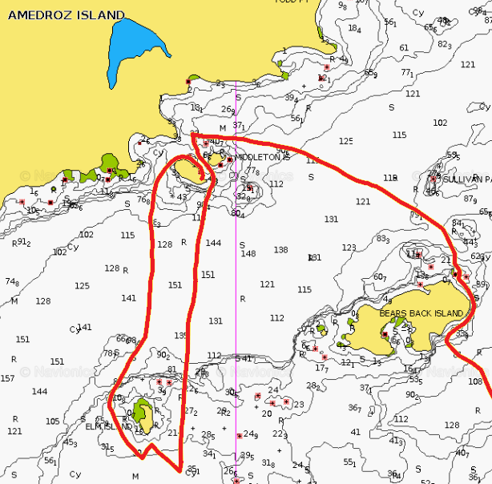
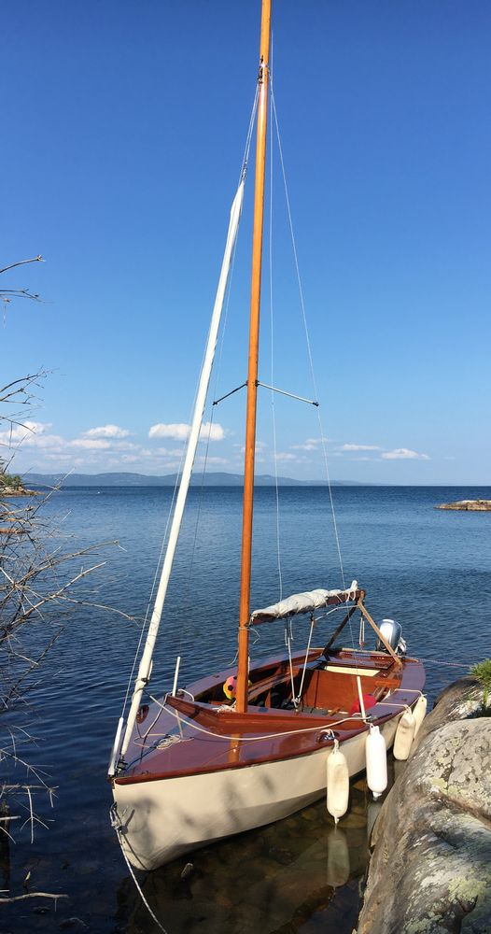

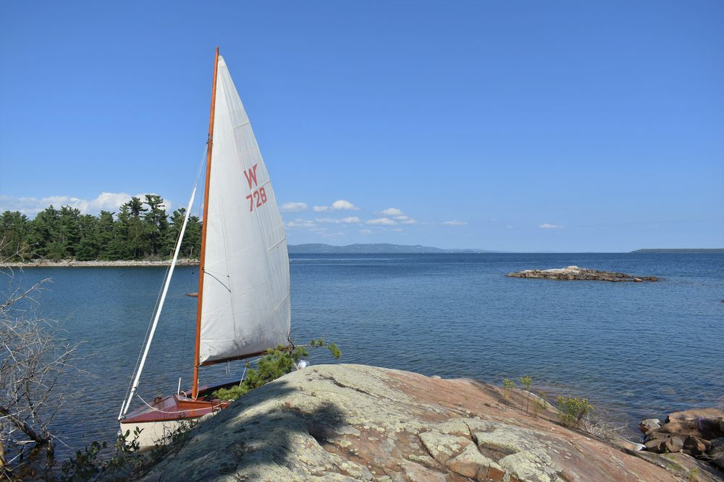
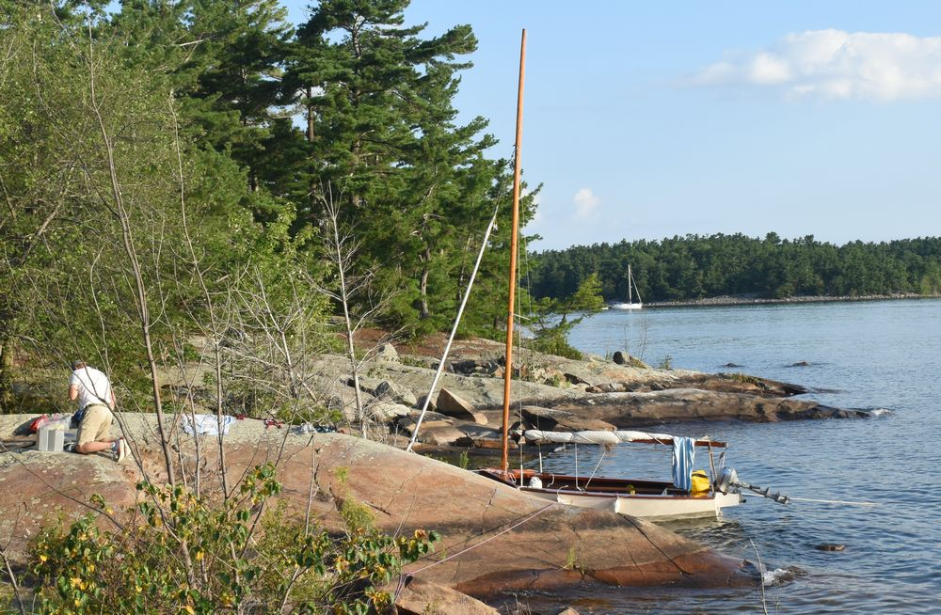
The one unfortunate part of this anchorage, was the night time view of the dozens of flashing red lights on all the wind turbines on Manitoulin Island.
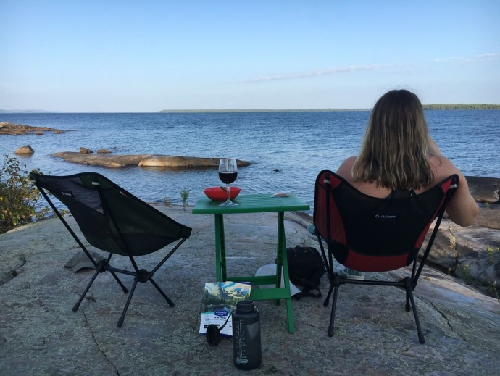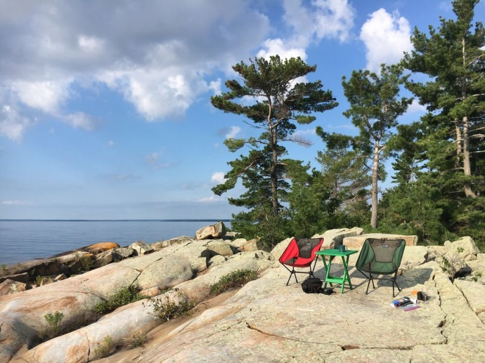

Keelboats
I suspect making fun of keelboats is a popular pastime for dinghy sailors. Those guys seem to use any excuse not to sail. Too little wind, too much wind, wind in the wrong direction, wrong colour of wind; you get the drift. I totally get they can be constrained to a channel, and if the wind is head on, well, they are going to have to motor. But when there is a nice 10 knot breeze, and they would be on a beam reach, there is no excuse. I will fully admit, that if the wind drops completely, I will fire up the motor rather than just sitting going nowhere. We did follow a keel boat one day with its spinnaker up; it looked nice. When we were returning to Little Current, a keel boat coming up the channel looked to be preparing its spinnaker for raising.

Day 2
Great wind today, departing Amadroz Island, with a destination of Croker Island. Total sailing of 14 NM over 4 hours.
Sometimes on our tracks, a drift will be noticed at times. We have come to love heaving to, being amazed at how quiet the boat becomes. The Wayfarer itself we find heaves to easily, with a closely hauled main.
The bay at Croker Island is extremely sheltered, with a couple of trawlers and three keel boats anchored. The anchorage is quite large, so they were well spread out. There is a nice little rock island in the middle of the anchorage with a large flat surface, which would have made a great camp. However, we opted for the shore of the main island, which after a fairly steep climb, gave us access to the top of the rock hill, with great views to the west.
Stuck in their protected anchorages, surrounded by trees, keel boats, IMHO, miss out on a lot of the best views. Though giving due, a couple from one of these keel boats were hiking up one of the hills upon our arrival, and brought their chairs to the top of our hill for coffee after dinner. But this is the only time we have seen this. There is though, a well-trodden path up to the top of this hill.
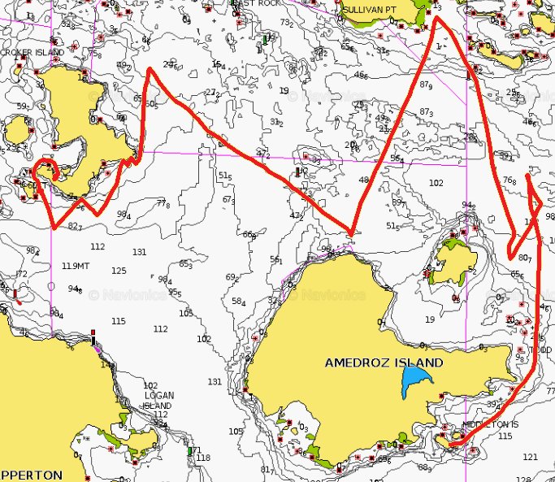
We did have a problem with our grapnel anchor holding in the mud and weeds on the bottom. Like most nights, we had the anchor and a line shore. However, when we pulled on the shore line to tighten up, we just dragged the anchor. Given we were so well protected, this wasn’t too worrying, but it did give food for thought.
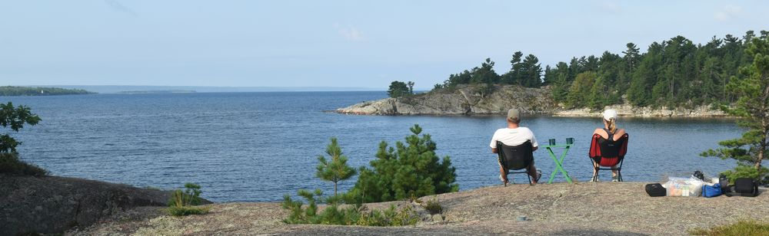
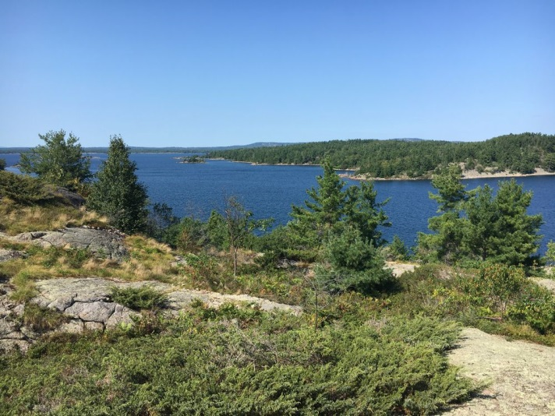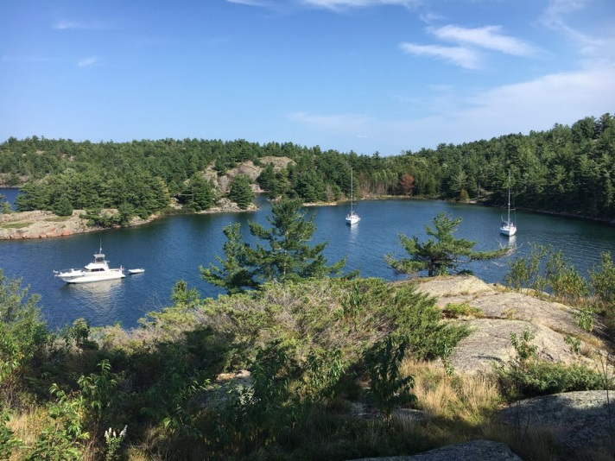
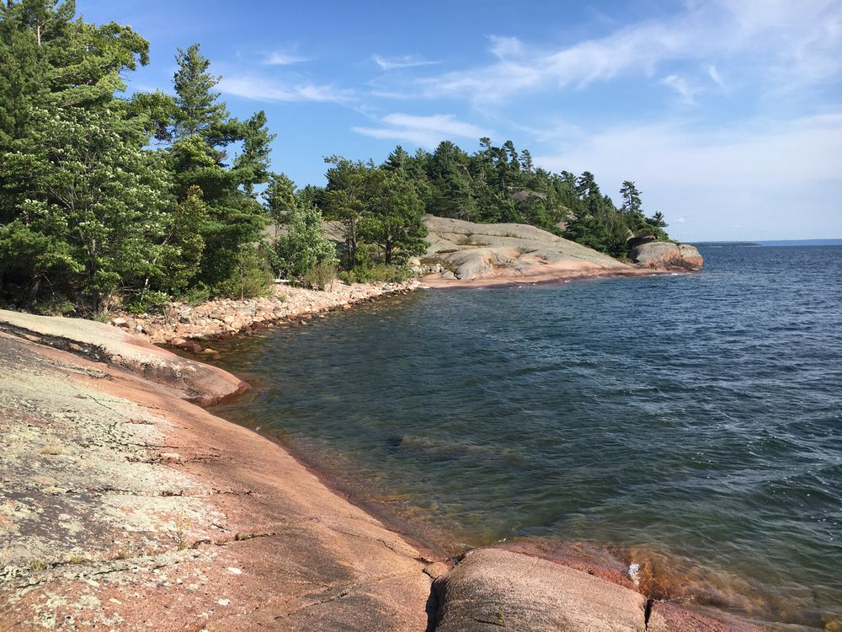

Stove
We use a 40 year old Svea white gas (naptha / Coleman gas) single burner stove. It is awesome; never needs cleaning, and no pumping required. On a one week cruise, we use about one litre of fuel.
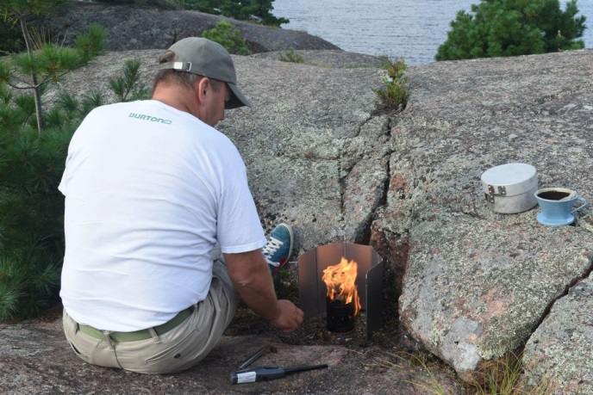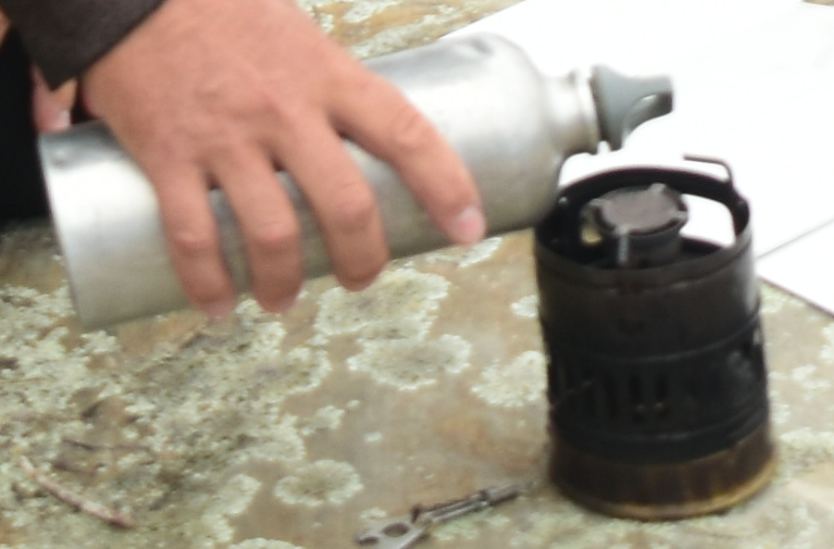

Radio Watch
After hearing a squall warning from the coast guard during our last cruise, while socialising on a keel boat, we decided we should be maintaining a 24/7 VHF channel 16 radio watch ourselves. We found that the battery in our Standard Horizon VHF handheld would last 24 hours if we charged it either during the day or overnight. No squall warnings received this time, but a number of coast guard broadcasts of a strong wind warning.
There was some keel boat social traffic, but on following them to their channel it was pretty lame. “This is X, calling Y. This is X, calling Z. This is X, please somebody talk to me” Well, not quite that bad. Though there was the fellow talking about not being sheltered from the wind, and saying “Its blowing though the, well the, the stuff up there, the mast thing”.
Though at 5:30am, the morning of the strong wind warning, I did hear a trawler calling the coast guard asking for a boost! He had run his battery flat, and wanted an early start. His transmission was breaking up, so the coast guard asked him to call *16 on his mobile telephone. The coast guard came back on broadcasting a maritime assistance all stations, but I was still half asleep and didn’t think of switching channels to see the outcome. To be honest there is no excuse for a motorboat to have both a flat engine start battery and a flat house battery. Though the anchor dragging keel boat from our last cruise also indicated that his batteries were “not working”. I guess there are a lot of folk out there that do not understand the electrical side of their boats.

Day 3
With good winds again, we planned a long day from Croker Island to Fox Island, via a very roundabout route. We came nicely around one end of Fox Island, and then headed for Frechette Island. We could have rounded Frechette Island and headed back to Fox Island. However, the wind was still great so we rolled the dice and made for a circumnavigation of Eagle Island. Unfortunately, this proved to be one island too far. As we came along the far side of Eagle Island, with what should have been a broad reach back to Fox Island, the wind died. We motored most of the remaining distance, then the wind picked up, and we were able to sail into Fox Island.
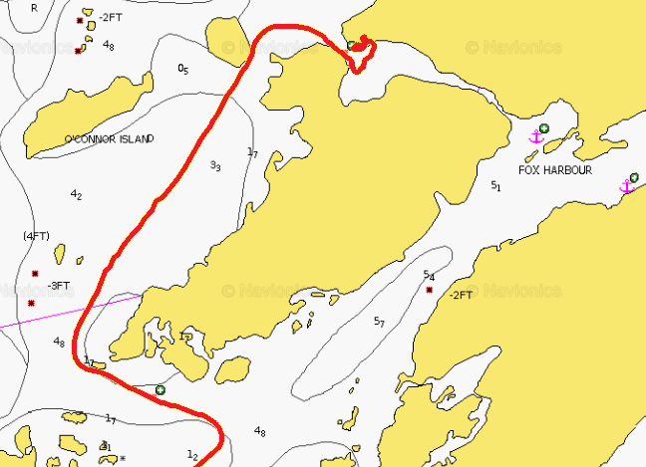
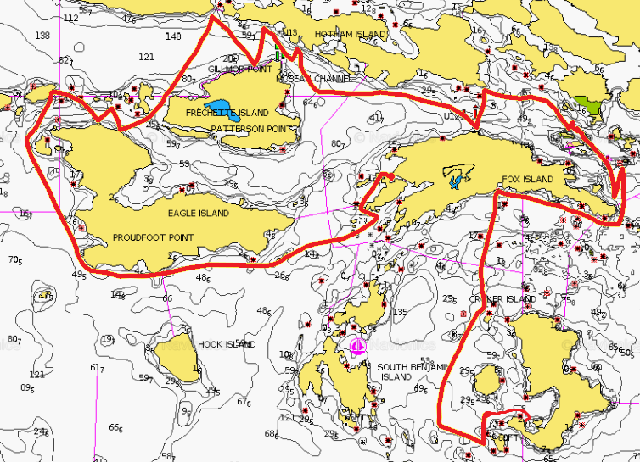
The first couple of anchorages we examined, each had a few keel boats; while we prefer isolation. So we rounded the island to check out a small bay. This was perfect, a narrow, shallow entrance that would prevent all but the bravest (most foolish?) of keel boat skippers from attempting. We moored up against a beaver lodge; we could literally look down a hole into the lodge. This night, as we were pretty much guaranteed to have the bay to ourselves, we just swung from the anchor in the middle. Total sailing of 18 NM over 5 1/2 hours.
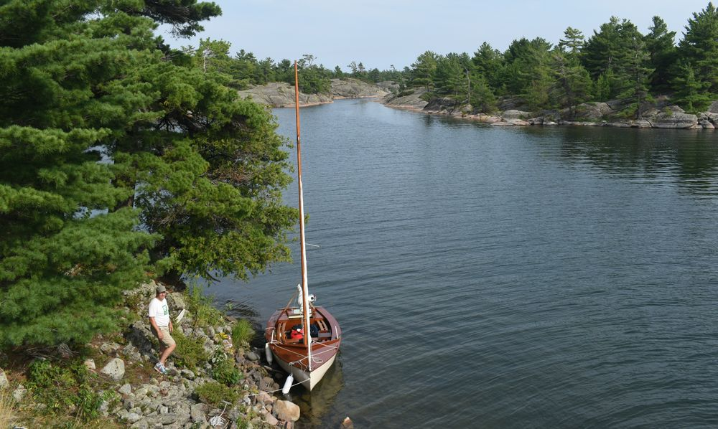
A channel led from this bay into one of the main anchorages, but from listening to a couple of motor boats (runabouts), there is a rock in the middle of the channel that you have to lift the motor over. There was this one really cool guy that came through in a long runabout, with a huge outboard motor, but with just a regular handle on the outboard, though with what appeared to be the throttle on the side of that. He looked to have his family / grandkids and a dog, and just oozed coolness and confidence. We heard them mention “That was the sailboat we saw earlier today”; we’re famous!
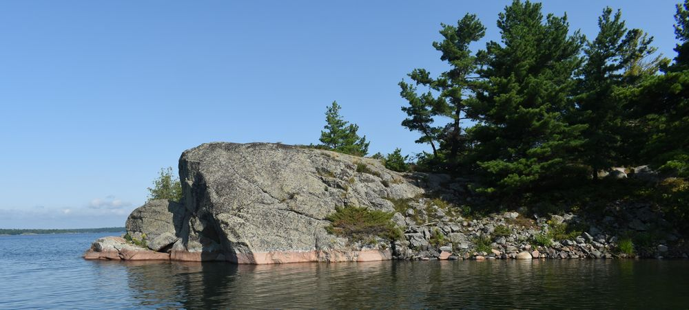
Another steep climb over broken boulders took us to the rock high above the entrance to the bay. There was a fire pit right at the top, and a few trees lower down in a protected bit. Rain was forecast for the morning, so we setup our tarp, with the expectation we might be running for it in the morning. In the end, after another night under out mosquito netting tent, there was no rain at all. Here we used beaver branches wedged under the boat to keep the hull off the rocks.
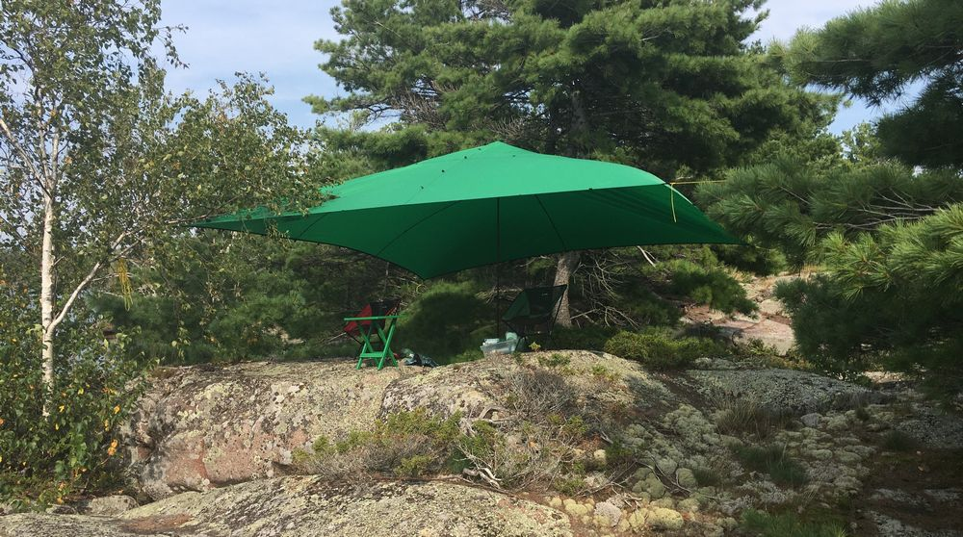
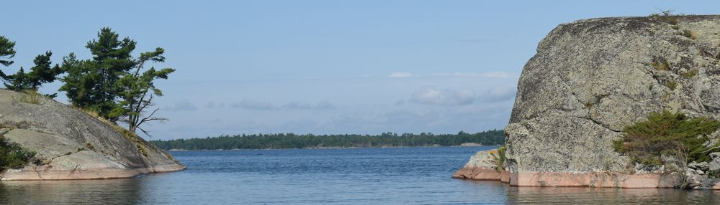
The wind died in the evening, so we had a great fire overlooking the channel. An abundance of wildlife. A beaver that kept getting upset at us and slapping its tail. A mink swam across the entrance, and three mink were playing off a little island and swam to another island. A few ducks did the same.
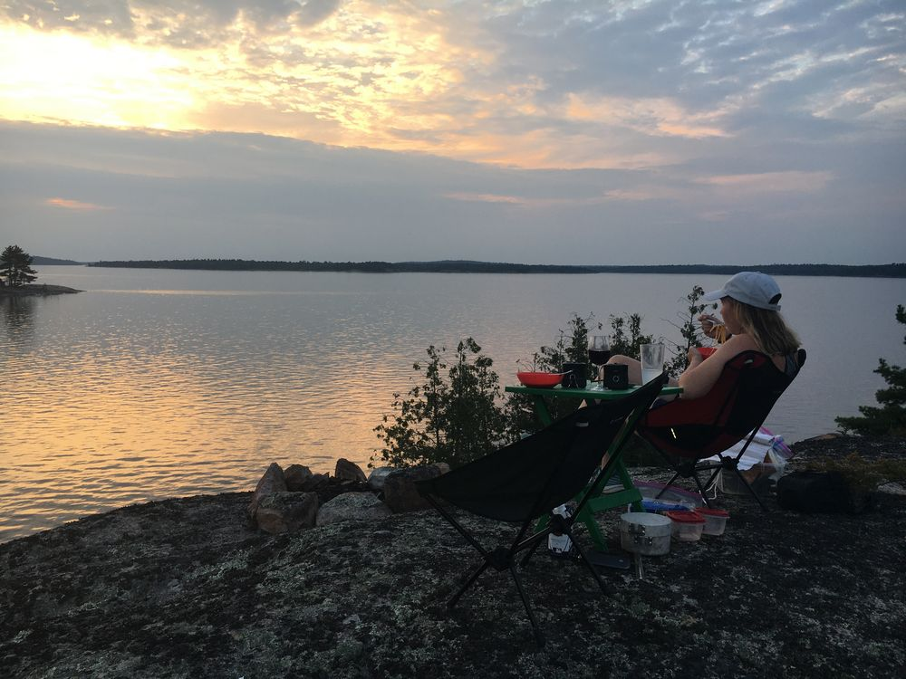
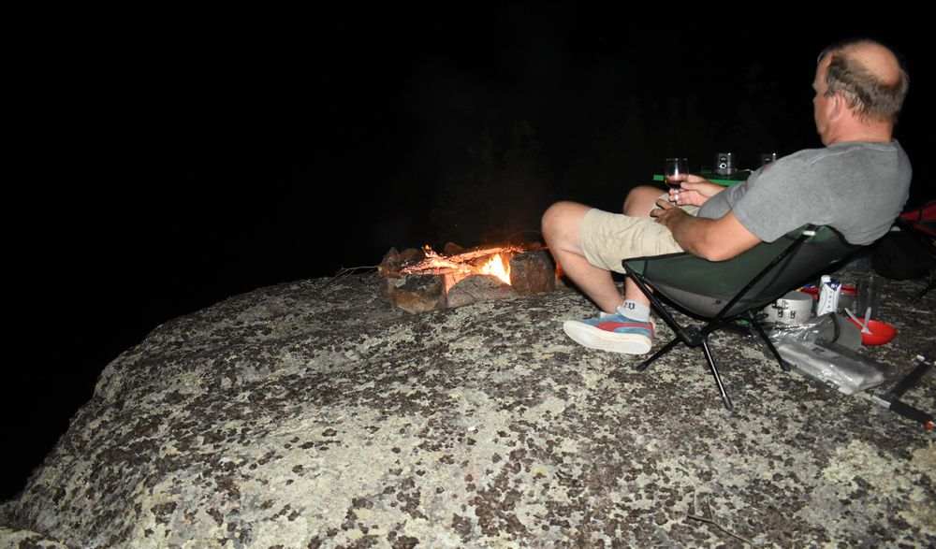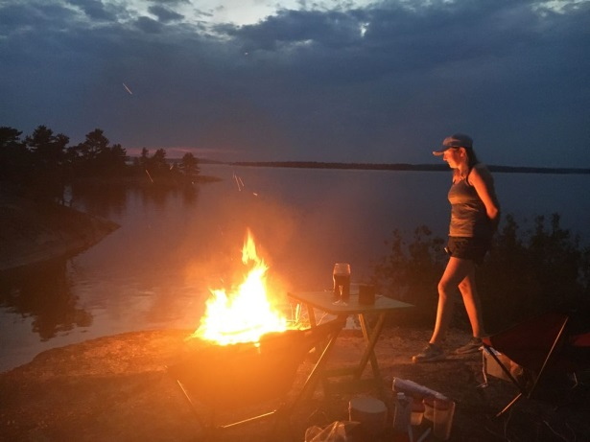

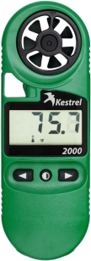
Anemometer
Having always wondered about how the real wind speed was matching to boat performance and our comfort level, I had added a Kestrel 2000 Anemometer to our kit. This worked out really well, telling us we were comfortable sailing in 15 knot winds. It also showed us that the morning of the strong wind warning, that the winds were peaking at 21 knots.

Day 4
Yet more good wind, and a circumnavigation of Innes Island, as we sailed from Fox Island to the Benjamin Islands. North and South Benjamin Islands I think are viewed as the pearls of the North Channel, and with good reason. Surprisingly there weren’t that many keel boats at anchorage, though we did see a couple of groups camping. We covered 20 NM today over 5 1/2 hours.
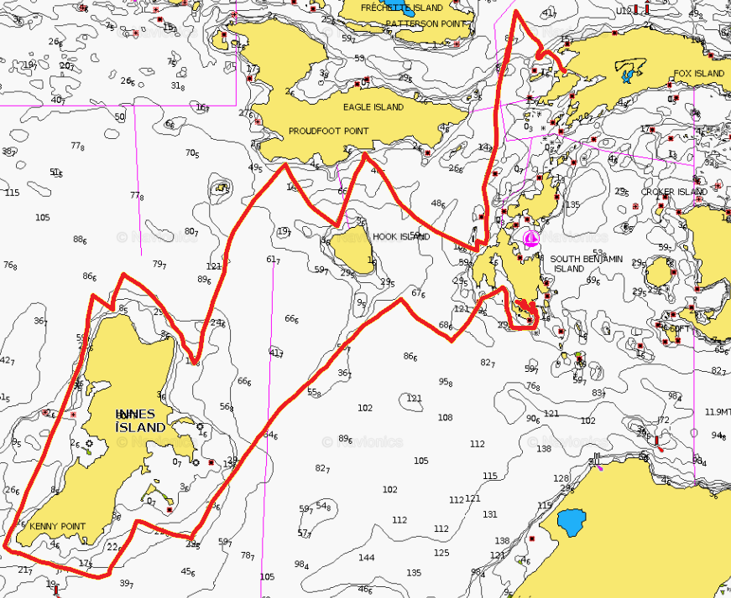
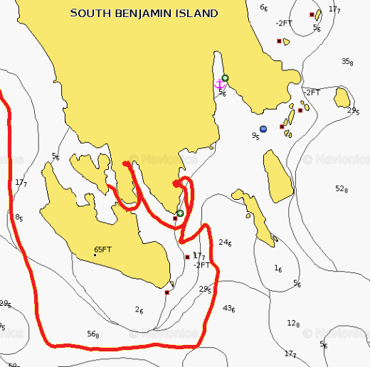
Wanting again to have a more isolated anchorage, we checked a few possibilities on South Benjamin Island. The first didn’t look protected enough, the next had a cliff that was way too hard to climb with camping gear, but eventually we got inland enough to find the perfect spot. We would be nicely sheltered from the expected wind, and we had learned how to tie a rope to the fenders to pull them partway under the boat such that they would hold the boat off the shallow sloping rock in these areas.
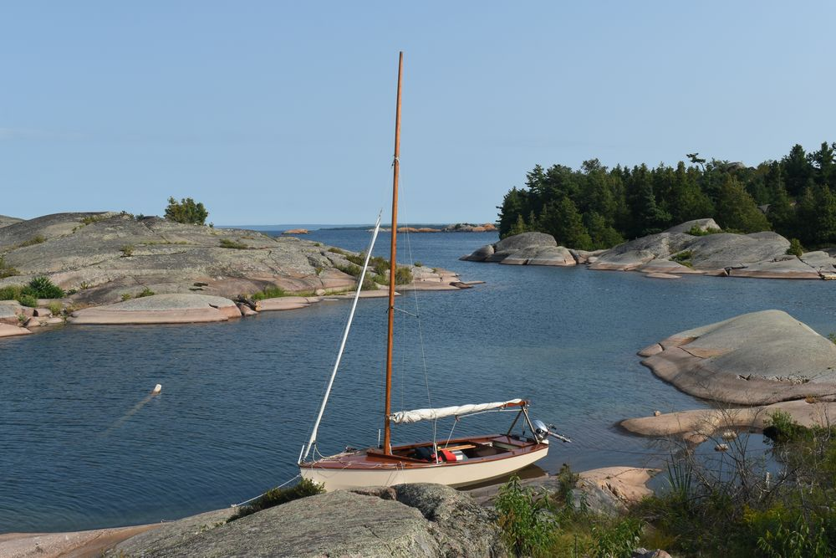
There was then a gently walk up a slope of rock to a hill that had beautiful views of both east and west. As it was boiling hot, 30+ °C yet again, we setup up the tarp as a shade from the afternoon sun. After worrying for a bit how we could still get a view to the west, we found that if we turned around, we had a beautiful view to the east, with no blinding sun! This was by far the best anchorage.
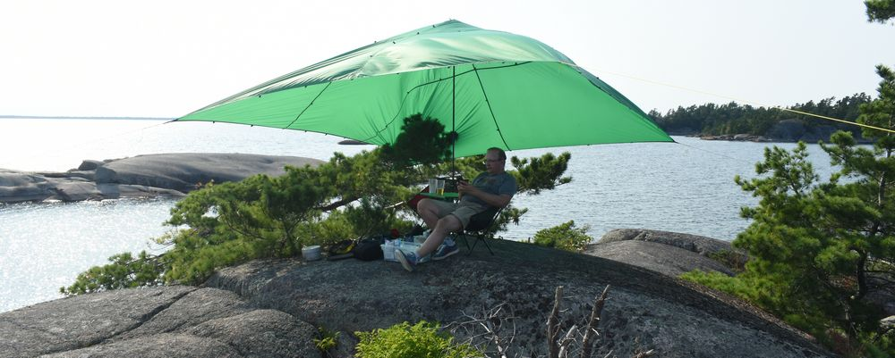

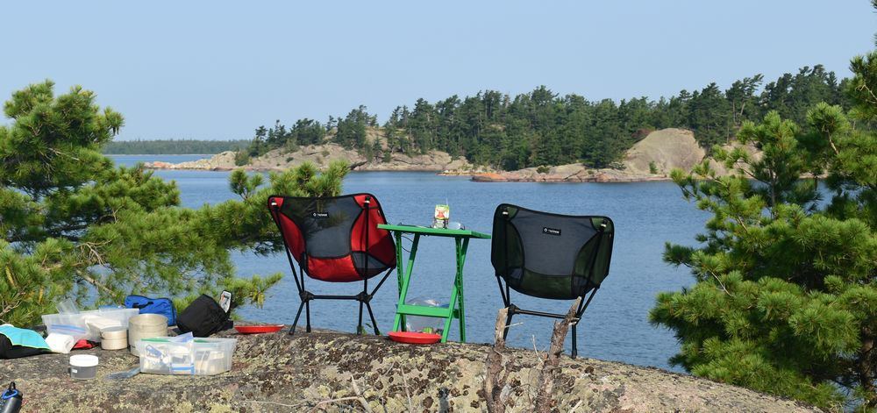
The wind was picking up overnight, and with no rain in the forecast, we struck the tarp once the sun had dropped. Quite a few rubber dinghies paraded through, one quite overloaded with some drinking going on. The next morning there even appeared to be a number of day tripping motor boats showing up.

Anchor Light
While few boats appeared to every move around the north channel at night, we did always display an anchor light. A light nylon harness supports the light, cord down, from the jib halyard.
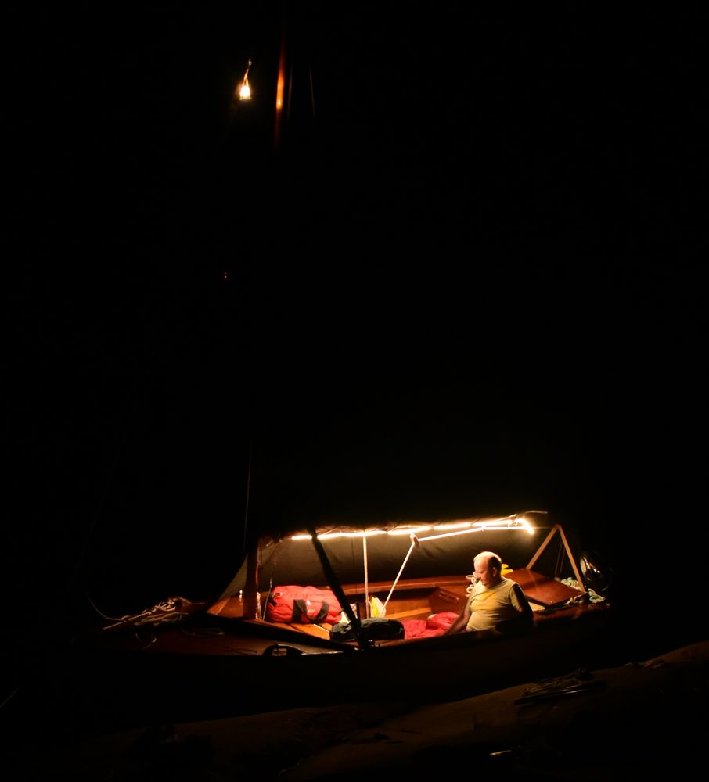 |  | 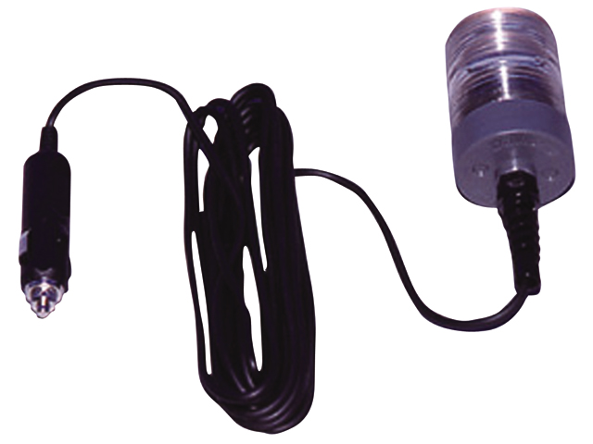

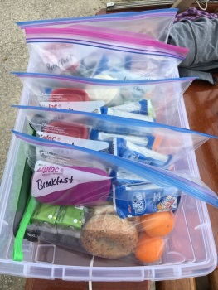
Meals
All meals, breakfast, lunches, and suppers, are prepared and packaged in individual Zip-loc bags. These are all stored in the stern compartment, where all ingredients for any give meal can then be quickly pulled out and taken on shore. The Zip-loc bags then serve double duty as holding all rubbish from the meal. Lunches were finger food such as cheese and pepperettes, that could be eaten easily while sailing. Supper was always a single pot meal for ease of cooking & cleaning. Naturally a full stock of beer, wine, and coolers!

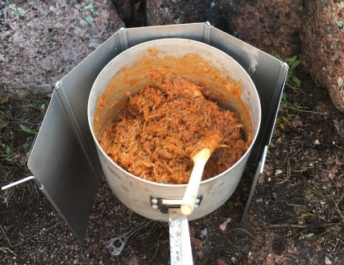
Day 5
With no wind in the morning, we motored completely around the Benjamin Islands, to give them a once over. They are really nice. All crown land except for one small bit.
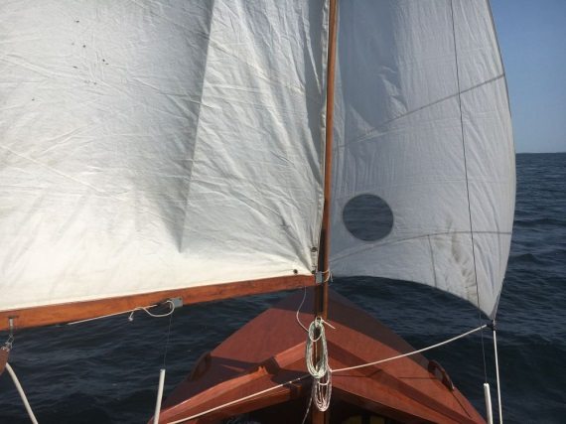
Runs are finicky, with the jib often wondering what to do. So we instead did a couple of broad reaches, with (mostly) intended gybes along the way. A broad reach (or a run) often feels like the boat is going nowhere.
But a quick check of the Navionics App showed that we were doing a solid five knots! We basically followed a marked channel as we skirted the La Cloche islands, to avoid a suite of rocks shown on the chart, but upon further investigation we think those were all well below the surface. The anchorage requirements for tonight were challenging. The wind was forecast to veer from west though north over to east, hitting 20 knots. Additionally, we were trying to get close to Little Current as the next day we were scheduled to be completing the cruise. We also wanted a nice island, with great views, for the last night.
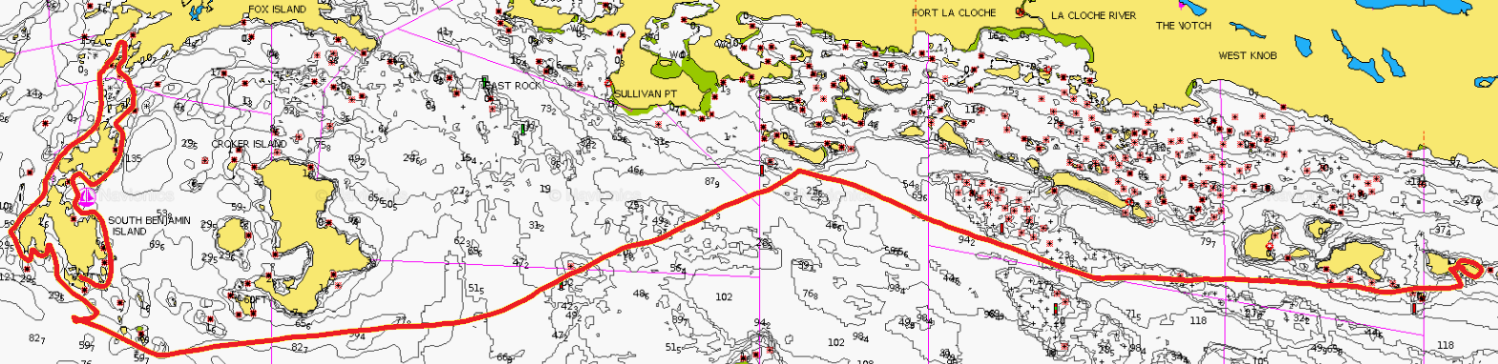

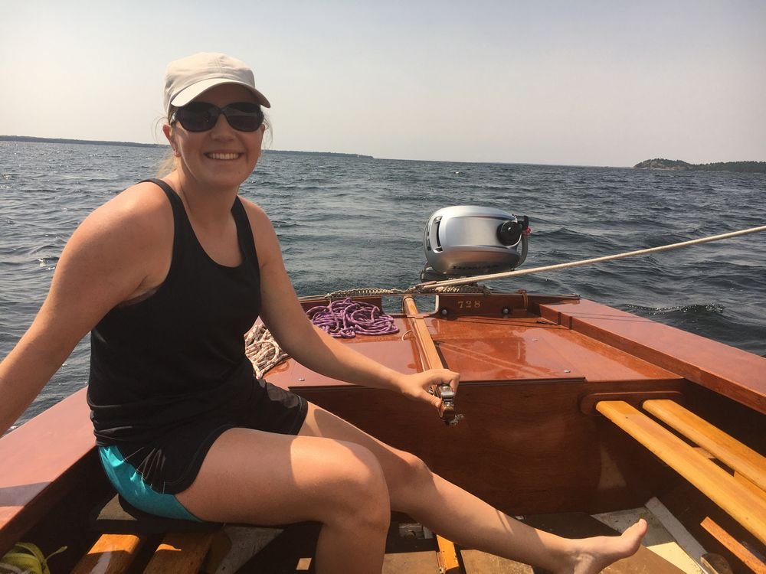
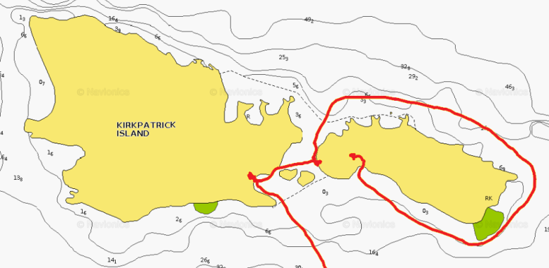
The chart showed a couple of possibilities on Kirkpatrick Island, but in person they weren’t very well protected, and not good for camping. But the next little island had a bay showing in Google satellite imagery, that did not show on the chart. This turned out to be a cute little Beaver pond bay, with only a small entrance facing south. We were able to scoot in perfectly. With the strong winds forecast, rather than use the anchor, we had painters bow and stern to either side of the pond.
Total sailing of 18 NM over 5 1/2 hours.
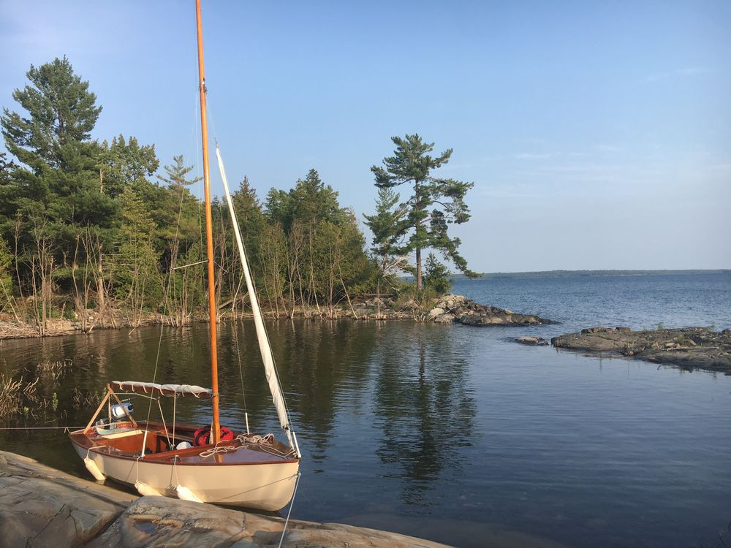
This is a great little location, with large rocks right around the island, so it was easy to move around to get the views we wanted, and to also get sun or shade as desired. With an immense amount of dead/dry driftwood, we had a nice fire in a natural fire pit. This was the first cloudless night, so a little star photography was also had.
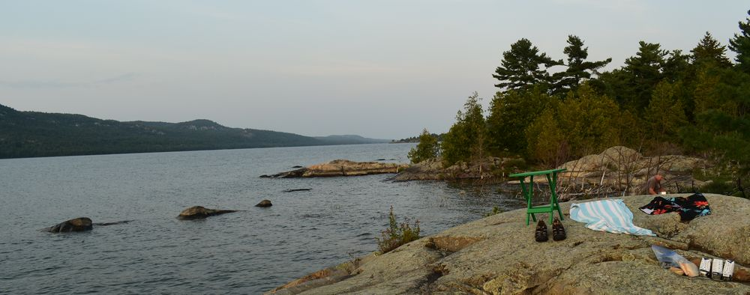
No rain was forecast, so again we had the mosquito tent on the boat. The wind had been light from the west, but just as we boarded the boat for the night, it suddenly increased to 20 knots from the north. While we had good wave protection, we didn’t have wind protection from the north. The wind was pulling the jib out from its roller furl, so we dropped that completely and stored it in the cockpit. As the wind hit the mosquito netting it made this whistling noise, and the boat itself was actually shuddering (it was bow on to the wind).

Lighting
A flexible, silicone coated, LED lighting strip, hung under the boom, lights the cockpit up like daylight. The same LiFePO₄ battery powers the anchor light, and recharges the mobile devices and VHF radio. While we have found the battery will last the full week of the cruise, it can be recharged by a solar panel during calm days.
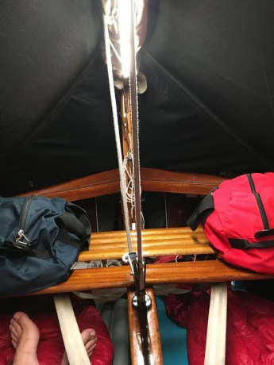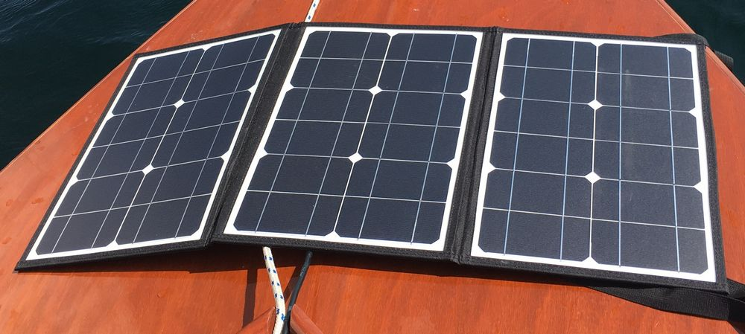

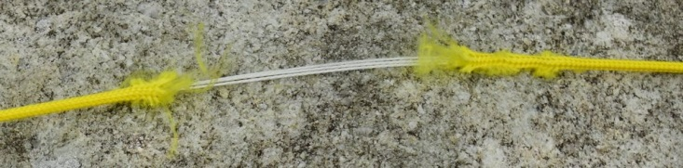
Day 6
We found the next morning the paracord we had used as our second mooring line was nearly worn through from the shuddering where it ran over a rock.
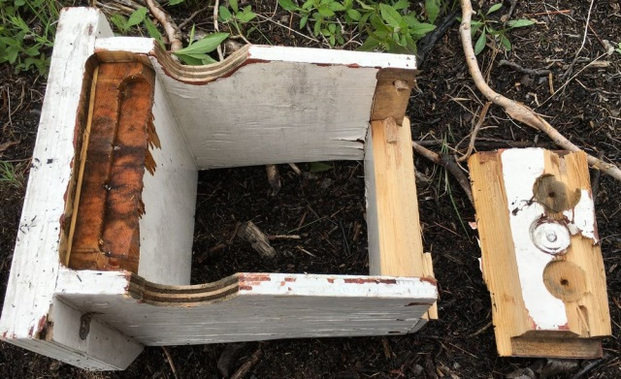
This last morning had the winds measuring 21 knots from the northeast. With this being our expected day out, and the waves not looking bad, we decided to go for it. We paddled out of our cove just fine, started the motor to get us away from shore, started hitting 3’ waves, and the motor mount snapped! As the sails were not set, we were being pushed towards rocks on the lee shore. We started to set the sails, but the saw that with a little paddling, we could redirect ourselves into the first beaver pond we had checked the day before.
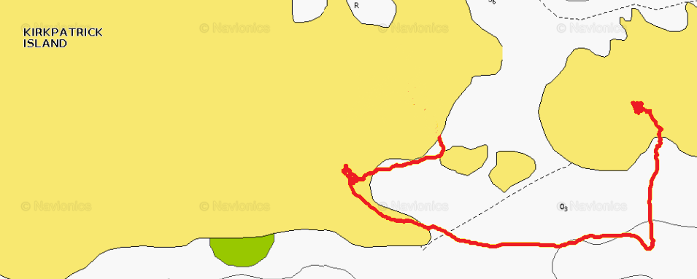
As we slid into there, we jumped into the water to hold the boat off the shore. There was a protected bit just a little bit further along, so we walked the boat to this beach and grounded here. Safe and sound.
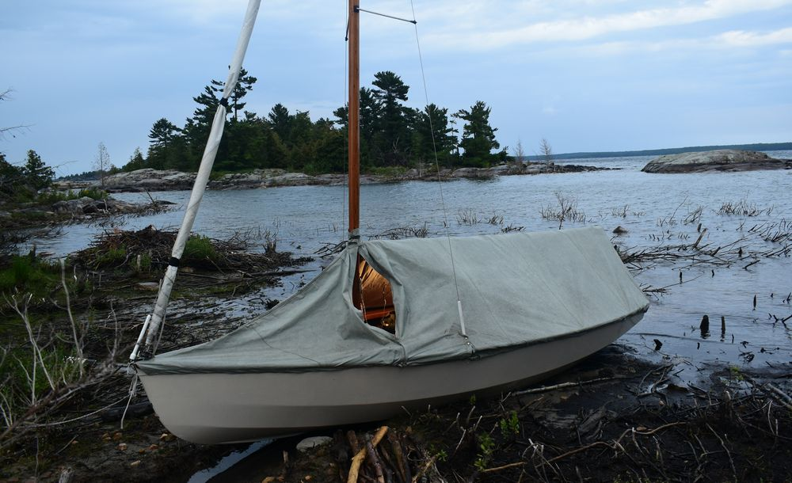
Taking stock of the situation we abandoned the idea of making for Little Current today. We were cold and wet at this point, and rain was forecast. So we found a not bad campsite, with a view of the La Cloche mountains, setup our tarp and got some warm beverages into us. We carry an emergency supply of food, and luckily, we still had several containers of wine remaining. So, we hunkered down for the day to wait out the storm.
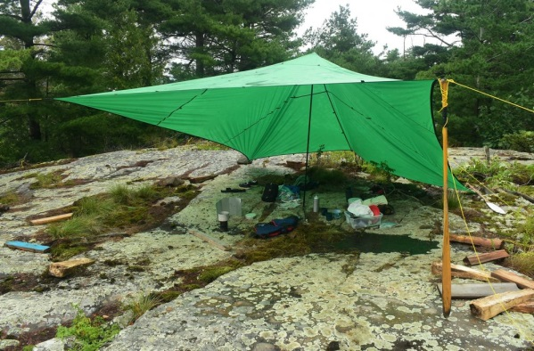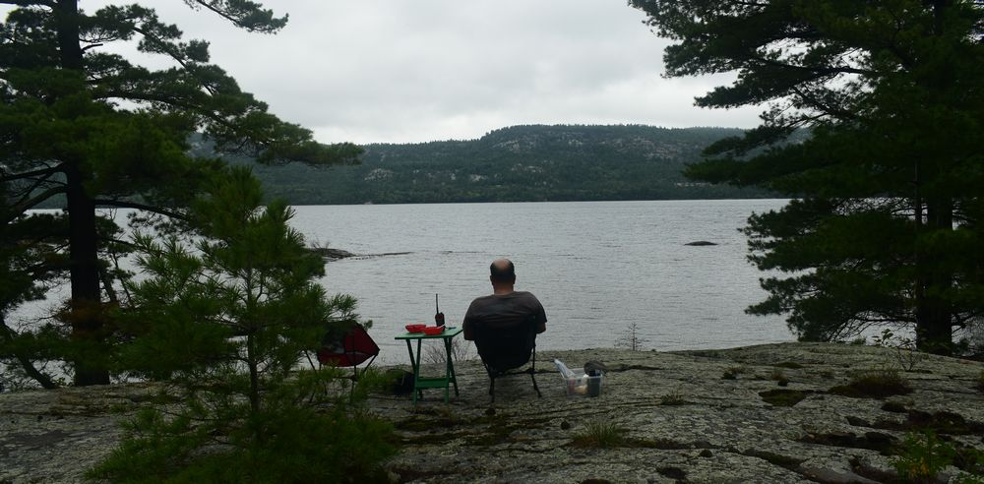
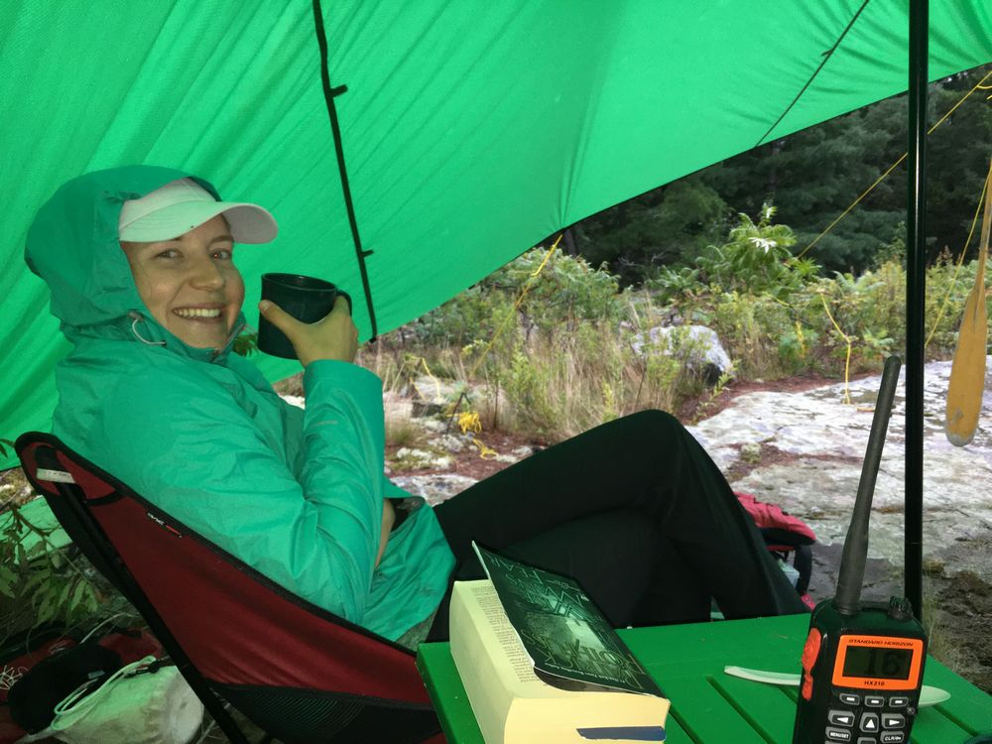
As we had cellular service, we were able to notify people back home that we would be a day late in returning. Heavy rain was forecast overnight, so for the first time this trip we setup the boom tent. It did pour down a couple of times overnight. Interestingly, as the wind shifted, so did the water in our bay. So, the boat went from being just grounded on shore, to being completely out of the water for about ten feet! I was quite worried that we wouldn’t be able to refloat her. However, as the wind shifted, we regained some of our water, and the refloating was quite easy.

Day 7
With the winds back to normal in the morning, we were able to easily sail down the Wabuno channel to Little Current. While it was overcast during the day, with no sunscreen for the first time, as soon we pulled the boat out, we realised it was positively roasting! As soon as the boat was derigged, and the gear pulled out, we headed to the 3 Cows and a Cone ice cream parlour for a well-deserved treat. Their ice cream is delicious! Total sailing of 8 NM over 3 1/2 hours.
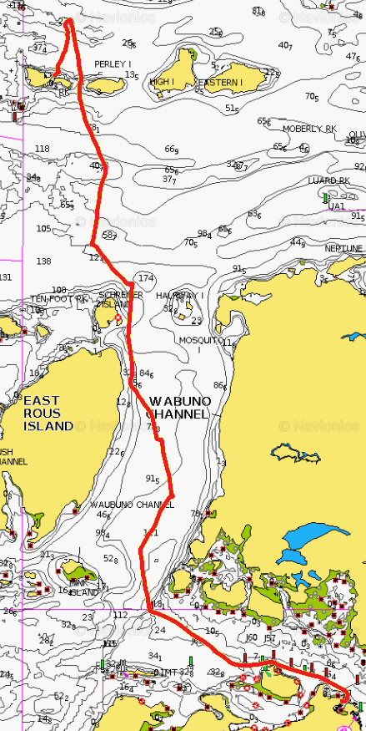
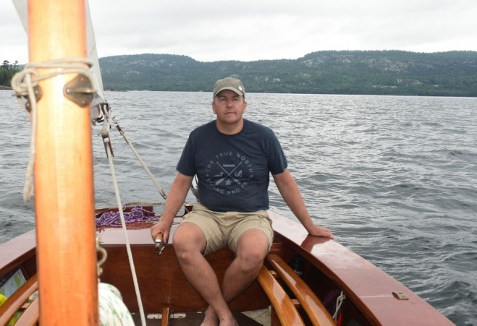
Allan & Heather Yates
allan@yates.ca
heather@yates.ca

Sailing Equipment
Life jackets
Compass
Anchor
Anchor rode
Anchor bag
Fender w/ tether and carabiner, 4
Bailer w/ tether and carabiner, 2
Boom crutch
Boom
Mast
Tiller
Rudder
Charts
Chart bag
Main sail
Main sheet
Batons
Jib
Jib sheet
Painters, 2
Oars, pair
Whistle
Throw bag
Paddles, 2
Reefing rope
Seat pad, 2
Radio, VHF, portable
Velcro halyard straps, 2
Under gunwale bags w/ carabiner, 2
Engine
Engine parts box
Engine spare fuel, 8

Camping Equipment
Matches
Svea stove
White gas, bottle, large
Pot set
Pot handle
Water containers, 1L, 4
Water containers, 500mL, 2
First aid kit
Watch
Torch
Cup, insulated, 2
Bowl, 3
Plate, 3
Knife, 2
Fork, 2
Tea spoon, 2
Dessert spoon, 2
Knife, Opinel
Can opener
Tinfoil
Wind break for stove
Paracord, hanks, 5
Kleenex
Garbage bags
Duct tape
Repair kit
Newspaper
Saw, folding
Dish soap
Dish cloth
Dish towel
Toilet paper, 3
Bleach
Multi-tool
Toaster, stove top
Notebook & pencil
Anemometer
Zip-loc bags, large & small
Rope, spare
Booster cables, pair
Spoon, wooden
Chair. collapsible, 2
LED string
Coffee filter holder, 2
Fly swatter

Insect repellant
Sunscreen
Anchor light
Main battery
Main batter distribution box
Solar panel
Power bank
Radio, VHF
Radio, VHF, charger
Boom tent
Mosquito tent
Mosquito tent boom padding
Phone case
Table
Mobile telephone charging cable
Tarp centre pole
Tarp
PSOC card

Personal Equipment
Sleeping bag
Sleeping pad
Headlamp
Spare batteries
Trousers
Shorts
Socks, short
Socks, long
Shirts, short sleeved
Shirts, long sleeved.
Long sleeved shirt
Swim suit
Towel
Sweat shirt
Fleece pants
Rain jacket
Rain pants
Pyjamas
Pillow
Tooth brush
Tooth paste
Wash kit
Hat
Camera
Camera battery
Sunglasses
Water shoes
Reading glasses
Mobile telephone
Ear plugs
Books
Chapstick

