Taking inspiration from the 2015 cruise log Following Beatrice into Paradise, my daughter and I planned a four night, five day, cruise in the North Channel of Lake Huron. Our previous cruises having been two nighters out of Parry Sound in Georgian Bay. The boat is W728, purchased by my late father, Frank Yates, in 1972 from the late Wallace Schwenger in Kingston.
Cruising specific outfitting of the Wayfarer included:
- Grapnel anchor with 150’ of rode.
- Hans Gottschling canvas boom tent.
- Self-made mosquito netting tent.
- Honda 2.3 HP 4 stroke outboard motor w/ eight litres of fuel.
- Main sail with single set of reefing points.
- 50 Amp-Hour LiFePO₄ battery for lighting and mobile charging.
- TrakMaps printed chart
- Navionics electronic chart plotter on an iPhone.
- Portable VHF marine radio.
- LED light string under the boom.
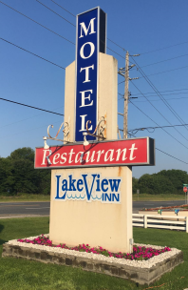
An eight hour drive from our home in Merrickville brought us to Blind River. As there are no (interesting) nearby anchorages to Blind River, we stayed the night prior to the cruise at the Lakeview Inn; actually a motel. In had the best accommodation reviews in the area, and an online booking cost of $120. The proprietor could not have been more friendly. The motel itself was very clean and well kept; highly recommended. Dinner this night was a satisfactory take out fish & ships from the 17 Restaurant, eaten on a picnic table by the river.
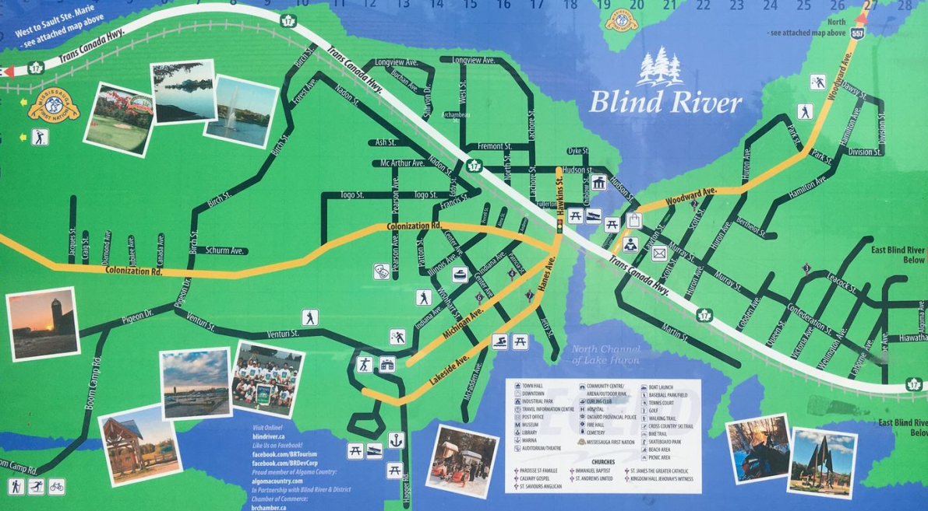
It turned out that the Blind River marina has camping as well. There are only a few spots, and they are small, but they are fully serviced and at a beautiful location right on the point in the marina. At a cost of only $15/night, the value can’t be beat. Toilets and showers are available as well. Overall we were very impressed with Blind River as an outpost. Somebody, obviously a few years ago, had put a lot of effort into sprucing the place up.
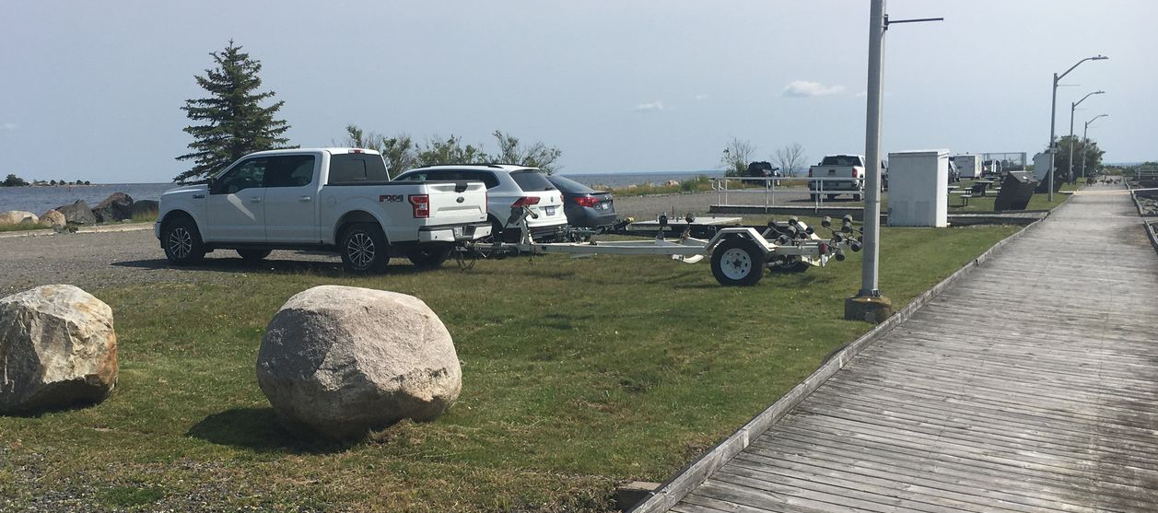
The next morning we launched at the marina; technical beside the marina. After a long discussion with the marina attendant, where they thought we wanted dock space, camping, mooring, and who knows what else, we eventually settled on that everything on the ramp side of the hedge was no charge, including both launching and parking. Bonus! The OPP launched a patrol boat while we were prepping, so we figured a reasonable eye must be kept on the place.
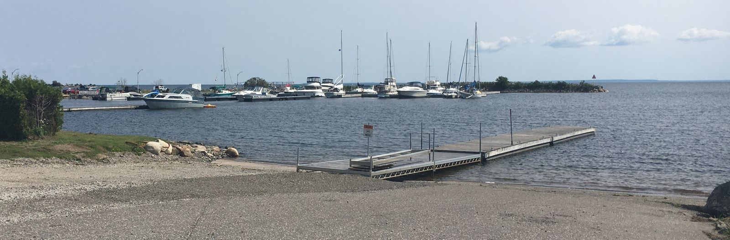
Wind the first day was not only light, but an easterly, which was exactly our intended direction. Our original final destination was the Benjamin Islands, but as we will see, that was not to be. After a 10am start, we were making mostly only 2-3 knots, and having to beat. After a short motor part way through the day to get some distance under our belt, the wind picked up, getting us up to four knots at times, it was obvious we were not going to make the first night’s objective of the east end of John Island. We decided to aim for a closer spot, and checked out a few locations, eventually settling on Turnbull island. Total distance covered was 18 NM over 6 ½ hours. Given our camping aspects, we always needed crown land.
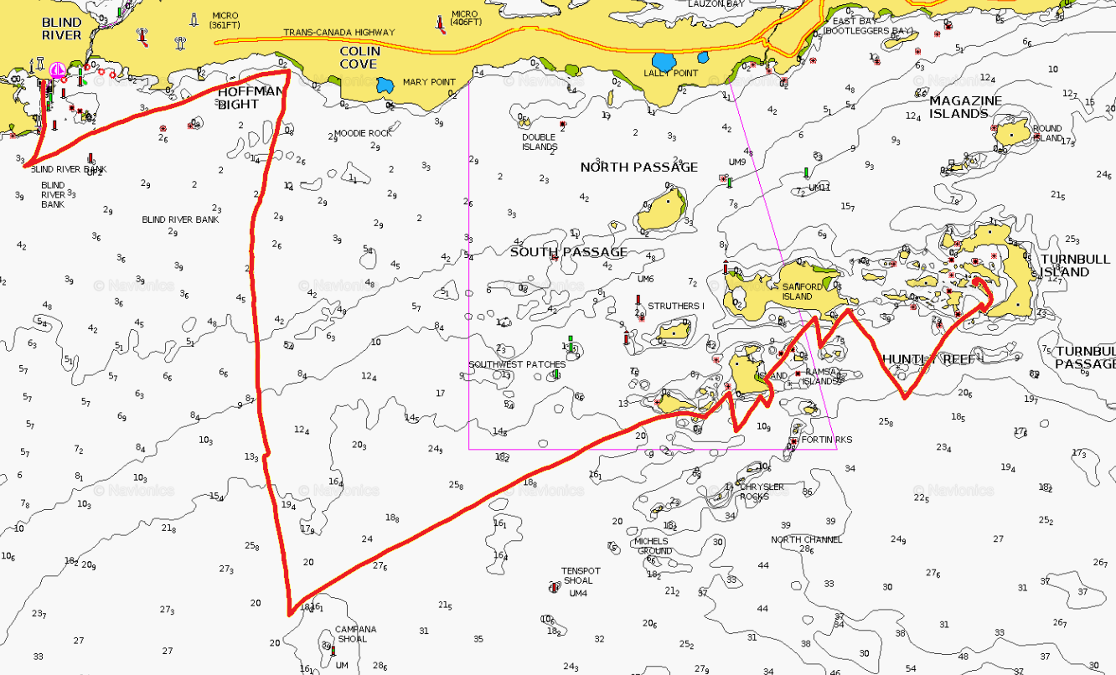
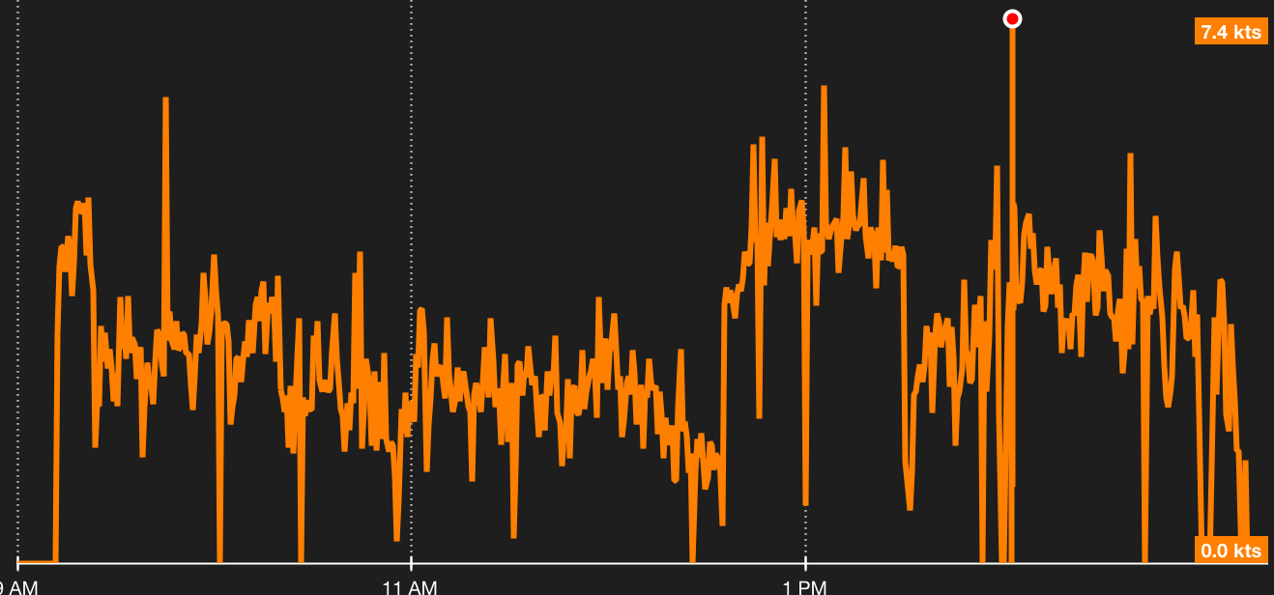
Here we had a sand beach and were absolutely completely protected from both wind and waves. However, there was no easily accessible open spot for cooking, relaxing, etc. The other side of the point had some rocky areas, with a view out to the channel, but it was not a great journey, fighting through the undergrowth. We did have a nice swim. We tried for coffee and hot chocolate on the beach, but were sent scurrying for the mosquito tent on the boat about 9:30pm when mosquitoes descended. This was in spite of a pair of Thermocell repellers, which work great at home. This mosquito feeding frenzy turned out to be a nightly occurrence.
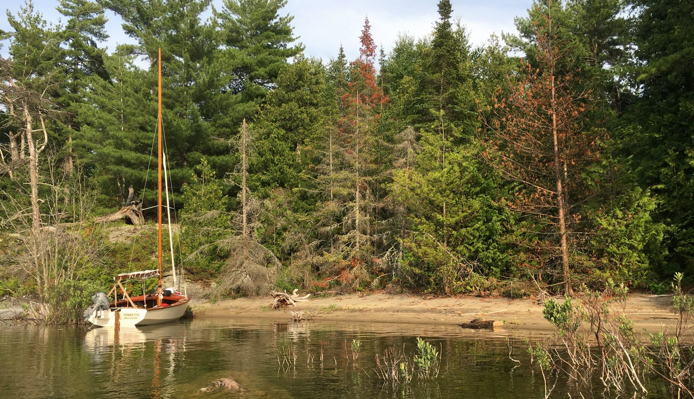
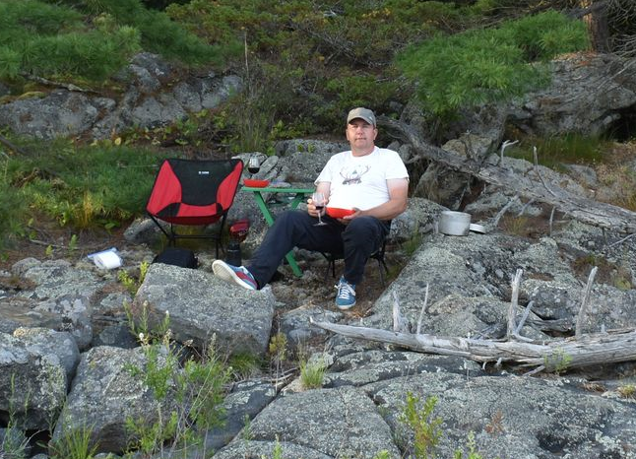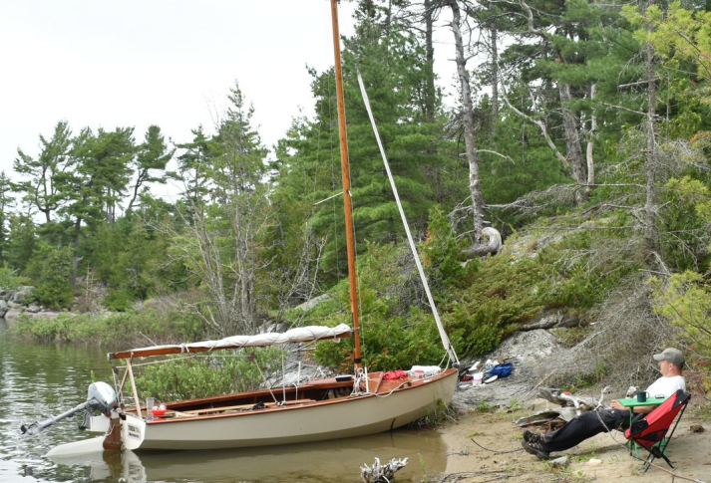
The second day dawned with a nice breeze, but very heavy rain forecast for early in the afternoon. We thus planned an abbreviated day, with the hope to get to an anchorage still dry. It was a nice sail, though still beating against an easterly breeze, averaging 3-4 knots. There are just so many islands, it makes for great cruising, as there is always something to go around. If the tack doesn’t work for one island, it works for the next. We were just making it close to the anchorage when the heavens opened. We kept sailing, but then the wind died completely, so we packed it in, and fired up the outboard. It was still raining cats and dogs when we anchored at Dewdney Island. A distance of 11 NM over 3 ¾ hours.
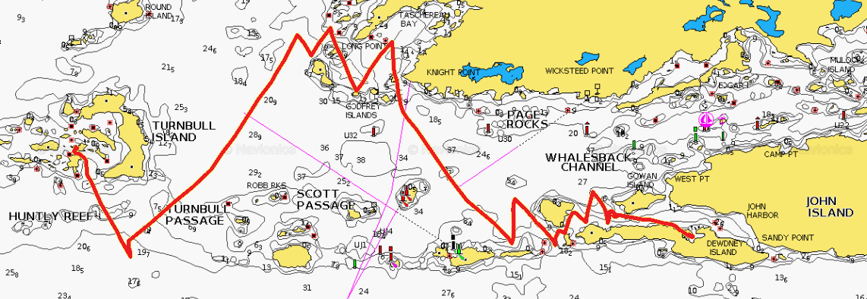
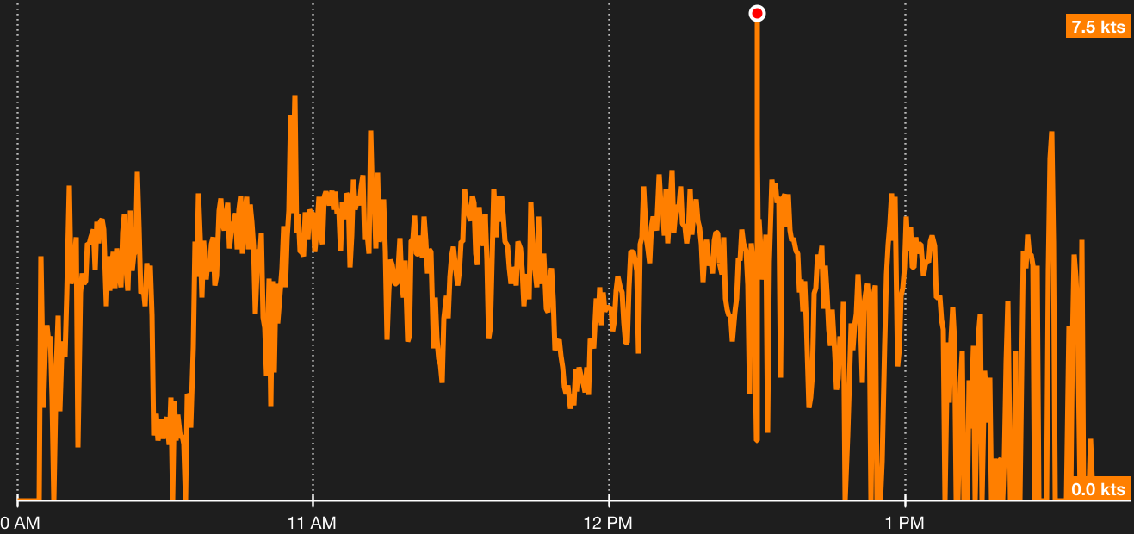
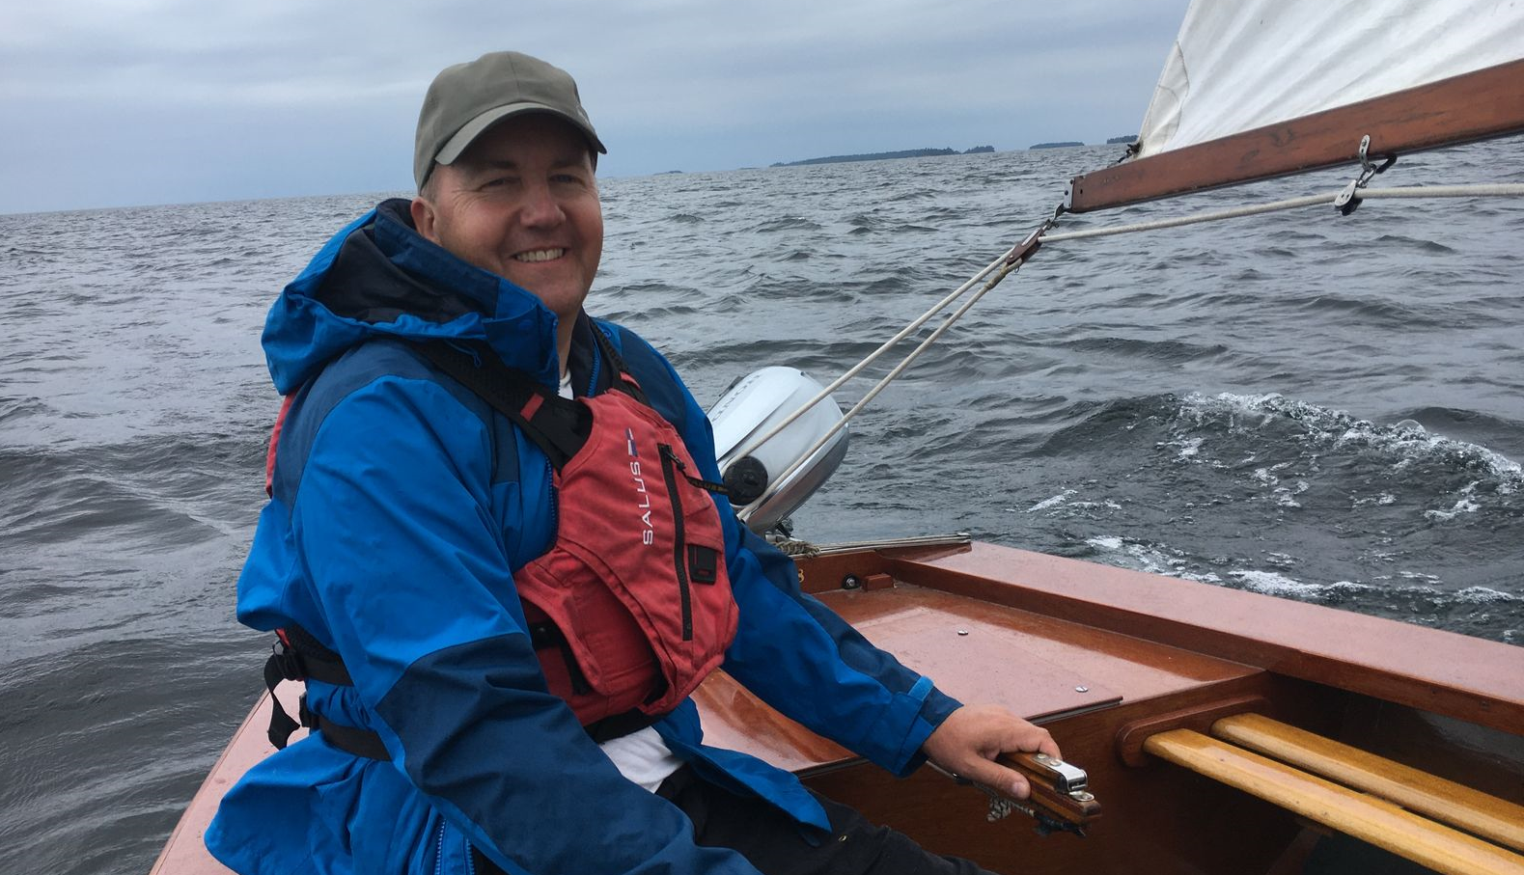
We setup the boom tent to keep the Wayfarer from being flooded, and then setup a tarp on land. This anchorage was much better, and it was an easy open walk to the top of the island for setting up camp. As we were already soaked, we setup our tarp, and then were able to change into dry clothes followed by a drink under shelter!
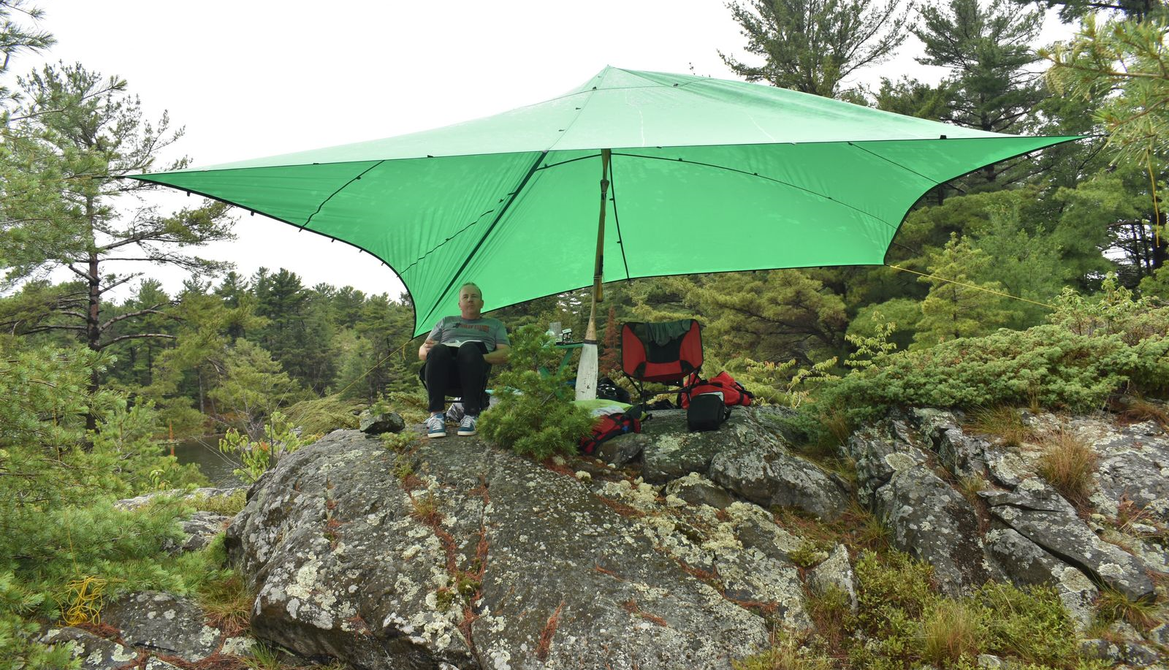
The anchorage itself was idyllic with a stupendous view from our campsite. There were only a couple of keel boats and a motor cruiser present.
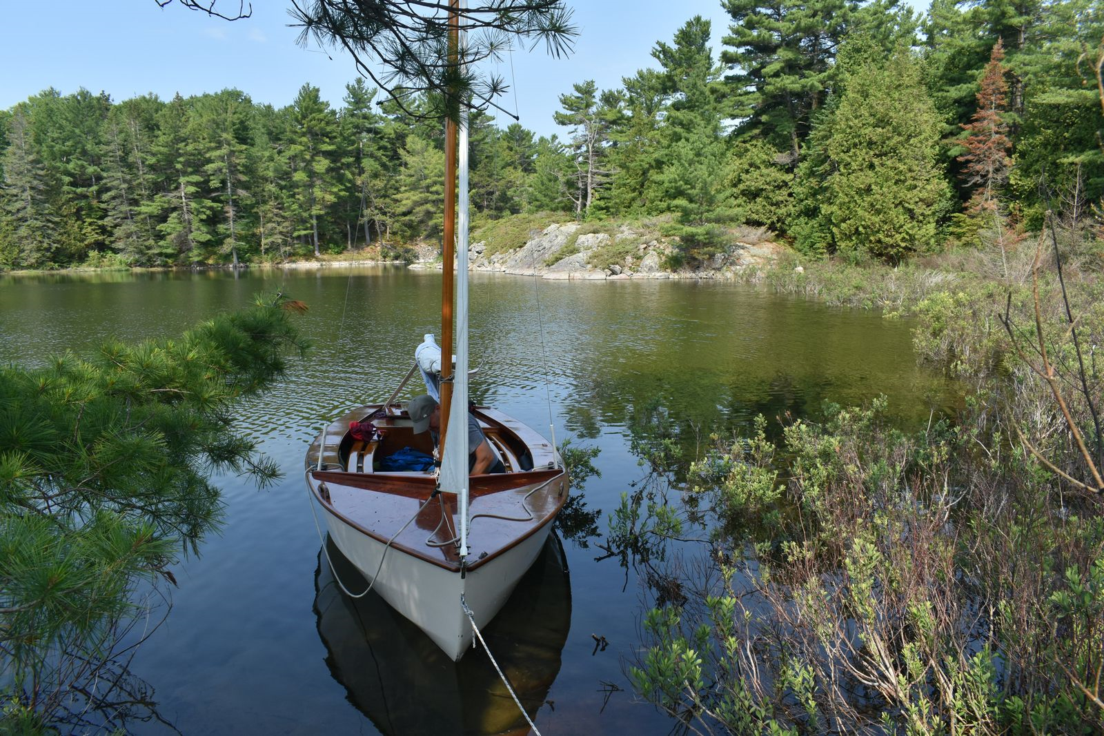
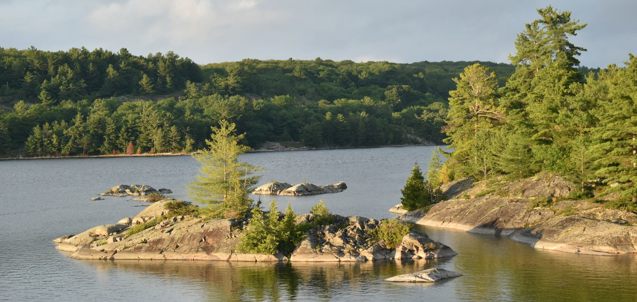
The forecast for our third day was light winds, but the fourth day was looking like 20-30 knots winds and an accompanying strong wind warning. As on the fifth day we had to be back in Blind River, we were hesitant to head further east. Thus we planned to just take a scenic route to an anchorage to our north in Bear Drop Harbour. The wind was nice to begin with, but faded away around noon. We drifted around for a while, but eventually had to give it up as a bad job, and motored around Lesueur Island and over to Bear Drop Harbour.
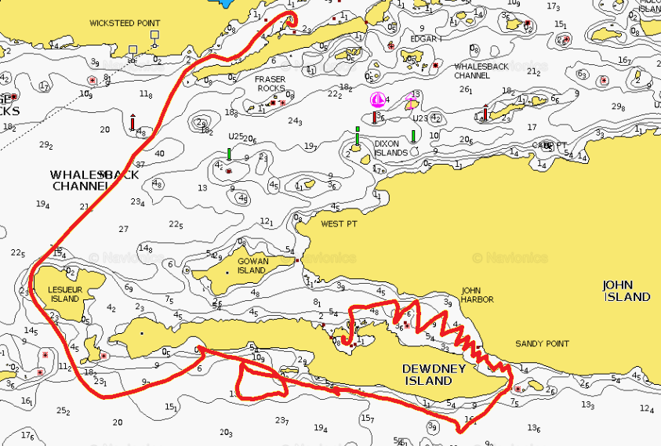
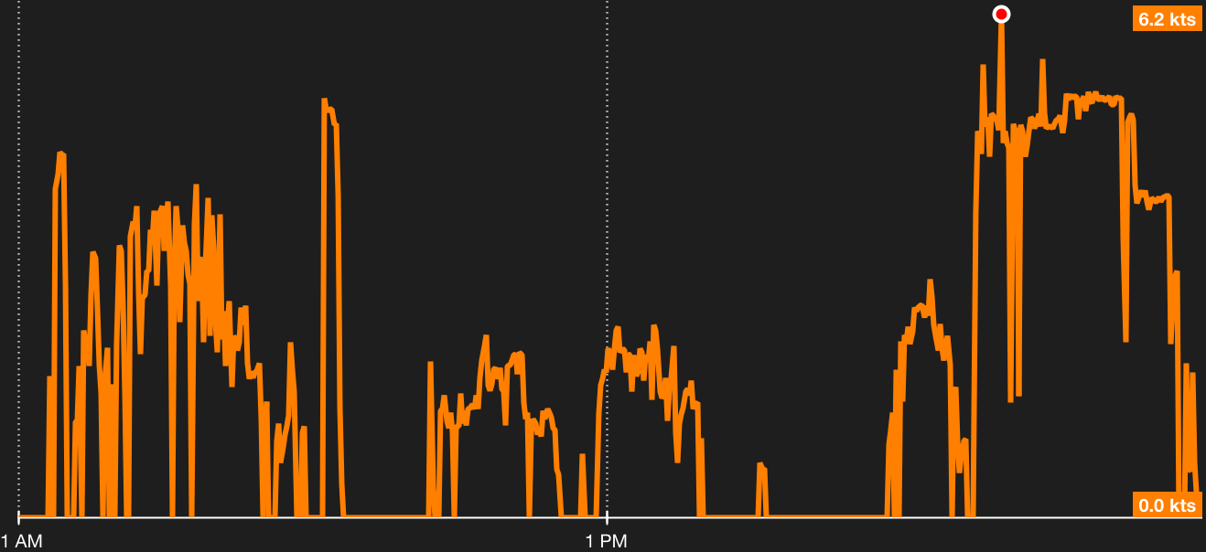
Bear Drop Harbour was the best anchorage yet. While we were sharing this particular cove with about eight keel boats, we had a gorgeous island all to ourselves. As to be expected, there are few dinghies cruising, and the keel boats occupants rarely go ashore. Given the projected winds for the next day, and that we would be spending two nights here, we setup camp in a well-protected area near the boat.
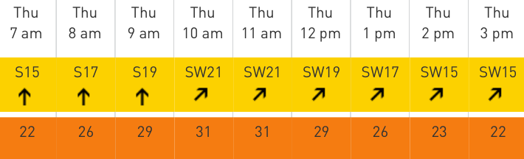
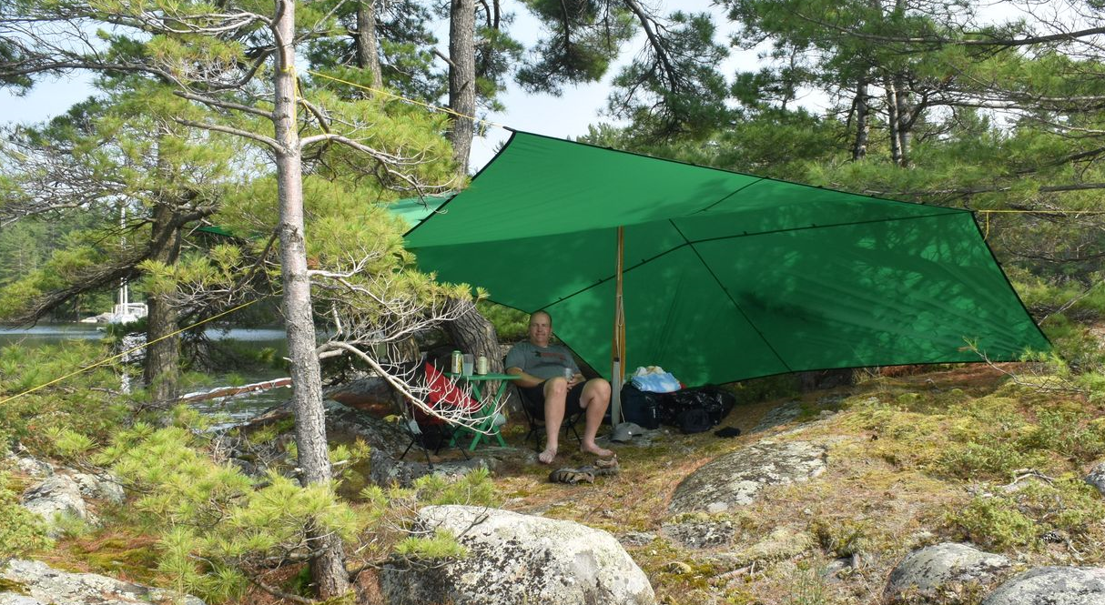
With heavy rain forecast for overnight, we setup the Wayfarer with the boom tent. Sometimes we just lie from the anchor; it’s fun to swing around during the night. Other times we keep a stern line to shore as well.
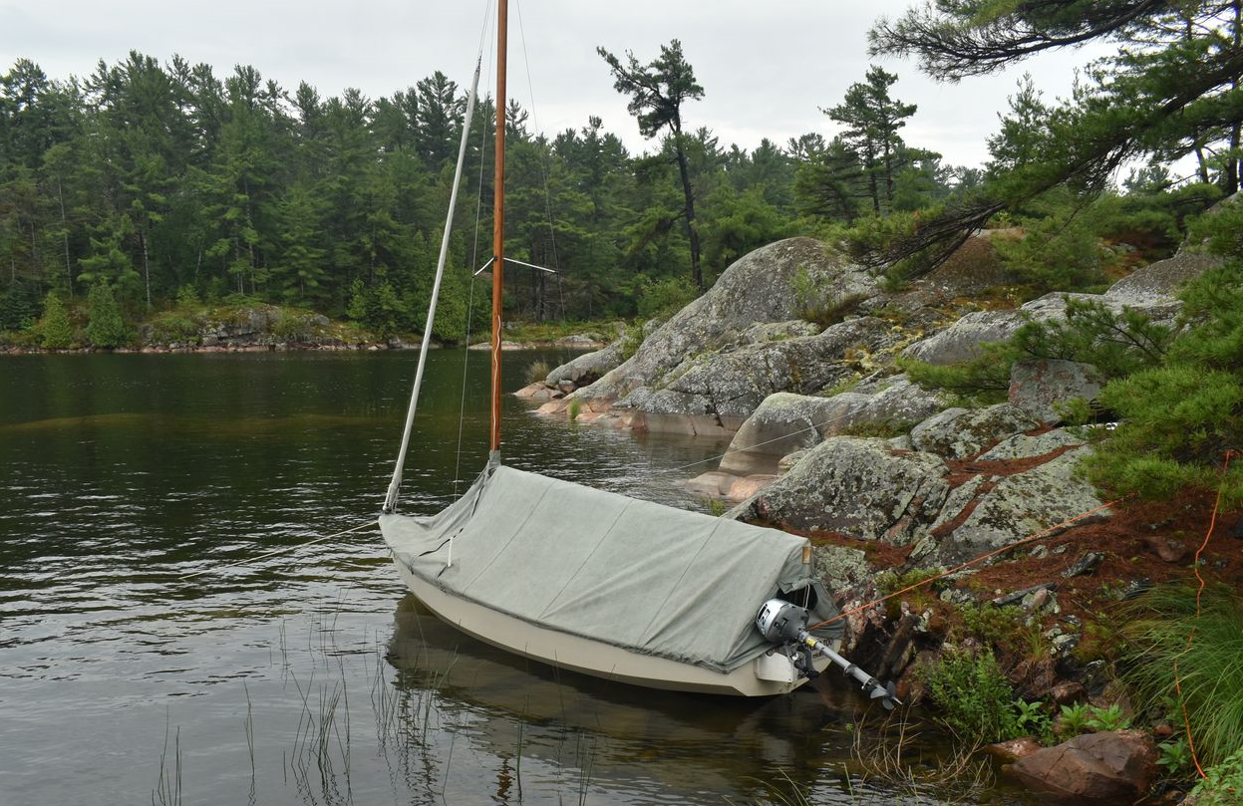
The key out here was definitely getting hidden within the tent by about 9:30pm. Soon after sunset, the mosquitoes would come out by the millions. Just getting into the tent would bring in hundreds which then must all be killed. It worked out much better to give up on the last 30 minutes of bug free time, and get established within the tent before the onslaught. In that manner, there would only be maybe 2-3 mosquitoes to swat; much more relaxing.
Overnight there was a tremendous down pour. While the boom tent needs a lot of holes around the shrouds and such plugged with socks to keep out the mosquitoes, it does keep out the rain perfectly. Other than a few drops trickling down the mast, it was as dry as a bone inside. We stayed inside a little later than normal, until around mid-morning, when the rain came to an end.
What should have been a little quiet day, reading books and drinking coffee, got a little more interesting... As the day progressed, and the wind shifted around, we buttoned down the tarp to protect us and keep us warm.
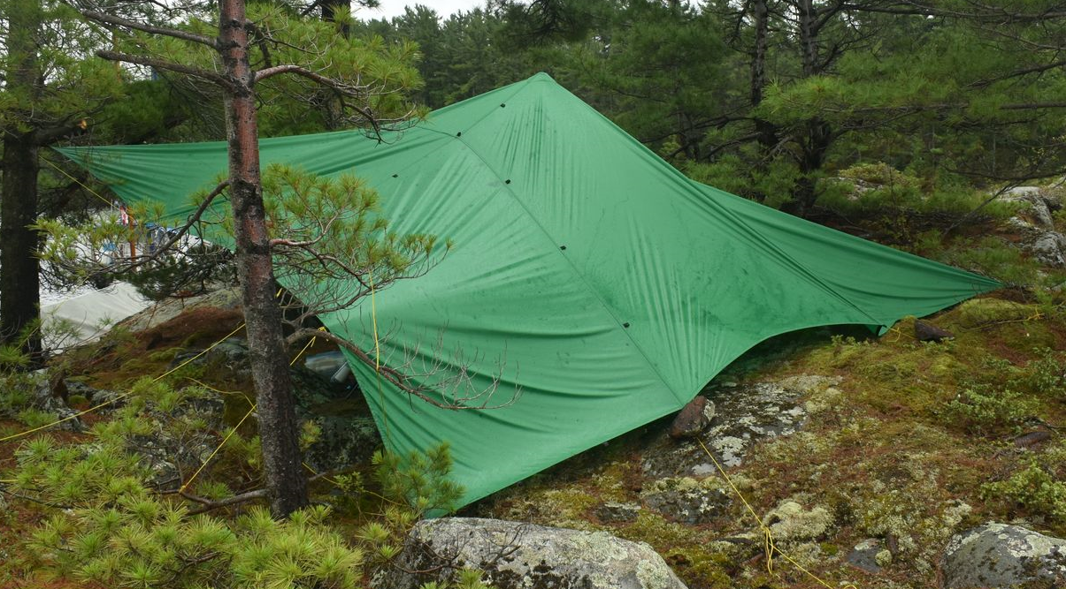
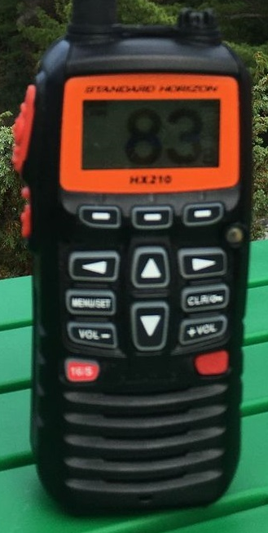
A keel boat, anchoring after us, had placed themselves pretty much on top of us. Clear, but only just. While we were relaxing, we suddenly noticed that boat wasn’t where it used to be, and was looking even closer to us. Running for the shore we could it was basically running loose with neither the anchor, nor stern line holding it. It was heading straight for our bow, and the only reason it didn’t crash into us, is that it hit the rocks just ahead of us; we naturally were drawing way less water. We grabbed the stern line to hold it off the rocks, and made a call over VHF 16 looking for the skipper (he was visiting another boat). I was actually surprised that two boats responded to the call, and were able to get hold of the skipper. They used one of their little dinghies to tow the boat into the middle of the harbour where the anchor was reset. We needed a drink after that bit of excitement!
A husband and wife, from one of the keel boats, invited us over for coffee in the afternoon. We had a very nice two hour chat with them. They live in Kitchener, keep their boat (a Catalina 28) at Lion’s Head, and do a three week cruise every summer. While we were having coffee, a Securité call came over the VHF radio from the coast guard, a squall was heading for us. Sure enough, 5-10 minutes later the winds jumped up and the water got choppy; and this in the very protected anchorage. We would not want to have seen that in the open channel.
We saw a couple of bald eagles, herons, and cormorants, and a pair of these cute little mink!
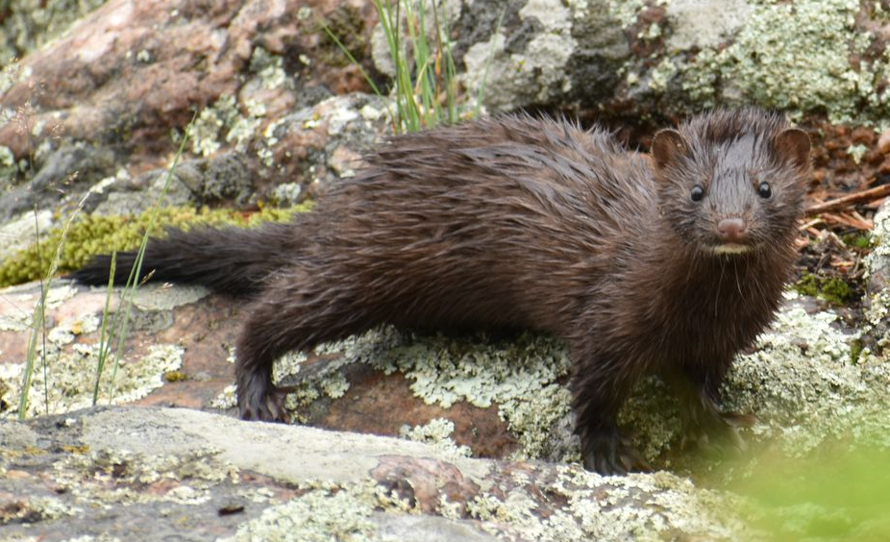
With our cruising, we always sleep on the boat, but do all cooking on land. I have seen people lighting up stoves on their bottom boards, but it’s not worth the risk for damage and the mess, to say nothing of the small space and wave action. All our meals were packaged up by our wife/mother , each in its own Zip-Loc bag. Never any frying as that just make a big mess to clean up. Single pot meals are the rule.
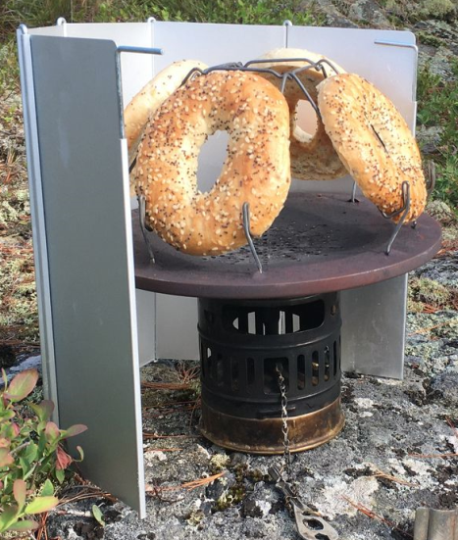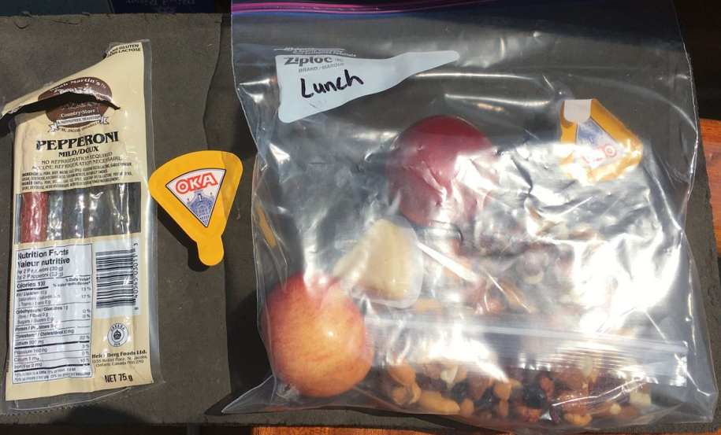
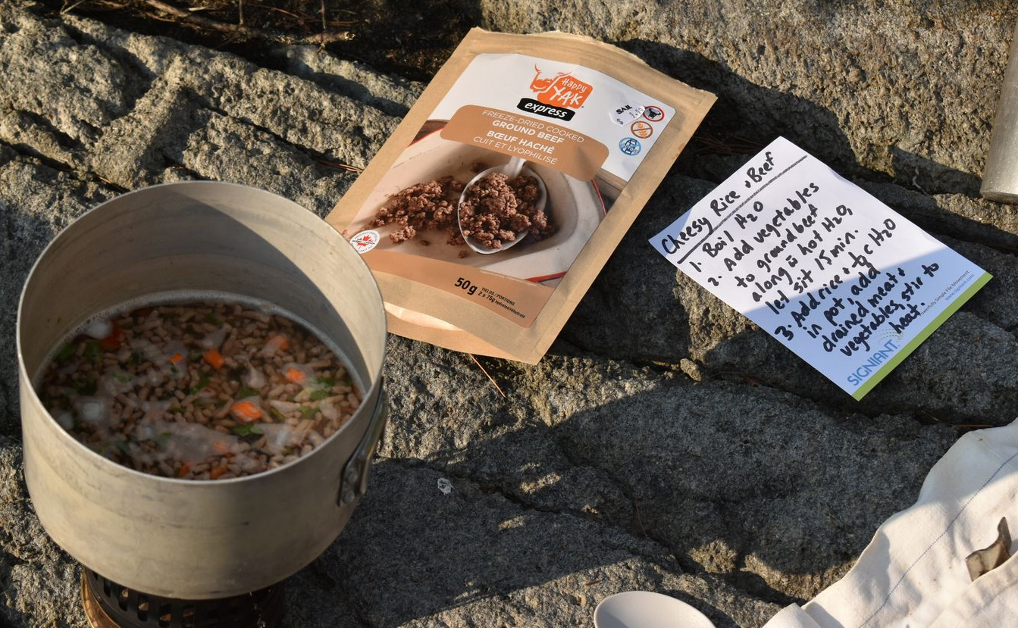
A swim around the island completed the day. As no rain was forecast overnight, we switched back to the mosquito netting tent. By now we had the night time routine down pat. Get under cover early, and relax a bit on the boat.
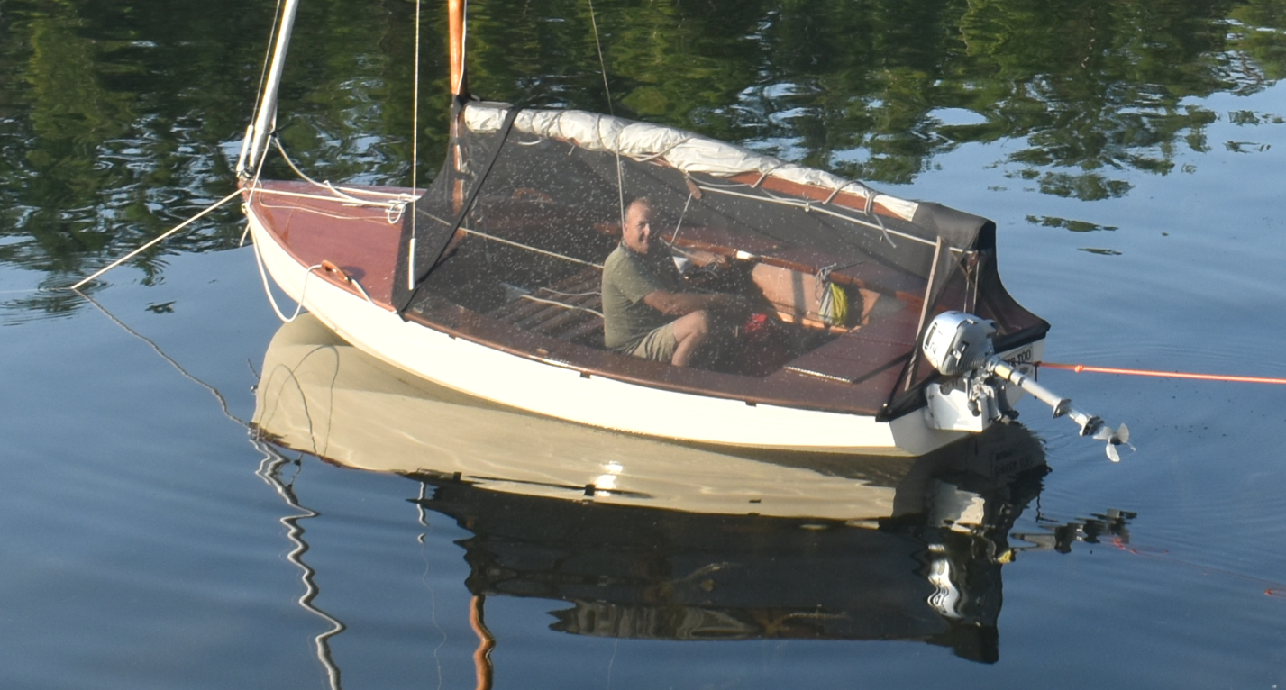
Very peaceful last evening watching the sunset... The keel boats at anchor don’t get this view!
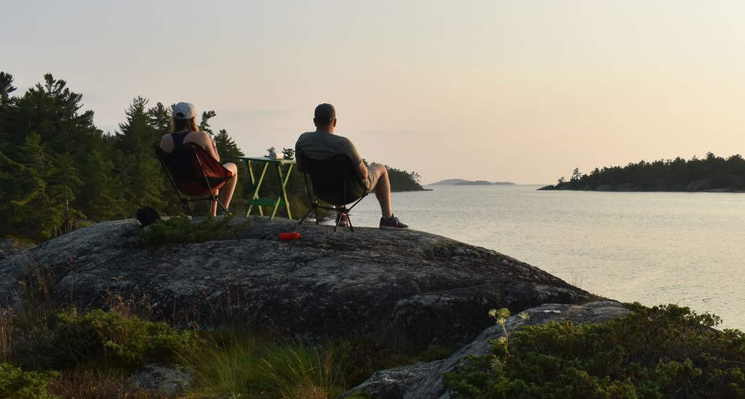
After a nice night, the day started with light winds. We motored out of the inlet, and picked up the breeze. We then had a wonderful sail back to Blind Harbour. Both the wind and waves picked up as the day progressed, giving a fine ending to the cruise.
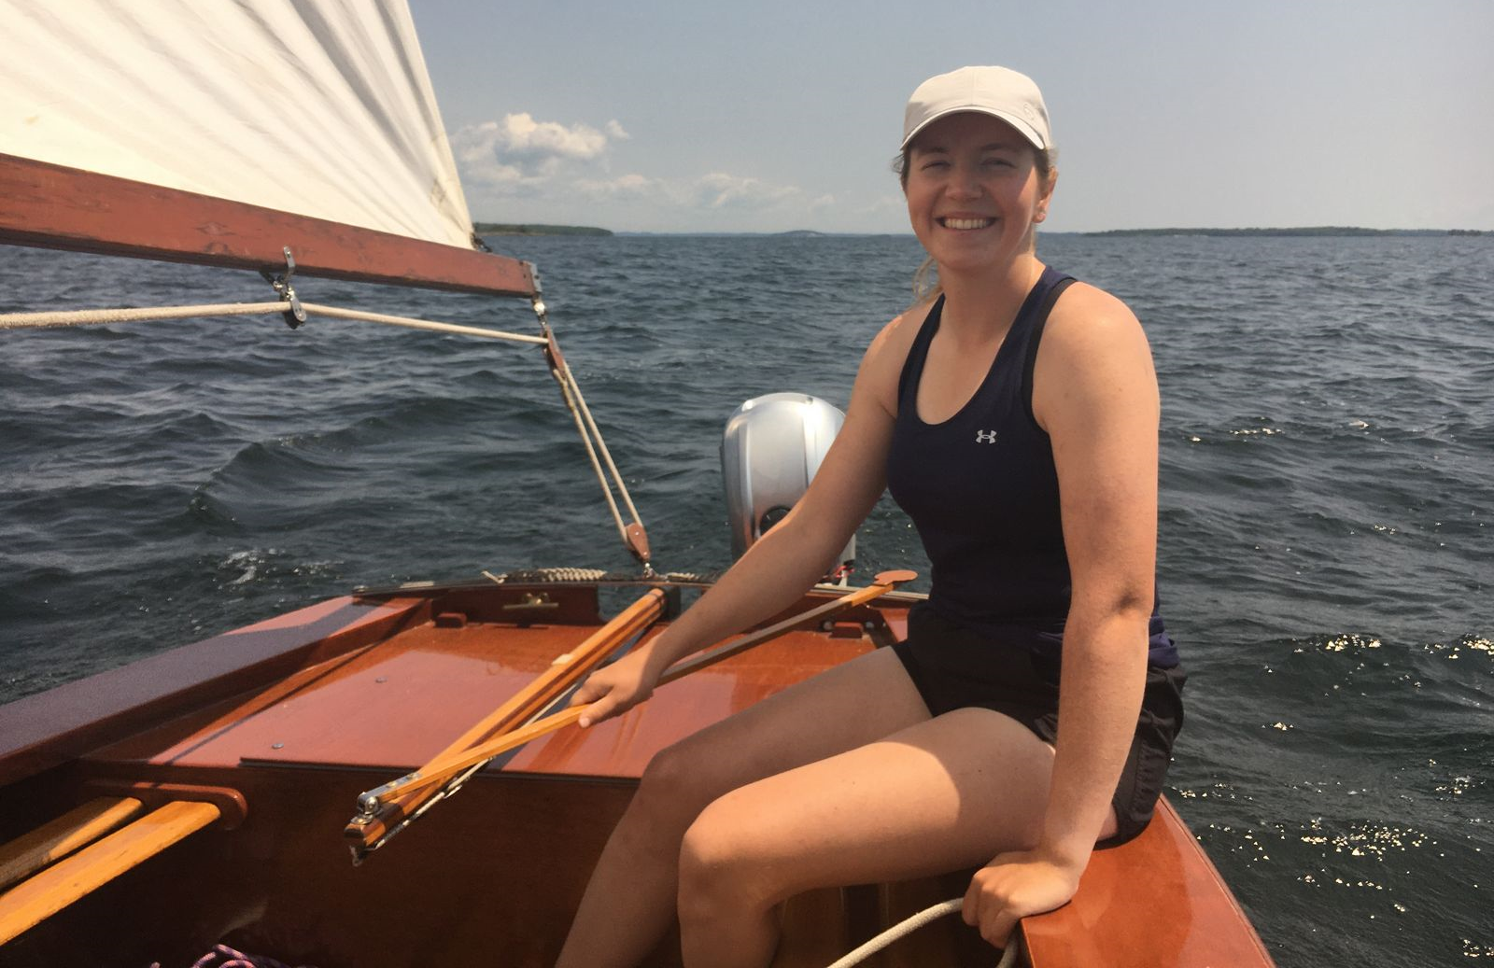
It took but a couple of tacks, to cover the 18 NM back, over 4 ½ hours.
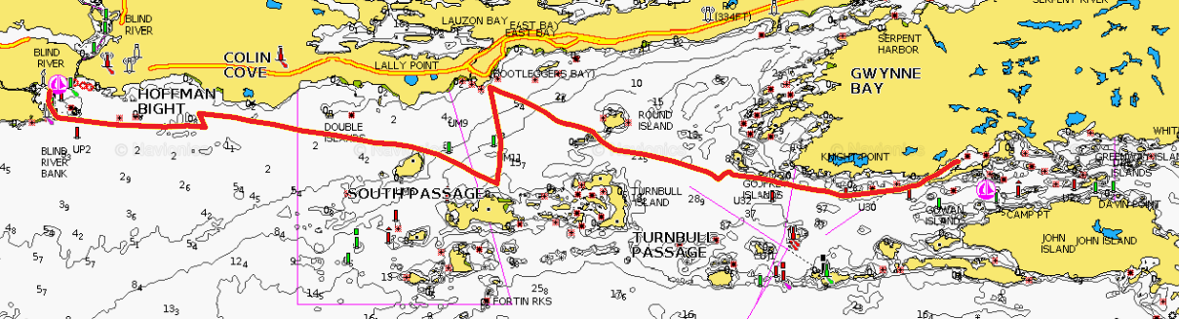
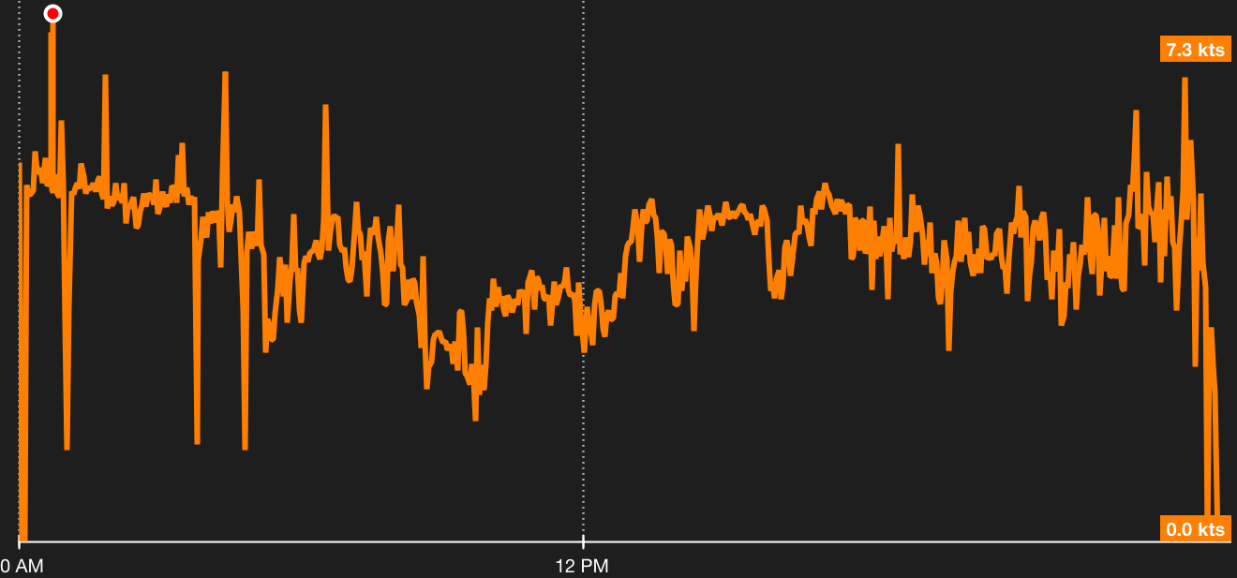
Most importantly Blind River has great ice cream, which can be found at the Video Movie House. Then right next door is A Touch of Home with very good home cooking and baking. Great for some food for the drive home.
While the original distance objectives of the trip were not met, it was a very good education on how much the wind can affect distance travelled. All the other experiences on the trip were very valuable in to increasing our capabilities and confidence.

Allan & Heather Yates
allan@yates.ca
heather@yates.ca

