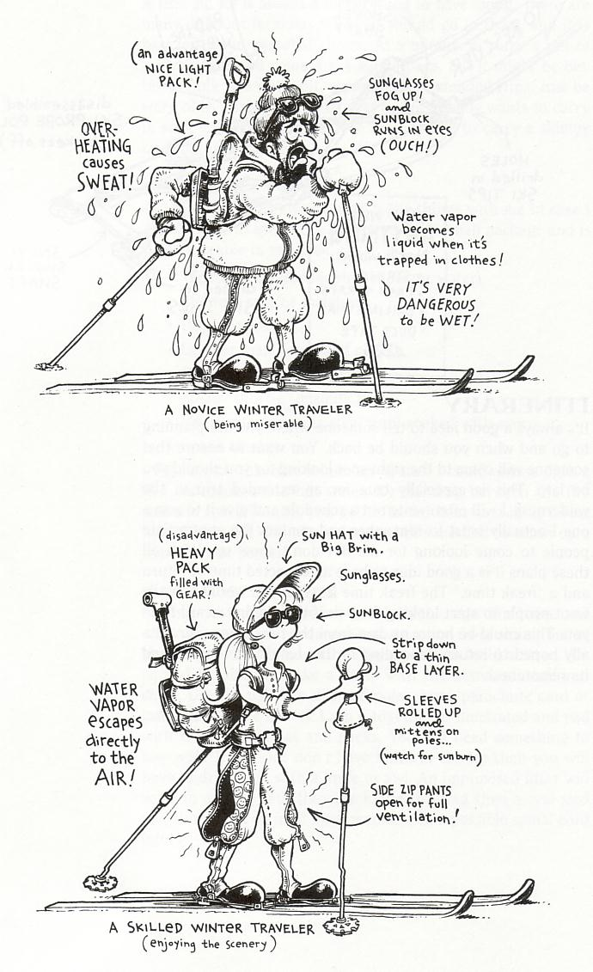Layering Your Clothing

If you’re too cold, too hot, or too wet, it's hard to think happy thoughts, let alone enjoy what you are doing. Layering your clothing, instead of one bulky, do-everything garment, can help prevent uncomfortable and potentially dangerous situations, such as hypothermia.
To provide an optimum environment, your internal systems try to maintain a thin layer of warm (30° to 33°C), still air around your body. If the surrounding environment were constant, and your life was void of activity, this private microclimate would be all you would need.
But once you step outdoors, you alter your microclimate because of physical activity, wind temperature, and moisture, which can create conditions too extreme for the body’s mechanisms to adapt to. Wearing a few layers of varying weight and fabric allows you to maintain an optimum microclimate during periods of physical exertion, as well as during times of inactivity.
However, a layering system works only as well as your ability to manage it. Before you layer up, put on a wool or fleece hat as up to 50% of your total heat loss occurs through the head. Choose the right inner, mid, and outer layer and fine tune your microclimate by shedding layers before you get too hot, or by adding layers before you to cool down. You can also use pit-zippers, double zippers, vents, and flaps to help regulate your internal thermostat.

Inner Layer
The inner layer (aka underwear) is the most critical because it's in direct contact with your skin. Underwear must transport body moisture (sweat) away from the skin and disperse it to the next layer where it can evaporate.
Because water is a good heat conductor, a wet garment against your skin draws heat away from your body twenty-five times faster than a dry one. Even in conditions above freezing, this rapid heat loss can cause a dangerous drop in your body’s core temperature, leading to hypothermia.

Synthetics such as polypropylene and polyester are common underwear materials. Light and strong, they absorb very little water. Their quick-drying ability reduces the risk of conductive heat loss.
Inner layers are available in light, medium, and heavy weights for different activities. Lightweight for aerobic activity where sweat dispersal is paramount. For more stop-and-go activities, midweight underwear provides both moisture control and insulation. Heavyweight underwear is best used in cold conditions, where you're relatively inactive.Finally, the inner layer should fit snugly but not be restricting.

Mid-Layer
The mid-layer provides insulation and continues the transportation of moisture from the inner layer. To slow heat loss, this layer must be capable of retaining the warmth generated by your body. Wool and synthetics are well suited for this purpose because the structure of the fibers create small air spaces that trap molecules of warm air.
Additional features, such as pit zippers and full-length front zippers, allow venting. As with the inner-layer, this layer should be snug but not constricting.

Outer Layer
The outer layer protects your microclimate from the elements and should allow air to circulate and excess moisture to escape. Choose on the basis of what you plan to do and what weather you may encounter.
For dry conditions, a breathable (uncoated) wind shell may be all you need. If you expect conditions to be more severe, a waterproof (coated) rain jacket might be adequate. A shell made of a breathable and waterproof fabric, such as Gore-Tex® and Gore-Tex® XCR™, will give you protection from wind and rain, as well as allowing water vapour to escape.
That said, there are no miracle fabrics. Under heavy exertion, your body simply produces more water vapour than any fabric can disperse. The result can be a build-up of moisture on the inside of the garment, leaving you wet, clammy, and cold. Strip off a layer or open any ventilation zippers before this happens, and you’ll be a happier camper.

Hands and Feet
In its effort to keep your head and your body's vital organs warm in cold conditions, the heart reduces blood flow to the hands and feet. These areas do not generate much heat on their own, so some insulation and protection from the elements is needed.
Mittens are warmer than an equivalent pair of gloves because the whole hand contributes to the warming process. The trade-off is that mitts inhibit dexterity. Gloves are good for activities that require independent finger control, such as tying knots, but each finger must warm up its own little compartment, making them less efficient at keeping your hands warm.
A layering system that consists of a thin wool or synthetic glove for moisture transport, an insulating mitten, and a non-insulated shell mitten for outer protection, will give you a wide range of temperature control and manual dexterity.
Keeping your feet warm and dry is absolutely mandatory on multi-day backpacking and ski touring trips, so your choice of socks can make or break a trip.
Wool is the preferred material and provides the best balance of moisture wicking, warmth, and cushioning. The addition of a polypro liner sock will speed up moisture transport from the feet to the outer wool layer. You can forego liner socks by purchasing thicker single socks made from a wool, acrylic, stretch nylon, and polyester blend.
Socks should fit snugly. If they're too tight, circulation can be restricted and your feet will get cold. Conversely, a loose sock can slip or bunch up, creating pressure spots that can lead to blisters.
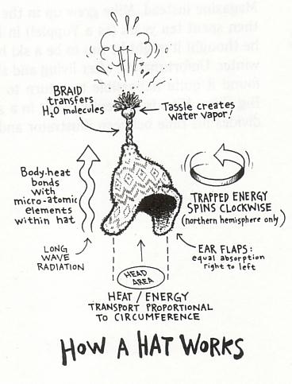

About Rainwear
MEC designs rainwear to protect you from every wet and rainy situation, whether it's climbing in light drizzle or hiking in a driving, persistent deluge.

Midweight Rainwear
Perfect for bushwhacking through soggy slide alder or canoeing in an afternoon downpour! Midweight rainwear utilizes abrasion-resistant nylon with a durable water repellency (DWR) treatment on the outside and a polyurethane coating on the inside.
Note that polyurethane-coated rainwear is not suitable for activities when you'll be sweating a lot - the polyurethane coating does not allow perspiration to escape. This limits rainwear's effectiveness in below-freezing temperatures, as cooling condensation inside the garment can possibly lead to hypothermia.

Light Rainwear
Affordable and easy to pack, lightweight rainwear is perfect for general camp use and hiking in open terrain. Unlike cheaper polyvinyl chloride (PVC) rain gear that is prone to ripping, our garments are made of a tightly-woven nylon treated with a durable water repellency on the outside and a polyurethane coating on the inside.

Features
Rainwear has many unique design features. Look for:
- Fully taped seams.
- Roomy cuts for layering over bulky mid-layers.
- Jacket lengths appropriate for activity level - long-backed jackets ideal for canoeing or general use and shorter cuts for climbers wearing a harness.
- Zippered pant legs or full-length zippers for easy changing.
- Generous zipper flaps that prevent water leakage through the front of the jacket.
- Volume adjustable hoods that fit easily over a helmet.
- Stiff, rain-shedding brims.

Care
Durable water repellent coatings lose their effectiveness if clogged with dirt, so wash your rain garments often. Both nylon and polyester-based rainwear can be machine washed and dried.
Outdoor Footwear
Once we sling a pack on our backs and venture onto trails or rock, and into water, our feet require traction, protection, and support. These needs vary with the activity, the terrain, and the load. The wrong footwear can be a serious downer. Worse still, ill-fitting footwear can result in discomfort and even injury! Be nice to your tootsies - make an informed decision about what boots are best for you!

Intended Use
Approach Shoes are used to approach various wilderness activities such as rock climbing or paddling. They are great for easy scrambling, fast hiking, or trail running. The emphasis is on lightness and sensitivity, with a function-specific sole.
Day Hiking Shoes and Boots are best for easy hikes of short duration. They are designed for use on trails, with no more than a light load. Emphasis is on lightness, comfort, stability, and moderate support.
Hiking Boots are designed for use on two- to three-day self-supported hikes on trails, or aggressive off-trail day hiking. Although emphasis is still on lightness and comfort, these boots should also be durable, water-resistant, and supportive.
Backpacking Boots are for long distance self-supported hiking on and off trails. Some can even be used for light mountaineering. As a result, they are heavier, and will take longer to break in than hiking boots. Emphasis is on control, long-term support, water resistance, and the boots' ability to withstand abuse.
Mountaineering Boots are designed for mountaineering, glacier travel, or aggressive backcountry travel. These boots are stiff and very durable. Moreover, mountaineering boots are compatible with clip-on crampons.

Materials
Full-grain leather retains the outer membrane of the hide, which is denser, and therefore more water-resistant and supportive. It conforms well to the foot over time, can be waterproofed, is abrasion-resistant, and will last for years when properly cared for.
Full-grain leather retains the outer skin membrane which consists of very tight fibres. If this membrane faces outward, it is termed "smooth-out." "Rough-out" leather has the membrane facing inward to protect the tighter fibres of the top grain from abrasion (giving the leather a longer functional life). Thicker leathers, though they require longer to break in, make a more durable boot that gives more support.
Suede (split leather) does not retain the outer skin membrane. Compared to full-grain leather, it is generally less abrasion-resistant, more prone to stretching and less stiff - it can also absorb water more easily. Tanning processes or copious applications of goop can, however, render suede waterproof. Although suede is less appropriate for heavy-duty applications, its flexibility, breathability, and lower price make it a good choice for lighter-duty uses.
Fabric (usually mesh or 1000-denier nylon) is often used in lighter shoes and boots for its breathability, low cost, and ease of breaking in. Fabric is often used in conjunction with suede or leather to construct footwear that achieves a good balance between support, light weight, and breathability. Fabric is difficult to waterproof, and is not as durable as leather, so it is usually found only in lighter-duty footwear.
Plastics (or Nylon) are used in mountaineering boots. They provide absolute waterproofness and durability. The rigidity of plastic boots makes them well-suited to use with crampons in extreme conditions. Plastics, however, will not break in, and are used almost exclusively in "double" boots where a padded inner boot buffers the foot from the outer shell.

Caring for Outdoor Footwear
Although today's boots incorporate many synthetic materials, leather remains a key component. Even leathers prepared with modern tanning techniques still require care. If neglected, leather can rot, or become brittle and crack. An ounce of prevention is worth a pound of cure when it comes to outdoor footwear.

After a Trip
Clean all mud and dirt from the outside of your boots with cool water, a stiff brush, and when possible, a cleaner such as Saddle Soap (but never detergents). Dry your boots by stuffing them with newspaper to absorb moisture and odours. Remove the laces and footbeds (wash them as well) to allow boots to dry quickly and thoroughly. Rinse or wipe out the interior of boots, dry them out, and spray them with a disinfectant or fungus preventative. If the lining is leather, apply a thin layer of Leather Lining Cream®.
Note: never cook your footwear - besides rendering the leather brittle, excess heat can soften the cements that hold upper and sole together. Footwear abused by overheating is not covered by warranties from either MEC or the manufacturer.

Prevention and Repair
Applying Freesole® or a similar urethane goop to the seams and the junction of the sole and upper will increase water resistance and durability. This works best on new, untreated boots (note that it will darken any leather or fabric). Urethanes can also be used for field repairs in an emergency.

Waterproofing and Conditioning
Waterproofing and conditioning are not always the same thing. Generally, a product that conditions will improve water repellency, but some waterproofing products do not condition leather.
Most commercial treatment products use one or more of the following active ingredients - oils, waxes, silicones, and fluoropolymers. Solvents or mineral spirits may be added for greater penetration.
- Animal oils and greases soften leather, reducing its supportiveness. MEC does not recommend them.
- Beeswax products provide the longest lasting nourishment for leathers, as well as some water repellency. They will darken and flatten suedes or nubucks, and can build up on all leathers, trapping dirt. The latter drawback can be overcome by buffing the wax to remove the excess.
- Silicones provide highly effective water repellency, with minimal reduction of breathability. Usually in liquid form, they penetrate top grain and smooth out leathers, and do not by themselves affect the nap of suede or nubuck. However, they stiffen at lower temperatures, do not condition leather, are not as durable as waxes and should be kept away from rubber soles and rands.
- Fluoropolymers dry quickly, instantly resist water, and maintain breathability. Furthermore, fluoropolymers repel oily stains and do not by themselves affect the appearance of either real or synthetic leathers. They do not condition leathers and are not as effective on smooth-out top grain leathers.
- Silicone and fluoropolymers are usually mixed with waxes and oils, and can be applied to wet or dry leather or fabrics. These combinations will condition and waterproof, allow the boots to breathe, and are long-lasting. Several applications are required for full effectiveness, with a 24-hour drying time between coats.

