Overview
The Winter Mountaineering Adventure is an annual snowshoe hike and climb of the 4,000’ mountains in the Adirondacks High Peaks district in New York State. This event is open to all Venturers, Rovers and their leaders. The base camp for this adventure is the Alpine Club of Canada (ACC) hut in Keene, New York. While hurricane Irene has caused extensive damage to the High Peaks district, it is believed this will not affect winter activities. However, in the event of any trail closures there are numerous alternatives; the event will not be compromised.

Dates
February 3rd - 5th, 2012
February 10th - 12th, 2012
February 17th - 19th, 2012 (Family Day weekend)
February 24th - 26th, 2012

Cost
$48/person, with two night's indoor accommodation (same cost as last year).
$24/person, with two night's camping.

Accommodation
Participants have the option of either heated indoor accommodation or camping. The indoor accommodation is in the ACC hut, the Keene Valley Hostel, or the Brookside Motor Inn. Groups may indicate a preference for which indoor accommodation they would prefer, but there are no guarantees as to the placement.

The ACC hut provides propane lighting, propane cooking burners, wood stove heating, a sleeping area with mattresses, as well as dishes, pots, and pans. Sleeping bags are required, and indoor footwear is highly recommended as outdoor shoes are not permitted past the entrance. Water is available from an outside pump. Outside toilets are available. Cut firewood is provided for the wood stoves.

The hostel and inn both provide beds with sheets, stoves, fridges, hot & cold running water, toilets, showers, dishes, pots, and pans. There may not be enough beds for all participants so it is recommended to bring a few sleeping bags and sleeping pads. Both these locations are only a 10-15 minute drive from the ACC hut.

Camping is in a field adjoining the ACC hut with a dining shelter, picnic tables, and fire pit. Some deadfall is available for use as firewood; cut firewood from the hut may not be used. Campers may not use the hut for cooking unless they have registered as hut participants.

Weekend Selection
To allow the maximum number of participants, groups are requested to select on their registration form multiple weekends on which could attend. This allows balancing of the groups across the weekends based on accommodation capacity restrictions. Your flexibility makes this event work for more people.

Transportation
Each group is responsible for their own transportation. The drive from Ottawa is approximately 3 ½ hours. Some groups stop just before the border for supper on Friday night.

Snowshoes
Technical snowshoes (or crampons) are required by law for the mountain climb. Snowshoes are available for use at no additional charge. The usage of ski poles while snowshoeing is highly recommended; these are not included with the snowshoes. Please indicate on the registration form the number of snowshoes required.

Registration
Payment is by cheque payable to the ‘1st Merrickville Scout Group’. Registrations will be accepted at the Venturer Advisors Forum meetings, via email to allan@yates.ca, or via the postal system. The registration form must be accompanied by payment in full for all participants. Refunds for cancellations are not guaranteed (though they have always been given in the past). Any excess funds from the event will be refunded to the participants. The financial objective of the event is to break even.

There is no registration deadline; however, on December 7th the registrations will be processed to balance the groups across the four weekends taking into account the expressed preferences. Groups will be notified shortly thereafter as to the weekend on which they have been placed. Registrations received after this date will be allocated any remaining accommodation.

Approximately 50 people per weekend can be accommodated. Priority will be given to groups from Voyageur council.

Hikes
The snowshoe hikes will depart from the parking lot of the ACC hut at 8:00am sharp on the Saturday morning. At least one easy and one more difficult trip will be offered. Each hike is limited to 14 participants (plus the hike leader) due to Adirondack park regulations. Everyone from a given group does not have to do the same hike. The duration of the hikes is 4-8 hours. It only takes about half the time to descend the mountain as it did to climb it. At least one person on each hike will have current standard first aid certification and carry a first aid kit.

Hike Leaders
Hike leader volunteers are needed. Christiaan Burchell has responsibility for the hike leader selection and route recommendation. Christiaan will be conducting a training session for the hike leaders after the January Venturer Advisor Forum meeting.

Other Attractions
Friday evening, Saturday evening, and Sunday are open for groups to do their own hikes, visit attractions in the vicinity, or just relax. Shopping is possible in Lake Placid, with Eastern Mountain Sports being popular, and at The Mountaineer in Keene Valley (highly recommended). Good skiing and snowboarding is available at Whiteface Mountain and Gore Mountain; it is even possible to drive to Jay Peak in Vermont. Ice climbing can be found in a variety of locations; with guides and equipment available from Rock and River. Bobsled rides are available at the Olympic Sports Complex. There is a long toboggan run onto Mirror Lake in Lake Placid. Groups can arrive Friday morning, making this a full three day event.

Accommodation Locations
Keene Farm ACC Hut Brookside Motor Inn Keene Valley Hostel
193 Styles Brook Road 7 Springfield Road 1755 New York State Route 73
Keene, New York Upper Jay, New York Keene Valley, New York
12942 12987 12943
(518) 946-8369 (518) 576-2030

Hospital
Adirondack Medical Centre
29 Church Street
Lake Placid, New York
12946
(518) 523-3311

Adirondack Search and Rescue
(518) 891-0235
Clothing and Equipment
Weather can change quickly and drastically in the mountains. Ensure all participants are suitably dressed in layers and have adequate food and drink for a very active outdoor winter day during the hike. Participants will need the ability to shed layers once they start snowshoeing. Mountain snowshoeing is a physically demanding activity and participants should be reasonably fit. Water and snacks should be brought on the hike. For additional information, see the following two documents (available on the Winter Adventure website):

Winter Clothing Recommendations
Winter Hiking Checklist

Paperwork
As this trip is outside of Canada, a Tour Permit must be completed and submitted to your Council office four weeks prior to the trip date. A Camping and Outdoor Activity Application must be approved by the section’s Group Committee. A Parent/Guardian Consent Form for Category Three Activities and Out of Country Travel must be completed for each participating youth.

Canada-US Border Requirements
Adults must present a passport. Youth, aged 18 or under, who are Canadian citizens, need only present proof of citizenship (birth certificate or passport). A birth certificate is allowed instead of a passport as we are travelling by land as a youth group. Note that while meat for personal consumption may be brought into the US, citrus fruit is forbidden.

Medical Insurance
Pursuant to BP&P, out of country medical insurance is mandatory for all participants. Many company medical plans already include this benefit for dependants.

Crests
No custom crest is manufactured for this event; however specific crests for each mountain may be obtained from The Mountaineer and the Adirondak Loj.

Photos
Photographs from last year’s trips may be found on the Venturer Advisor Forum website.

Food
Each group must come self contained with all food for the entire weekend; or may make use of the local restaurants, with some groups doing a combination. Some groups bring their food with them; other groups purchase it in Malone. The store in Malone is on the right hand side of the main highway.

Mountains
Mountain | Summit  Elevation (ft) | Ascent (ft) | Loop  Length (km) | Difficulty | Average  Slope | View
Hurricane | 3,694 | 1,873 | 8.4 | C | 0.230 | A+
Cascade | 4,098 | 1,893 | 7.7 | C+ | 0.246 | A
Phelps | 4,161 | 1,982 | 13.5 | B | 0.137 | C+
Giant | 4,627 | 2,930 | 8.7 | B+ | 0.310 | B
Wright | 4,580 | 2,358 | 11.3 | B+ | 0.209 | B+
Big Slide | 4,240 | 2,920 | 12.9 | B+ | 0.181 | B
Algonquin | 5,114 | 2,936 | 11.6 | A | 0.186 | A+
Colden | 4,714 | 2,490 | 19.3 | A | 0.114 | B

Maps
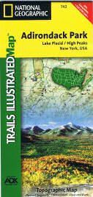
Maps are not required for those participating in hikes. However, the recommended map is: National Geographic, Adirondack Park - Lake Placid / High Peaks, 742, 1:75,000. This is available from The World of Maps in Ottawa or your favorite map store.

Emergency Kits
Each hike leader will be provided with a kit consisting of: Waterproof topographical maps of the trails, a map to the local hospital, a compass, a snowshoe repair kit, an advanced first aid kit, and a rope.

Contacts
Registration Mountaineering
Allan Yates Christiaan Burchell
(613) 269-3074 (613) 274-3900
allan@yates.ca cburchell@yahoo.com

Shops
The Mountaineer Eastern Mountain Sports

1866 New York State Route 73 2453 Main Street
Keene Valley, New York Lake Placid, New York
(518) 576-2281 (518) 523-2505
Open daily 8:00am to 5:30pm Sunday - Thursday Friday - Saturday
10:00am to 6:00pm 10:00am to 9:00pm
Further Information
Winter Adventure Information www.1stmerrickville.ca/winteradventure/
Venturer Advisor Forum web.ncf.ca/ad554/
Alpine Club of Canada Keene Farm www.accmontreal.ca/en/huts/keenefarm/
Keene Valley Hostel www.keenevalleyhostel.com
Brookside Motor Inn www.adirondacks.com/brookside/
Canadian Border Services Agency www.cbsa-asfc.gc.ca/whti-ivho/ls-tm-eng.html
Olympic Bobsled www.orda.org/newsite/todo/winter/bobsled_luge.php
Lake Placid Toboggan Chute www.northelba.org/government/park-district/toboggan-chute.html
The Mountaineer store www.mountaineer.com
Eastern Mountain Sports www.ems.com
Whiteface Mountain Ski Resort www.whiteface.com
Gore Mountain Ski Resort www.goremountain.com
Jay Peak Ski Resort www.jaypeakresort.com
Lake Placid Chamber of Commerce www.lakeplacid.com
The World of Maps www.worldofmaps.com
Adirondak Loj www.adk.org/ad_loj/
Rock and River guiding www.rockandriver.com
National Geographic Maps www.nationalgeographic.com/maps/

GPS Waypoints
Waypoints for each of the trails, in GPX format, are available from the Winter Adventure website.

Lake Placid Toboggan Chute
Pricing: $5/sled rental + $5/adult and $3/youth (up to 18) to use it. Unlimited rides.
Hours: Friday 7:00pm - 9:30pm, Saturday 12:00pm - 4:00pm & 7:00pm - 9:30pm, Sunday 12:00pm - 4:00pm

Directions
From Ottawa, take Highway 417 east until exit 58 and turn right onto Highway 138 south to Cornwall and follow signs for Bridge to USA. Cross over the bridge (toll payment required), go through Customs, and take Highway 37 east to Malone. In Malone, Highway 37 changes to Highway 30 south to Paul Smiths. Take a left turn onto Highway 86 to Lake Placid. A short cut, bypassing Lake Placid, may be taken by turning right on County Road 35 (Old Military Road); then turning right on Highway 73 east. Otherwise, proceed into and through Lake Placid, turning right onto Highway 73 east. Keep on Highway 73 until Keene. In Keene, turn left onto 9N. Travel 5km and turn right on to Styles Brook Road. Go 1.5km up a hill to the small sign for the ACC Montreal Section. Turn left into the parking lot and hike up the hill to the hut. The path to the hut is at the far end of the parking lot, up through the trees. The path to the camping field is directly ahead of the driveway where it turns left into the parking lot; up a small hill.

Route Map
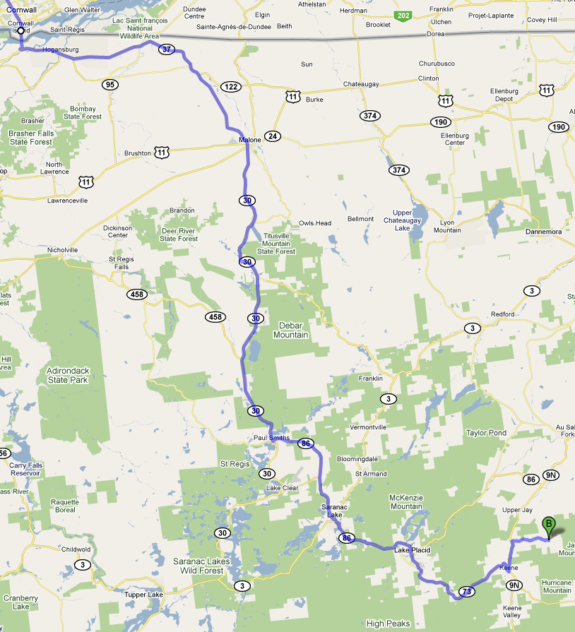
ACC Hut
Hostel
Brookside
Shortcut around Lake Placid
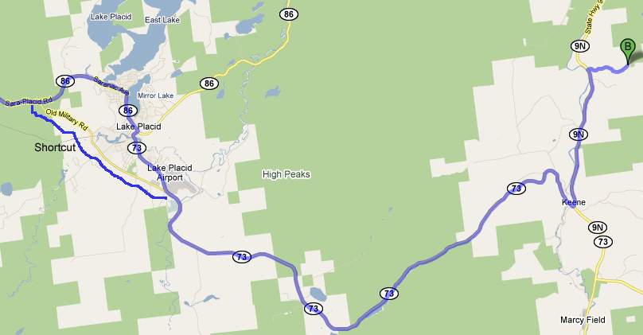

Map to Hut
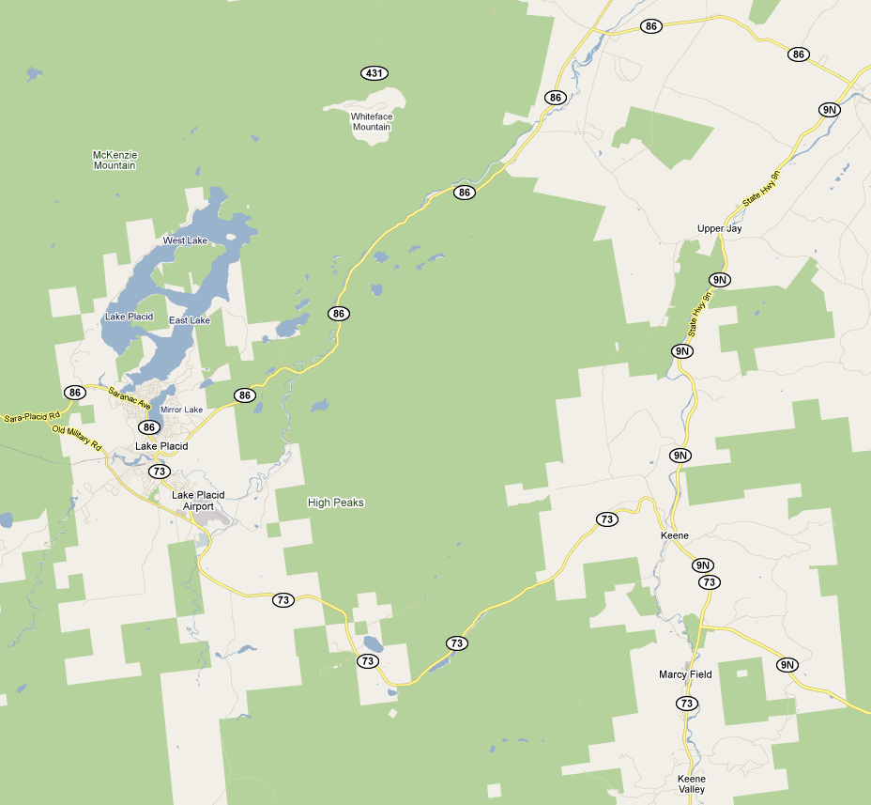
ACC Hut
Styles Brook Road
Road to
Whiteface Mountain
The Mountaineer
Adirondack Medical Centre
Hostel
Brookside
Olympic Regional Development Authority Map
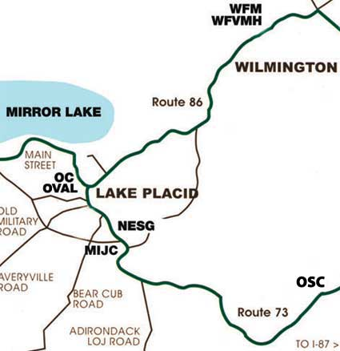
Bobsled
Lake Placid Map
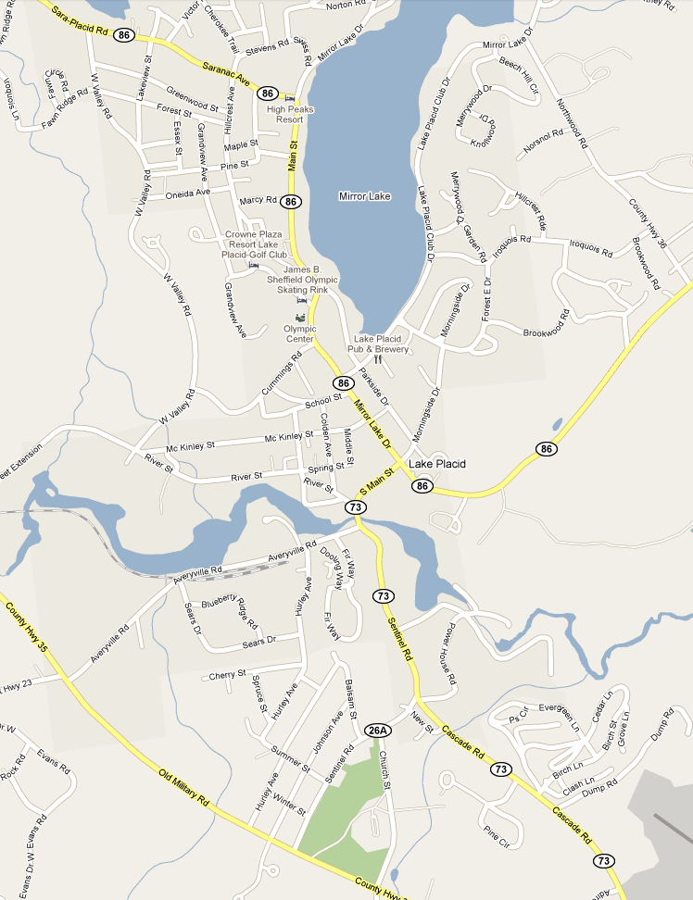
Toboggan
Chute
Eastern Mountain Sports
Adirondack Medical Centre
To Canada
To ACC Hut
Shortcut
to Canada
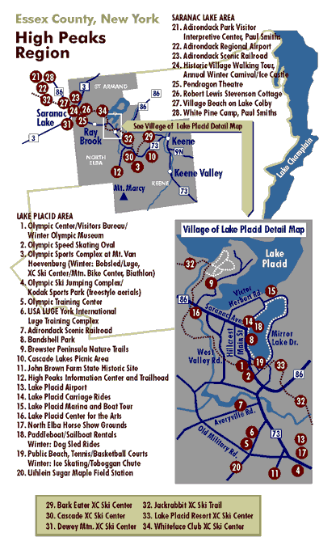

Keene Farm Hut
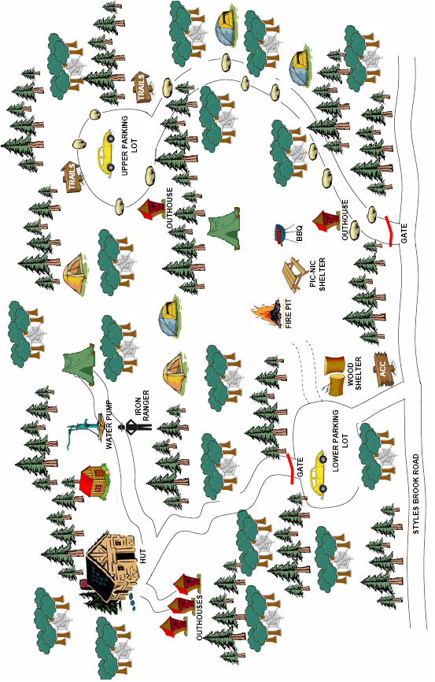
Camping Area
Entrance
ACC Hut Dining Shelter
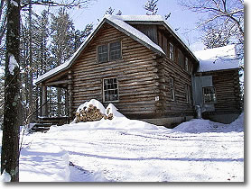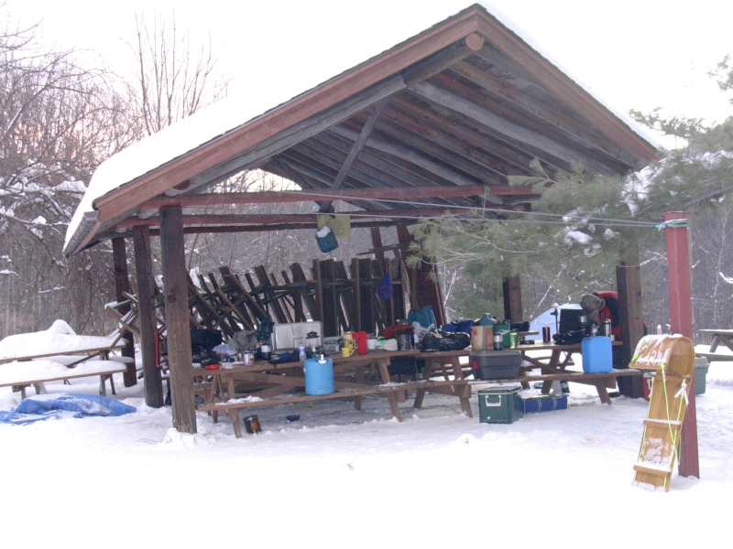

Dining Shelter Hut Sleeping Floor
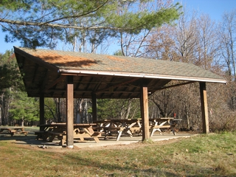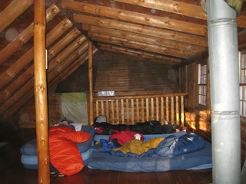

Hut Kitchen Hut Kitchen
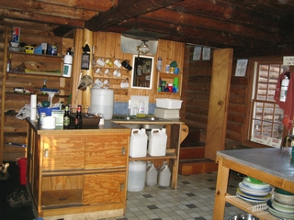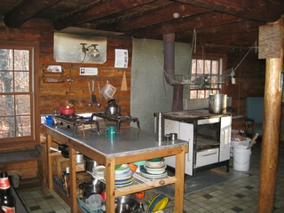

Hut Living Room Hut Living Room
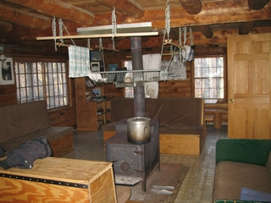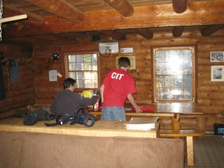

Camping Area Fire pit Camping Area
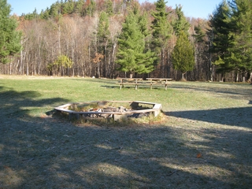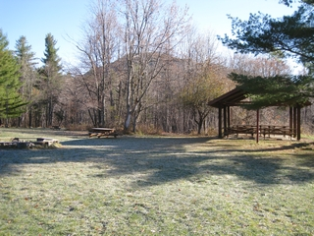

Path to Camping Area Path to Hut
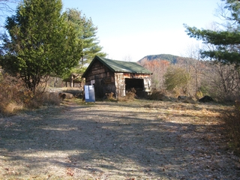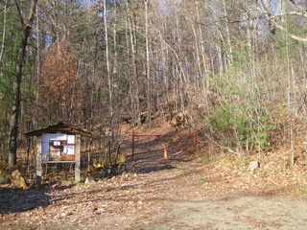

Keene Valley Hostel Brookside Motor Inn
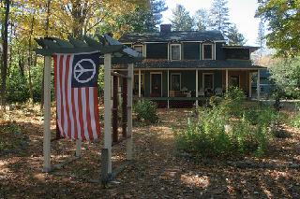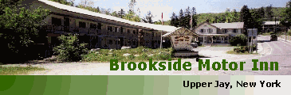

Ice Climbing
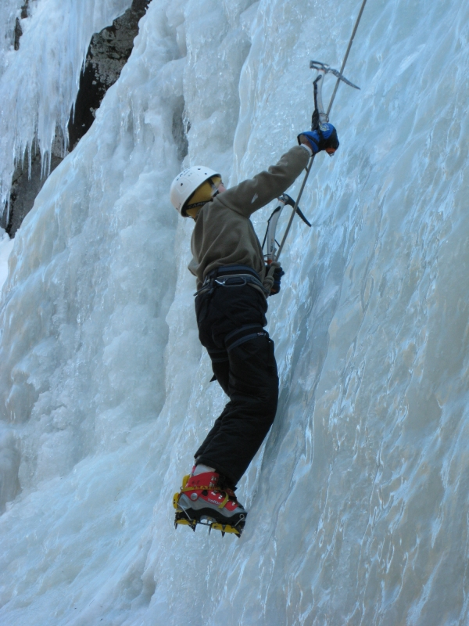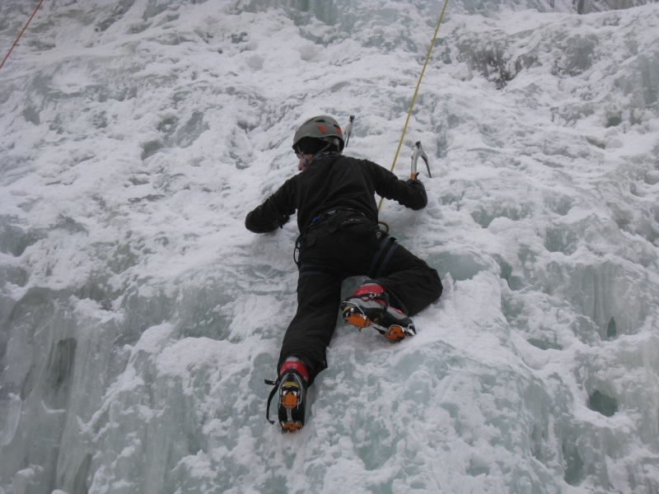

Snowshoeing
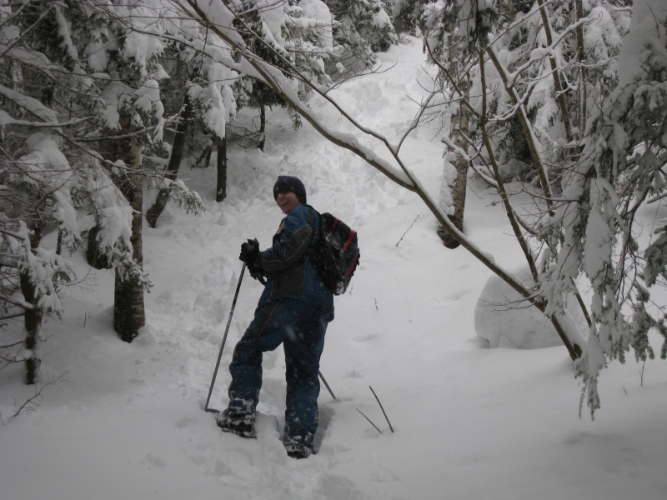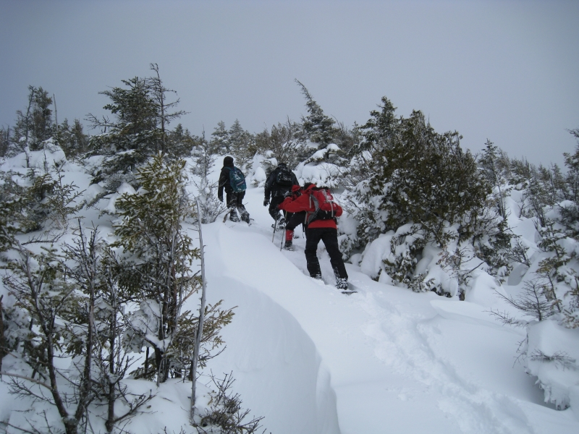
Olympic Bobsled Olympic Bobsled
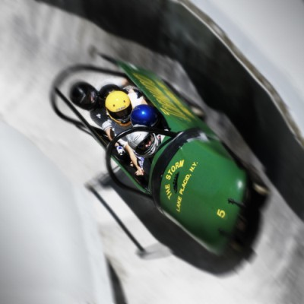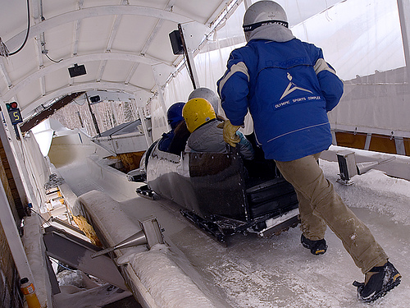

Toboggan Chute Toboggan Chute
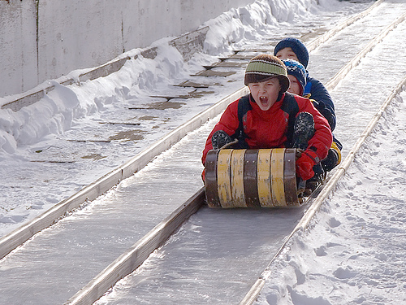
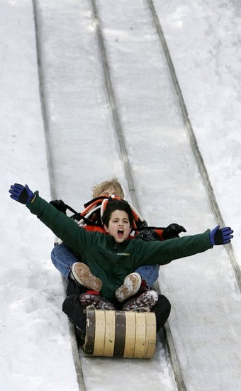

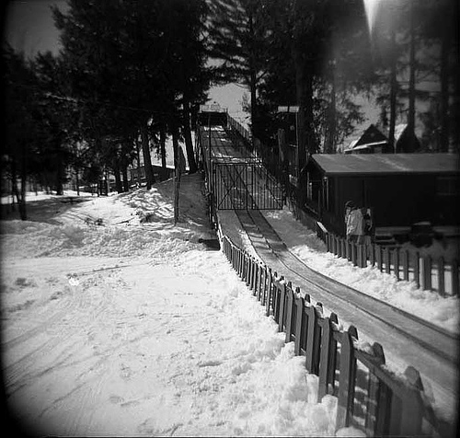
Accommodation Locations
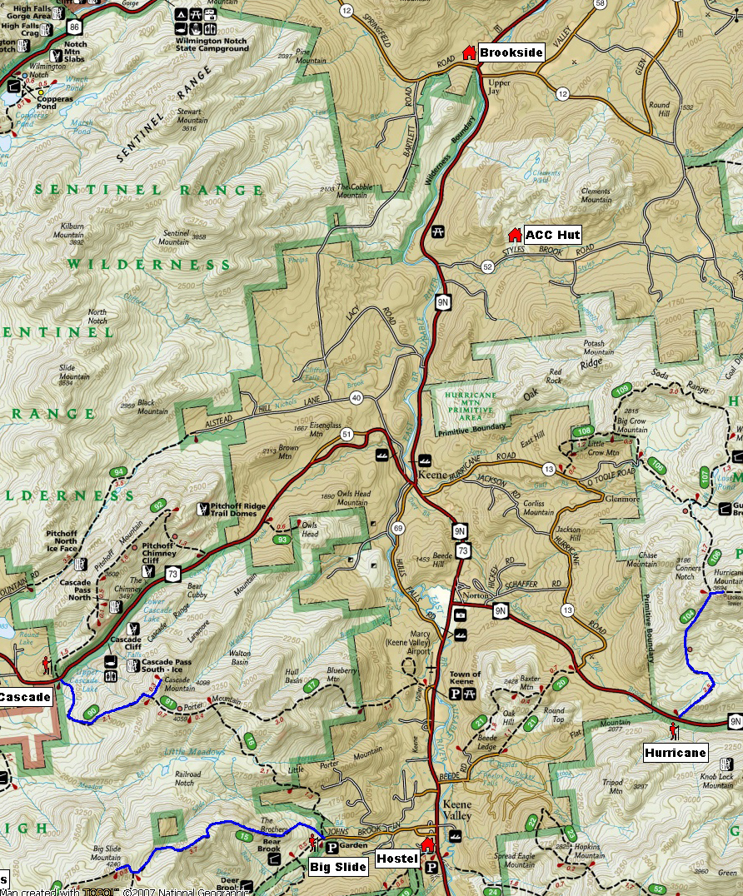
To Lake Placid
Trail Start Locations
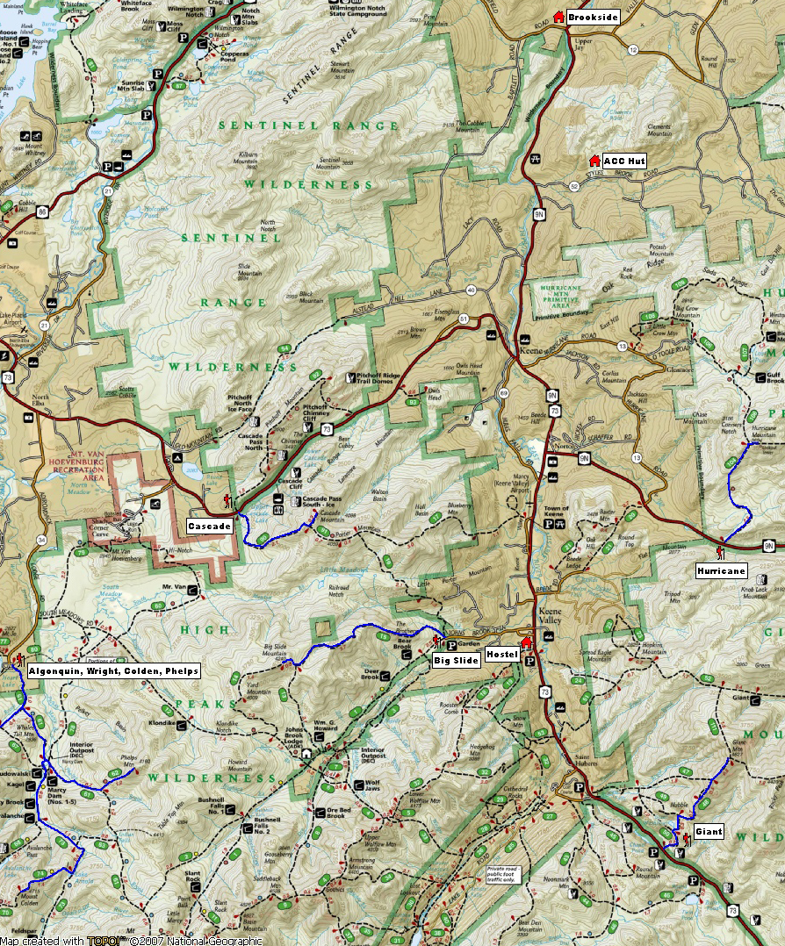
To Lake Placid
Cascade Mountain
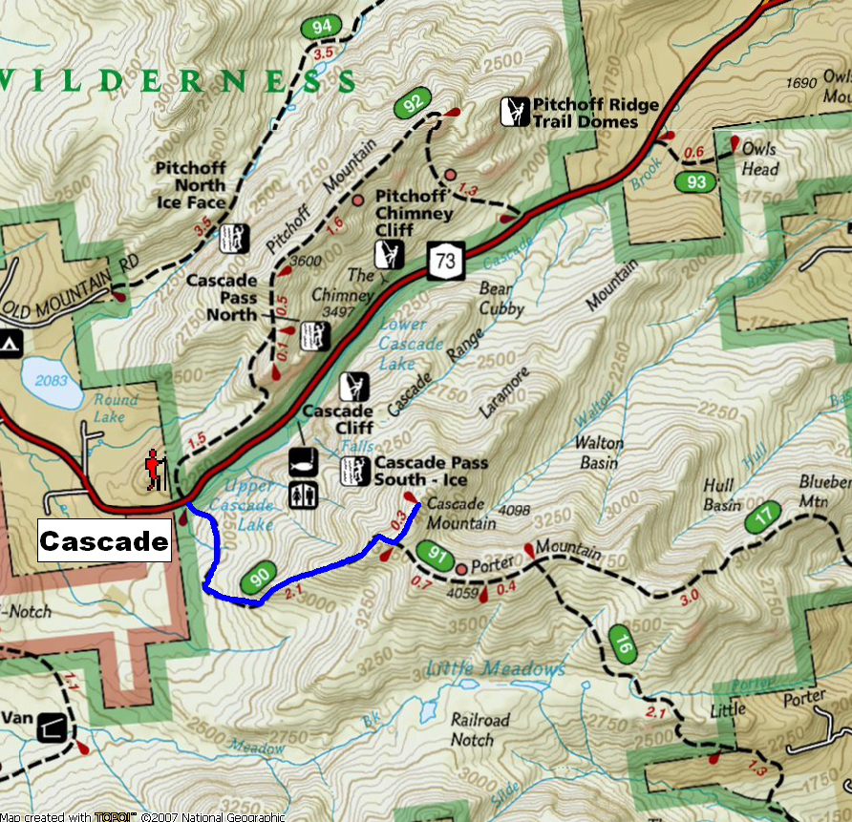

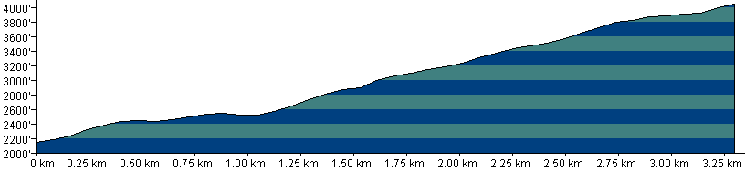
Big Slide Mountain
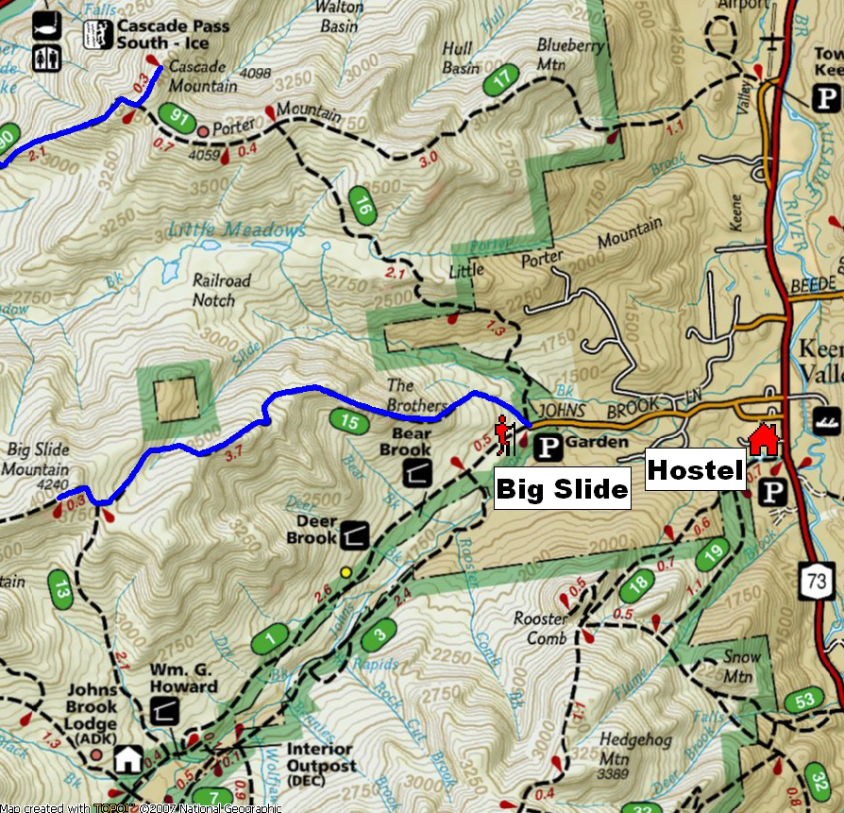

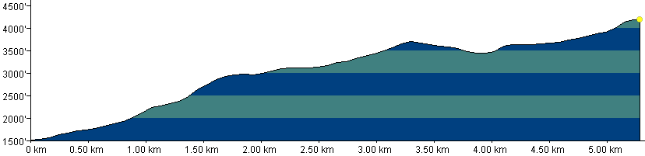
Hurricane Mountain
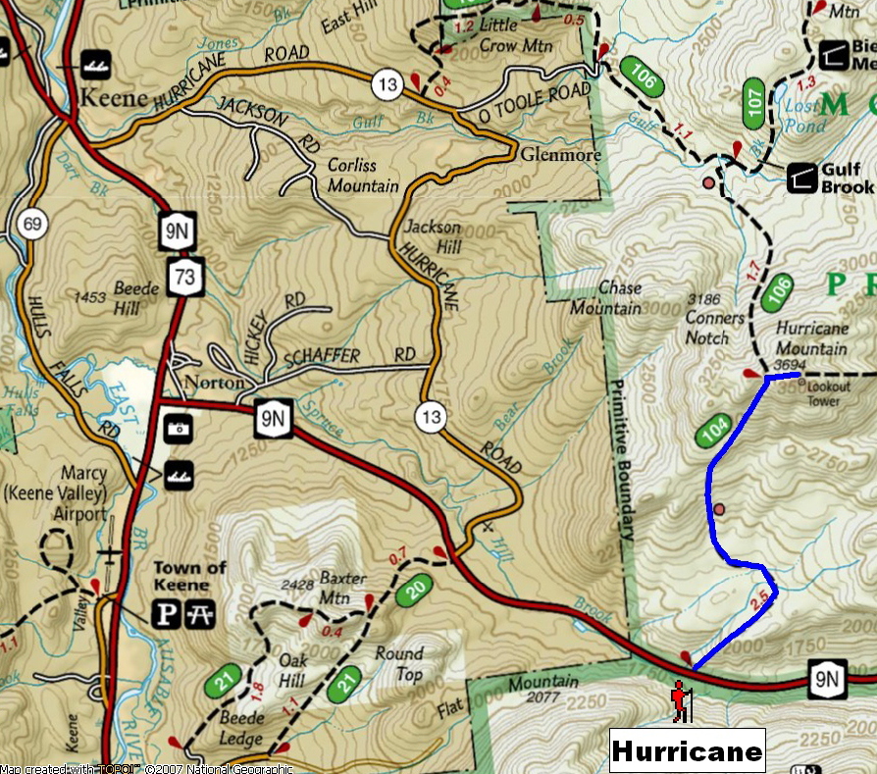

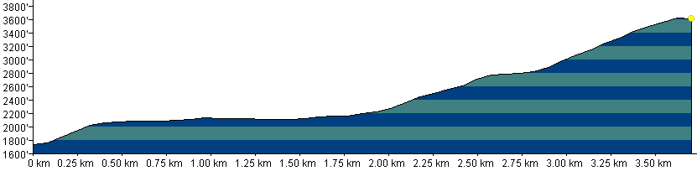
Giant Mountain
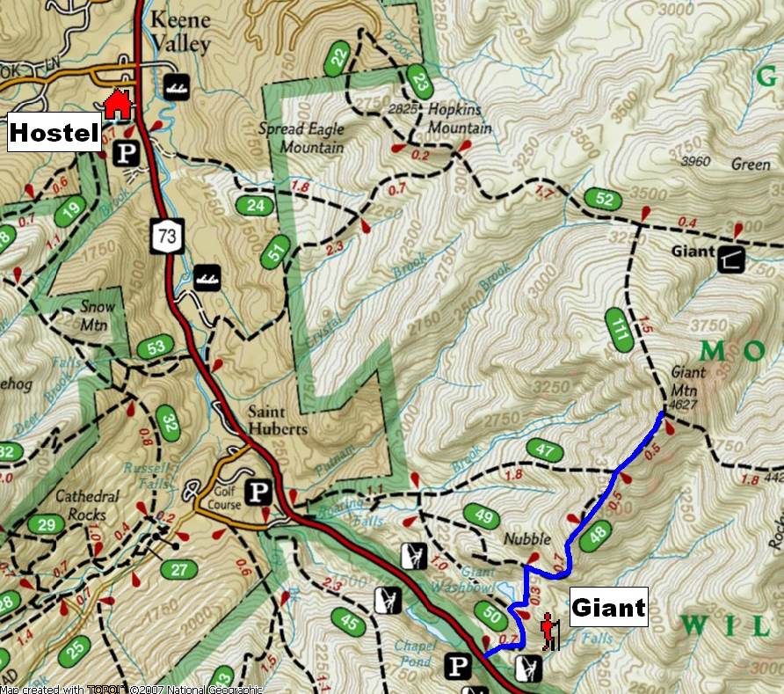

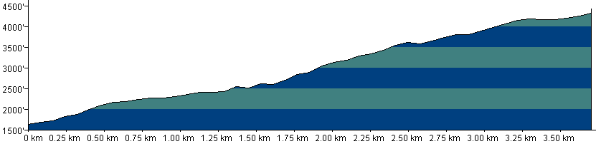
Algonquin, Colden, Phelps, and Wright Mountains
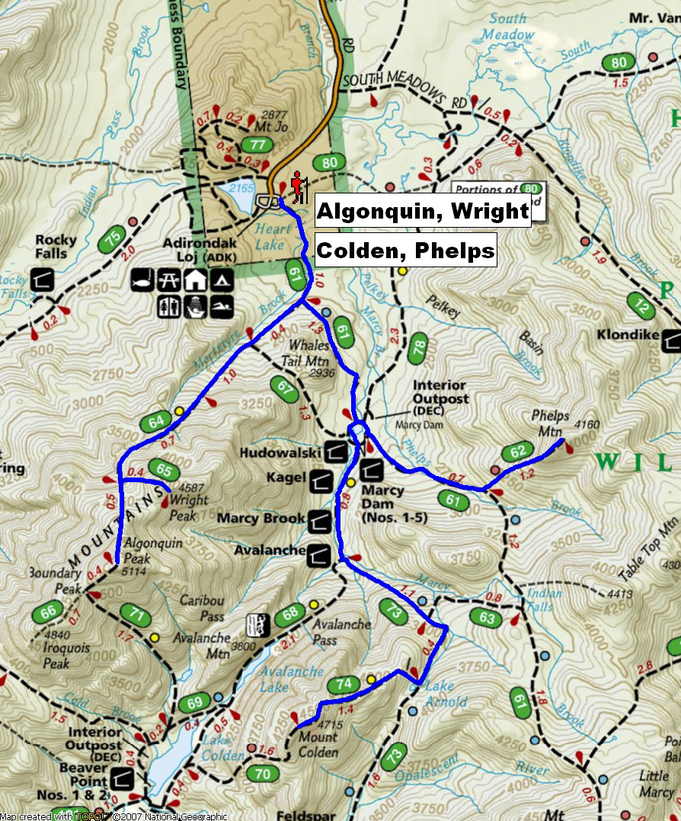

Algonquin Mountain
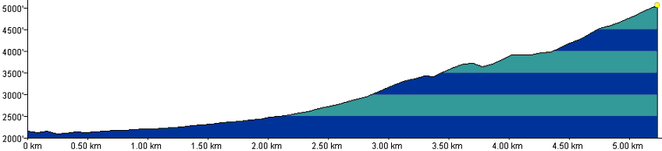

Wright Mountain
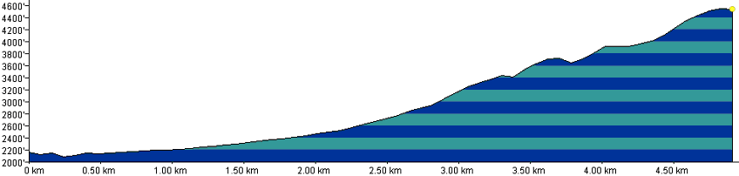

Phelps Mountain
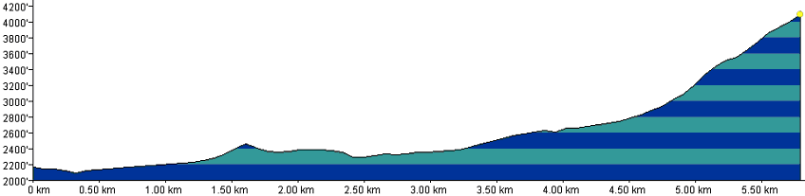

Colden Mountain


